- Address Raj's question: was sir2 cross docking was not a "fair test"?
  - It depends on what you mean by fair. The simulation in question started with the AC protein conformation and attempted to cross dock to get the AB pocket pose of NAD+. In order to get the desired pose of NAD+ in the AB pocket (for which we had the answer from 1YC2 chain A), multiple constraints needed to be implemented. These constraints can be scene either as "cherry picking" if the point of the cross docking was to see if Glide or Induced Fit could correctly replicate the known answer without imposing serious constraints to guide the answer. On the other hand, it is acceptable to use prior knowledge in simulations to guide the result. The danger, however, is that we cannot use these constraints as reliably with SIRT3, as we don't have co-crystallized structure answers for NAD+ in the AB or AC pockets.
  - What were the exact constraints used in Sir2?
    - excluded volume for the C pocket. This is definitely fair, otherwise the ligand bound to the AC pockets - an interaction predicted to be more favorable.
    - additional excluded volumes in multiple locations where the nicotinamide could go. kept the B pocket clear. Yes, these could pose a problem when applying this to SIRT3.
    - torsional constraints on the ligand to impose the AB like conformation in which the nicotinamide is pointing away from the C pocket. This constraint does bias the result.
    - H-bond constraints. These are fair, because all the H-bond constraints are for the A pocket, which has H-bonds for both the AB and AC poses, as seen in Sir2Af2 (1YC2)
- Comments on Raj's email: "I really don't understand the status with cross docking on Sir2 AB pocket. I'm not sure what we did is a suitable cross-docking test. We need to see the precise protocol" Why was Sir2 cross docking successful and SIRT3 unsuccessful? Was the exact same protocol applied to Sir2 and 3?
  - Cross docking on Sir2 AB pocket (1YC2: Sir2Af2). Two simulations were done:
    - (1) no constraints except for a volume exclusion for the C pocket. The result matched for the portion of NAD+ in the A pocket. However the nicotinamide did not adopt the exact same conformation as the co-crystallized structure of NAD+ in the AB pockets. However, it was close. Note that this result could still be legitimate. The B pocket is heavily exposed to solvent, and there is a lot of room for nicotinamide to adopt various conformations, as seen in the ensemble of docked poses. None of the docked poses matched the co-crystallized structure possibly because it had an intramolecular H-bond between the nicotinamide and the phosphate oxygen. Glide may bias results against intramolecular H-bonds. Note that I previously reported that these Sir2 results failed. I the subsequently revised this statement to say that the position of the nicotinamide in the B pocket could be degenerate, because the B pocket is a very roomy, open volume exposed to solvent in which the nicotinamide moves around.
    - (2) multiple additional constraints such as ligand torsion constraints, more excluded volumes. This may not be the most suitable cross docking, but it did reproduce a very close match to the crystal structure.
  - Why was Sir2 cross docking successful and SIRT3 unsuccessful?
    - the starting structures for Sir2 had very open volumes in the B pocket, while there was multiple steric clashes in the B pocket of SIRT3. These clashes may create a lot of difficulty in docking.
  - Was the exact same protocol applied to Sir2 and SIRT3?
    - initially yes. But when SIRT3 failed to work, protocol changes were made that differed from those that worked for Sir2. See the document on the docking protocols.
- Raj's comment: We need to benchmark any "induced fit" docking methodologies used with SIRT3 on Sir2. Otherwise, it would appear that we have cherry picked the methodology/results.
  - still need to answer this.

Ligand Interaction Diagram for SIRT3:
Don't have AC or AB pocket filled with NAD+. Best that have is the thio-intermediate from PDB:3GLT SIRT3-AceCS2-K_s-ac-ADPR. The nicotinamide has been cleaved and a bond to the thioacetyl is trapped. I could not figure out how to create the nice ligand interaction diagram in Maestro, because Maestro does not recognize peptides as ligands. I'm looking for a way to define the ligand as peptide B, which is the peptide with the thio-acetyl ADPR intermediate. Otherwise, a standard 3D picture of the H-bonds between the ADPR and the protein residues within 3 Å of the ligand are shown here:

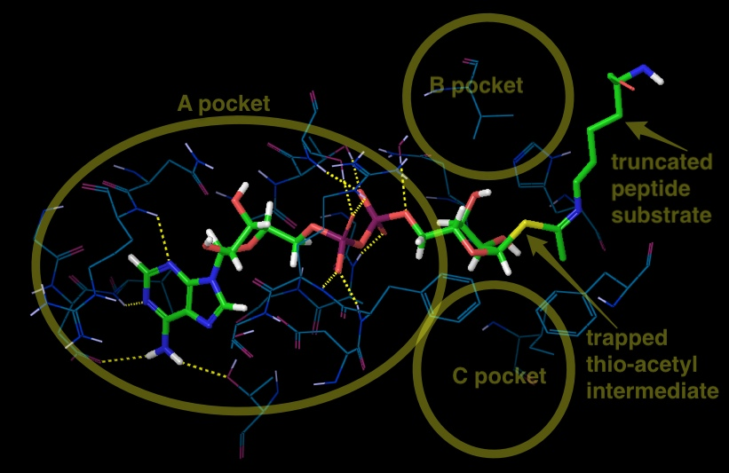
Above Figure: SIRT3, 3GLT with the trapped thio-acetyl lysine ADPR intermediate. Note the intermolecular 12 H-bonds between the ligand and the protein in the A pocket.

Steric Clashes in SIRT3:
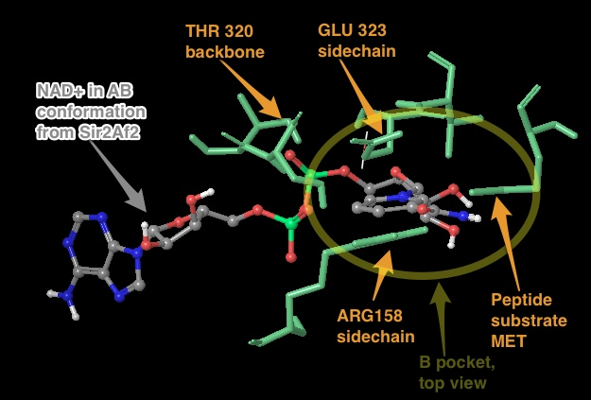

Above figure: Steric clashes between NAD+ in the AB conformation and SIRT3 (from the thio-acetyl ADPR intermediate). This is a top view of the NAD+, where the A pocket is oriented on top of the C pocket within the axis perpendicular to the figure. Other views have shown the A pocket above the C pocket in the X direction in the plane of the picture. The steric clashes are labeled in orange, and the B pocket is labeled with the yellow circle. Analysis as to why docking did not work: it is not clear to me why these mostly side chains could not be pushed out of the way with induced fit docking.

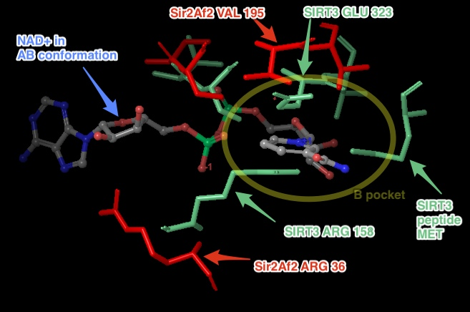
Above figure: shows similar view as previous figure, but with the addition of important Sir2Af2 residues within 6 Å of the nicotinamide in the B pocket (in red). The Sir2Af2 structure is from the NAD+ co-crystallized PDB file 1YC2 chain A with NAD+ in the AB pockets. This structure is aligned to the SIRT3 protein backbone from 3GLT (the pdb file with a structure closest to one with an NAD+). 3GLT has the thio-acetyl ADPR intermediate, which has the nicotinamide cleaved off. The SIRT3 residues as shown in the previous figure that obstruct the B pocket are in aqua. Note that Sir2 does not obstruct the B pocket. For example, the ARG 36 in Sir2Af2 is moved back and its side chain rotated out of the way in comparison to SIRT3 ARG 158. While SIRT3 has GLU 323 which obstructs the nicotinamide, Sir2Af2 has a Val 195 pushed farther back leaving room for the nicotinamide. There are no steric clashes with peptide substrate residues, like there is with the SIRT3 MET.

