**Results of carba NAD solubility studies done at PMC-AT and recommended future steps:**

Carba-NAD solubility at 2 mg/ml (3 mM) was tested in-house in the following solvents:

a) 5% DMSO-HDAC buffer

b) HDAC buffer

c) water

d) Control (HDAC buffer only, 5% DMSO-HDAC buffer only)

**a)** The **procedure** for experiment a) is given below:

1. 1.12 g carba NAD weighed in microbalance
2. 500 ul, 5% DMSO-HDAC buffer added
3. Sample vortexed till no clear particles present
4. Incubated in RT for 10 min
5. Sample centrifuged at 4 C for 10 min: **Pellet seen** in the tube after c/f (**please see attached photo: 4 C**)
6. After c/f at 4 C, sample vortexed at RT to dissolve pellet
7. Incubated in RT for 10 min
8. Sample centrifuged at 25 C for 10 min: Pellet seen in the tube after c/f (**please see attached photo: RT**)

**Results for experiment a) 3 mM carba NAD solubility in 5% DMSO-HDAC buffer:**

* After centrifugation of the sample at both 4 C and 25 C, **a pellet was seen** in the tube (please see following pictures) indicating possible insolubility.

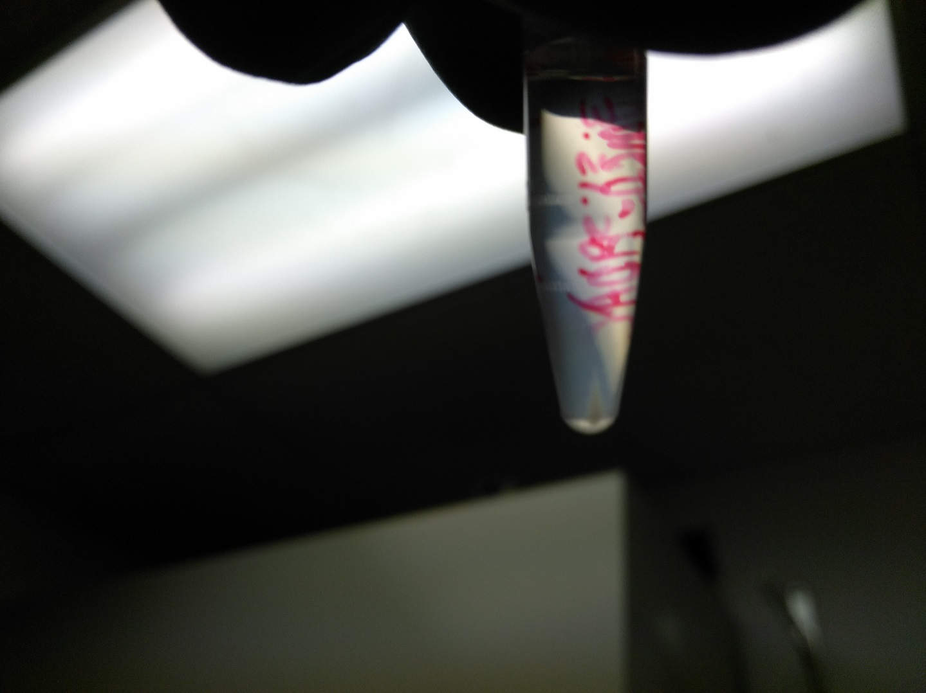 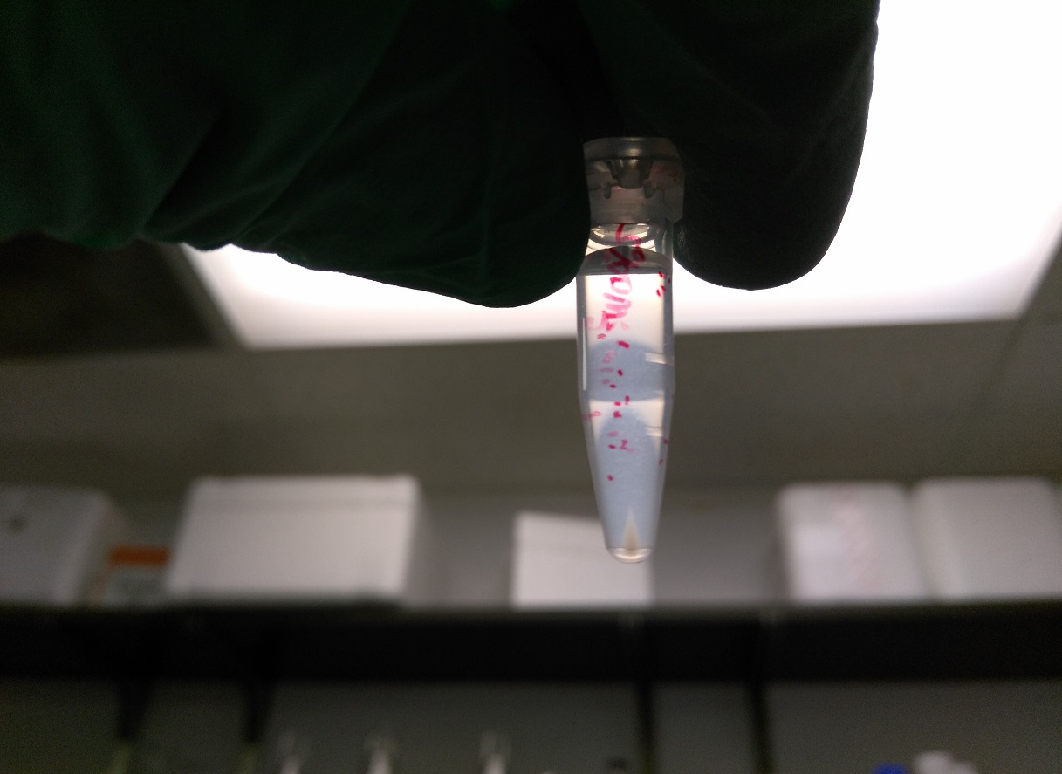

**Sample a) after c/f at 4 C Sample a) after c/f at 25 C**

**Conclusions for experiment a):**

* Pellet was seen after centrifugation at both temperatures 4 C and 25 C, indicating that there may potentially be (temperature independent) solubility issuesat 3 mM carba NAD in 5% DMSO-HDAC buffer.
* These results corroborate Thomas’ findings.
* However, as explained below, the above **results do not indicate for sure** if 3 mM carba NAD is insoluble in 5% DMSO-HDAC buffer.

**b) Results for experiment b) 3 mM carba NAD solubility in HDAC buffer (no DMSO):**

* As seen in the picture below, **a pellet was formed** after c/f for 10 min at 25 C, even for a 3 mM carba NAD solution in just HDAC buffer.

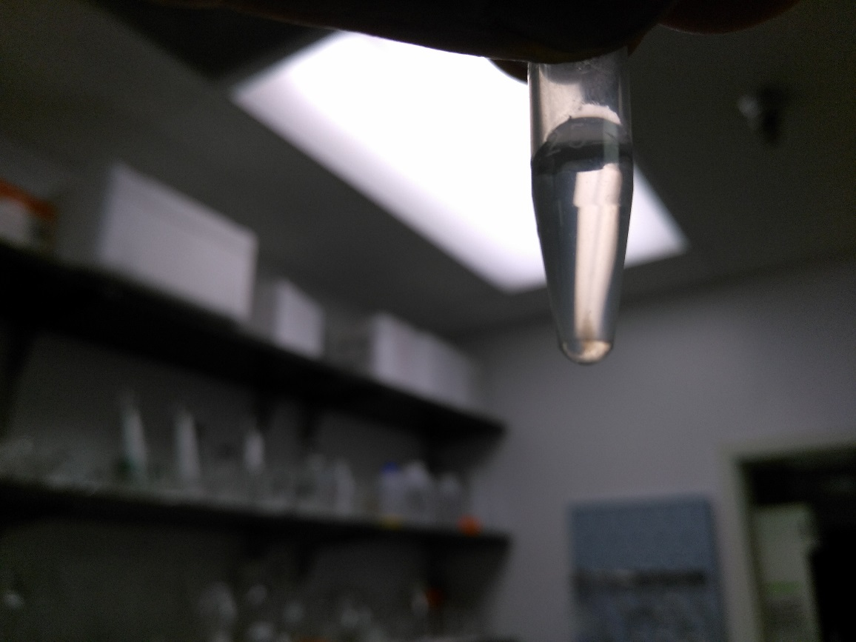

**Sample b) after c/f at 25 C**

**Conclusions for experiment b):**

* Pellet was formed at 3 mM carba NAD even in HDAC buffer (no DMSO), suggesting that 5% DMSO probably does not contribute to the solubility issues.
* As shown below in experiment c), it is probably the HDAC buffer which is giving rise to the pellet.

**c) Results for experiment c) 3 mM carba NAD solubility in water:**

* As seen in the picture below, **no pellet was formed** after c/f for 10 min at 25 C, for a 3 mM carba NAD solution in water.

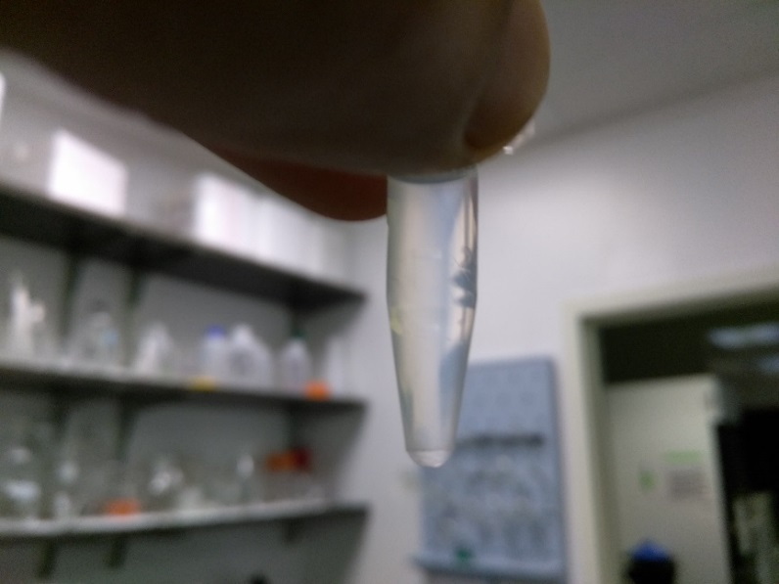

**Sample c) after c/f at 25 C**

**Conclusions for experiment c):**

* **No pellet was formed for 3 mM carba NAD solution in water**, suggesting that it is in fact HDAC buffer that is contributing towards formation of the pellet.

**d) Results for experiment d) Controls (HDAC buffer only, 5% DMSO-HDAC buffer only):**

* HDAC buffer only and 5% DMSO-HDAC buffer only (no carba NAD) were incubated in RT and centrifuged at 25 C for 10 min.
* **No pellet was formed in either of the samples.**

**Conclusions for experiment d):**

* **No pellet was formed for just HDAC buffer and 5% DMSO-HDAC buffer**, suggesting that it is not components buffer itself that is forming the pellet.
* Rather, it points to the possibility **that some kind of interaction between HDAC buffer components and the carba NAD sample are causing the solubility issues.**

**Overall conclusions regarding carba NAD solubility:**

* Based on in-house results, carba NAD is definitely soluble at 3 mM in water (no pellet formed)
* Since no pellet was seen in case of the solution made in water, but pellets were only seen in cases of solutions made in HDAC buffer and 5% DMSO HDAC buffer, **we could conclude that HDAC buffer and possibly 5% DMSO may be contributing to the solubility issues in the carba NAD samples.**
* **It is important to note that the pellet we are seeing in case of HDAC buffer and 5% DMSO HDAC buffer, may be due to the buffer components causing some of the carba NAD to come out of solution or it could be some impurity in the carba NAD that is insoluble in HDAC buffer.**
* The above conclusion is supported by the fact that only HDAC buffer and **only 5% DMSO-HDAC buffer do not form pellets** (experiment d)).
* Thus we (and Thomas) may have been making carba NAD solutions of the correct concentration all this time, but may have been misguided by formation of the pellet in 5% DMSO-HDAC buffer.
* In order to resolve the above issue (of whether the carba NAD solutions are indeed of the right concentration), the following steps could be taken.

**Recommended steps:**

* **As proof of principle (to make sure the pellet being formed is not carba NAD, but from the buffer)**, we need to verify if the carba NAD solution in HDAC/5% DMSO-HDAC buffer is indeed 3 mM, as prepared.
* From the above verification, **we would know if the pellet being formed after c/f is just from the buffer, in which case, it could safely be ignored after the c/f step**, since the supernatant solution would have the right concentration.
* Since the 3 mM solution in water does not form a pellet, we could use that as a standard for HPLC analysis of the peak area of 3 mM carba NAD.
* We could then compare the above peak area to those obtained from 3 mM solutions in HDAC and 5% DMSO-HDAC respectively.
* If all 3 peak areas for “3 mM” carba NAD are comparable (accounting for pipetting, weighing, injection errors), we could safely assume that the 3 mM solutions prepared in HDAC or 5% DMSO-HDAC are correct and we don’t need to worry about the pellet.
* If we see major differences in the peak areas for the samples in buffer, then we can conclude that the HDAC buffer or 5 % DMSO is contributing to solubility issues.