C pocket identified by Wolberger’s group[1]:
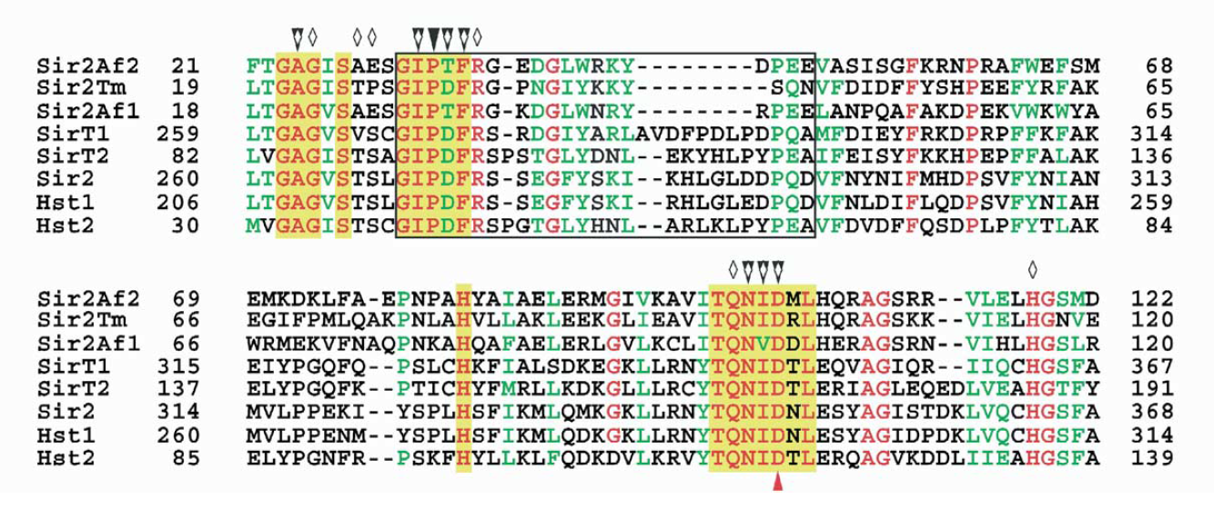
Multiple sequence alignment of eight sirtuins showing highly conserved residues (red) and conserved residues (green). Residues that are involved in making the C pocket are highlighted in yellow, flexible loop is indicated by box. Residues that contact nicotinamide (black triangles) or contact NAD+ bound in the productive conformation (white diamonds) are indicated above the alignment.
Structural analysis based on various structures:
- Free SIRT3(3GLS)/SIRT1(4IG9)
3GLS_A 86 122 ---K---L-SLQDVAELIRARACQRVVVMVGAGISTPSGIPDFRS-PGSGLYSNL
4IG9_A 85 -1 MRKKRKDINTIEDAVKLLQ--ECKKIIVLTGAGVSVSCGIPDFRSRD-G-IYARL

3GLS_A 86 169 QQ-Y-DLPYPEAIFELPFFFHNPKPFFTLAKELYPGNYKPNVTHYFLRLLHDKGL
4IG9_A 85 284 AVDFPDLPDPQAMFDIEYFRKDPRPFFKFAKEIYPGQFQPSLCHKFIALSDKEGK

3GLS_A 86 222 LLRLYTQNIDGLERVSGIPASKLVEAHGTFASATTVQRPFPGEDIRADVMADRVP
4IG9_A 85 339 LLRNYTQNIDTLEQVAGIQ--RIIQCHGSFATASLIKYKVDCEAVRGDIFNQVVP

3GLS_A 86 279 RPV-T---G-VVKPDIVFFGEPLPQRFL-LHVVDFPMADLLLILGTSLEVEPFAS
4IG9_A 85 394 RPRPADEPLAIMKPEIVFFGENLPEQFHRAMKYDKDEVDLLIVIGSSLKVRPVAL

3GLS_A 86 330 LTEAVRSSVPRLLINRDLVGPLAWHPRSRDVAQLGDVVHGVESLVELLGWTEEMR
4IG9_A 85 451 IPSSIPHEVPQILINREPL---PHLHF-D-VELLGDCDVIINELCHRLGG--EYA

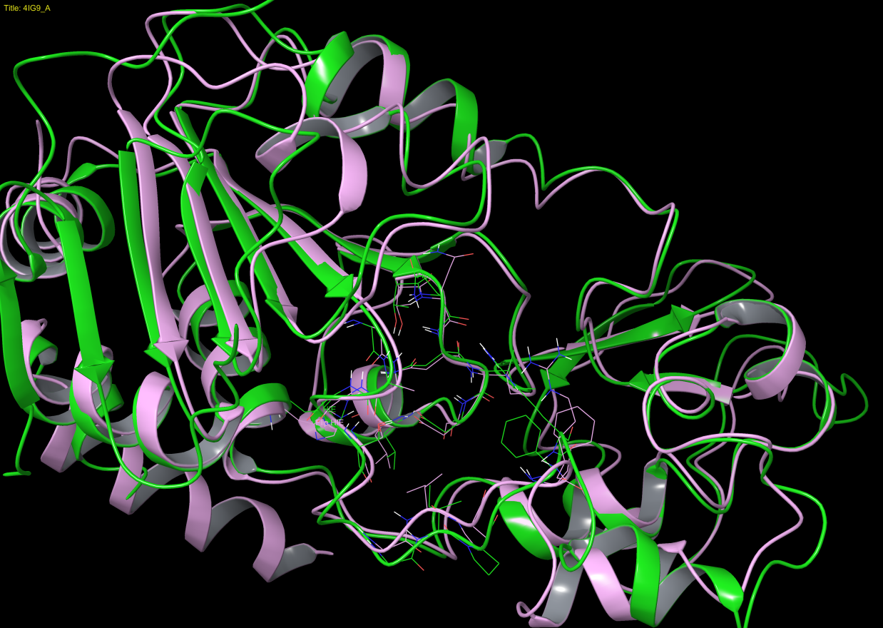
RMSD: 1.61 Å. (The residues highlighted are displayed.SIRT3 in plum, SIRT1 in green)
- Alignment between free SIRT3(3GLS)/SIRT3(ternary structure; 4FVT)
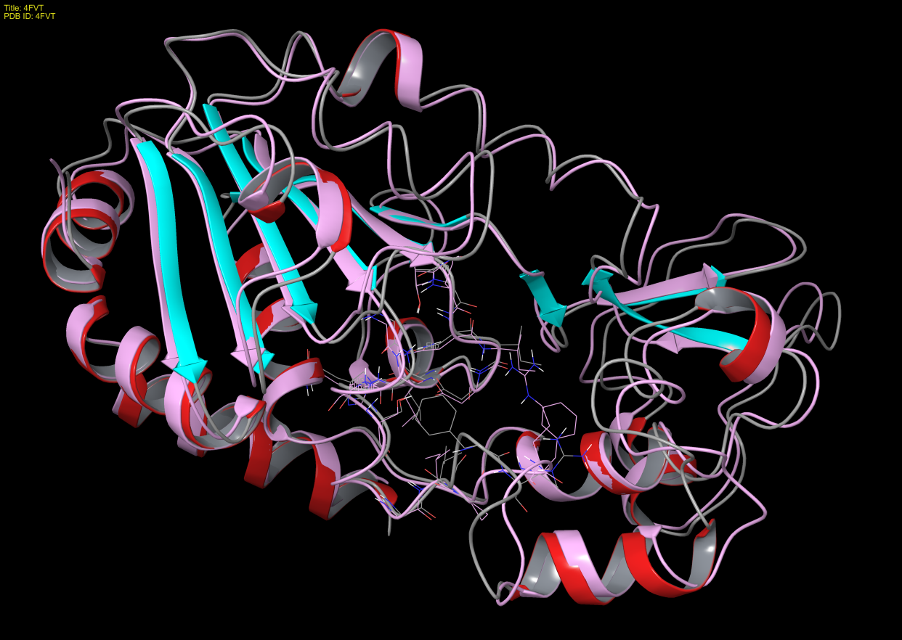
RMSD: 1.16 Å. (Free SIRT3in plum, ternary SIRT3 colored based on secondary structure.)
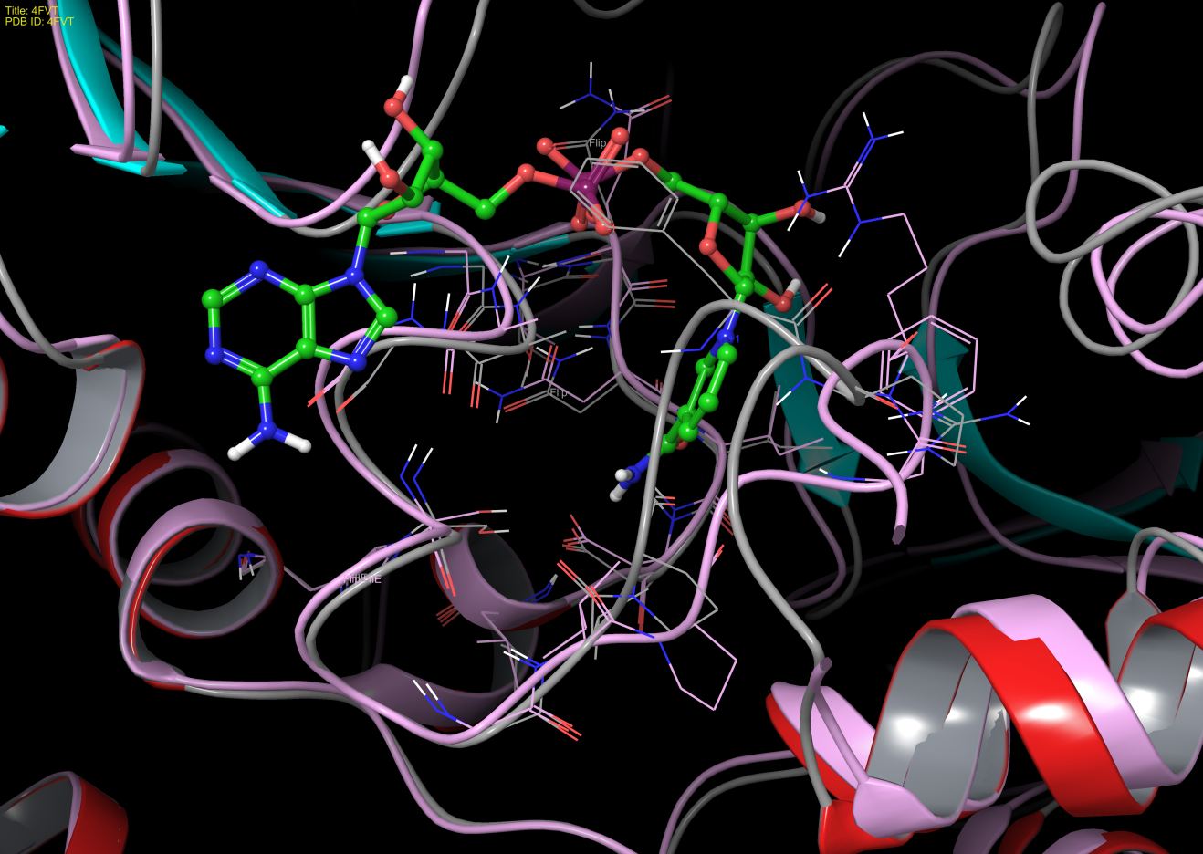
The major difference occurs at the dynamics loop region, PDFR.
The interaction diagram of the nicotinamide moiety in ternary SIRT3 (4FVT) show shorter C-pocket binding residue sequence but span over the similar region:
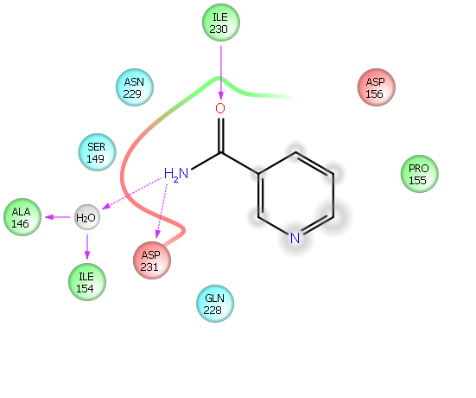
- Alignment between ternary SIRT3 (4FVT) and Sir2Af2 (1YC2:A, NAM in C)
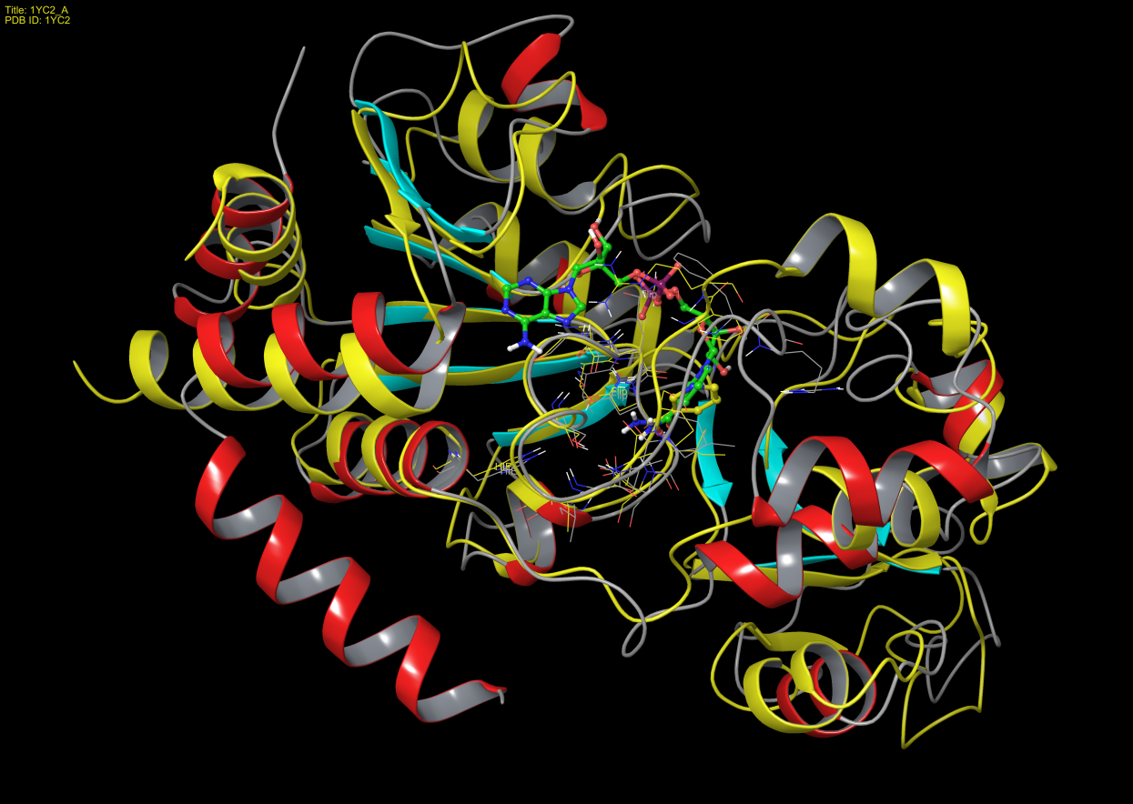
The interactions with nicotinamide alone differs slightly compared to those with nicotinamide moiety in NAD+. The major difference occurs at the dynamics loop, DFR.
A close-up view of the C pocket is attached.
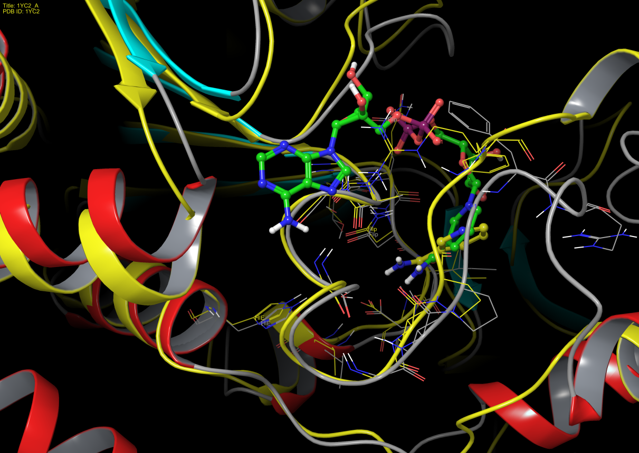
The interaction diagram of nicotinamide in C pocket of Sir2Af2 is attached.
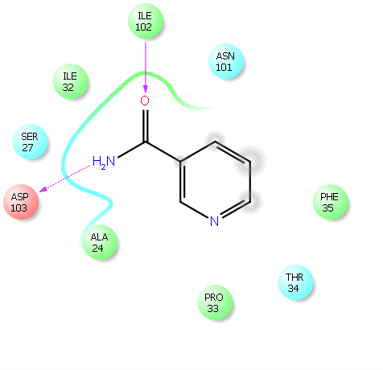
- Alignment of free SIRT1(4IG9) and ligand bound SIRT1(4KXQ)
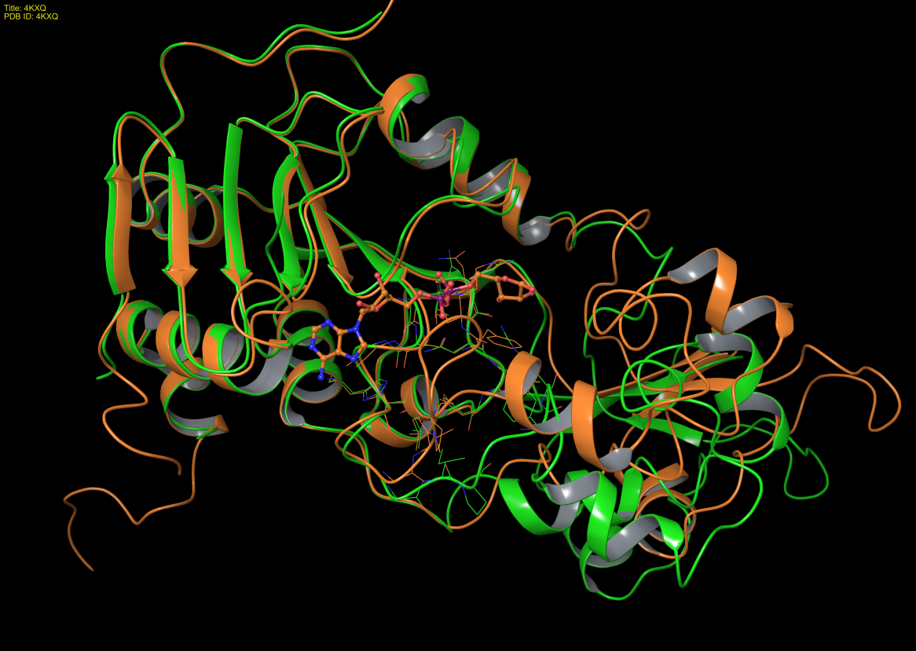
RMSD of Rossmann fold domain is 0.49 Å after alignment with the domain. The Zn-binding domain show significant movement upon ligand binding (adenosine-5-diphosphoribose).
A close-up view is also provided.
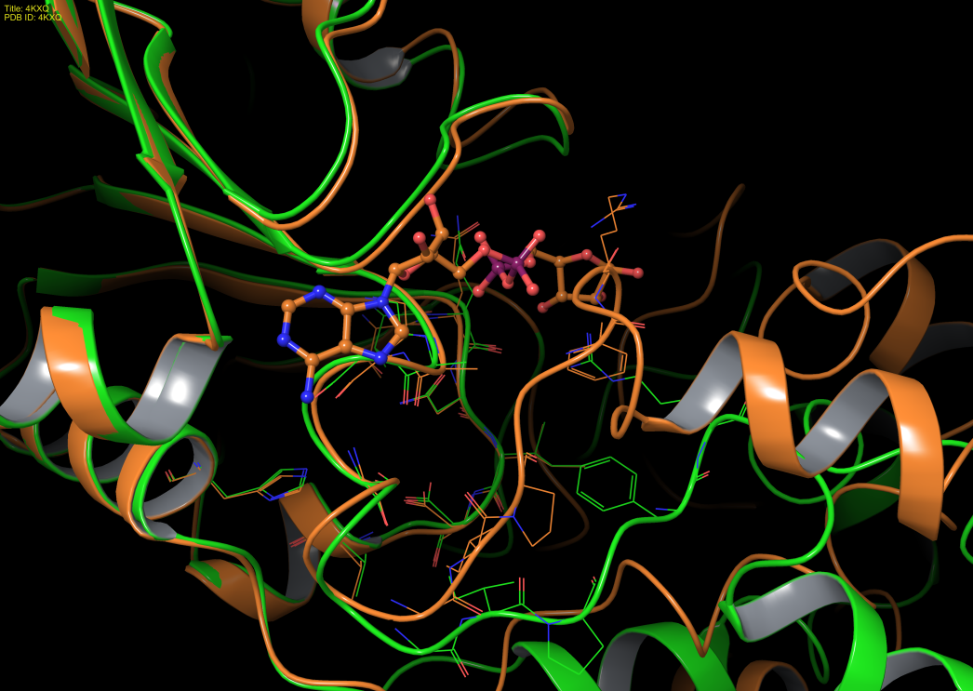
- Alignment and comparison between ligand bound SIRT1 (4KXQ) and ternary SIRT3 (4FVT)
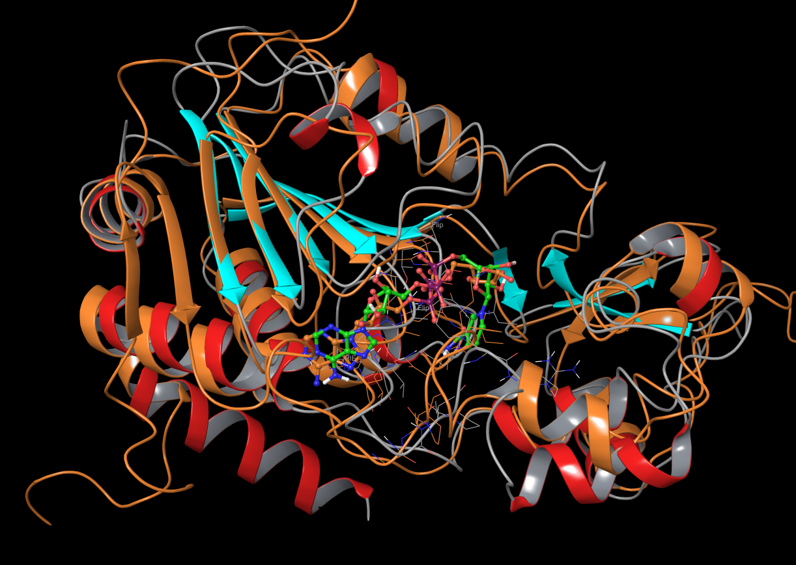
RMSD is 2.04 Å. Again, the residues on the dynamic loop do not align well. However, the ligand in SIRT1 doesn’t have NAM moiety.

1. Avalos JL, Bever KM, Wolberger C (2005) Mechanism of sirtuin inhibition by nicotinamide: altering the NAD(+) cosubstrate specificity of a Sir2 enzyme. Mol Cell 17: 855–868.

