Date: 4/12/2016

**Task 1:**

Mapping the remaining raw data files relevant to the information contained KT documents.

Status:

I need to document the location of the files as a part of the KT document. However, the location of all important data files necessary for the paper is self-contained in Task 1 document.

**Task 2:**

Create new B factor plots based on the MD data contained in

C:\Users\plin\Documents\MD_works \Flexible_Loop_Bfactor_Summary.xlsx

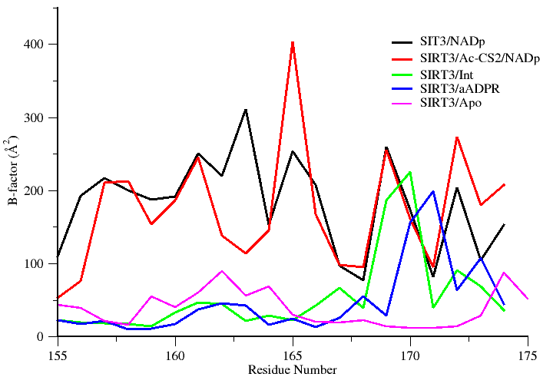

Fig ------: Plot showing simulated B-factor values for Cα atoms belonging to the co-factor binding loop region of various SIRT3 complexes. Residues (162-170) are known to adapt a helix conformation when bound to substrate.

------------------------------------------------------------------------------------------------------------------------------

**Task 3:**

Perform a structure based sequence alignment using PROMALS3D to recreate the figure presented in Pling’s summary document.

The following PDB ids 4I5I, 3ZGV, 4FVT, 3RIY, 3ZG6, 2H59, 1YC2, and 1SZC will be considered for alignment and highlight regions containing the conserved residues critical for catalysis and their mutations.

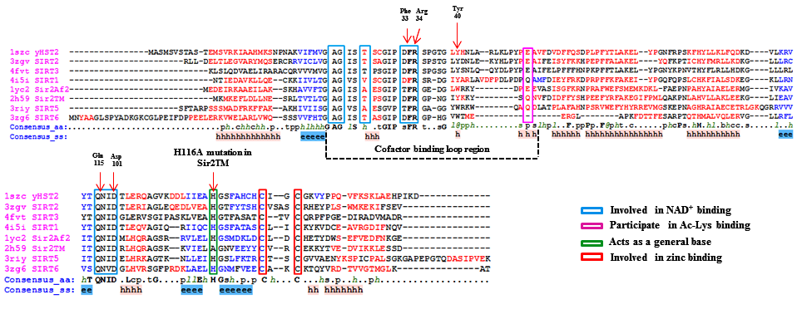

**Fig ……. :** PROMALS3D based sequence alignment of sirtuin proteins.  Residues shown in the alignment are colored according to their predicted secondary structure elements (red: α-helix, blue: β-strand). The boundaries of the co-factor binding loop region are highlighted using black dotted lines. The consensus sequence (consensus_aa) and consensus predicted secondary structure (consensus_aa) are shown at the bottom of the alignment. Consensus amino acid symbols are represented by: conserved amino acids are in bold and uppercase letters; aliphatic (I, V, L): l; aromatic (Y, H, W, F): @; hydrophobic (W, F, Y, M, L, I, V, A, C, T, H): h; alcohol (S, T): o; polar residues (D, E, H, K, N, Q, R, S, T): p; tiny (A, G, C, S): t; small (A, G, C, S, V, N, D, T, P): s; bulky residues (E, F, I, K, L, M, Q, R, W, Y): b; positively charged (K, R, H): +; negatively charged (D, E): −; charged (D, E, K, R, H): c. The global consensus predicted secondary structure are represented by alpha helix (h) and beta strand (e). Residues important for co-factor binding, substrate binding and catalysis are highlighted in colored boxes.

**Task 4:**

Pymol rendering showing the conformational heterogeneity of the cofactor binding loop (with and without the side chains displayed). The following PDB ids will be used to carry out a structural alignment. (4BVG and 4FVT).

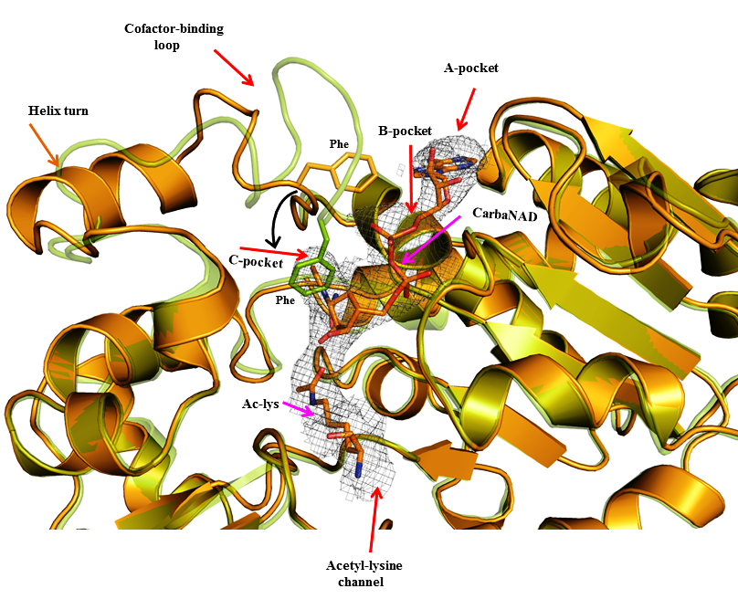

Figure XXXXX: Superposition of Sirt3 native intermediate (4BVG - Green) and Sirt3 ternary complex (4FVT - Orange) showing differences in the conformation of the cofactor binding loop and the position of the Phe residue. Individual subsites are highlighted and the movement of Phe residue is indicated by black arrows. The substrates Carba-NAD and Ac-Lysine are rendered in stick representation.

**Task 5:** A new figure showing the comparison of MD averaged structures of SIRT3- INT-NAM complexes with cofactor binding loop modeled based on coordinates of ternary (4FVT) and intermediate complex (4BVG).

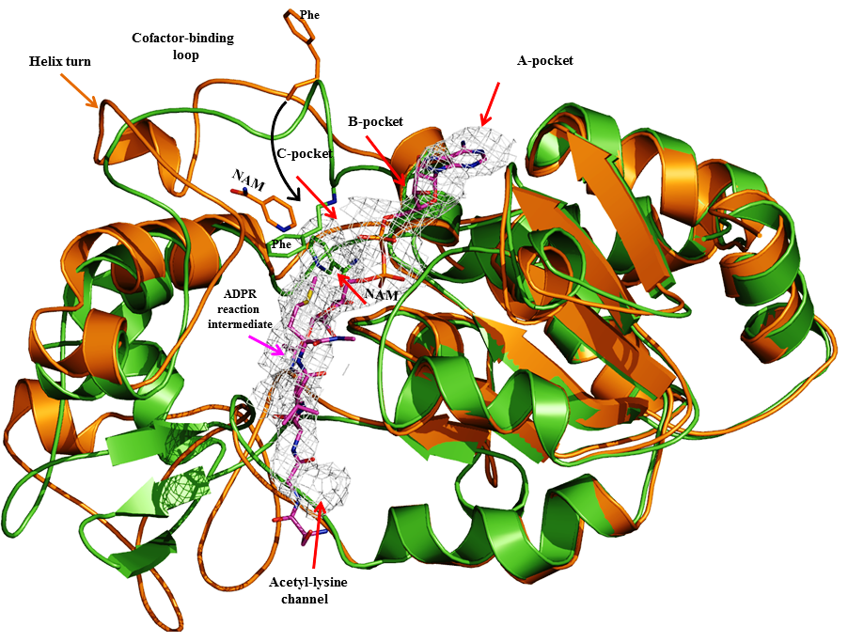

Fig ---- : Superposition of the time averaged MD structures of Sirt3/ADPR/NAM intermediate complex modelled based on the crystal structure of Sirt3 ternary complex (4FVT- orange) and another with the co-factor binding loop residues (155-178) being replaced from an native intermediate structure (4BVG–green). Differences in the conformations of the co-factor binding loop and the position of the Phe residue and NAM are highlighted. Individual subsites are highlighted; ADPR intermediate is rendered in sticks (carbons in Magenta) and NAM also shown in stick representation (Carbon atoms colored based on their respective protein cartoon color). A short helix is evident in Sirt3/ADPR/NAM intermediate complex modelled using 4FVT (Ternary complex), but not in the complex modelled using the co-factor binding loop replaced from the 4BVG (Native intermediate).

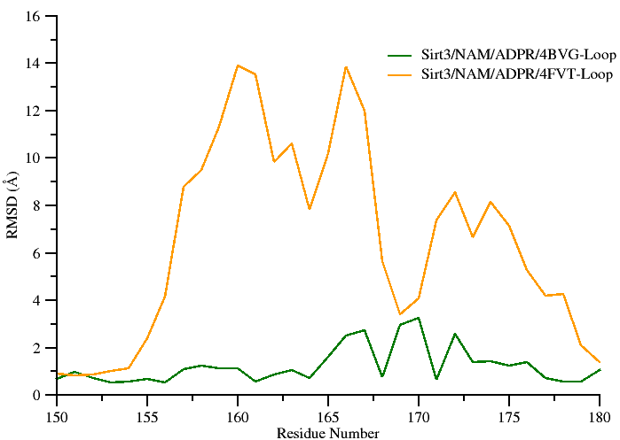

**Figure…..** Per-residue RMSD values for the cofactor binding loop region calculated using the MD averaged structure of Sirt3: ADPR: NAM complex modeled using the loop coordinates obtained from 4BVG (Green) and 4FVT (Orange). Crystal structure of a Sirt3 intermediate complex (4BVG) was used as the reference structure. Residues (162-170) form a short alpha helix when bound to co-factors.

***Note: This figure will be merged with MD averaged figures of Sirt3:ADPR:NAM complex shown above. That’s the reason I used the same colors as used for structural alignment.***

-----------------------------------------------------------------------------------------------------------------------------

**Task 6:** Recreate new MM/GBSA and MM/PBSA tables similar to the previous PLOS ONE 2014 paper, reporting only binding energy values computed between 2-12 ns time scale. Two such tables need to be created.

**Table ….. : Calculated binding energies using MM-PBSA and MM-GBSA. Energy values are reported in kcal/mol.**

|  |  |  |
| --- | --- | --- |
| Energy Components | SIRT3/INT/NAM prepared from 4FVT | SIRT3/INT/NAM prepared from 4FVT with loop (res 155-178) replaced from 4BVG |
| MM-GBSA (Complex) | -7146.48 ± 3.55 | -7201.58 ± 3.44 |
| MM-GBSA (Receptor) | -7050.17 ± 3.55 | -7105.13 ± 3.43 |
| MM-GBSA (Ligand) | -75.99 ± 0.18 | -75.95 ± 0.18 |
| **MM-GBSA (ΔGBind )** | **-20.33 ± 0.13** | **-22.50 ± 0.13** |
| MM-PBSA (Complex) | -5873.69 ± 3.87 | -5901.23 ± 3.76 |
| MM-PBSA (Receptor) | -5796.70 ± 3.89 | -5820.47 ± 3.74 |
| MM-PBSA (Ligand) | -73.03 ± 0.18 | -73.02 ± 0.18 |
| **MM-PBSA ( ΔGBind )** | -**3.96** **± 0.25** | **-7.73 ± 0.26** |

**Miscellaneous tasks (Added during the course of revision)**

Task 1: Plot showing experimental B factor values for the cofactor loop region of various Sit3 complexes.

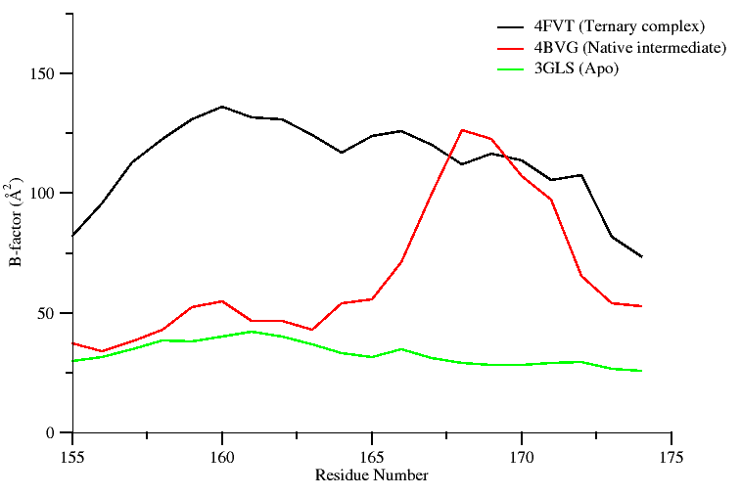

Fig ------: Plot showing crystallographic B-factor values of the Cα atoms belonging to the co-factor binding loop region of SIRT3 in different states. Residues (162-170) adapt a helix conformation when bound to co-factor.

Task2: Summary on the role of the highlighted residues shown in sequence alignment (Task 3)

**Summary on the role of the highlighted residues: (Adapted from Ping’s document)**

Phe 33 in ySir2

* Plays a critical role both in the initial reaction steps
* Its orientation is likely to be a key mediator of the nicotinamide exchange reaction

His 116 in Sir2Tm

* Catalytically Important residue
* H116D and H116Y mutation decrease deacylation rates in vivo and in vitro
* His acts as a general base to deprotonate one of the ribose oxygens.

Asp 101 in Sir2Tm

* The D101N mutation would lead to the disruption of key hydrogen bonds in the nicotinamide binding pocket and the change of the binding conformation of NAD+.

Gln 115 in Sir2Af1

* Enzymatic activity is severely affected by mutations
* Located at the floor of the NAD binding pocket

Task 3: Analysis of global and loop RMSD for various Sirt3 complexes

|  |  |  |
| --- | --- | --- |
| Complex | Global heavy atom RMSD | Co-factor loop RMSD |
| 4FVT (ternary complex) – Xtal vs 4BVG ( native intermediate) Xtal | 0.5 Å | 4.0 Å |
| Sirt3/ADPR complex/NAM modelled from 4FVT (**MD average**)  vs  Sirt3/ADPR complex/NAM modelled from 4FVT but with loop replaced form 4BVG (**MD average**) | 2.2 Å | 5.9Å |
| 4FVT (ternary complex) – Xtal  vs  Sirt3/ADPR complex/NAM modelled from 4FVT (MD average) | 1.9Å | 3.9Å |
| 4FVT (ternary complex) – Xtal  vs  Sirt3/ADPR complex/NAM modelled from 4FVT but with loop replaced form 4BVG (MD average) | 1.1Å | 3.7Å |
| 4BVG (native intermediate) Xtal  vs  Sirt3/ADPR complex/NAM modelled from 4FVT (MD average) | 2.0Å | 6.3Å |
| 4BVG (native intermediate) Xtal  vs  Sirt3/ADPR complex/NAM modelled from 4FVT but with loop replaced form 4BVG (MD average) | 1.0Å | 1.4Å |

Task 5: RMSD plots of various Sirt3 and Sirt2 crystallographic complexes

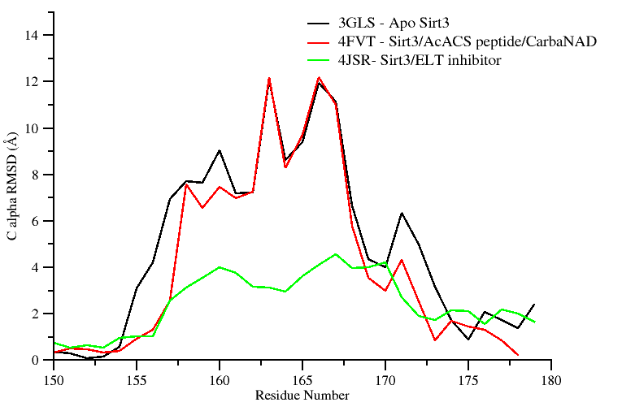 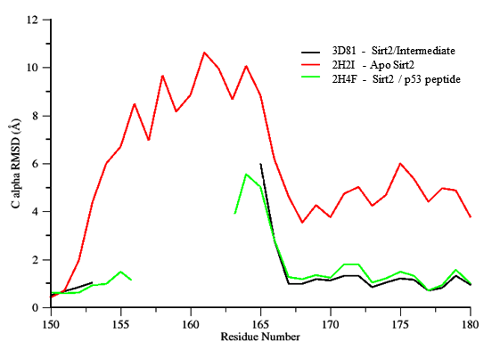

**Figure.** Shown in the left panel are Sirt3 proteins and their per-residue RMSD values for the cofactor binding loop region computed over all atoms with reference to crystal structure of a Sirt3 intermediate complex (4BVG). The right panel shows RMSD values for Sir2Tm proteins calculated with reference to crystal structure of a Sir2 ternary complex (2H59). Residues (155-178) correspond to the co-factor binding loop region and residues (162-170) form a short alpha helix when bound to co-factors. Unresolved loop region are not plotted in the figure.

Task 6: RMSD plots (all for loops only) for various complexes

1. 4FVT/4BVG (pdb) – 4FVT:INT:NAM (md average ---Reference structure)
2. 4BVG/4FVT (pdb) – 4FVT:INT:NAM with loop replacement from 4BVG (md average-- Reference structure)
3. 4FVT/4BVG (pdb) – 4BVG:INT:NAM with loop replacement from 4FVT (md average-- Reference structure)
4. 4BVG/4FVT (pdb) – 4BVG:INT:NAM (md average -- Reference structure)
5. 4FVT/4BVG (pdb) with **reference to 4FVT:INT:NAM** (md average)

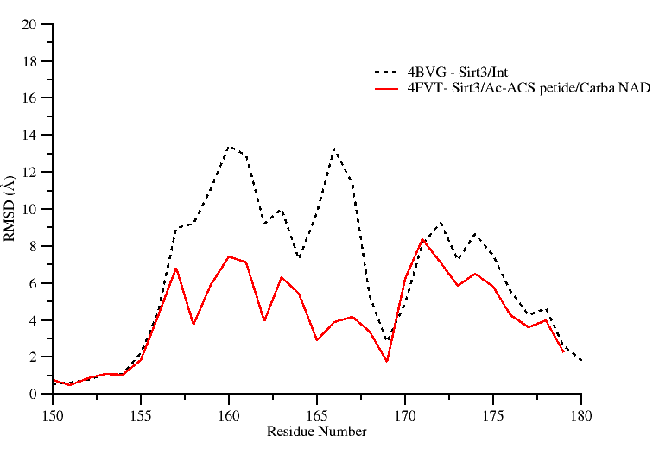

1. 4BVG/4FVT (pdb) with **reference to 4FVT:INT:NAM with loop replacement from 4BVG (md average)**

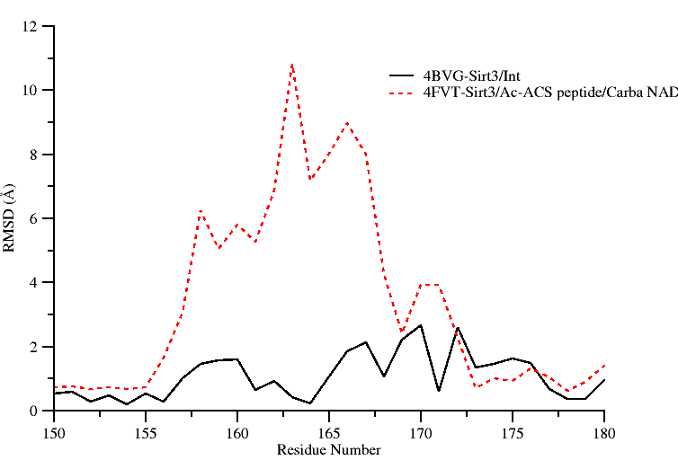

1. 4FVT/4BVG (pdb) – 4BVG:INT:NAM with loop replacement from 4FVT (md average)

NOT COMPLETE

1. 4BVG/4FVT (pdb) with **reference to 4BVG:INT:NAM (md average) (md average)**

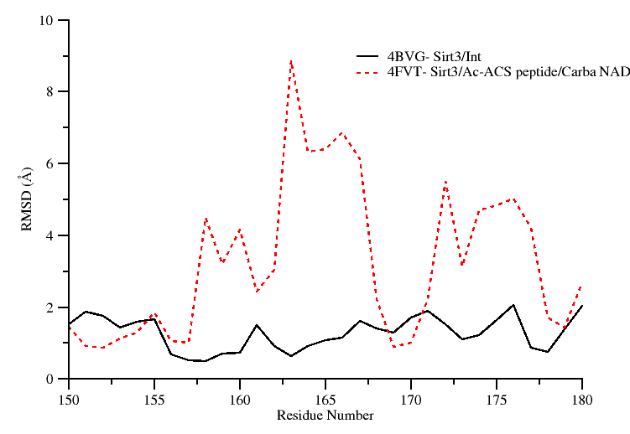

Task 7 : Time series plot of MM-GBSA energies for Sirt3/Int/NAM MD trajectories

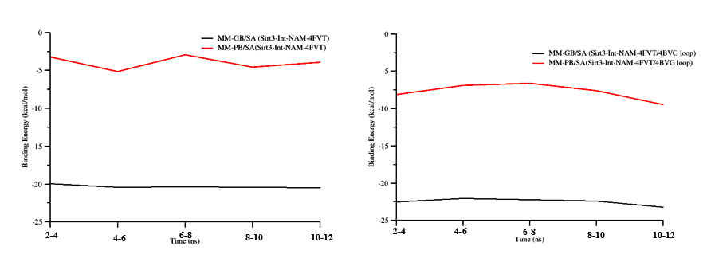

Figure--------. Molecular dynamics trajectories for SIRT3 complexes after structure preparation. Time course of MD trajectories: MM-GB(PB)SA energy vs time.