Comparison between SIRT1 2013 paper and SIRT5 2012 paper

Note: The fold of SIRT1 activation by resveratrol was firstly reported on Nature 2003 paper (Dr. Sinclair’s group). Data reported in
SIRT5 paper was comparable to 2003 Nature paper.
Enzyme |  | SIRT1 | SIRT5 |  | SIRT1
Author |  | Dr. Sinclair's group | Dr. Steegborn's group |  | Dr. Sinclair's group
year |  | 2003 | 2012 |  | 2013
Journal |  | Nature | PLOS one |  | Science
Methods | Kit | Fluor de Lys  (BIOMOL) | Fluor de Lys  (BIOMOL) |  | BIOMOL assay  PNC1-OPT assay  PNC1-GDH assay  OAcADPR assay  ITC measurement
 | substrate | Acetylated FdL1 | succinylated FdL1 |  | Depends on assay type
Activation by Resveratrol | 2 fold simulation | 11uM | 50 uM |  | Resveratrol and other STACs
 | 8 fold simulation | 100-200 uM | 200 uM
Mechanism |  | N/A | Figure 1 |  | Figure 2
Figure 1. Models of assisted allosteric activation of SIRT1.  Yellow box indicates hydrophobic residues C-terminal to the acetylated lysine. The inverted N indicates the conformation of the N-terminus that supports the activated state when STACs are bound to the activation domain, which may be facilitated by interactions with the C-terminus and/or catalytic domain. The red “E” represents E230, whose negative charge may interact with a positively-charged amino acid in SIRT1 to facilitate alllosteric activation. E=enzyme; S=substrate; X=STAC; X:E:S=activator:enzyme:substrate complex; KX=activator equilibrium constant; KM=Michaelis constant; KX=activator equilibrium constant in the presence of a docked substrate/factor; KF=factor equilibrium constant. |  |  |  | 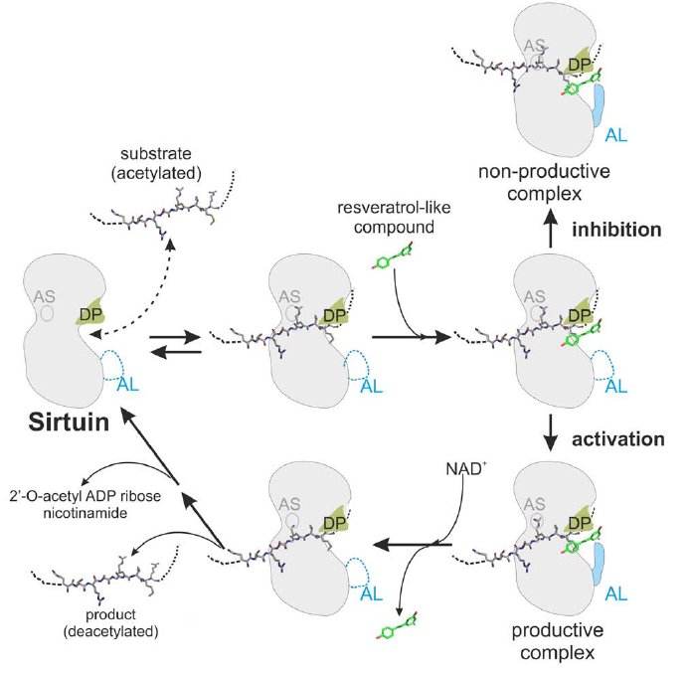  Figure 2. Model for the regulation of Sirtuins by resveratrol-like compounds. After binding of the substrate polypeptide the small molecule attaches to a ‘‘docking patch’’ (DP). It induces ordering of an ‘‘adaptable loop’’ (AL), leading to closure of the peptide exit and stabilization of the enzyme/ substrate complex. Depending on the fit between substrate and small-molecule, the substrate is properly oriented in the active site (AS; e.g. Sirt5/ Cytochrome c/resveratrol) or adopts a non-productive conformation (e.g. Sirt3/GDH/ resveratrol), leading to stimulation or inhibition of turnover, respectively. After deacetylation, the activator dissociates, opening the peptide exit for product release.

