**Plan for project 2 – subproject 1: Activator design targeting base-exchange reaction**

Aim: Identify new leads that work by inhibiting nicotinamide base-exchange reaction, successful design and experimental validation will improve our understanding of reaction/inhibition mechanism.

RC(10-25): We may find that many of these molecules are inhibitors; if we cannot find effective activators, the accurate prediction of binding affinities can be highlighted as a focus of the paper. We have chosen these small molecules with known binding modes because less computational sampling will be required to predict binding affinities.

Introduction:

1. Nicotinamide inhibition via base-exchange reaction
2. Iso-nicotinamide is found to relief nicotinamide inhibition at high concentration

Work flow:

1. 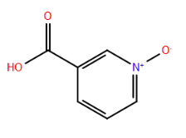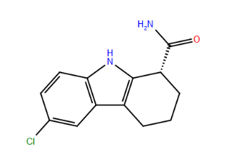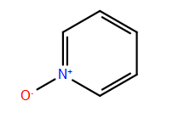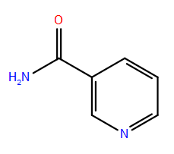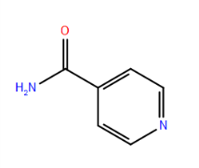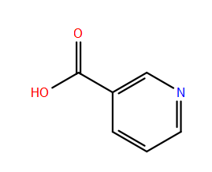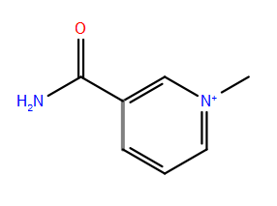Selection/search for small molecules with potential high affinity for SIRT3/Intermediate complex: currently these following molecules are included in both experimental and computational study

Nicotinamide (NAM)

IC50 (SIRT3): 36.7 M *

N(1)-methylnicotinamide

IC50 (SIRT3): 9.2 mM *

Pyridine, 1-oxide

IC50 (SIRT3): 24.1 mM*

Nicotinic Acid

IC50 (SIRT3): 14.5 mM*

Iso-Nicotinamide (IsoNAM)

IC50 (SIRT3): 13.8 mM*

Ex527

IC50 (SIRT3): 174.9 M *

Nicotinic Acid, 1-oxide

IC50 (SIRT3): 13.0 mM *

RC(10-25): How do these Kd’s compare to those for the thiobarbituates published by Jung, which also fell into a congeneric series?

PL(10-25):

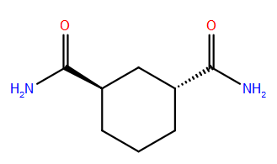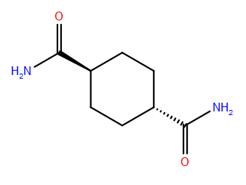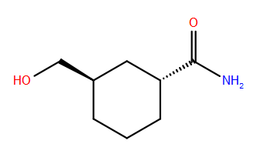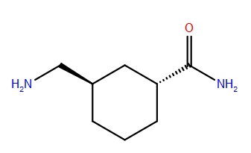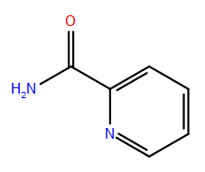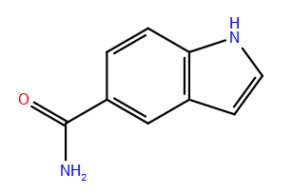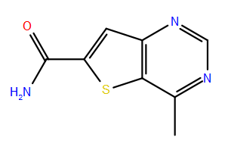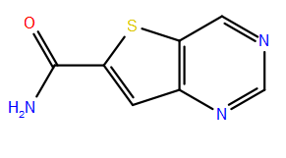Additionally, the following molecules (including their steroisomers) are selected for computational tests.

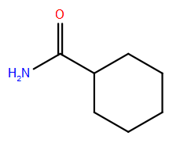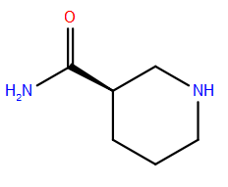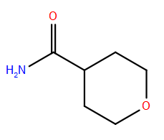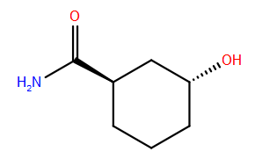

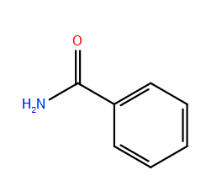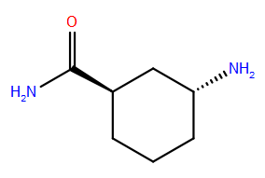

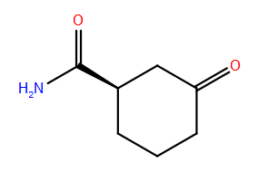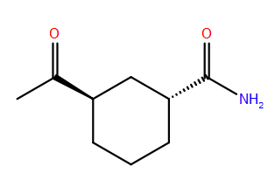

More molecules are expected to add to the list (Expect to have a few hundreds molecules in the list.)

RC(10-25): Are these all from a drug database like Chembridge?

PL(10-25): Some are from part of ELT molecules, some are PL’s invention.

1. Using SIRT3 apo-enzyme (from free enzyme 3GLS and ternary complex 4FVT) as receptor, carry out Glide XP docking followed by MM-GBSA calculations. (approximately about one hour for each small molecule/receptor docking and MM-GBSA calculations.)

RC(10-25): Any estimate of total time required for this part of the computational work; will the experimental IC50 work be done in parallel?

PL(10-25): PL will proceed the computational work for while XG finish up the continuous assay. It will take a month. At the meantime, the small molecules need to be selected and ordered. Then XG will test them in the lab.

Check if there is any correlation between MM-GBSA values and experimental IC50 for these small molecules, excluding NAM and EX-527.

RC(10-25): Will LIA be included here?

PL(10-25): LIA will be applied to check the correlation between MM-GBSA values and experimental IC50.

More experiments can be carry out for other small molecules.

**IC50 measurements:**

**Reagents:** Inhibitors, Fluor-de-Lys kit

RC(10-25): Will the continuous assay be used anywhere in this project?

**XG(10-**25): Yes, we can use continuous assay for IC50 measurement. For current progress, 1 month is needed to finish continuous assay. I would prefer to focus on completing the continuous assay. Fluor-de-Lys kit is an alternative choice in case we want to have their IC50 values right away.

**Instrument:** Fluorometric microplate reader (Fluoroskan Ascent® FL, Thermo LabSystems)

**Time:** 2 month for up to 20 inhibitors can be screened.

RC(10-25): To get Ki’s suitable for correlation studies, are we assuming we know the inhibition mode and hence that inhibition mode experiments are not required at this stage?

**XG(10-**25): On current phase, IC50 will provide the potencies of above SIRT3 inhibitors. It will not provide if it will be a good SIRT3 activator till we do more work on Phase II.

RC(10-25): Are you planning to use the training set of 20 molecules to predict the binding affinities of other molecules, hence using the binding affinity prediction for screening? If not, where does prediction fit into the workflow?

PL(10-25): Yes.

1. Using SIRT3/Intermediate complex structure as receptor, carry out Glide XP docking followed by MM-GBSA calculations. (approximately about one hour for each small molecule/receptor docking and MM-GBSA calculations.) Check how these binding affinities correlates with the binding affinities obtained in step 2).
2. Experiments can be set up for those molecules with better binding affinities, similar to the following:IsoNAM competitively inhibit NAM-exchange reaction thereby activates hSIRT3 activity by relieving NAM inhibition.

RC(10-25): Do you mean experiments to determine the inhibition mode?

RC(10-25): Will some MD be used with LIE/LIA after the first round of experiments in case the correlations between experiment and theory are low?

**This part of experiments are related NAM Exchange Study. Please check the details listed below:**

**NAM Exchange Study:**

**Reagents:**SIRT3 and other interest Sirtuins

NAD+, Acetyl-lysine peptide, DTT, Tris-Cl,TFA, acetonitrile.

[14C] nicotinamide, Permission of use of radioactive reagent in NJ: Ask Sherry for help

**Instruments:** Reversed-Phase HPLC

Phenomenex Luna 3u C18 column, 4.6x150 mm

Liquid scintillation counter

**Mechanism:**

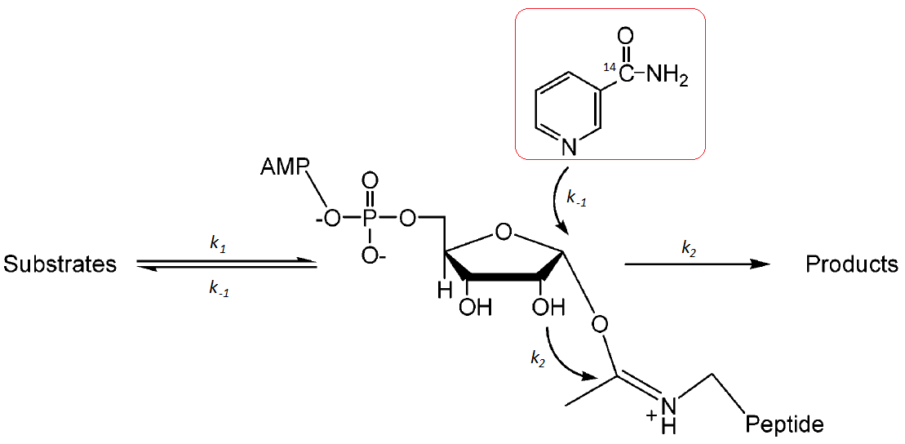

**Results:**

(1) % NAM exchanged can be measured and NAM exchange rates can be fitted to the Michaelis-Menten equation. kcat(exchange) and km (exchange) can be obtained.

(2) ADPR and OAADP Ribose products will be measured to compare the rates of deacetylation reactions. The production of these compounds is stoichiometrically linked with lysine deacetylation and can be used to quantify deacetylation. kcat(deacetylation) and Ki (deacetylation) can be obtained.

(3) % reduction of NAM exchange rate and a corresponding % decline in the deacetylation ratecan be measured in the presence of different small molecules with fixed NAM concentration.

(4) The residual deacetylation rate in the presence of 2 mM NAM, kint(deacetylation), can be measured.

(5) Rate constants for Intermediate formation (*k1*) and decomposition (*k2*). For SIRT3, modest assumptions

* kcat(exchange)>kcat(deacetylation) by a factor of at least 3

RC(10-25): interesting; do you mean that we already have an estimate of the relative magnitudes of the exchange and deacetylation rate constants suitable for assessing whether SIRT3 is a good candidate for activation? I recall Sauve(?) mentioned these rate constants must satisfy such a condition in order for base exchange inhibition to be effective.

XG(10-25): Right. The factor 3 is from Sauve previous work (Biochemistry 2003, 42: 9249-9256.) In the paper, the NAM exchange and deacetylation of bacterial, yeast and mouse Sir2 were studied. NAM did not cause complete inhibition for the bacterial and yeast Sir2 (21% and 65%). For the mouse Sir2, >95% inhibition occurred at high NAM concentration. In our experiments, for human SIRT3, nearly 100% inhibition occurred at 2 mM NAM. Therefore, we will expect a similar estimation of the relative magnitudes of the exchange and deacetylation rate constants suitable for assessing whether SIRT3 is a good candidate for activation.

* A common rate constant k1 is shared by both NAM exchange and deacetylation. K1>k2 and k-1> k2 by a factor of at least 3. Then we assume k2=kcat(deacetylation)
* K-1/k2 = kcat(exchange)/kint(deacetylation)reflects the ratio of the two competing rates that deplete the ADPR intermediate.
* K1 = kcat(exchange)+kint(deacetylation)

**Estimate time:**2 ½ month

1. Check if there is correlation between observed activation effect and calculated binding affinities.
2. Evaluate the success and failure of the strategy and suggest future developments.
3. Crystallography work can be carried out at this stage.