Docking of 1,4-dihydropyridine (DHP) compounds derivatives.

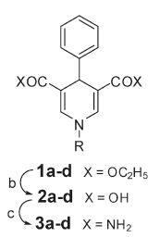 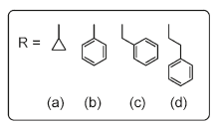

1. Docking of DHP-1c (C atom in grey) and DHP-1d (C atom in white) in SIRT3 (taken from 4BN5, NAD+ and inhibitor removed, enzyme only) compared with 4BVH structure (SIRT3:ac-ADPR:Ex-243, C atom in green)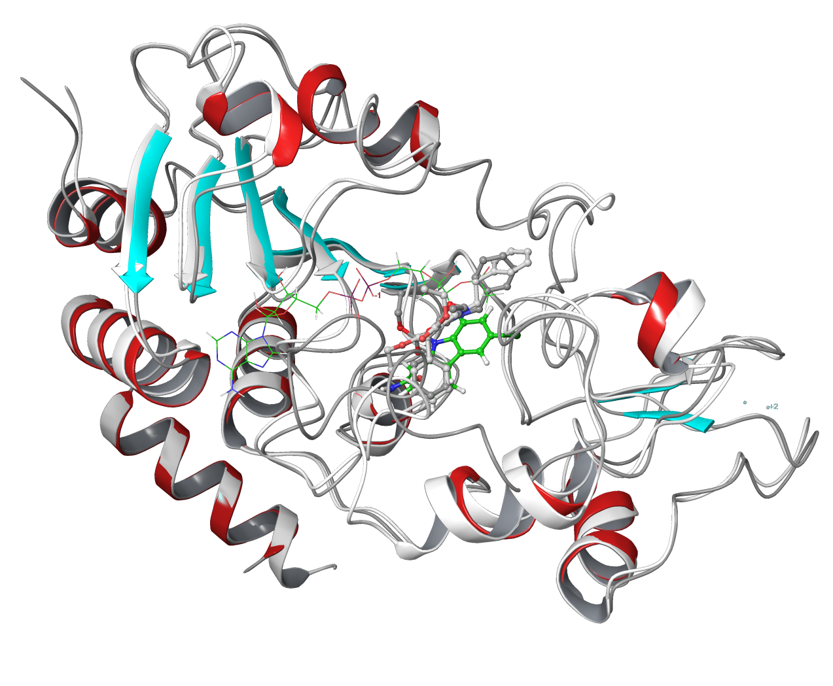
2. Complete view

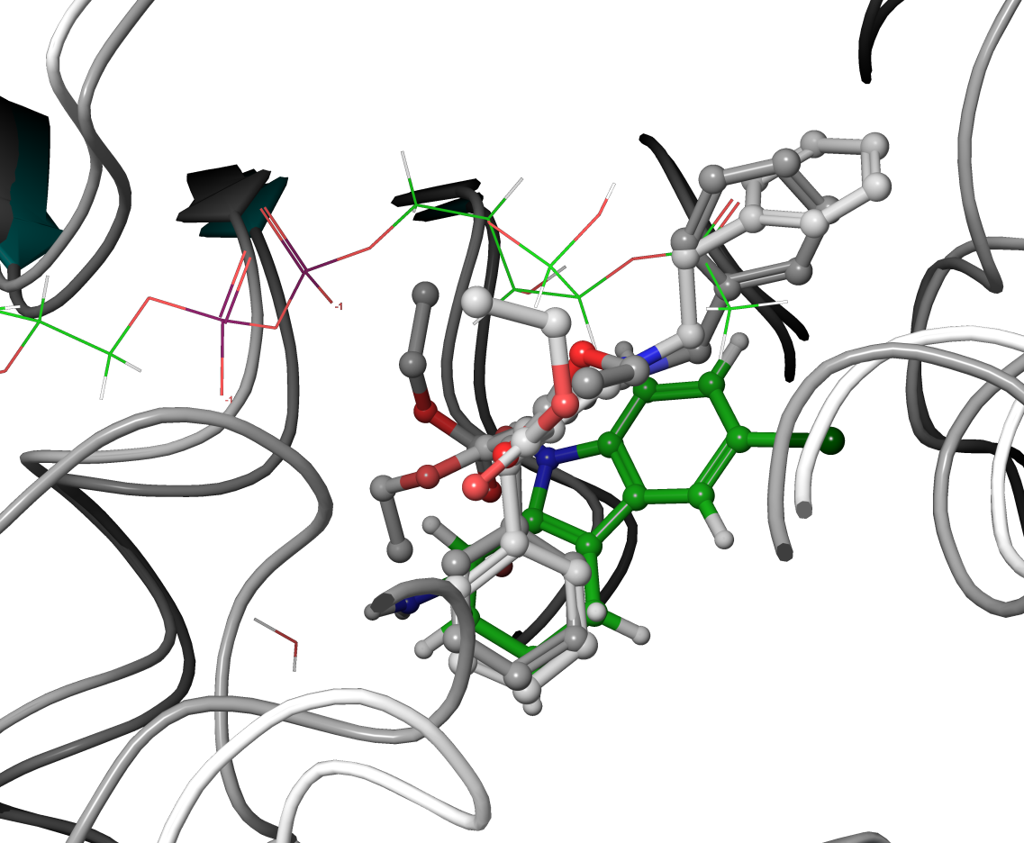

1. Close-up view
2. Docking of DHP-1c (C atom in grey, ball-and-stick) and DHP-1d (C atom in grey, line) in SIRT3 (taken from 4BVG, Intermediate removed, enzyme only) compared with 4BVG structure (SIRT3:Intermediate, C atom in white)

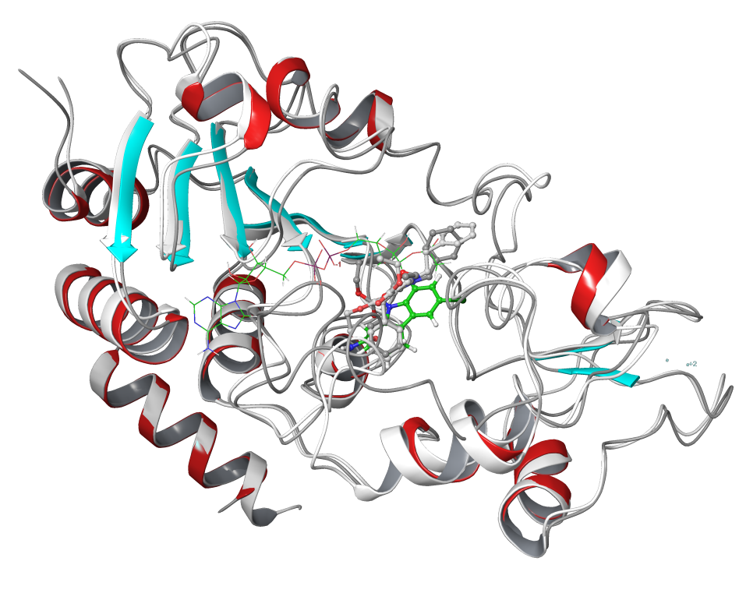

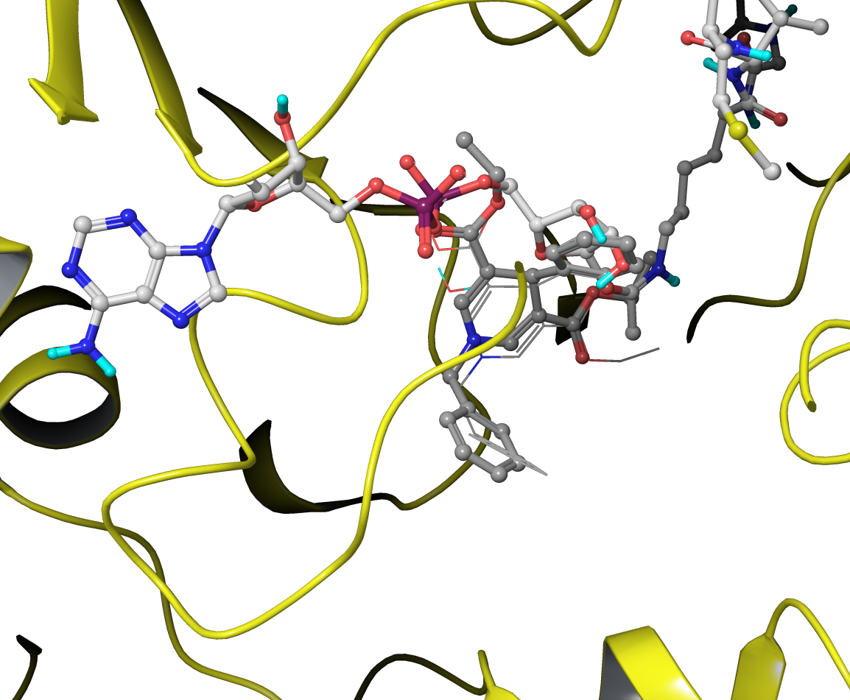

1. Docking with NAD+ or Intermediate presented all failed without any results.

|  |  |  |  |
| --- | --- | --- | --- |
| Ligand | Receptor | MM-GBSA scores | Note |
| Ex243 | SIRT3:ac-ADPR | -97.31212 | in-place |
| DHP-1c | SIRT3(from 4BN5) | -69.275284 |  |
| DHP-1d | SIRT3(from 4BN5) | -82.207429 |  |
| DHP-1d | SIRT3(from 4JSR) | -64.798252 |  |
| DHP-1c | SIRT3(from 4JSR) | -70.454133 |  |
| DHP-1c | SIRT3(from 4BVG) | -53.258382 |  |
| DHP-1d | SIRT3(from 4BVG) | -40.350892 |  |
| DHP-1c | SIRT3(from 4FVT) | -67.978951 |  |
| DHP-1d | SIRT3(from 4FVT) | -64.411029 |  |
| ELT | SIRT3(from 4JSR) | -137.583328 | in-place |
|  |  | Calculated after Glide XP docking |  |