Computational and Experimental Analyses of the Inhibition Mechanism of Human SIRT3 Deacetylase§
Xiangying Guan^{1}, Eric Knoll^{1}, Raj Chakrabarti^{2*}
¹ PMC Advanced Technology, LLC, NJ 08003, USA
² Department of Chemical Engineering, College of Engineering,
Carnegie Mellon University, PA, USA
 Both authors contributed equally to the results of this work.
§This work was partially supported by NSF Grant 1157446

* To whom correspondence should be addressed:
Raj Chakrabarti, Ph.D.

Associate Professor of Chemical Engineering and

Center for Advanced Process Decision-Making

Department of Chemical Engineering

College of Engineering

Carnegie Mellon University

Doherty Hall 3122

5000 Forbes Avenue

Pittsburgh, PA 15213

Phone: (412) 268-8999

Email: rajc@andrew.cmu.edu

Keywords: NAD⁺-dependent deacetylation, competitive/ noncompetitive, product inhibition, MM-GBSA, induced fit docking.
ABSTRACT
Sirtuins are key regulators of many cellular functions including cell growth, apoptosis, metabolism, and genetic control of age-related diseases. In mammals there are seven sirtuin analogues -- SIRT1 to SIRT7. Among them, only SIRT3 has been reported to be linked with longevity of man through increased expression. The kinetics and mechanism of inhibition of hSIRT3, as well as that of Sir2 and SIRT1, were investigated in vitro and computationally. Physiological concentrations of nicotinamide competitively inhibit human recombinant hSIRT3 versus NAD⁺. The critical roles of nicotinamide and its analogue (iso-nicotinamide) as inhibitor/activator of hSIRT3 were explored. Induced fit protein-ligand docking along with a subsequent binding affinity estimation using molecular mechanics/generalized born surface area (MM/GBSA) calculations suggest that nicotinamide binds approximately equally well to the two alternate binding sites of Sir2, known as the AB and AC pockets, and that nicotinamide preferentially binds to the AC pockets of hSIRT3. These results provide important insights for the computationally driven development of SIRT3-specific modulators.

INTRODUCTION
Many severe diseases often occur later in life (e.g., diabetes, neurodegenerative diseases, cancer, cardiovascular disease, pro-inflammatory diseases, and osteoporosis), indicating that aging is an important risk factor for these conditions.¹ The silent information regulator 2 (Sir2) was required for the life span of yeast to be extended by calorie restriction. ^{2; 3} In mammals, seven sirtuin genes, SIRT1 to SIRT7, have been identified.^{4; 5}
Human sirtuin type 3 (hSIRT3), one of the seven mammalian sirtuins so far identified, is a major mitochondrial protein and has an NAD⁺-dependent deacetylase activity regulating global mitochondrial lysine acetylation.^{6; 7} Proper mitochondrial function is required for metabolic homeostasis and involves careful regulation of the activity of multiple metabolic enzymes. SIRT3 targets many key metabolic enzymes, including AceCS2 (acetyl-CoA synthetase 2),^{8; 9}../../../AppData/Local/Microsoft/Windows/Temporary Internet Files/Local Settings/Temporary Internet Files/Content.IE5/9N1O72K2/Documents and SettingspmclabMy Documentsxg%22 l - _ENREF_8 OTC (ornithine transcarbanmylase),¹⁰ LCAD (long-chain acyl-CoA dehydrogenase),¹¹ and ALDH2 (aldehyde dehydrogenase 2),¹² and therefore potentiates fat metabolism during fasting. Given that SIRT3 overexpression promotes oral squamous cell carcinoma (OSCC), cell proliferation and survival,¹³ and that SIRT3 expression is reduced in human breast cancers,¹⁴ SIRT3 is a double edged sword which plays a role in both cancer development and prevention.¹⁵ SIRT3 also aggravates paracetamol-induced liver toxicity, which indicates that down regulation of SIRT3 would provide a therapeutic strategy for treatment of oral cancer and liver injury.
Nicotinamide, a well known sirtuin inhibitor, is a water-soluble vitamin of the B complex, which, together with nicotinic acid, belongs to vitamin B3 and acts as a constituent of the enzyme cofactors NAD (nicotinamide adenine dinucleotide) and NADP (nicotinamide adenine dinucleotide phosphate).¹⁶ These molecules function as electron carriers in the cell metabolism of carbohydrates, fatty acids and amino acids. Nicotinamide has been used to treat pellagra and is the most powerful neuroprotective agent in clinical use.^{17; 18; 19}
Interestingly, NAM is the physiological regulator of human sirtuins and is a reaction product and endogenous noncompetitive inhibitor of the yeast Sir2 protein. Mechanistically, NAM binds to a conserved region in the Sir2 catalytic site and favors a base-exchange reaction instead of deacetylation.²⁰An NAM analogue, isonicotinamide (isoNAM), which competes for free NAM binding but does not react appreciably with the enzyme intermediate, increases Sir2 activity. NAM inhibition and isoNAM activation of Sir2 deacetylase activity is achieved without affecting substrate binding.²¹
Low levels of NAM have been measured in several rat tissues, probably as a result of its rapid utilization in the synthesis of NAD⁺ and other pyridine nucleotides.²²However, NAM concentrations as high as 300 μM have been reported in the brain of Tg2576 mice, providing evidence that NAM concentrations could be a factor regulating sirtuin activities in mammalian cells.²³

Available experimental evidence such as x-ray structures and kinetic assays are limited in their ability to explain mechanistic details of inhibition by NAM, isoNAM and other inhibitors; computational modeling can further describe the inhibitory mechanism as competitive or noncompetitive with respect to binding of the native substrate. The design of novel high affinity and specificity inhibitors and activators can be aided with docking and computational binding affinity estimates, such as Molecular Mechanics – Generalized Born Surface Area (MM-GBSA).^{24; 25; 26; 27}. While the employed binding affinity methods do not produce an accurate ∆G of binding, order of magnitude comparisons in MM-GBSA binding affinity estimates often correlate well with a rank ordering of binding affinities when used with accurate substrate or inhibitor bound co-crystallized x-ray structures. Computational studies presented here include docking and binding affinity estimates of the native NAD⁺ cofactor in the two different binding modes (AB vs. AC pockets) for Sir2 and SIRT3.
The identity of the binding site of the inhibitory NAM molecule has implications for the development of rational activators of Sir2/SIRT1 that exert their effect through reduction of NAM inhibition. Therefore, modulation of NAM inhibition has emerged as an attractive strategy for structure-based design of sirtuin activators, which is contrasted with the design of allosteric activators.^{2829; 30} This work presents the first studies of nicotinamide inhibition of human SIRT3, as well as the role of isoNAM as a human SIRT3 modulator. The focus of the current work is to (1) find the inhibition mode of NAM on hSIRT3; (2) identify the critical roles of NAM and isoNAM responsible for modulating hSIRT3 activity; (3) establish a solid computational protocol for virtual screening of SIRT3 inhibitors.

RESULTS
NAM inhibition at physiological concentration
NAM is a known inhibitor of the deacetylation activity of sirtuins, but the inhibition mechanism of NAM has not yet been determined for human SIRT3. In order to compare the inhibitory potency of NAM toward SIRT3 to its potency toward other human sirtuins, we measured its IC50 value--the concentration of inhibitor required to half-substate the enzyme population under specific assay conditions -.-³¹ The inhibition of hSIRT3 deacetylation by nicotinamide and isonicotinamide (isoNAM) was tested in the presence of different concentrations of NAM and isoNAM with 90 minutes incubation of 1mM NAD⁺ at 37 ºC, providingIC50 values of 36.7μM and 13.8 mM, respectively. Their IC5 values in for hSIRT1 were also measured using the same method. In the case of this enzyme,he IC50 of NAM is 68.1 μM and of isoNAM is 12.2 mM (Figure 1). These values are in good agreement with reported data³².
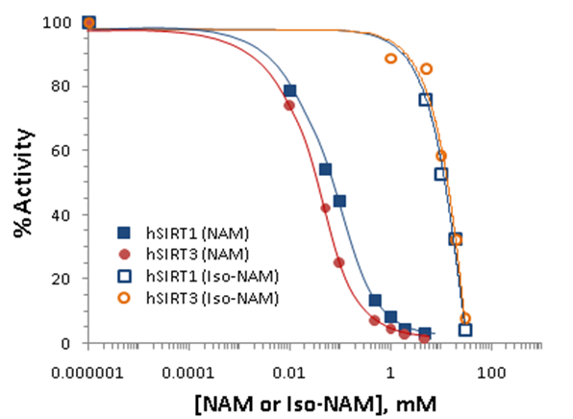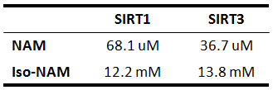

Figure 1:Nicotinamide inhibition assays showing percent change in deacetylation activity as a function of nicotinamide concentration. Data for the hSIRT1 enzyme are indicated with closed squares and a blue curve; data for the hSIRT3 enzyme are indicated with filled circles and a red line. The IC50 for the hSIRT3 enzyme is 36.7 μM, and that of the hSIRT1 enzyme is 68.1 μM (inset table).
Nicotinamide is a noncompetitive inhibitor of recombinant human SIRT1 and competitive inhibitor of recombinant human SIRT3 in vitro.
To gain more insight into the effects of nicotinamide on hSIRT3 activity, the in vitro hSIRT3 deacetylation activity was measured in the presence of varying amounts of nicotinamide. We utilized a novel deacetylation activity assay that generates a fluorescent signal upon deacetylation of a peptide substrate. When incubated with acetylated substrate and NAD⁺, recombinant human SIRT3 gives a strong fluorescent signal 10-fold greater than no enzyme and no NAD⁺controls (data not shown). Using this assay, we tested the ability of nicotinamide to inhibit deacetylation in the presence of varying concentrations of NAD⁺. To evaluate the reliability of the method, the in vitro hSIRT1 deacetylation activity was measured as well. A double reciprocal Lineweaver-Burk plot of the data (Figure 2a) shows that nicotinamide is a strong noncompetitive inhibitor of this reaction. We next studied the inhibitory mechanism of nicotinamide in the case of human SIRT3 in vitro. Using recombinant hSIRT3, we monitored deacetylation of the substrate in the presence of varying amounts of nicotinamide and NAD⁺. I, A Lineweaver-Burk plot of the data (Figure 2b) shows important differences with respect to SIRT1. These results imply that nicotinamide does not inhibit hSIRT1 deacetylation by competing with NAD⁺ for binding to the enzyme, but does inhibit hSIRT3 deacetylation by competing with NAD⁺ for binding to the enzyme.
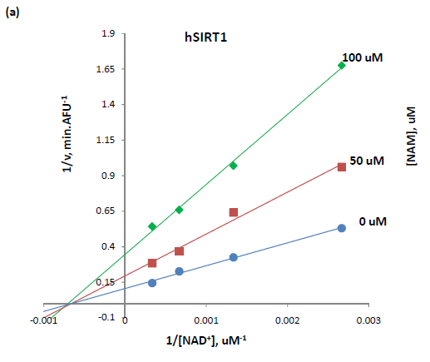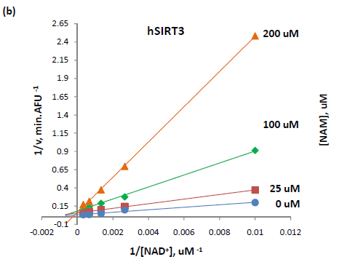
Figure 2: (A) Recombinant human SIRT1 was incubated with 50 uM of SIRT1 substrate for 0, 10, 20, 30, 60, 120, 180, and 240 min at 37ºC in the presence of 125, 250, 500, 1000 μM NAD⁺ and 0, 50, and 100μM nicotinamide. (B) Recombinant human SIRT3 was incubated with 100 μM of acetylated substrate for 40 min at 37ºC in the presence of 100, 375, 750, 1500, 3000 μM NAD⁺ and 0, 25, 100, and 200 μM nicotinamide. Reactions were terminated by the addition of developer and samples were analyzed by flourimetry (excitation set at 355 nm and emission at 460 nm). Experiments were performed in triplicate. Data are shown as a Lineweaver-Burk double-reciprocal plot of arbitrary fluorescence units (AFU) min⁻¹ versus 1/[NAD⁺] uM⁻¹.
Human SIRT3 inhibition effect by nicotinamide in the presence of isonicotinamide. Isonicotinamide was reported as an activator of Sir2 activity ²¹ shown to directly compete with nicotinamide for binding. Nicotinamide is a potent inhibitor of the Sir2 reaction because of its ability to rebind with the enzyme and react with a high-energy intermediate, preventing deacetylation and regenerating starting materials. ^{33; 34} The basis for the observed activation is the relief of the inherent nicotinamide inhibition by competition with isonicotinamide, which does not readily react with the enzyme intermediate. Does this depression effect ofisoNAM also apply to hSIRT3? The hSIRT3 inhibition effect by NAM was studied in the presence of different concentrations of isoNAM. Figure 3 shows that in the presence of isonicotinamide (50 - 900 μM), hSIRT3 inhibition of NAM was slightly decreased.
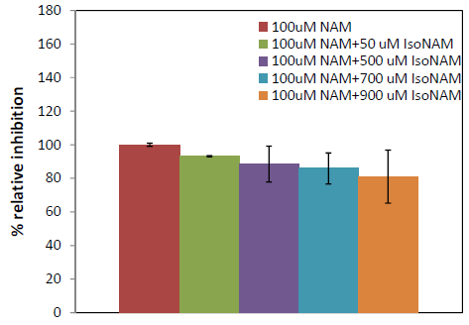
Figure 3: Recombinant human SIRT3 was incubated with 50, 500, 700 and 900 μM of isoNAM for 40 min at 37ºC in the presence of 500 μM NAD⁺, 50 μM of Acetylated substrate, and 100 uMnicotinamide. Reactions were terminated by the addition of developer and samples were analyzed by flourometry (excitation set at 355 nm and emission at 460 nm). Experiments were performed in triplicate.
Although the IC50 for isonicotinamide was about three orders of magnitude higher than that for nicotinamide binding, in vivo yeast studies showed that millimolar levels of isonicotinamide increased Sir2- dependent silencing of the telomeric URA3 gene. These results suggest that the development of higher affinity nicotinamide antagonists may provide a means to upregulate cellular sirtuins. However, great care will be needed to avoid cross reactivity with other nicotinamide utilizing enzymes -- in particular, those involved in NAD⁺ salvage and synthesis.

Simulation Result – Sir2
As a complement to the experimental results,a computer simulation method involving protein-ligand docking and a subsequent rescoring of the estimated protein-ligand binding affinity with a more accurate method called MM-GBSA was used. While MM-GBSA scores, which are reported in kcal/mol,are not absolute binding affinities, they have been shown to have a good correlation to experimental binding affinities for many protein-ligand data sets.^{24; 25; 26; 27} While the wet lab results focused on hSIRT1 and hSIRT3, appropriate x-ray structures necessary for simulations were not publicly available for hSIRT1. Instead, the homologous protein yeast Sir2 was used to mechanistically compare to hSIRT3 because, like hSIRT1, Sir2 has been shown to have a similar noncompetitive nicotinamide inhibition mechanism.
MM-GBSA scores for Sir2 support the noncompetitive nicotinamide inhibition experimental results. In noncompetitive inhibition mechanistic models, when the inhibitor (such as nicotinamide) occupies the C pocket, preventing NAD+ from occupying the productive AC pocket binding mode, NAD+ can equally bind to the AB pockets and wait for the noncompetitive inhibitor to leave. Scores for NAD+ binding in the two different modes are about equal, supporting the noncompetitive mechanistic model.
To help validate the MM-GBSA method, both in-place and cross-docking scores were computed with the multiple NAD+ co-crystallized structures available for Sir2in the single PDB file (Sir2Af2, YC2).As hypothesized for noncompetitive inhibition, the MM-GBSA in-place scores are very similar for NAD+ in the AC pocket (-99.0 kcal/mol) and the AB pocket (-95.0 kcal/mol). The cross-docked scores are similar at -92.6 and -95.2 kcal/mol for the AB and AC pockets, respectively. Cross-dockinginvolves induced fit docking NAD⁺ into the AC pocket starting with the x-ray structure with the NAD+ originally in the AB pocket, and vice versa. These results were compared with the in-place MM-GBSA binding affinity estimate, in which the co-crystallized structure is used in-place for scoring without any docking, and with minimal ligand and protein relaxation to within 0.30 Å RMSD of the crystal structure coordinates.
The aforementioned cross-docking required induced-fit docking or constraints to prevent redocking of the ligand into the same co-crystallized pose. For example,for cross-docking into the AB pockets, an exclusion volume in the C pocket was necessary to prevent re-docking to the starting AC pocket structure. For cross-docking into the AC pocket, inducedfit was required to move the side chain of ARG:36, which occupies ligand-free C pocket in the co-crystallized structure with NAD+ in the AB pocket. With the induced-fit and exclusion volume, the best scoring cross-docked poses were within 2 Å RMSD of the non-docked superimposed co-crystallized structures, as shown in Figure 4.

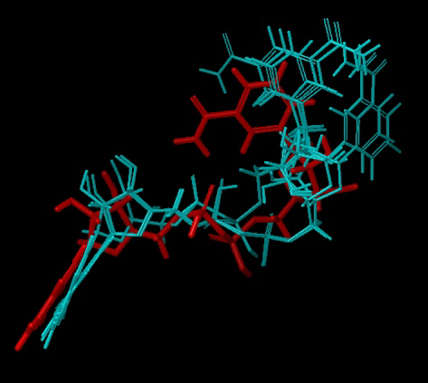
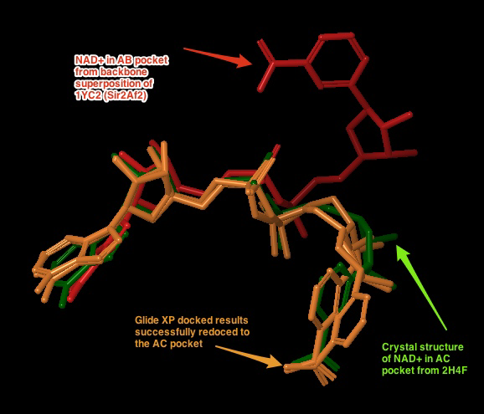
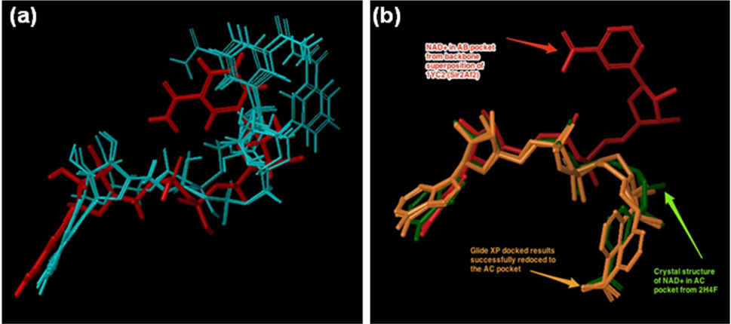
Figure 4:(a) Cross docking of NAD+ into the AB pocket of the crystal structure of 1YC2 (Sir2) with NAD+ originally in the AC pocket. The red pose is from the AB pocket co-crystallized structure. The blue are the degenerate top ranked and only output from Glide XP with an excluded volume in the C pocket and a completely flexible ligand. The RMSD of the closest structure is 1.98 Å, and the GlideScores for all 5 degenerate structures ranged from -9.9 to -12.2. (b) the two top ranked Glide XP docked results of NAD+ docked to the Sir2 AC pocket (orange), with the co-crystallized comparison structure from 2H4F (Sir2Tm) in green. The NAD+ in the AB pocket conformation is shown in red. GlideScores ranged from -15.0 to -17.5.

Simulation Result – SIRT3
Unlike Sir2, fewer co-crystallized structures were available for hSIRT3, requiring the use of docking into the closest structure to either NAD+ in the AB or AC pockets. A co-crystallized structurewith the ADPR intermediate (3GLR) was used (Figure 5).³⁵The relatively similar results between in-place scoring and induced fit cross docking with Sir2 indicate that the induced fit protocol can accommodate for protein and ligand conformational changes between the two different binding modes. The same induced fit protocol was used for hSIRT3 with NAD+ docked into the AC pockets. For docking into the AB pocket, a similar protocol called template based induced fit method is described in the Methods and Discussion sections.
hSIRT3 NAD+ protein-ligand MM-GBSA scores support a competitive inhibition mechanism, which agrees with the experimental results. NAD+ binding scores predict that the ligand binds more favorably to the AC pockets vs. the AB pockets. The top ranked AB pocket binding approximation is -84.4 kcal/mol. The top ranked AC pocket induced fit docking result was much more favorable at -107.9 kcal/mol.Figure 7depicts the top ranked poses for docking into the AB and AC pockets. Since there is no publicly available co-crystallized hSIRT3 structure with NAD+ in the AB pockets, Figure 7compares the docked poses to the backbone-superimposed structure of NAD+ co-crystallized in Sir2 (1YC2 chain A, B and C). Because of the high homology between Sir2 and hSIRT3, NAD+ is expected to bind in a similar fashion for both, and only poses within 4.0 Å RMSD to the Sir2 superimposed co-crystallized NAD+ were considered. For AB docked structures, RMSD ranges from 1.82 to 2.48 Å , while for AC docked structures the RMSD are less than 3.0 Å.

In addition to NAD+, standard docking of the inhibitor nicotinamide and the related compound isonicotinamide places these molecules in the C pocket of hSIRT3 (3GLR) in the expected pose within 2.0 Å of the nicotinamide end of the docked NAD+ molecule.These results,along with previously published crystal structures that show that nicotinamide binds to the C pocket in Sir2(PDB 1YC2 and 1YC5³⁶) corroborate the competitive inhibitor mechanism in which the nicotinamide blocks NAD+ from binding to the C pocket, while the AB pocket binding of NAD+ is not equally favored, as it is in Sir2.
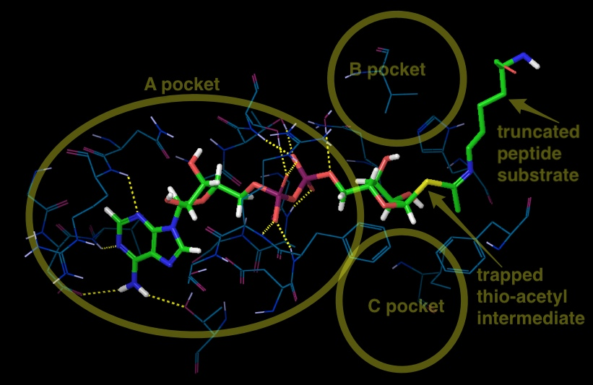
Figure 6:The best docking starting structure for SIRT3 is 3GLT, which has the thio-intermediate of the acetyl-lysine peptide. The nicotinamide has been cleaved and a bond to the thioacetyl is trapped. SIRT3, 3GLT with the trapped thio-acetyl lysine ADPR intermediate. The B and C pockets are unoccupied because of the intermediate . H-bonds between the ADPR and the protein residues within 3 of the ligand are shown here.

Figure 7: For comparison in both (a) and (b): NAD+ in the AC pocket from the co-crystallized structure of 1YC2:B is in red. The 2 structures from 1YC2 (chains A and D) with NAD+ in the AB pocket are pink. (a) AB pocket docking:4 out of the top 20 (based on the emodel glide score; colored white) docked the NAD+ into the AB pocket of SIRT3. The rank order of these 4 structures was 11, 13, 17, and 18 with RMSD to the superimposed 1YC2:A NAD+ of 2.18, 1.82, 2.17, 2.48 respectively. (b) AC pocket docking:8 out of top 10 (based on emodel glide score) docked the NAD+ into the AC pocket of SIRT3 are in green.The amide from the nicotinamide is pointing in both directions.

DISCUSSION
SIRT3 is a mitochondrial deacetylase protein that can regulate a number of cellular processes, including apoptosis, growth, and metabolism.²⁶ It has been reported that SIRT3 has tumor suppressive functions and reduces the glycolytic metabolism. Cancer initiation and progression depend on aerobic glycolysis, by which cancer cells synthesize biomass for their rapid growth. On the other hand, for normal tissue, downregulation of SIRT3 would increase glycolytic metabolism and allow cells in impacted tissues to survive longer, reducing longterm tissue damage. Understanding the properties of the inhibitory mechanism of SIRT3 will help elucidate the mechanism of SIRT3-mediated deacetylation and allow improvements in the design of inhibitor selectivity and affinity. ²⁷ In this way, its inhibitors are of interest not only as tools for elucidating in detail the biological functions of the enzyme, but also as potential therapeutic agents for both inhibition and activation.
The inhibition of enzyme activity is one of the major regulatory devices of living cells, and one of the most important diagnostic procedures of the enzymologist. Inhibition studies provide important information about the specificity of an enzyme, the physical and chemical architecture of the active site, and the kinetic mechanism of the reaction. Three potential types of enzyme inhibitors are defined as follows, according to their mode of inhibition (Table 1): (A) Competitive inhibitorsbind exclusively to the free enzyme form. There are a very large number of drugs in clinical use today that function as competitive enzyme inhibitors. (B) Noncompetitive inhibitors bind with some affinity to both the free enzyme and to the enzyme-substrate complex (ES complex).
Table 1. The equilibria describing 3 modes of inhibitions.²⁸
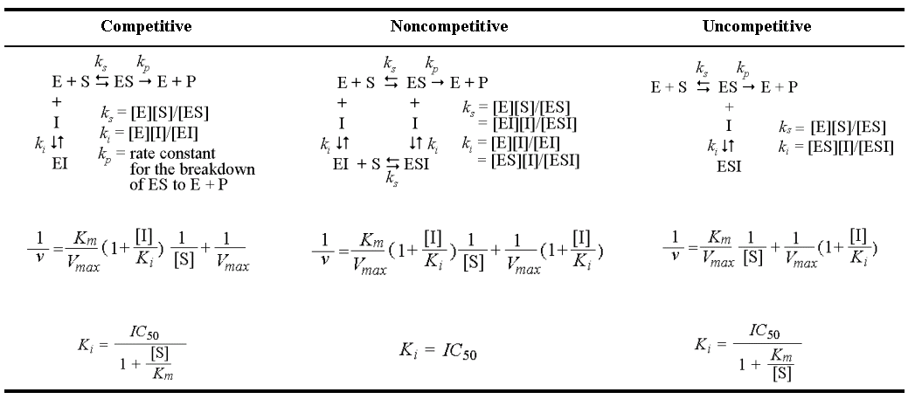
Relative to competitive inhibitors, there are fewer examples of noncompetitive inhibitors in clinical use as drugs today. This reflects the historic approaches to drug discovery that have been largely focused on active-site directed inhibitors. (C) Uncompetitive inhibitors bind exclusively to the ES complex or subsequent species.
Given the potential roles of sirtuins in metabolic, neurodegenerative, and aging-related diseases, potent and selective inhibitors of sirtuins with different inhibition modes have been investigated. These include: 1)suramin, which is a noncompetitive SIRT1 inhibitor respect to NAD⁺ ²⁹ by binding into the B- and C- pockets of the NAD⁺-binding site as well as the substrate-binding site; and 2) cambinol, whichcompetitively inhibits SIRT1/SIRT2 against the acetyl lysine peptide substrate.³⁰

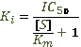

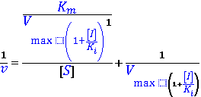

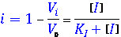
The human SIRT3 crystal structure has been solved in 2009, promoting us to use computer-based design methods to identify novel inhibitors or to establish structure-activity relationships for known inhibitors. Ligand docking methods have provided insights into the binding mode of Sir2 inhibitors.
Nicotinamide is the physiological sirtuin inhibitor. The IC50 values for nicotinamide inhibition of bacterial Sir2, yeast Sir2, mouse Sir2, human SIRT1, SIRT2 and human SIRT3 were 26, 120, 160, 50, 100, and 36.7*uM, respectively (*current work). Nuclear nicotinamide levels have been estimated to be 10-150 uM,¹⁴ which most likely make NAM a sirtuin activity regulator in vivo. Early studies reported nicotinamide binds at an allosteric site; ³³ however, more recent work observed that NAM inhibition depends on its ability to condense with the high-energy enzyme: ADP ribose:acetyl-lysine intermediate to reverse the reaction, reforming NAD⁺ (Scheme 1). NAM noncompetitively inhibits the deacetylation reaction of sirtuins with a single
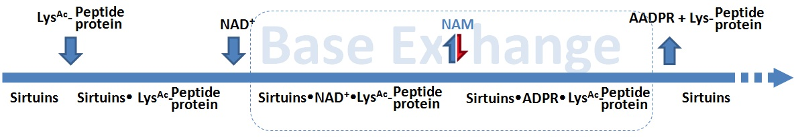
Scheme 1. The sirtuin deacetylation reaction follows ordered sequential mechanism.
Binding pocket C, the same site that binds the nicotinamide of NAD⁺. Rebinding of nicotinamide to the Sir2/intermediate complex can promote the reverse reaction to reform the substrates, thus inhibiting the deacetylation reaction. ³⁵Sir2 thus appears to be affected by physiological nicotinamide concentrations, assumed to be up to 0.1mM, and a role of nicotinamide as an endogenous Sir2 regulator has beensupported by in vivo studies in yeast, flies, and mammalian cells.
A few groups have been reported that NAM can react to regenerate acetyllysine and NAD⁺ in a nicotinamide exchange reaction, in which the imidate intermediate is emptied during normal steady-state turnover, directing NAM inhibition of deacetylation. By using [carbonyl-¹⁴C] nicotinamide, the base exchange reaction for Sir2 was extensively studied (Scheme 2).
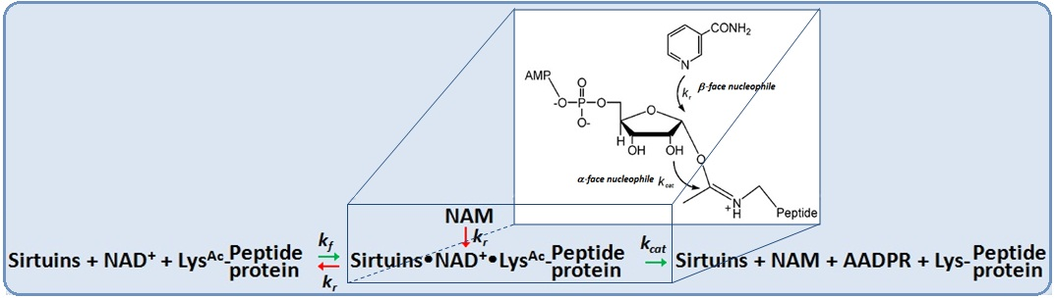
Scheme 2.The competitive nucleophilic attacks on the Sir2 intermediate occur from both stereochemical faces.
The reactivity between base exchange and deacetylation reactions occurs when NAM is present. This competition partitions the intermediate forward (a α-face nucleophilic process) and backward (β-face nucleophile process) to provide inhibition of deacetylation. The exchange and deacetylation reactions share the intermediate forming step, and the ratio is determined by the chemical processes. It seems likely that unreactive isosteres of NAM that interfere with NAM binding could decrease sirtuin enzymatic activity and increase sirtuin function.

Isonicotinamide can compete with nicotinamide for binding but cannot initiate the reverse reaction, thereby leading to apparent activation through relief of nicotinamide inhibition . Similar findings were observed in current study. The addition of 900uM isonicotinamide slightly decreases the hSIRT3 inhibition in the presence of 100uM NAM.Computational, structural and further biochemical studies on these compounds and mechanisms might enable the development of isoform selective modulators. Combining computational docking results, a proposed mechanism of activation of hSIRT3 deacetylation by isoNAM is described in Scheme 3. IsoNAM has a minor inhibition effect on hSIRT3 with IC50 = 13.8 mM.IsoNAM does not compete with NAD+ or acetyl lysine binding to hSIRT3, and it does not react with the imidate. However, isoNAM competitively inhibits the NAM-exchange reaction, thereby activating hSIRT3 by relieving NAM inhibition. The compound isoNAM is a weak binder to hSIRT3 and only derepresses NAM inhibition at millimolar concentrations. The effect of isoNAM on yeast Sir2 has been reported to enhance gene silencing and correct for deletion of PNC1³⁵. IsoNAM is relatively non-toxic to mammalian cells, readily penetrates cells, and is very stable and highly soluble in water, which makes it a suitable starting compound to study for the design of sirtuin activators.
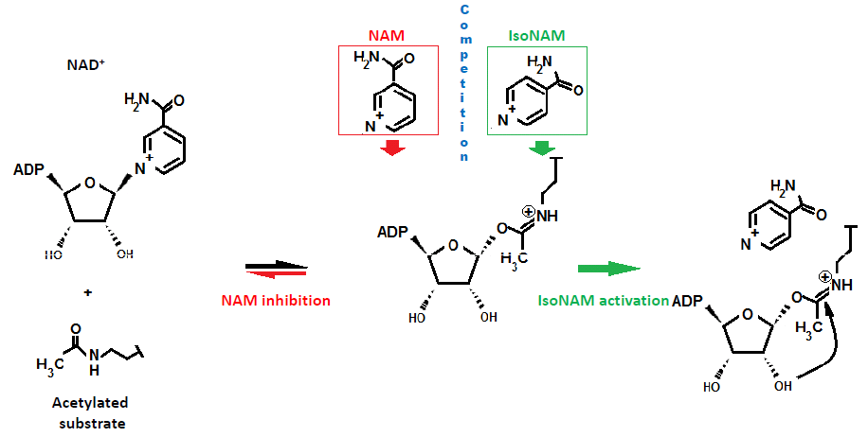
Scheme 3: Mechanism of activation of hSIRT3 deacetylation by isoNAM. IsoNAM competes with NAM to block the position above the β-face of the imidate. NAM induces chemical reversal of the imidate.

One path to computationally design these types of activators is to balance increased C-pocket affinity with design of compounds that are non-reactive with the imidate intermediate. A more potent C-pocket binding species that is not reactive to the imidate must also be able to leave upon the next reaction cycle - either by movement in the C-pocket due to the deaceylated peptide leaving or the the product 2’-O-acetyl-ADPR leaving. Alternatively, one could imagine a high affinity activator leaving when the next NAD+ that bound to the AB pocket shifts its nicotinamide end, booting out the activator. While these possible mechanisms are conjecture, this activator must, at some point dissociate from the C pocket so the NAD+ can react with the acetyl-lysine peptide.

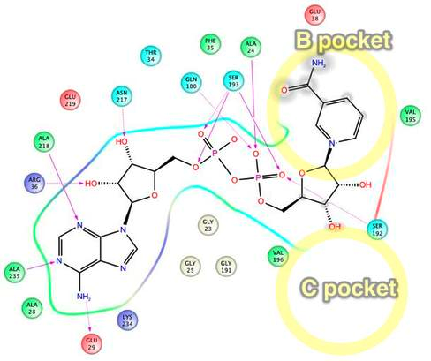
Figure 10: Sir2Af2 NAD+ in AB pocket
[TO add: side-by-side ligand interaction diagram between Sir2 and SIRT3 of NAD+ in AB – to discuss why Sir2 is similar in energy between AB and AC, and why SIRT3 is different in energy]. Intermolecular protein-ligand diagram of Sir2Af2 (1YC2 chain A) with NAD+ in the AB pocket. In this flattened 2D reppresentation of the protein-ligand interactions, residues are represented as colored spheres, where: red=acidic, green=hydrophobic, blue=polar, light gray=(Gly,water), dark gray=metal atoms. Solid pink lines are H-bonds to the protein backbone; dotted pink are H-bonds to the side chains; green are pi-pi stacking interactions; orange are pi-cation interactions. Protein and water residues within 3.0 Å of the NAD+ are shown. The lack of a protein "pocket" line around the nicotinamide end and the grey spheres around those atoms indicate that the nicotinamide end is exposed to solvent. The B pocket (show as a yellow circle) is a crevice open to solvent, while the C-pocket (lower yellow circle) is protected by a loop from the solvent (shown in the next diagram). The C-pocket is empty or collapsed in this structure. Also note that there are no H-bonds or other specific intermolecular interactions between the protein and the nicotinamide end of NAD+. Images produced in Maestro.
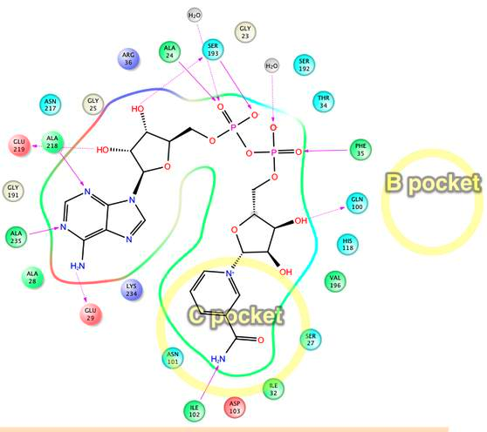
Figure 11: Sir2Af2 NAD+ in AC pocket
Intermolecular protein-ligand diagram of Sir2Af2 (1YC2 chain B) with NAD+ in the AC pocket. Protein and water residues within 3.0 circle) is protected by a loop from the solvent (shown in the next diagram). The C-pocket is empty oein residues in the entire A and C pockets. The nicotinamide is not exposed to solvent, unlike in the B pocket. The approximate location of the B pocket is shown due to distortions created by transforming the 3D protein-ligand picture into a simple 2D diagram. There is a backbone H-bond between the protein ILE102 and the

Discussion about why NAD+ binding is similar in energy between AB and AC for Sir2, but not for SIRT3. Much of this is moved from the results section. Note that figures also moved here]

The nicotinamide end of NAD+ adopts two flipped conformations in the crystal structures: one with amide hydrogen of the nicotinamide end of NAD+ in the AB pocket of the Sir2Af2 (1YC2 chain D) making an intramolecular hydrogen bond to the ligand phosphotidyl oxygen, and another with this amide pointed towards the solvent (1YC2 chain A). There are no hydrogen bonds in the B pocket with the outer half of the pocket exposed to solvent allowing the nicotinamide to move. This intramolecular H-bond is never seen in the docking, possibly because the energy is truly degenerate in this case where most of the nicotinamide is exposed to solvent, or Glide has systematic bias against ligand intramolecular H-bonds. In addition, the nicotinamide in the B pocket must move to the C pocket, and this degenerate flexibility in solvent could facilitate this motion.

The hSIRT3 AB docking results use the template-based induced fit method (as described in the Methods section) because of the difficulty in docking NAD+ into the AB pocket of SIRT3. While traditional and induced fit docking succeeded in placing NAD+ in Sir2 and into the AC pockets of SIRT3, these docking methods failed for the AB pocket when starting with the best available crystal structure for SIRT3 (3GLT) (see figure 6). AB pocket docking did not work for SIRT3 because the standard induced fit side chain and backbone optimization could not sufficiently open the B pocket for the nicotinamide end of NAD+, as shown in Figure 8. Only the template based induced fit method successfully docked NAD+ into the AB pocket. This method mainly moved the side chains shown inFigure 8, and it also minimally moved the backbone for residues 320 to 324, while maintaining identical backbone structure for the remaining residues (see Figure 12Figure 9).
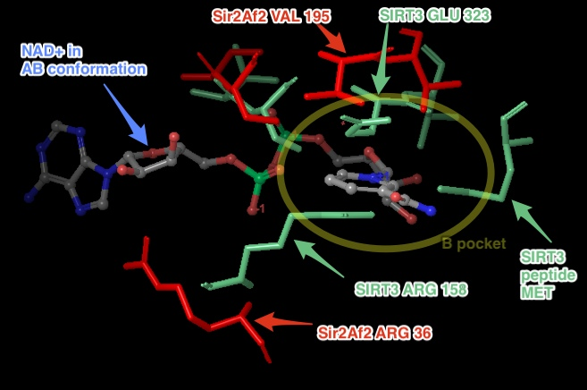
Figure 12:Steric clashes between NAD+ in the AB conformation and SIRT3 (from the thio-acetyl ADPR intermediate). This is a top view of the NAD+, where the B pocket is oriented on top of the C pocket within the axis perpendicular to the figure. The steric clashes are labeled in aqua, and the B pocket is labeled with the yellow oval. Comparable Sir2Af2 residues within 6 ?of the nicotinamide in the B pocket are in red. The Sir2Af2 structure is from the NAD+ co-crystallized PDB file 1YC2 chain A with NAD+ in the AB pockets. This structure is aligned to the SIRT3 protein backbone from 3GLT. 3GLT has the thio-acetyl ADPR intermediate, which has the nicotinamide cleaved off. The depicted NAD+ cofactor is from the Sir2Af2 co-crystallized structure. Note that Sir2 does not obstruct the B pocket. For example, the ARG 36 in Sir2Af2 is moved back and its side chain rotated out of the way in comparison to SIRT3 ARG 158. While SIRT3 has GLU 323 which obstructs the nicotinamide, Sir2Af2 has a Val 195 pushed farther back leaving room for the nicotinamide. There are no steric clashes with peptide substrate residues, like there is with the SIRT3 MET.
Figure 13: SIRT3 backbone movement after PLOP minimization with the template NAD+ in the AB conformation was minimal. In the constrained minimization, only residues 157 to 160, 320 to 324, and 365 to 367 were free to move. The backbone moved only for residues 320 to 324, while the remaining backbone for other residues were either constrained or did not move.

Although the use of the template of the AB docked NAD+ from Sir2 superimposed onto SIRT3 may bias the resulting docking to the AB pocket, a few factors justify this method. One, all other docking attempts with and without multiple constraints failed. Two, the possibly biased result still remained less favorable than AC pocket binding estimates. Even if AB pocket docking is precluded in the real system, the mechanistic conclusion of competitive inhibition is the same. Thirdly, crystallographers failed with multiple protocols to co-crystallize NAD+ into either the SIRT3 productive or unproductive binding pocket, with or without the acetyl-lysine substrate ³⁸. While NAD+ has been observed to bind in the productive (AC) binding site for Sir2Af2 and Sir2Af1 and in the non-productive (AB) binding site for Sir2Af2, Sir2Af1 in the absence of the peptide substrate , NAD+ cannot bind to SIRT3 efficiently in the absence of this peptide ³⁸.

[Deleted paragraphs]
There are a few key limitations of the docking/MM-GBSA method. Protein structural changes other than localized side chain or small backbone movements are ignored. Allosteric inhibition or activation by nicotinamide or iso-nicotinamide binding cannot be tested. MM-GBSA method provides a fast, first estimation to more accurately rank order the raw protein-ligand docking results than docking alone . While sufficient in detecting relatively similar binding affinities (as between AB and AC binding in Sir2) or large differences (as between AB and AC binding in SIRT3), MM-GBSA ignores a number of important dynamic contributions to binding affinity and mechanistic studies.
Future simulations to obtain more reliable estimates of binding affinity differences between the AB and AC pockets could involve more sophisticated techniques. Accurate computational affinity predictions using more sophisticated simulations beyond docking are known to be challenging ⁴². For example, the customized template-based induced fit protocol used for docking NAD+ into the AB pocket of SIRT3 could be extended to iteratively incorporate template based loop/side chain prediction with a flexible ligand. More computationally intensive molecular dynamics based simulations such as linear interaction energy (LIE), thermodynamic integration (TI) or free energy perturbation (FEP) have been shown to be more accurate ⁴² and include more degrees of freedom to dock to the AB pocket. TI or FEP studies are critical next steps, especially amenable to the manageably low number of protein-ligand complexes studied in this paper.
In summary, SIRT3 is the major sirtuindeacetylase in mitochondria, where bioenergetics, oxidative stress, and apoptosis are controlled. In order to have better understanding of the basic cell biology processes as well as a pharmacological and/or nutritional target for intervention, the extensive efforts for development of SIRT3 modulators are needed. Experimental results reported here indicate that NAM, a noncompetitive inhibitor of Sir2 and hSIRT1, competitively inhibits hSIRT3 by competing the binding site at C pocket with NAD⁺, which reveals a different strategy for SIRT3 inhibitor design. Molecular docking is performed in current study. X-ray crystal structures of Sir2Af2 and human SIRT3 are employed as the starting point for docking analysis. In addition, incorporation of protein flexibility and backbone conformation change upon ligand association are taken into consideration. MM-GBSA scores are consistent with experiment for the noncompetitive and competitive inhibition mechanism for Sir2 and SIRT3, respectively. Sir2 has approximately equal scores for NAD+ binding to the AB and AC pockets,, while SIRT3 has substantially better scores for AC binding. Computer-assisted drug design coupled with experimental confirmation has become an attractive alternative to the tradition in vitro and in vivo screenings. Taken together, we anticipate that the structural elucidation of the NAM inhibitory for hSIRT3 enzymes reported here will provide the direction for designing a new generation of hSIRT3 modulator.

The noncompetitive and competitive inhibition mechanism by NAM in the C pocket provides the foundation of interesting further research into designing inhibitors and activators for hSIRT1 and hSIRT3.Ligands designed to dock into the C pocket of hSIRT3 may prevent full binding of NAD+ since NAD+ is predicted to unfavorably bind to the AB pockets. While still blocking the catalytically active conformation of NAD+ in the AC pockets of hSIRT1, C pocket ligands would have a different kinetic effect with hSIRT1. In addition, ligands exclusively in the B pocket may have a lesser inhibitory effect in hSIRT3 since NAD+ may not have a high occupancy in the AB pockets. Ligands binding to the A pocket are predicted to have similar affects for both sirtuins.
Knowing inhibition modality is important for making quantitative comparions among different compounds against the target enzyme, and for making quantitiative comparisons of the affinity of a particular compound among different potential enzyme targets. By knowing the modality of inhibition, we can make these comparisons on the rational basis of the enzyme-inhibitor dissociation constant, Ki. By quantifying inhibitor affinity in terms of Ki, we can also define the Gibbs free energy of binding, and the changes in Gibbs free energy of binding that accompanies structural changes in the compound or the enzyme. This provides a means of defining the energetic contributions of specific types of interactions between groups on the enzyme and functionalities on the compounds to the overall binding energy of interaction.
[[How does our mechanism study direct the virtual screening/simulation/inhibitordesign work?]]
MATERIALS AND METHODS
Chemicals and reagents. The acetylated substrate peptide based on the sequence of Acetyl-coenzyme A synthetase 2 (AceCS2 638-649, H2N-TRSGK (Ac)VMRRLLR-OH) was synthesized at PEPTIDE 2.0 Inc (Chantilly, VA, USA). Human recombinant SIRT3 was purchased from Creative BioMart (Shirley, NY, USA). Enzyme concentrations were determined using the method of Bradford⁴³ with bovine serum albumin (BSA) as the standard. All other chemicals used were of the highest purity commercially available and were purchased from Sigma (St. Louis, MO, USA), and Fisher Scientific (Pittsburgh, PA, USA).
Measurement of Deacetylation activity using a Fluorolabeled peptide. The steady state parameters (K_{m} and K_{cat}) and catalytic efficiency (K_{cat}/K_{m}) of deacetylase activity of recombinant human SIRT3 was determined using a fluorimetric assay. The deacetylation activity was measured by using the SIRT3 Fluorimetic Drug Discovery Kit (AK 557, Enzo Life Sciences). This assay system allows detection of a fluorescent signal upon deacetylateion of an acetylated substrate peptide, comprising amino acids 317-320 of human p53 (Gln-Pro-Lys-Lys (Ac)), when treated with developer. The Intensity of fluorescence was measured on a fluorometric microplate reader (Fluoroskan Ascent® FL, Thermo LabSystems) with excitation set at 355 nm and emission detection set at 460 nm. The initial rate of the NAD⁺-dependent deacetylation activity of SIRT3 enzyme was measured at different concentrations of nicotinamide adenine dinucleotide. The reactions were carried out at 37ºC in a 50ul reaction volume containing 50 mMTris/Cl (pH=8), 137 mMNaCl, and 100 uMflourolabeled peptide substrate. The enzyme concentration of the SIRT3 was 50ug/ml. Unless otherwise indicated, all initial rate measurements were means of three or more replicates, obtained with single incubation times, at which point 5% or less of the substrate initially present had been deacetylated. The raw data were fitted to the Michaelis-Menten equation by using GraphPad Prism (GraphPad Software, Inc, CA) to obtain the kinetic constants.
Measurement of IC50 values for SIRT3 inhibitor: Nicotinamide. This assay was also used to measure the inhibition by nicotinamide, isonicotinamide and a combination of both. Reactions were performed in the presence of 100 uM NAD⁺, 100 uM of substrate peptide, and either nicotinamide (0, 12.5, 25, 50, 100, 200, 500 uM) or 50 uM of nicotinamide with isonicotinamide (0, 0.05, 0.1, 1, 5, and 10 mM). The initial rates were measured at different concentrations of nicotinamide and isonicotinamide, and the reaction conditions were the same as above. The data were fitted to Equation 1 by using Prism to calculate the IC₅₀ values:
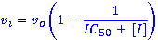(1)
Where v₀ is the initial rate of the uninhibited reaction and v_{I} is the initial rate of the reaction at concentration I of inhibitor.
In Silico Docking and Binding affinity estimation:

In addition to the experimental assays, computational simulations elucidated the mechanism of SIRT3 compared to Sir2 through protein-ligand docking and a subsequent more accurate scoring of the docked poses. These techniques allow for an approximation of binding affinity of the native NAD⁺ substrate. Protein-ligand docking, and the MM-GBSA protocol ⁴⁴, as well as an induced fit protocol were used for the binding affinity estimates, as described below.
Although protein-ligand docking programs such as Glide ⁴⁴, AUTODOCK ⁴⁵, or DOCK ⁴⁶ rank order ligand poses based on a docking score, these outputs are not reliable estimates for the binding affinity. Docking programs were designed to distinguish actives from inactives when screening large databases of potential ligands to a given protein active site. The computational simulations in this study attempted to differentiate between the Sir2 and SIRT3 nicotinamide inhibition mechanism, for which subtle variations in absolute binding energy between the various binding modes of the native NAD+ cofactor needed to be estimated. While other groups have reported correlating docking scores ⁴⁷ to or developing a custom scoring function ³⁹ for binding affinity, these approaches are limited to congeneric series of ligands for which dozens of experimentally determined binding affinities are used as a training set. These methods are not applicable, as we are concerned with a possible subtle difference between two binding modes of the native cofactor, NAD+ and two inhibitors.
MM-GBSA enhances docking scores by adding an estimation of the missing energy contributions of the solvent through the generalized Born implicit solvent model. Because correlations to free energy of binding for multiple test systems were found to be good for a single structure approach ⁴⁴ and because the computationally more intensive combined molecular dynamics ensemble averaged MM-GBSA approach added little additional accuracy ⁴⁷, we employed the simpler single structure method. The docking algorithm outputs multiple poses for each ligand, each with a slightly different conformation docked into the same starting protein. All of these structures, even lower ranking ones, are re-scored and re-ranked with the MM-GBSA function. The single highest ranked MM-GBSA score is used as the final binding affinity energy estimate.
Using the standard scoring functions to predict poses, then subsequently re-scoring those poses with MM-GBSA offers better prediction of binding affinities. The scoring functions in Glide and other docking programs are optimized to minimize the RMSD difference between predicted and x-ray determined structures for a large database of co-crystallized protein-ligand structures ⁴⁸, rather than optimized to predict binding affinity. Re-ranking the poses with MM-GBSA method incorporates implicitly modeled solvent effects that are an important energy contribution and that are not modeled well in standard docking scores.
The first step in estimating binding affinity with MM-GBSA is prepping the raw crystal structure PDB file for docking. Multiple starting structures of SIRT3 (3GLT) and Sir2 (1YC2) with NAD+ co-crystallized in either the AB or AC pockets of the protein ⁴⁰ were prepared with the Schrodinger protein preparation protocol ⁴⁹. Bond orders were assigned, missing hydrogens added, zero-order bonds to the zinc atoms created, missing side chains were filled in with the PLOP algorithm(Jacobson, Friesner et al. 2002)⁴⁵, and protein chain termini are capped. Protonation and tautomer states for the ligands were generated with Epik⁵⁰ for a pH range of 7.0 +/- 3.0. H-bond assignment was done using PROPKA at pH 7.0 and included sampling all water orientations, as well as using crystal symmetry information. A final restrained minimization was performed with heavy atoms converged to RMSD 0.30 Å with the OPLS 2005 force field.
Three different protocols were used for docking, depending on the availability of NAD+ co-crystallized structures: (A) traditional docking, (B) induced fit docking, and (C) template induced fit docking. For Sir2, which has optimal x-ray structures with NAD+ co-crystallized in both the AB and AC pockets (PDB:1YC2 chains A and B, respectively), standard Glide XP docking (A) was used for both NAD+ docking into the AB and AC pockets and inhibitor/activator docking into the C pocket. This traditional docking is useful when the receptor structure does not change upon docking. Since SIRT3 had no publically available co-crystallized structures with NAD+ in the AB or AC pockets, the induced fit protocol (B) ⁴², which increases sampling by adding flexibility to the receptor, was used to dock NAD+ into the AC pocket. Neither traditional docking nor the induced fit protocol were sufficient to dock NAD+ into the AB pocket, thus a template induced fit method (C) was used to dock inhibitors/activators and NAD+ into the AB pocket. Below are details of each method A, B, and C.
Standard Docking method (A). Before docking, docking grids were calculated with the grid box centered on the known NAD+ binding site. For docking simulations which had difficulty reproducing the expected binding mode observed in crystal structures, such as the Sir2 AB pocket docking, optional ligand positional constraints, H-bond or metal constraints, hydrophobic constraints, and excluded volumes were added. In particular, an excluded volume was place in the C pocket for AB docking.
Glide was run in both SP (standard precision) and XP (extra precision) modes. Since Glide does not allow for receptor flexibility in docking, van der Waals (vdW) radius scaling softens the potential for nonpolar atoms in the receptor. The vdW radius was initially set at 0.85 (no scaling) with a partial charge cutoff of 0.15, then decreased to 0.50 in cases to minimize steric obstructions. Partial charges for the ligand and receptor are based on the OPLS 2005 force field along with the Epik determined ionization states on the ligand and the PROPKA ionization states on the receptor.
Induced Fit docking method (B). A number of similar implementations of induced fit docking are available which take advantage of side chain rotamer libraries to add protein receptor flexibility . We used the Schrodinger Induced Fit protocol, which iteratively uses Glide and a side chain optimization algorithm called PLOP ⁵⁴ to exhaustively consider possible binding modes and the associated conformational changes within the receptor. Traditional Glide docking with a static receptor for Sir2 and SIRT3 is not sufficient when the starting crystal structure is not from a co-crystallized structure with NAD+ in the desired binding mode because a loop as well as side chains move upon binding of NAD+ and upon NAD+ changing from the AC to the AB binding pocket. For example, Error: Reference source not found and Figure 8 show steric clashes in docking NAD+ into Sir2 and SIRT3, respectively.
The induced fit method first docks the ligand into an inflexible receptor, similar to standard Glide docking. The collection of generated poses is then used as templates to refine the receptor, in which the ligand is kept frozen in its docked conformation and the protein side chains are optimized with PLOP. Next, the ligand and receptor from each of the structures refined with PLOP are energy minimized, allowing for both ligand relaxation and slight backbone/sidechain protein movement. The backbone movement only occurs through this relaxation step, rather than through extensive rotomer sampling as done with the side chains. The docking score, as well as receptor OPLSA energy and solvation are used to rank order each of these protein-ligand structures. Top ranked structures are then used iteratively as input back into the first step until the change in docking score is less than 0.5. Unlike with traditional docking, the Schrodinger Induced Fit protocol has limited constraints available. Excluded volumes and ligand positional or torsional constraints are currently not implemented in the protocol. As in traditional docking, a receptor region around the AB and AC binding pockets of around 18 Å a side is defined, and the ligand is docked flexibly, or, alternatively, rigidly in the expected conformation seen in the co-crystallized structures of NAD+ in the AB or AC pockets of Sir2Af2 (1YC2). Specified side chains are temporarily mutated to alanine to accommodate the ligand and improve side chain flexibility. In particular, Arg36 on Sir2Af2 (1YC2) sterically hinder the B pocket as shown in Error: Reference source not found.
Template Induced Fit method (C). Large steric clashes and loop minimization for docking NAD+ into the AB pocket of SIRT3 that the standard induced fit protocol could not accommodate were handled with a template based induced fit method. Unlike for Sir2 which has cocrystallized structures with NAD+, 3GLT with the trapped thio-acetyl ADPR intermediate is the closest available to a cocrystallized structure of NAD+ either in the AB or AC pockets. Glu323, Arg158, and MET644 from Chain B (the acetyl-lysine peptide substrate) obstruct the B pocket of SIRT3, as shown in Figure 8.
This method used NAD+ in the AB co-crystallized conformation from Sir2 as a template. First, the NAD+ intermediate and the bound peptide substrate, which are co-crystallized in 3GLT, were deleted. Next, the backbone of 1YC2 chain A (Sir2Af2) was superimposed into SIRT3, and the NAD+ from Sir2 was inserted into the nascent AB pocket of SIRT3 as the template. Side chains and backbone residues of the sterically clashing residues (A:157 to A:160 AND A:320 to A:324, and A:365 to A:367) were optimized with PLOP. This algorithm minimizes only these specified clashing residues around the fixed, superimposed NAD+ in the AB conformation by exhaustively considering sidechain and backbone rotamers based on a rotamer library. Additionally, sidechains are refined for residues within 6.0 Å of the clashing residues, while all other residues remain fixed. A dielectric constant of 1.00 internal and 80.0 external was used. Following this minimization, standard Glide docking is performed without any constraints as previously described.
The docked poses generated by any of the three above described docking protocols were used to calculate the MM-GBSA binding affinity estimate. Glide XP mode output a handful of highly scored poses, which were re-ranked using MM-GBSA. The SP mode output up to 1024 more lower scored poses which were also re-reranked, allowing for a more comprehensive sampling of poses with scores slightly higher in energy. The energies were calculated using the OPLS-AA force field and the GBSA continuum model. The binding free energy ∆G_{bind} is estimated as
∆G_{bind} = ∆E_{MM} - ∆G_{SOLV} + ∆G_{SA}
where ∆E_{MM} is the difference in energy between the complex structure and the sum of the energies of the ligand and unliganded protein, using the OPLS force field, ∆G_{solv} is the difference in the GBSA solvation energy of the complex and the sum of the solvation energies for the ligand and unliganded protein, and ∆G_{SA} is the difference in the surface area energy for the complex and the sum of the surface area energies for the ligand and uncomplexed protein.
…
RFERENCES
1. Minino, A. M., Murphy, S. L., Xu, J. & Kochanek, K. D. (2011). Deaths: final data for 2008. National vital statistics reports : from the Centers for Disease Control and Prevention, National Center for Health Statistics, National Vital Statistics System59, 1-126.
2. Frye, R. A. (1999). Characterization of five human cDNAs with homology to the yeast SIR2 gene: Sir2-like proteins (sirtuins) metabolize NAD and may have protein ADP-ribosyltransferase activity. Biochemical and Biophysical Research Communications260, 273-279.
3. Frye, R. A. (2000). Phylogenetic classification of prokaryotic and eukaryotic Sir2-like proteins. Biochemical and Biophysical Research Communications273, 793-798.
4. Onyango, P., Celic, I., McCaffery, J. M., Boeke, J. D. & Feinberg, A. P. (2002). SIRT3, a human SIR2 homologue, is an NAD-dependent deacetylase localized to mitochondria. Proceedings of the National Academy of Sciences of the United States of America99, 13653-13658.
5. Lombard, D. B., Alt, F. W., Cheng, H. L., Bunkenborg, J., Streeper, R. S., Mostoslavsky, R., Kim, J., Yancopoulos, G., Valenzuela, D., Murphy, A., Yang, Y., Chen, Y., Hirschey, M. D., Bronson, R. T., Haigis, M., Guarente, L. P., Farese, R. V., Weissman, S., Verdin, E. & Schwer, B. (2007). Mammalian sir2 homolog SIRT3 regulates global mitochondrial lysine acetylation. Molecular and Cellular Biology27, 8807-8814.
6. Alhazzazi, T. Y., Kamarajan, P., Joo, N., Huang, J. Y., Verdin, E., D'Silva, N. J. & Kapila, Y. L. (2011). Sirtuin-3 (SIRT3), a Novel Potential Therapeutic Target for Oral Cancer. Cancer117, 1670-1678.
7. Finley, L. W. S., Carracedo, A., Lee, J., Souza, A., Egia, A., Zhang, J. W., Teruya-Feldstein, J., Moreira, P. I., Cardoso, S. M., Clish, C. B., Pandolfi, P. P. & Haigis, M. C. (2011). SIRT3 Opposes Reprogramming of Cancer Cell Metabolism through HIF1 alpha Destabilization. Cancer Cell19, 416-428.
8. Kim, H. S., Patel, K., Muldoon-Jacobs, K., Bisht, K. S., Aykin-Burns, N., Pennington, J. D., van der Meer, R., Nguyen, P., Savage, J., Owens, K. M., Vassilopoulos, A., Ozden, O., Park, S. H., Singh, K. K., Abdulkadir, S. A., Spitz, D. R., Deng, C. X. & Gius, D. (2010). SIRT3 Is a Mitochondria-Localized Tumor Suppressor Required for Maintenance of Mitochondrial Integrity and Metabolism during Stress. Cancer Cell17, 41-52.
9. Berger, F., Ramirez-Hernandez, M. H. & Ziegler, M. (2004). The new life of a centenarian: signalling functions of NAD(P). Trends in Biochemical Sciences29, 111-118.
10. Chang, M. L., Yang, J., Kem, S., Klaidman, L., Sugawara, T., Chan, P. H. & Adams, J. D. (2002). Nicotinamide and ketamine reduce infarct volume and DNA fragmentation in rats after brain ischemia and reperfusion. Neuroscience Letters322, 137-140.
11. Yang, J., Klaidman, L. K. & Adams, J. D. (2002). Medicinal chemistry of nicotinamide in the treatment of ischemia and reperfusion. Mini reviews in medicinal chemistry2, 125-34.
12. Yang, J., Klaidman, L. K., Chang, M. L., Kem, S., Sugawara, T., Chan, P. & Adams, J. D. (2002). Nicotinamide therapy protects against both necrosis and apoptosis in a stroke model. Pharmacology Biochemistry and Behavior73, 901-910.
13. Avalos, J. L., Boeke, J. D. & Wolberger, C. (2004). Structural basis for the mechanism and regulation of Sir2 enzymes. Molecular Cell13, 639-648.
14. Sauve, A. A., Moir, R. D., Schramm, V. L. & Willis, I. M. (2005). Chemical activation of Sir2-dependent silencing by relief of nicotinamide inhibition. Molecular Cell17, 595-601.
15. Adams, J. D. & Klaidman, L. K. (2007). Sirtuins, nicotinamide and aging: A critical review. Letters in Drug Design & Discovery4, 44-48.
16. Qin, W. P., Yang, T. L., Ho, L., Zhao, Z., Wang, J., Chen, L. H., Zhao, W., Thiyagarajan, M., MacGrogan, D., Rodgers, J. T., Puigserver, P., Sadoshima, J., Deng, H. T., Pedrini, S., Gandy, S., Sauve, A. A. & Pasinetti, G. M. (2006). Neuronal SIRT1 activation as a novel mechanism underlying the prevention of Alzheimer disease amyloid neuropathology by calorie restriction. Journal of Biological Chemistry281, 21745-21754.
17. Hou, T., Wang, J., Li, Y. & Wang, W. (2011). Assessing the performance of the molecular mechanics/Poisson Boltzmann surface area and molecular mechanics/generalized Born surface area methods. II. The accuracy of ranking poses generated from docking. J Comput Chem32, 866-77.
18. Rastelli, G., Rio, A. D., Degliesposti, G. & Sgobba, M. (2010). Fast and accurate predictions of binding free energies using MM-PBSA and MM-GBSA. Journal of Computational Chemistry31, 797-810.
19. Guimarães, C. R. W. & Cardozo, M. (2008). MM-GB/SA Rescoring of Docking Poses in Structure-Based Lead Optimization. J. Chem. Inf. Model.
20. Lyne, P. D., Lamb, M. L. & Saeh, J. C. (2006). Accurate Prediction of the Relative Potencies of Members of a Series of Kinase Inhibitors Using Molecular Docking and MM-GBSA Scoring. J. Med. Chem.49, 4805-4808.
21. Rye, P. T., Frick, L. E., Ozbal, C. C. & Lamarr, W. A. (2011). Advances in Label-Free Screening Approaches for Studying Sirtuin-Mediated Deacetylation. Journal of Biomolecular Screening16, 1217-1226.
22. Jackson, M. D., Schmidt, M. T., Oppenheimer, N. J. & Denu, J. M. (2003). Mechanism of nicotinamide inhibition and transglycosidation by Sir2 histone/protein deacetylases. Journal of Biological Chemistry278, 50985-50998.
23. Sauve, A. A. & Schramm, V. L. (2003). Sir2 regulation by nicotinamide results from switching between base exchange and deacetylation chemistry. Biochemistry42, 9249-9256.
24. Jin, L., Wei, W., Jiang, Y., Peng, H., Cai, J., Mao, C., Dai, H., Choy, W., Bemis, J. E., Jirousek, M. R., Milne, J. C., Westphal, C. H. & Perni, R. B. (2009). Crystal structures of human SIRT3 displaying substrate-induced conformational changes. J Biol Chem284, 24394-405.
25. Avalos, J. L., Bever, K. M. & Wolberger, C. (2005). Mechanism of Sirtuin Inhibition by Nicotinamide: Altering the NAD+ Cosubstrate Specificity of a Sir2 Enzyme. Molecular Cell17, 855-868.
26. Giralt, A. & Villarroya, F. (2012). SIRT3, a pivotal actor in mitochondrial functions: metabolism, cell death and aging. Biochemical Journal444, 1-10.
27. Cen, Y. (2010). Sirtuins inhibitors: The approach to affinity and selectivity. Biochimica Et Biophysica Acta-Proteins and Proteomics1804, 1635-1644.
28. Segel, I. H. (1993). Enzyme Kinetics Behavior and analysis of rapid equilibrium and steady-state enzyme systems, Wiley Classics Library, USA.
29. Schuetz, A., Min, J. R., Antoshenko, T., Wang, C. L., Allali-Hassani, A., Dong, A. P., Loppnau, P., Vedadi, M., Bochkarev, A., Sternglanz, R. & Plotnikov, A. N. (2007). Structural basis of inhibition of the human NAD(+)-dependent deacetylase SIRT5 by suramin. Structure15, 377-389.
30. Heltweg, B., Gatbonton, T., Schuler, A. D., Posakony, J., Li, H. Z., Goehle, S., Kollipara, R., DePinho, R. A., Gu, Y. S., Simon, J. A. & Bedalov, A. (2006). Antitumor activity of a small-molecule inhibitor of human silent information regulator 2 enzymes. Cancer Research66, 4368-4377.
31. Schmidt, M. T., Smith, B. C., Jackson, M. D. & Denu, J. M. (2004). Coenzyme specificity of Sir2 protein deacetylases - Implications for physiological regulation. Journal of Biological Chemistry279, 40122-40129.
32. Tervo, A. J., Kyrylenko, S., Niskanen, P., Salminen, A., Leppanen, J., Nyronen, T. H., Jarvinen, T. & Poso, A. (2004). An in silico approach to discovering novel inhibitors of human sirtuin type 2. Journal of Medicinal Chemistry47, 6292-6298.
33. Bitterman, K. J., Anderson, R. M., Cohen, H. Y., Latorre-Esteves, M. & Sinclair, D. A. (2002). Inhibition of silencing and accelerated aging by nicotinamide, a putative negative regulator of yeast Sir2 and human SIRT1. Journal of Biological Chemistry277, 45099-45107.
34. Sauve, A. A., Wolberger, C., Schramm, V. L. & Boeke, J. D. (2006). The biochemistry of sirtuins. In Annual Review of Biochemistry, Vol. 75, pp. 435-465.
35. Sauve, A. A. (2010). Sirtuin chemical mechanisms. Biochimica Et Biophysica Acta-Proteins and Proteomics1804, 1591-1603.
36. Anderson, R. M., Bitterman, K. J., Wood, J. G., Medvedik, O. & Sinclair, D. A. (2003). Nicotinamide and PNC1 govern lifespan extension by calorie restriction in Saccharomyces cerevisiae. Nature423, 181-185.
37. Cen, Y., Youn, D. Y. & Sauve, A. A. (2011). Advances in Characterization of Human Sirtuin Isoforms: Chemistries, Targets and Therapeutic Applications. Current Medicinal Chemistry18, 1919-1935.
38. Jin, L., Wei, W. T., Jiang, Y. B., Peng, H., Cai, J. H., Mao, C., Dai, H., Choy, W., Bemis, J. E., Jirousek, M. R., Milne, J. C., Westphal, C. H. & Perni, R. B. (2009). Crystal Structures of Human SIRT3 Displaying Substrate-induced Conformational Changes. Journal of Biological Chemistry284, 24394-24405.
39. Henrich, S., Feierberg, I., Wang, T., Blomberg, N. & Wade, R. C. (2010). Comparative binding energy analysis for binding affinity and target selectivity prediction. Proteins-Structure Function and Bioinformatics78, 135-153.
40. Avalos, J. L., Bever, K. M. & Wolberger, C. (2005). Mechanism of sirtuin inhibition by nicotinamide: Altering the NAD(+) cosubstrate specificity of a Sir2 enzyme. Molecular Cell17, 855-868.
41. Chang, J. H., Kim, H. C., Hwang, K. Y., Lee, J. W., Jackson, S. P., Bell, S. D. & Cho, Y. (2002). Structural basis for the NAD-dependent deacetylase mechanism of Sir2. Journal of Biological Chemistry277, 34489-34498.
42. Sherman, W., Day, T., Jacobson, M. P., Friesner, R. A. & Farid, R. (2006). Novel procedure for modeling ligand/receptor induced fit effects. Journal of Medicinal Chemistry49, 534-553.
43. Bradford, M. M. (1976). RAPID AND SENSITIVE METHOD FOR QUANTITATION OF MICROGRAM QUANTITIES OF PROTEIN UTILIZING PRINCIPLE OF PROTEIN-DYE BINDING. Analytical Biochemistry72, 248-254.
44. Rastelli, G., Del Rio, A., Degliesposti, G. & Sgobba, M. (2010). Fast and Accurate Predictions of Binding Free Energies Using MM-PBSA and MM-GBSA. Journal of Computational Chemistry31, 797-810.
45. Goodsell, D. S., Morris, G. M. & Olson, A. J. (1996). Automated docking of flexible ligands: Applications of AutoDock. Journal of Molecular Recognition9, 1-5.
46. Moustakas, D. T., Lang, P. T., Pegg, S., Pettersen, E., Kuntz, I. D., Brooijmans, N. & Rizzo, R. C. (2006). Development and validation of a modular, extensible docking program: DOCK 5. Journal of Computer-Aided Molecular Design20, 601-619.
47. Kim, R. & Skolnick, J. (2008). Assessment of programs for ligand binding affinity prediction. Journal of Computational Chemistry29, 1316-1331.
48. Unknown. FIND REFERENCE FOR THIS.
49. Schrodinger Suite 2012. Schrodinger, Inc, New York, NY.
50. Shelley, J. C., Cholleti, A., Frye, L. L., Greenwood, J. R., Timlin, M. R. & Uchimaya, M. (2007). Epik: a software program for pK (a) prediction and protonation state generation for drug-like molecules. Journal of Computer-Aided Molecular Design21, 681-691.
51. Carlson, H. A. & McCammon, J. A. (2000). Accommodating protein flexibility in computational drug design. Mol Pharmacol57, 213-8.
52. Schaffer, L. & Verkhivker, G. M. (1998). Predicting structural effects in HIV-1 protease mutant complexes with flexible ligand docking and protein side-chain optimization. Proteins33, 295-310.
53. Nabuurs, S. B., Wagener, M. & de Vlieg, J. (2007). A Flexible Approach to Induced Fit Docking. Journal of Medicinal Chemistry50, 6507-6518.
54. Jacobson, M. P., Kaminski, G. A., Friesner, R. A. & Rapp, C. S. (2002). Force Field Validation Using Protein Side Chain Prediction. The Journal of Physical Chemistry B106, 11673-11680.

