Computational and Experimental Analyses of the Inhibition Mechanism of Human SIRT3 Deacetylase**§**

Xiangying Guan1✝, Eric Knoll1✝, Raj Chakrabarti2*

1 PMC Advanced Technology, LLC, NJ 08003, USA

2 Department of Chemical Engineering, College of Engineering,

Carnegie Mellon University, PA, USA

✝ Both authors contributed equally to the results of this work.

**§**This work was partially supported by NSF Grant 1157446

* To whom correspondence should be addressed:

Raj Chakrabarti, Ph.D.

# Associate Professor of Chemical Engineering and

# Center for Advanced Process Decision-Making

# Department of Chemical Engineering

# College of Engineering

# Carnegie Mellon University

# Doherty Hall 3122

# 5000 Forbes Avenue

# Pittsburgh, PA 15213

# Phone: (412) 268-8999

# Email: rajc@andrew.cmu.edu

**Keywords:** NAD+-dependent deacetylation, competitive/ noncompetitive, product inhibition, MM-GBSA, induced fit docking.

**ABSTRACT**

Sirtuins are key regulators of many cellular functions including cell growth, apoptosis, metabolism, and genetic control of age-related diseases. In mammals there are seven sirtuin analogues - SIRT1 to SIRT7. Among them, only SIRT3 has been linked with longevity of man through increased expression. The kinetics and mechanism of inhibition of hSIRT3, as well as that of Sir2 and SIRT1, were investigated *in vitro* and computationally. Physiological concentrations of nicotinamide (NAM) competitively inhibit human recombinant hSIRT3 versus NAD+. The critical roles of NAM and its analogue (isonicotinamide) as inhibitor/activator of hSIRT3 were explored. Induced fit protein-ligand docking along with a subsequent binding affinity estimation using molecular mechanics/generalized born surface area (MM/GBSA) calculations suggest that NAM binds approximately equally well to the two alternate binding sites of Sir2, known as the AB and AC pockets, and that NAM preferentially binds to the AC pockets of hSIRT3. These results provide important insights for the computationally driven development of SIRT3-specific modulators.

**INTRODUCTION**

Many severe diseases often occur later in life (e.g., diabetes, neurodegenerative diseases, cancer, cardiovascular disease, pro-inflammatory diseases, and osteoporosis), indicating that aging is an important risk factor for these conditions.1 The silent information regulator 2 (Sir2) was required for the life span of yeast to be extended by calorie restriction.2; 3 In mammals, seven sirtuin genes, SIRT1 to SIRT7, have been identified.4; 5

Human sirtuin type 3 (hSIRT3), one of the seven mammalian sirtuins so far identified, is a major mitochondrial protein and has an NAD+-dependent deacetylase activity regulating global mitochondrial lysine acetylation.6; 7 Proper mitochondrial function is required for metabolic homeostasis and involves careful regulation of the activity of multiple metabolic enzymes. SIRT3 targets many key metabolic enzymes, including AceCS2 (acetyl-CoA synthetase 2),8; 9 OTC (ornithine transcarbamylase),10 LCAD (long-chain acyl-CoA dehydrogenase),11 and ALDH2 (aldehyde dehydrogenase 2),12and therefore potentiates fat metabolism during fasting. Given that SIRT3 expression is reduced in human breast cancers,[14](#_ENREF_14" \o "Finley, 2011 #258) and that SIRT3 overexpression promotes oral squamous cell carcinoma (OSCC), cell proliferation and survival,13 SIRT3 is a double edged sword which plays a role in both cancer development and prevention.15 SIRT3 also aggravates paracetamol-induced liver toxicity, which indicates that down regulation of SIRT3 would provide a therapeutic strategy for treatment of oral cancer and liver injury.

Nicotinamide (NAM), a well-known water soluble sirtuin inhibitor, is the amide form of vitamin B3, nicotinic acid, and acts as a constituent of the enzyme cofactors NAD+ (nicotinamide adenine dinucleotide) and NADP (nicotinamide adenine dinucleotide phosphate).16 These molecules function as electron carriers in the cell metabolism of carbohydrates, fatty acids and amino acids. NAM has been used to treat pellagra and is the most powerful neuroprotective agent in clinical use.17; 18; 19

Interestingly, NAM is the physiological regulator of human sirtuins and is a reaction product and endogenous noncompetitive inhibitor of the yeast Sir2 protein. Mechanistically, NAM binds to a conserved region in the Sir2 catalytic site and favors a base-exchange reaction instead of deacetylation.20 An NAM analogue, isonicotinamide (isoNAM), which competes for free NAM binding but does not react appreciably with the enzyme intermediate, increases Sir2 activity. NAM inhibition and isoNAM activation of Sir2 deacetylase activity are achieved without affecting substrate binding.[21](#_ENREF_21" \o "Sauve, 2005 #170)

Low levels of NAM have been measured in several rat tissues, probably as a result of its rapid utilization in the synthesis of NAD+ and other pyridine nucleotides.22 However, NAM concentrations as high as 300 M have been reported in the brain of Tg2576 mice, providing evidence that NAM concentrations could be a factor regulating sirtuin activities in mammalian cells.[23](#_ENREF_23" \o "Qin, 2006 #235)

Available experimental evidence such as x-ray structures and kinetic assays are limited in their ability to explain mechanistic details of inhibition by NAM, isoNAM and other inhibitors; computational modeling can further describe the inhibitory mechanism as competitive or noncompetitive with respect to binding of the native substrate. Knowing the inhibition modality of a compound is critical for setting up conditions for simulation studies of the enzyme complex, which will further benefit the development of potent inhibitors and activators.24; 25 The design of novel high affinity and specificity inhibitors and activators can be aided with docking and computational binding affinity estimates, such as Molecular Mechanics – Generalized Born Surface Area (MM-GBSA).26; 27; 28; 29 While the employed binding affinity methods do not produce an accurate ∆G of binding, MM-GBSA binding affinity estimates often correlate well with a rank ordering of binding affinities when used with accurate substrate or inhibitor bound cocrystallized x-ray structures. Computational studies presented here include docking and binding affinity estimates of the native NAD+ cofactor in the two different binding modes (AB vs. AC pockets) for Sir2 and SIRT3.

The identity of the binding site of the inhibitory NAM molecule has implications for the development of rational activators of Sir2/SIRT1 that exert their effect through reduction of NAM inhibition. Therefore, modulation of NAM inhibition has emerged as an attractive strategy for structure-based design of sirtuin activators, which is contrasted with the design of allosteric activators.30; 31; 32 In this paper, the inhibition mode of NAM on hSIRT3 has been investigated. The mechanism of NAM as an hSIRT3 inhibitor has been studied. Furthermore, the role of isoNAM up regulating hSIRT3 activity has been discussed. Our computational docking results stand for experimental findings.

**RESULTS**

NAM inhibition at physiological concentration

NAM is a known inhibitor of the deacetylation activity of sirtuins, but the inhibition mechanism of NAM has not yet been determined for human SIRT3. In order to compare the inhibitory potency of NAM toward SIRT3 to its potency toward other human sirtuins, we measured its IC50 value - the concentration of inhibitor required to cause 50% inhibition under a given assay conditions.33 The inhibition of hSIRT3 deacetylation by nicotinamide and isonicotinamide was tested in the presence of different concentrations of NAM and isoNAM with 90 minutes incubation of 1 mM NAD+ at 37 oC, providing IC50 values of 36.7 M and 13.8 mM, respectively. Their IC50 values for hSIRT1 were also measured using the same method. In the case of this enzyme, the IC50 of NAM is 68.1 M and of isoNAM is 12.2 mM (Figure 1). These values are in good agreement with reported data.34

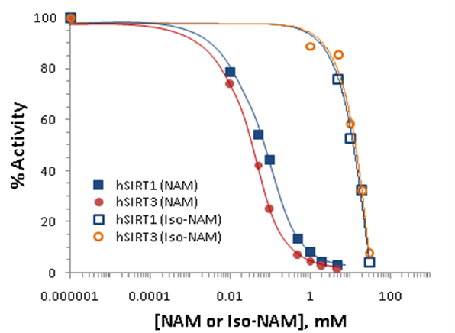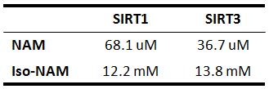

Figure 1: Nicotinamide / isonicotinamide inhibition assays showing percent change in deacetylation activity as a function of NAM/isoNAM concentration. Data for the hSIRT1 enzyme are indicated with closed squares and a blue curve; data for the hSIRT3 enzyme are indicated with filled circles and a red line. The IC50NAM for the hSIRT3 enzyme is 36.7 M, and that of the hSIRT1 enzyme is 68.1 M. The IC50isoNAM for the hSIRT3 enzyme is 13.8 mM, and that of the hSIRT1 enzyme is 12.2 mM (inset table).

NAM is a noncompetitive inhibitor of recombinant human SIRT1 and competitive inhibitor of recombinant human SIRT3 in vitro.

To gain more insight into the effects of NAM on hSIRT3 activity, the *in vitro* hSIRT3 deacetylation activity was measured in the presence of varying amounts of NAM. We utilized a novel deacetylation activity assay that generates a fluorescent signal upon deacetylation of a peptide substrate. When incubated with acetylated substrate and NAD+, recombinant human SIRT3 gives a strong fluorescent signal 10-fold greater than no enzyme and no NAD+controls (data not shown). Using this assay, we tested the ability of nicotinamide to inhibit deacetylation in the presence of varying concentrations of NAD+. To evaluate the reliability of the method, the *in vitro* hSIRT1 deacetylation activity was measured as well. A double reciprocal Lineweaver-Burk plot of the data (Figure 2a) shows that NAM is a strong noncompetitive inhibitor of this reaction. We next studied the inhibitory mechanism of nicotinamide in the case of human SIRT3 *in vitro*. Using recombinant hSIRT3, we monitored deacetylation of the substrate in the presence of varying amounts of NAM and NAD+. A Lineweaver-Burk plot of the data (Figure 2b) shows important differences with respect to SIRT1. These results imply that NAM does not inhibit hSIRT1 deacetylation by competing with NAD+ for binding to the enzyme, but does inhibit hSIRT3 deacetylation by competing with NAD+ for binding to the enzyme.

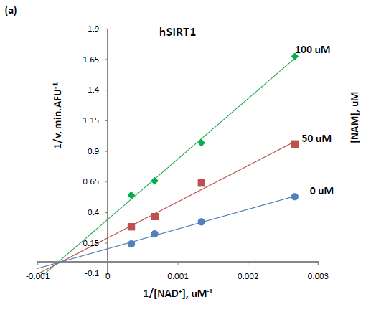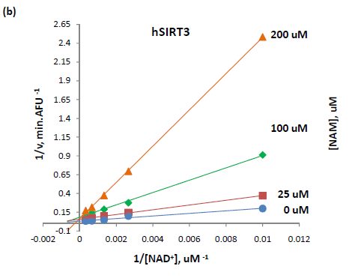

Figure 2: (A) Recombinant human SIRT1 was incubated for 0, 10, 20, 30, 60, 120, 180, and 240 min at 37oC in the presence of 125, 250, 500, 1000 M NAD+ and 0, 50, and 100M NAM. (B) Recombinant human SIRT3 was incubated for 40 min at 37oC in the presence of 100, 375, 750, 1500, 3000 M NAD+ and 0, 25, 100, and 200 M NAM. Reactions were terminated by the addition of developer and samples were analyzed by flourimetry (excitation set at 355 nm and emission at 460 nm). Experiments were performed in triplicate. Data are shown as a Lineweaver-Burk double-reciprocal plot of arbitrary fluorescence units (AFU) min-1 versus 1/[NAD+] uM-1.

Human SIRT3 inhibition effect by NAM in the presence of isoNAM.

Isonicotinamide was reported as an activator of Sir2 activity 21 shown to directly compete with nicotinamide for binding. NAM is a potent inhibitor of the Sir2 reaction because of its ability to rebind with the enzyme and react with a high-energy intermediate, preventing deacetylation and regenerating starting materials.35; 36 The basis for the observed activation is the relief of the inherent NAM inhibition by competition with isoNAM, which does not readily react with the enzyme intermediate. Does this depression effect of isoNAM also apply to hSIRT3? The hSIRT3 inhibition effect by NAM was studied in the presence of different concentrations of isoNAM. Figure 3 shows that in the presence of isoNAM (50 - 900 M), hSIRT3 inhibition of NAM was slightly decreased.

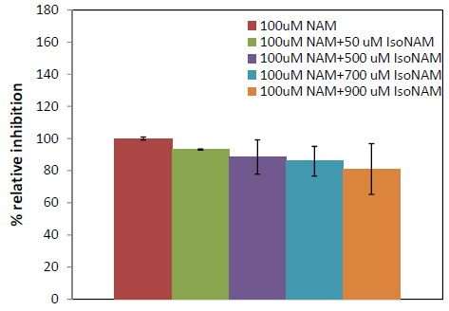

Figure 3: Recombinant human SIRT3 was incubated with 50, 500, 700 and 900 M of isoNAM for 40 min at 37oC in the presence of 500 M NAD+, and 100 µM NAM. Reactions were terminated by the addition of developer and samples were analyzed by flourometry (excitation set at 355 nm and emission at 460 nm). Experiments were performed in triplicate.

Although the IC50 for isoNAM was about three orders of magnitude higher than that for NAM binding, *in vivo* yeast studies showed that millimolar levels of isonicotinamide increased Sir2- dependent silencing of the telomeric URA3 gene. These results suggest that the development of higher affinity nicotinamide antagonists may provide a means to upregulate cellular sirtuins. However, great care will be needed to avoid cross reactivity with other NAM utilizing enzymes - in particular, those involved in NAD+ salvage and synthesis.

Simulation Result – Sir2

As a complement to the experimental results, a computer simulation method involving protein-ligand docking and a subsequent rescoring of the estimated protein-ligand binding affinity with a more accurate method called MM-GBSA was used. MM-GBSA scores, reported in kcal/mol, are not absolute binding affinities, but they have been shown to have a good correlation to experimental binding affinities for many protein-ligand data sets.26; 27; 28; 29 While the wet lab results focused on hSIRT1 and hSIRT3, appropriate x-ray structures necessary for simulations were not publicly available for hSIRT1. Instead, the homologous protein yeast Sir2 was used to mechanistically compare to hSIRT3 because, like hSIRT1, Sir2 has been shown to have a similar noncompetitive NAM inhibition mechanism.37

MM-GBSA scores for Sir2 support the noncompetitive NAM inhibition experimental results. Scores were computed in-place with two independent NAD+ bound structures for Sir2 in a single crystal structure (Sir2Af2, 1YC2).37 MM-GBSA in-place scores are very similar for NAD+ in the AC pocket (-99.0 kcal/mol) and the AB pocket (-95.0 kcal/mol). In-place protein-ligand binding scoring uses the cocrystallized structure without docking, and with minimal ligand and protein relaxation to within 0.30 Å RMSD of the crystal structure coordinates. In noncompetitive inhibition mechanistic models, when the inhibitor (such as NAM) occupies the C pocket, preventing NAD+ from occupying the productive AC pocket binding mode, NAD+ can equally bind to the AB pockets and wait for the noncompetitive inhibitor to leave.

Cross-docking scores for NAD+ binding in the two different modes are also about equal, supporting the noncompetitive mechanistic model and further validating the MM-GBSA method. The cross-docked scores are -92.6 and -95.2 kcal/mol for the AB and AC pockets, respectively. Cross-docking involves induced fit docking NAD+ into the AC pocket starting with the x-ray structure from 1YC2 with the NAD+ originally in the AB pocket, and vice versa. Cross-docking required constraints to prevent re-docking of the ligand into the same cocrystallized pose. For example, cross-docking into the AB pockets needed an exclusion volume in the C pocket to prevent re-docking to the starting AC pocket crystal structure. For cross-docking into the AC pocket, induced fit was required to move the side chain of ARG:36, which occupies the ligand-free C pocket in the cocrystallized structure with NAD+ in the AB pocket. With the induced-fit and exclusion volume, the best scoring cross-docked poses were within 2 Å RMSD of the non-docked superimposed cocrystallized structures, as shown in Figure 4.

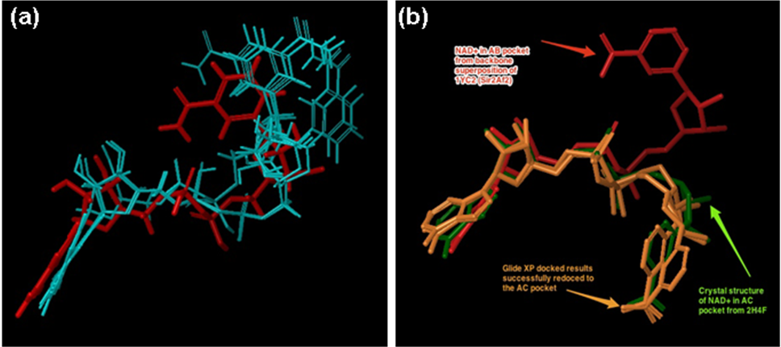

Figure 4:(a) Cross-docking of NAD+ into the AB pocket of the crystal structure of 1YC2 (Sir2) with NAD+ originally in the AC pocket. The red pose is from the AB pocket cocrystallized structure. The five blue structures are the degenerate and top ranked and only output from Glide XP with an excluded volume in the C pocket and a completely flexible ligand. The RMSD of the closest structure is 1.98 Å. (b) The two top ranked Glide XP docked results of NAD+ docked to the Sir2 AC pocket (orange), with the cocrystallized comparison structure from 2H4F (Sir2Tm) in green. The NAD+ in the AB pocket conformation is shown in red.

Simulation Result – SIRT3

Fewer cocrystallized structures were available for hSIRT3 than for Sir2, requiring the use of docking into the closest structure to either NAD+ in the AB or AC pockets. The best starting cocrystallized structure has the ADPR intermediate (3GLR)38 rather than NAD+(Figure 5). The relatively similar results between in-place scoring and induced fit cross-docking with Sir2 indicate that the induced fit protocol can accommodate for protein and ligand conformational changes between the two different binding modes. The same induced fit protocol was used for hSIRT3 with NAD+ docked into the AC pockets. For docking into the AB pocket, a similar protocol called template-based induced fit method is described in the Methods and Discussion sections.

hSIRT3 NAD+ protein-ligand MM-GBSA scores support a competitive inhibition mechanism, which agrees with the experimental results. NAD+ binding scores predict that the ligand binds more favorably to the AC pockets vs. the AB pockets. The top ranked AB pocket binding score is -84.4 kcal/mol. The top ranked AC pocket score is energetically more favorable at -107.9 kcal/mol. Figure 6 depicts the top ranked poses for docking into the AB and AC pockets. Since there is no publicly available cocrystallized hSIRT3 structure with NAD+ in the AB pockets, Figure 6 compares the docked poses to the backbone-superimposed structure of NAD+ cocrystallized in Sir2 (1YC2 chain A, B and C). Because of the high homology between Sir2 and hSIRT3, NAD+ is expected to bind in a similar fashion for both, and only poses within 4.0 Å RMSD to the Sir2 superimposed cocrystallized NAD+ were considered. For AB docked structures, RMSD ranges from 1.82 to 2.48 Å, while for AC docked structures the RMSD are less than 3.0 Å.

In addition to NAD+, standard docking of the inhibitor NAM and the related compound isoNAM places these molecules in the C pocket of hSIRT3 (3GLR) in the expected pose within 2.0 Å of the NAM end of the docked NAD+ molecule. These results, along with previously published crystal structures that show that NAM binds to the C pocket in Sir2 (PDB 1YC2 and 1YC5)37 corroborate the competitive inhibitor mechanism in which the NAM blocks NAD+ from binding to the C pocket, while the AB pocket binding of NAD+ is not equally favored, as it is in Sir2. In particular, the carboxamide of these molecules in the docked SIRT3 structures interact with the same conserved residues found to anchor the NAM in the C pocket in the corresponding cocrystallized structure of Sir2Af2 with ADP Ribose and NAM. The carboxamide oxygen of NAM hydrogen bonds to the backbone amino group of ILE230. The isoNAM also forms the same hydrogen bond with ILE230, as well as the corresponding hydrogen bond between the isoNAM carboxamide amino and the conserved ASP231. ILE230 and ASP231 are conserved across all sirtuins. Residue numbering is for SIRT3.

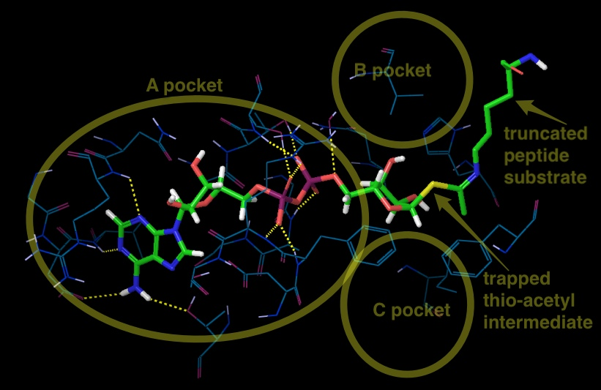Figure 5: The best docking starting structure for SIRT3 is 3GLT, which has the thio-intermediate of the acetyl-lysine peptide. The NAM has been cleaved and a bond to the thioacetyl is trapped. SIRT3, 3GLT with the trapped thio-acetyllysine ADPR intermediate.  The B and C pockets are unoccupied because of the intermediate. H-bonds between the ADPR and the protein residues within 3.0 Åof the ligand are shown here.

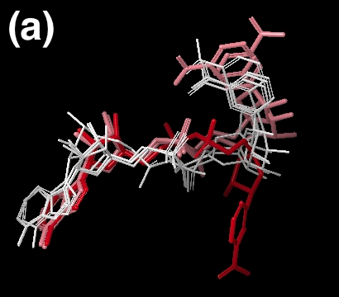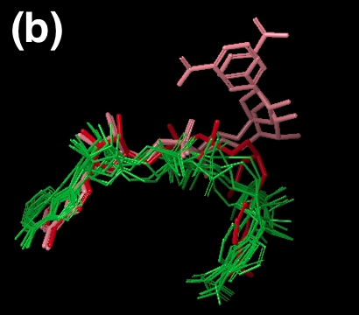

Figure 6:  For comparison in both (a) and (b): NAD+ in the AC pocket from the cocrystallized structure of 1YC2:B is in red.  The 2 structures from 1YC2 (chains A and D) with NAD+ in the AB pocket are pink. (a) AB pocket docking: 4 out of the top 20 (based on the Glide score; colored white) docked the NAD+ into the AB pocket of SIRT3. The rank order of these 4 structures was 11, 13, 17, and 18 with RMSD to the superimposed 1YC2:A NAD+ of 2.18, 1.82, 2.17, 2.48 respectively.  (b) AC pocket docking: 8 out of top 10 (based on Glide score) docked the NAD+ into the AC pocket of SIRT3 are in green. The amide from the NAM is pointing in both directions.

**DISCUSSION**

SIRT3 is a mitochondrial deacetylase protein that can regulate a number of cellular processes, including apoptosis, growth, and metabolism.39 It has been reported that SIRT3 has tumor suppressive functions and reduces the glycolytic metabolism. Cancer initiation and progression depend on aerobic glycolysis, by which cancer cells synthesize biomass for their rapid growth. On the other hand, for normal tissue, down regulation of SIRT3 would increase glycolytic metabolism and allow cells in impacted tissues to survive longer, reducing long-term tissue damage. Understanding the properties of the inhibitory mechanism of SIRT3 will help elucidate the mechanism of SIRT3-mediated deacetylation and allow improvements in the design of inhibitor selectivity and affinity.40 In this way, its inhibitors are of interest not only as tools for elucidating in detail the biological functions of the enzyme, but also as potential therapeutic agents for both inhibition and activation.

The inhibition of enzyme activity is one of the major regulatory devices of living cells, and one of the most important diagnostic procedures of the enzymologist. Inhibition studies provide important information about the specificity of an enzyme, the physical and chemical architecture of the active site, and the kinetic mechanism of the reaction. Three potential types of enzyme inhibitors are defined as follows, according to their mode of inhibition (Table 1): (A) *Competitive inhibitors* bind exclusively to the free enzyme form. There are a very large number of drugs in clinical use today that function as competitive enzyme inhibitors. (B) *Noncompetitive inhibitors* bind with some affinity to both the free enzyme and to the enzyme-substrate complex (ES complex).

Table 1. The equilibria describing 3 modes of inhibitions.41

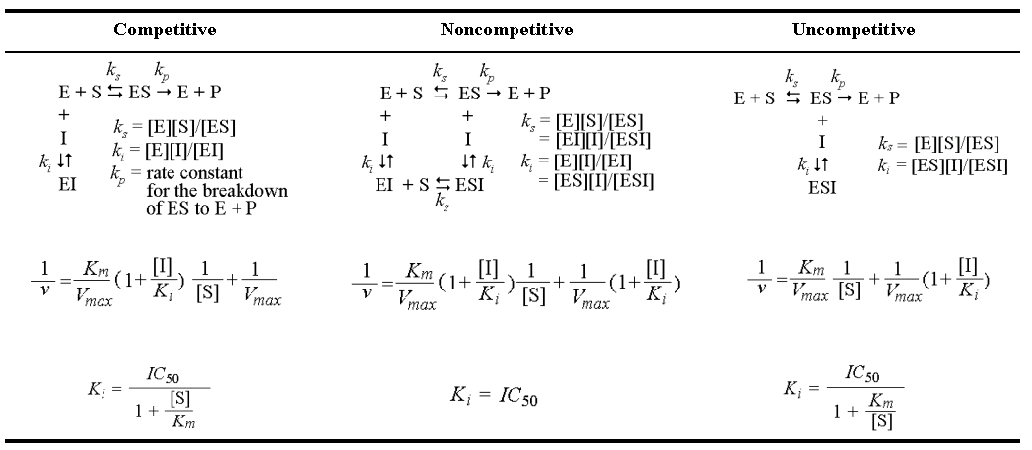

Relative to competitive inhibitors, there are fewer examples of noncompetitive inhibitors in clinical use as drugs today. This reflects the historic approaches to drug discovery that have been largely focused on active-site directed inhibitors. (C) *Uncompetitive inhibitors* bind exclusively to the ES complex or subsequent species.

Defining the inhibition modality is important for making quantitative comparisons among inhibitors of sirtuins, and is necessary for calculating the enzyme-inhibitor dissociation constant, Ki, from the experimental assays.. Ki and the related protein-inhibitor Gibbs free energy of binding provide a means of defining the energetic contributions of specific types of interactions between groups on the enzyme and functionalities on the compounds to the overall binding energy of interaction.

Given the potential roles of sirtuins in metabolic, neurodegenerative, and aging-related diseases, potent and selective inhibitors of sirtuins with different inhibition modes have been investigated. These include: 1)suramin, which is a noncompetitive SIRT1 inhibitor with respect to NAD+42 by binding into the B and C pockets of the NAD+-binding site as well as the substrate-binding site; and 2) cambinol, whichcompetitively inhibits SIRT1/SIRT2 against the acetyllysine peptide substrate.43 [add sentences on latest SIRT1-3 nM inhibitors from 2013 Sirtris paper? 44]

NAM is the physiological sirtuin inhibitor. The IC50 values for nicotinamide inhibition of bacterial Sir2, yeast Sir2, mouse Sir2, human SIRT1, SIRT2 and human SIRT3 were 26, 120, 160, 50, 100, and 36.7*uM, respectively 36; 45; 46(*current work). Nuclear NAM levels have been estimated to be 10-150 uM,21 which most likely make NAM a sirtuin activity regulator *in vivo*. Early studies reported nicotinamide binds at an allosteric site; 47 however, more recent work 35; 48 observed that NAM inhibition depends on its ability to condense with the high-energy enzyme: ADP ribose:acetyl-lysine intermediate to reverse the reaction, reforming NAD+ (Scheme 1a). NAM noncompetitively inhibits the deacetylation reaction of Sir2 with a single binding pocket C, the same site that binds the NAM of NAD+.{Avalos, 2005 #26}{Avalos, 2005 #26}

Rebinding of NAM to the Sir2/intermediate complex can promote the reverse reaction to reform the substrates, thus inhibiting the deacetylation reaction.{Avalos, 2005 #26}49 Sir2 thus appears to be affected by physiological NAM concentrations, assumed to be up to 0.1mM, and a role of NAM as an endogenous Sir2 regulator has beensupported by *in vivo* studies in yeast, flies, and mammalian cells.49; 50

A few groups have reported that NAM can react to regenerate acetyllysine and NAD+ in a nicotinamide exchange reaction, in which the imidate intermediate is emptied during normal steady-state turnover, directing NAM inhibition of deacetylation. By using [carbonyl-14C] NAM, the base exchange reaction for Sir2 was extensively studied (Scheme 1b).

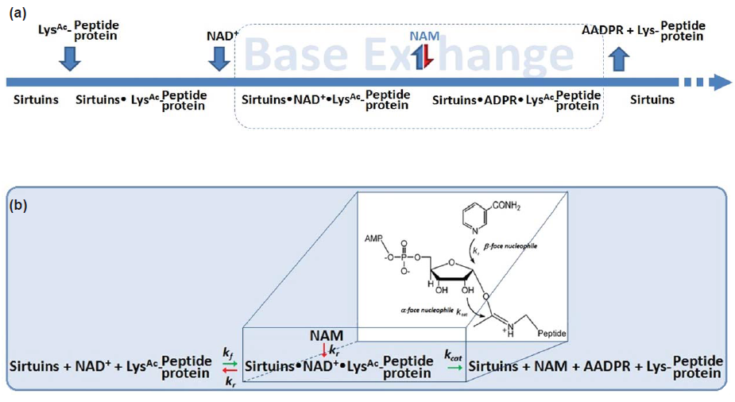

**Scheme 1. (a)** The sirtuin deacetylation reaction follows ordered sequential mechanism. **(b)** The competitive nucleophilic attacks on the Sir2 intermediate occur from both stereochemical faces.

The reactivity between base exchange and deacetylation reactions occurs when NAM is present. This competition partitions the intermediate forward (a -face nucleophilic process) and backward (-face nucleophile process) to provide inhibition of deacetylation. The exchange and deacetylation reactions share the intermediate forming step, and the ratio is determined by the chemical processes. It seems likely that unreactive isosteres of NAM that interfere with NAM binding could decrease sirtuin enzymatic activity and increase sirtuin function.

IsoNAM can compete with NAM for binding but cannot initiate the reverse reaction, thereby leading to apparent activation through relief of nicotinamide inhibition.21; 51 Similar findings were observed in the current study. The addition of 900M isoNAM slightly decreases the hSIRT3 inhibition in the presence of 100uM NAM. Computational, structural and further biochemical studies on these compounds and mechanisms might enable the development of isoform selective modulators. Combining computational docking results of isoNAM in the C pocket, a proposed mechanism of activation of hSIRT3 deacetylation by isoNAM is described in Scheme 2. IsoNAM has a minor inhibition effect on hSIRT3 with IC50 = 13.8 mM. IsoNAM does not compete with NAD+ or acetyllysine binding to hSIRT3, and it does not react with the imidate. However, isoNAM competitively inhibits the NAM-exchange reaction, thereby activating hSIRT3 by relieving NAM inhibition. The compound isoNAM is a weak binder to hSIRT3 and only depresses NAM inhibition at millimolar concentrations. The effect of isoNAM on yeast Sir2 has been reported to enhance gene silencing and correct for deletion of PNC1.49 IsoNAM is relatively non-toxic to mammalian cells, readily penetrates cells, is very stable and is highly water soluble, which makes it a suitable starting compound to study for the design of sirtuin activators.

One path to computationally design these types of activators is to balance increased C pocket affinity with design of compounds that are non-reactive with the imidate intermediate. A more potent C pocket binding species that is not reactive to the imidate must also be able to leave upon the next reaction cycle - either by movement in the C pocket due to the deaceylated peptide leaving or the product 2’-O-acetyl-ADPR leaving. Alternatively, one could imagine a high affinity activator leaving when the next NAD+ that bound to the AB pocket shifts its nicotinamide end, booting out the activator. While these possible mechanisms are conjecture, this activator must, at some point dissociate from the C pocket so the NAD+ can react with the acetyl-lysine peptide.

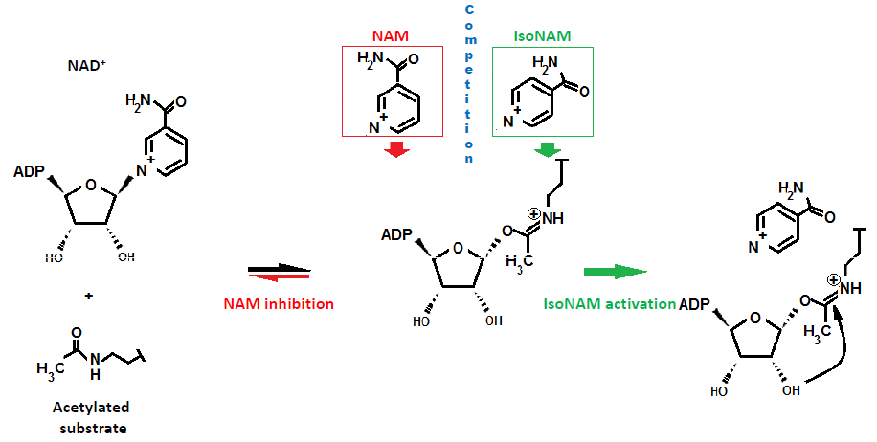

**Scheme 2:** Mechanism of activation of hSIRT3 deacetylation by isoNAM. IsoNAM competes with NAM to block the position above the -face of the imidate. NAM induces chemical reversal of the imidate.

In addition to the investigation of NAM and isoNAM, protein-ligand docking methods withthe newly available human SIRT3 crystal structures from 2009 - 2013 52; 53 agreed with previous crystal structures and provided insights into the different inhibition modes between published studies of Sir237; 54 and our current kinetic experiments with hSIRT3. Although the overall binding scores were different, the protein-ligand intramolecular interactions were similar between Sir2-NAD+ and SIRT3-NAD+, and the docked interactions agreed with cocrystallized x-ray structures of Sir2 and SIRT3. The similarity helps validate the induced fit docked poses of SIRT3, because the same expected protein-ligand contacts with conserved residues seen in the Sir2 crystal structures are satisfied in the SIRT3 docked structures as well. Figure7 depicts the protein-ligand interaction diagram of Sir2Af2 cocrystallized with NAD+ in AB and AC pockets. Both Sir2 and hSIRT3 make similarly energetically favorable interactions in the AB pose, as well as in the AC pose. The adenine and diphosphates have similar intramolecular interactions in the A pocket, especially with conserved residues. For example, conserved residues SER193 and SER321 form critical contacts with a phosphotidyl oxygen in Sir2 and SIRT3, respectively. As with the NAM in the C pocketcocrystallized structure of Sir2 and the docked structure in SIRT3, the carboxamide at the nicotinamide end of NAD+ in the AC binding mode makes a crucial hydrogen bond with Ile102 and Ile230 in Sir2 and SIRT3, respectively.

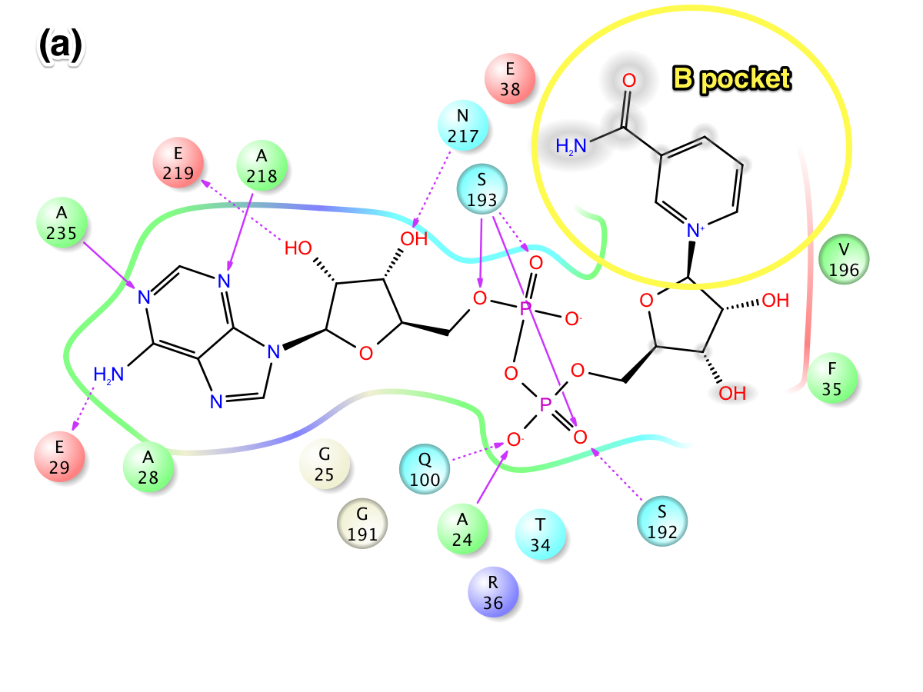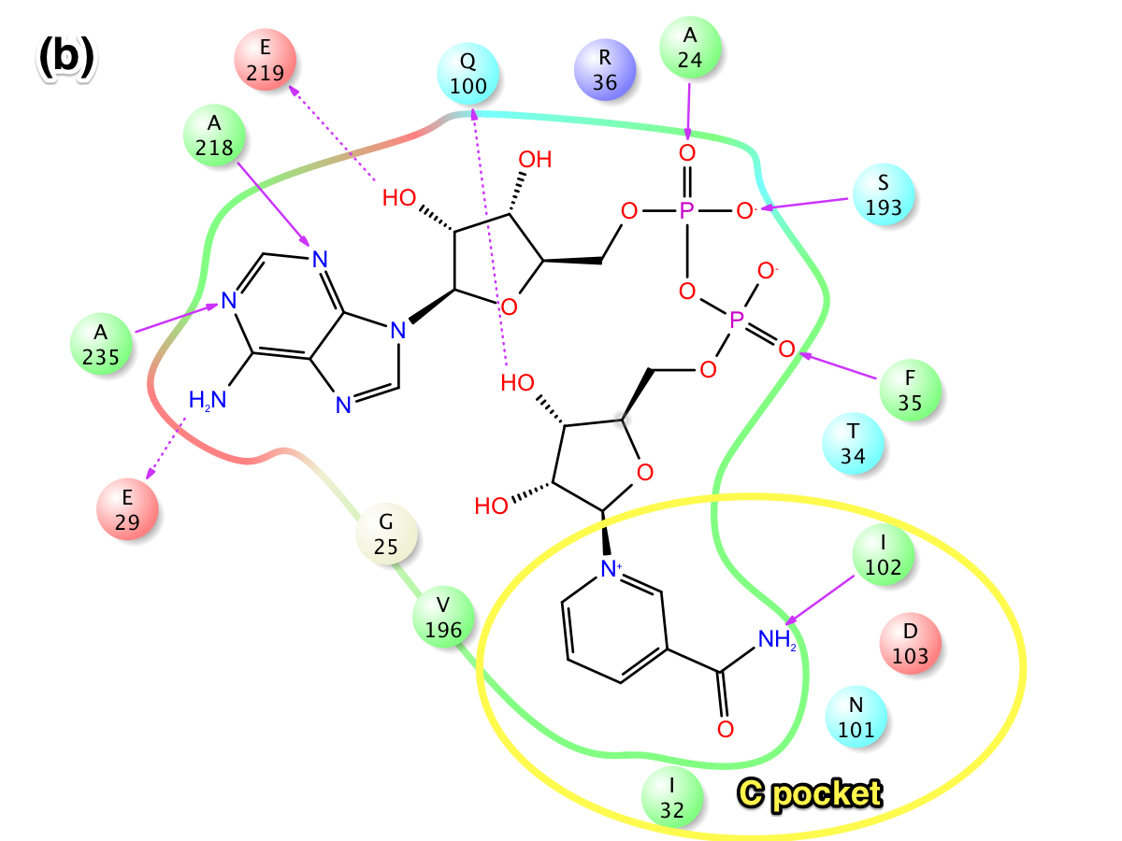Figure 7: Intermolecular protein-ligand interaction diagrams of NAD+ in Sir2Af2. In this flattened 2D representation, residues within 2.5 Å of the NAD+ are represented as colored spheres, where: red=acidic, green=hydrophobic, blue=polar, light gray=(Gly). Solid pink lines are H-bonds to the protein backbone; dotted pink are H-bonds to the side chains. (a) NAD+ in the AB pocket(1YC2 chain A). The lack of a protein "pocket" line around the NAM end and the grey spheres around those atoms indicate that the NAM end is exposed to solvent in the B pocket (show as a yellow circle). There are no specific intermolecular interactions between the protein and the NAM end of NAD+. (b) NAD+ in the AC pocket (1YC2 chain B). The NAM is not exposed to solvent, unlike in the B pocket. While the C pocket is collapsed in (a), the NAM end makes specific H-bond contacts with residues in the C pocket.

Predicted NAD+ binding scores are similar between AB and AC binding modes for Sir2, but the binding score for AC is favored over AB binding in SIRT3. Analysis of the individual energy terms to the binding score for MM-GBSA does not explain the difference between the Sir2 and SIRT3 scores, possibly because molecule’s large size. The largest part of the NAD+ molecule containing the adenine and the diphosphates is bound in a similar conformation in both the AB and AC modes for both Sir2 and SIRT3, masking individual energetic differences. However, because the MM-GBSA scores do not include the full energetic protein reorganization penalty from the induced fit methods used with SIRT3, the less favorable AB binding in SIRT3 may be even more pronounced than reported here. The missing penalty further supports the SIRT3 competitive NAD+ inhibition mode in which AB binding is not observed because it is energetically unfavorable. There is a >100 kcal/molprotein reorganization penalty when transforming the relaxed SIRT3 crystal structure to the induced fit and template-based method used to dock NAD+ into the AB pocket.

The NAM end of NAD+ adopts two flipped conformations in the crystal structures: one with amide hydrogen of the NAM end of NAD+ in the AB pocket of the Sir2Af2 (1YC2 chain D) making an intramolecular hydrogen bond to the ligand phosphotidyl oxygen, and another with this amide pointed towards the solvent (1YC2 chain A). There are no hydrogen bonds in the B pocket with the outer half of the pocket exposed to solvent allowing the NAM to move. This intramolecular H-bond is never seen in the docking, possibly because the energy is truly degenerate in this case where most of the NAM is exposed to solvent, or Glide has systematic bias against ligand intramolecular H-bonds. In addition, the NAM in the B pocket must move to the C pocket, and this degenerate flexibility in solvent could facilitate this motion.

The hSIRT3 AB docking results use the template-based induced fit method (as described in the Methods section) because of the difficulty in docking NAD+ into the AB pocket of SIRT3. While traditional and induced fit docking succeeded in placing NAD+ in Sir2 and into the AC pockets of SIRT3, these docking methods failed for the AB pocket when starting with the best available crystal structure for SIRT3 (3GLT) (see Figure 5). AB pocket docking did not work for SIRT3 because the standard induced fit side chain and backbone optimization could not sufficiently open the B pocket for the NAM end of NAD+, as shown in Figure **8** (a). Only the template-based induced fit method successfully docked NAD+ into the AB pocket. This method mainly moved the side chains shown in Figure **8** (a), and it also minimally moved the backbone for residues 320 to 324, while maintaining identical backbone structure for the remaining residues (see Figure **8** (b)).

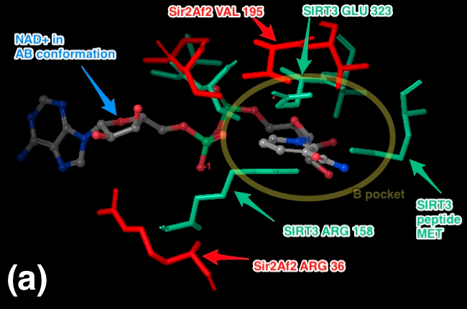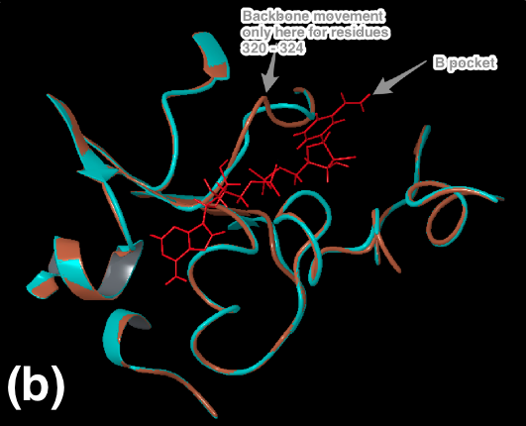

Figure 8: (a) Steric clashes between NAD+ in the AB conformation and SIRT3 (from the thio-acetyl ADPR intermediate).  This is a top view of the NAD+, where the B pocket is oriented on top of the C pocket within the axis perpendicular to the figure. The steric clashes are labeled in aqua, and the B pocket is labeled with the yellow oval.  Comparable Sir2Af2 residues within 6 Å of the NAM in the B pocket are in red.  The Sir2Af2 structure is from the NAD+ cocrystallized PDB file 1YC2 chain A with NAD+ in the AB pockets.  This structure is aligned to the SIRT3 protein backbone from 3GLT.  3GLT has the thio-acetyl ADPR intermediate, which has the NAM cleaved off.  The depicted NAD+ cofactor is from the Sir2Af2 cocrystallized structure. Sir2 residues do not obstruct the B pocket.  (b) SIRT3 backbone movement after PLOP minimization with the template NAD+ in the AB conformation was minimal. In the constrained minimization, only, residues 157 to 160, 320 to 324, and 365 to 367 were free to move. The backbone moved only for residues 320 to 324, while the remaining backbone for other residues were either constrained or did not move.

Although the use of the template of the AB docked NAD+ from Sir2 superimposed onto SIRT3 may bias the resulting docking to the AB pocket, three factors justify this method. (A)All other docking attempts with and without multiple constraints failed, possibly because of the nonexistence of a low energy structure when the backbone remained constrained. (B) The possibly biased result still remained less favorable than AC pocket binding estimates. Inclusion of the protein reorganization penalty from the template induced fit method, which is not fully included in the MM-GBSA scores, would make AB pocket score even less favorable. Even if AB pocket docking is precluded in the real system, the mechanistic conclusion of competitive inhibition is the same. (C)Crystallographers failed with multiple protocols to cocrystallize NAD+ into the SIRT3 unproductive AB binding pocket, with or without the acetyl-lysine substrate.52 While NAD+ has been observed to bind in the productive AC binding site for Sir2Af2, Sir2Af1 and in the non-productive AB binding site for Sir2Af2, Sir2Af1 in the absence of the peptide substrate,55; 56NAD+ cannot bind to SIRT3 efficiently in the absence of the substrate peptide.52 Due to the short lived nature of the SIRT3/acyl-peptide/NAD+ complex, the only available ternary crystal structure uses an unreactive NAD+ analog, carba-NAD.57The carba-NAD is only observed in the AC binding mode.

[Deleted paragraphs]

There are a few key limitations of the docking/MM-GBSA method. Protein structural changes other than localized side chain or small backbone movements are ignored. Allosteric inhibition or activation by NAM or isoNAM binding cannot be tested. MM-GBSA method provides a fast, first estimation to more accurately rank order the raw protein-ligand docking results than docking alone 52; 58. While sufficient in detecting relatively similar binding affinities (as between AB and AC binding in Sir2) or large differences (as between AB and AC binding in SIRT3), MM-GBSA ignores a number of important dynamic contributions to binding affinity and mechanistic studies, and MM-GBSA shows highest correlations to binding affinity energies with a congeneric series of ligands bound in a similar mode.

Future simulations to obtain more reliable estimates of binding affinity differences between the AB and AC pockets could involve more sophisticated techniques. Accurate computational affinity predictions beyond docking are known to be challenging 59. For example, the template-based induced fit protocol used for docking NAD+ into the AB pocket of SIRT3 could be extended to iteratively incorporate template-based loop/side chain prediction with a flexible ligand. More computationally intensive molecular dynamics based simulations such as thermodynamic integration (TI) or free energy perturbation (FEP) have been shown to be more accurate 59 and include more degrees of freedom to dock to the AB pocket. TI or FEP are amenable to the manageably low number of protein-ligand complexes studied in this paper.

In summary, SIRT3 is the major sirtuindeacetylase in mitochondria, where bioenergetics, oxidative stress, and apoptosis are controlled. In order to have better understanding of the basic cell biology processes as well as a pharmacological and/or nutritional target for intervention, the extensive efforts for development of SIRT3 modulators are needed. Experimental results reported here indicate that NAM, a noncompetitive inhibitor of Sir2 and hSIRT1, competitively inhibits hSIRT3 by blocking NAD+ from the binding site at the C pocket, which reveals a different strategy for SIRT3 inhibitor design. Molecular docking performed in the current study use x-ray crystal structures of Sir2Af2 and human SIRT3 as the starting point for analysis. In addition, incorporation of protein flexibility and backbone conformation change upon ligand association are taken into consideration. MM-GBSA scores are consistent with experiment for the noncompetitive and competitive inhibition mechanism for Sir2 and SIRT3, respectively.

The noncompetitive and competitive inhibition mechanism by NAM in the C pocket provides insight for further research into designing inhibitors and activators for hSIRT1 and hSIRT3. Ligands should be designed to dock into the C pocket, rather than the B pocket of hSIRT3, as supportedby a recent publication of high affinity inhibitors found for SIRT1-3 which bind to both the C pocket and the acetyllysine substrate channel.44 Ligands exclusively in the B pocket may have a lesser inhibitory effect in hSIRT3 since NAD+ may not have a high occupancy in the AB pockets. Ligands binding to the A pocket are predicted to have similar affects for both sirtuins. Our work indicates that activators, working through NAM base exchange inhibition relief, should bind exclusively to the C pocket in SIRT3 and other sirtuins. These inhibition relief compounds also act as NAD+ inhibitors with different kinetic effectson hSIRT1 and hSIRT3 due to the different NAD+ inhibition modes.

Computer-assisted drug design coupled with experiment has become an attractive alternative to the tradition *in vitro* and *in vivo* screenings. Taken together, we anticipate that the structural elucidation of NAM inhibition for the hSIRT3 enzyme reported here can guide the design of a new generation of hSIRT3 modulators.

[[The next paper will have more description and discussion about LIA and computational inhibitor design. ?]]

**MATERIALS AND METHODS**

*Chemicals and reagents.* The acetylated substrate peptide based on the sequence of Acetyl-coenzyme A synthetase 2 (AceCS2 638-649, H2N-TRSGK (Ac)VMRRLLR-OH) was synthesized at PEPTIDE 2.0 Inc (Chantilly, VA, USA). Human recombinant SIRT3 was purchased from Creative BioMart (Shirley, NY, USA). Enzyme concentrations were determined using the method of Bradford60 with bovine serum albumin (BSA) as the standard. All other chemicals used were of the highest purity commercially available and were purchased from Sigma (St. Louis, MO, USA), and Fisher Scientific (Pittsburgh, PA, USA).

*Measurement of Deacetylation activity using a Fluorolabeled peptide.* The steady state parameters (Km and Kcat) and catalytic efficiency (Kcat/Km) of deacetylase activity of recombinant human SIRT3 was determined using a fluorometric assay. The deacetylation activity was measured by using the SIRT3 Fluorimetic Drug Discovery Kit (AK 557, Enzo Life Sciences). This assay system allows detection of a fluorescent signal upon deacetylation of an acetylated substrate peptide, comprising amino acids 317-320 of human p53 (Gln-Pro-Lys-Lys (Ac)), when treated with developer. The intensity of fluorescence was measured on a fluorometricmicroplate reader (Fluoroskan Ascent® FL, Thermo LabSystems) with excitation set at 355 nm and emission detection set at 460 nm. The initial rate of the NAD+-dependent deacetylation activity of SIRT3 enzyme was measured at different concentrations of nicotinamide adenine dinucleotide. The reactions were carried out at 37oC in a 50 µl reaction volume containing 50 mMTris/Cl (pH=8), 137 mMNaCl, and 100 µM flourolabeled peptide substrate. The enzyme concentration of the SIRT3 was 50 µg/ml. Unless otherwise indicated, all initial rate measurements were means of three or more replicates, obtained with single incubation times, at which point 5% or less of the substrate initially present had been deacetylated. The raw data were fitted to the Michaelis-Menten equation by using GraphPad Prism (GraphPad Software, Inc, CA) to obtain the kinetic constants.

*Measurement of IC50 values for SIRT3 inhibitor,NAM:* This assay was also used to measure the inhibition by NAM, isoNAM and a combination of both. Reactions were performed in the presence of 100 µM NAD+, and either NAM (0, 12.5, 25, 50, 100, 200, 500 µM) or 50 µM of nicotinamide with isonicotinamide (0, 0.05, 0.1, 1, 5, and 10 mM). The initial rates were measured at different concentrations of NAM and isoNAM, and the reaction conditions were the same as above. The data were fitted to Equation 1 by using Prism to calculate the IC50 values:

(1)

Where v0 is the initial rate of the uninhibited reaction and vI is the initial rate of the reaction at concentration I of the inhibitor.

*In Silico Docking and Binding affinity estimation:*

In addition to the experimental assays, computational simulations elucidated the mechanism of SIRT3 compared to Sir2 through protein-ligand docking and a subsequent more accurate scoring of the docked poses. These techniques allow for an approximation of binding affinity of the native NAD+ substrate. Protein-ligand docking, and the MM-GBSA protocol,61 as well as an induced fit protocol were used for the binding affinity estimates, as described below.

Although protein-ligand docking programs such as Glide61, AUTODOCK62, or DOCK63 rank order ligand poses based on a docking score, these outputs are not reliable estimates for the binding affinity. Docking programs were designed to distinguish actives from inactives when screening large databases of potential ligands to a given protein active site. The computational simulations in this study attempted to differentiate between the Sir2 and SIRT3 NAM inhibition mechanism, for which subtle variations in absolute binding energy between the various binding modes of the native NAD+ cofactor needed to be estimated. While other groups have reported correlating docking scores64 to or developing a custom scoring function55 for binding affinity, these approaches are limited to congeneric series of ligands for which dozens of experimentally determined binding affinities are used as a training set. These methods are not applicable, as we are concerned with a possible subtle difference between two binding modes of the native cofactor, NAD+ and two inhibitors.

MM-GBSA enhances docking scores by adding an estimation of the missing energy contributions of the solvent through the generalized Born implicit solvent model. Because correlations to free energy of binding for multiple test systems were found to be good for a single structure approach61 and because the computationally more intensive combined molecular dynamics ensemble averaged MM-GBSA approach added little additional accuracy,64 we employed the simpler single structure method. The docking algorithm outputs multiple poses for each ligand, each with a slightly different conformation docked into the same starting protein. All of these structures, even lower ranking ones, are re-scored and re-ranked with the MM-GBSA function. The single highest ranked MM-GBSA score is used as the final binding affinity energy estimate.

Using the standard scoring functions to predict poses, and subsequently re-scoring those poses with MM-GBSA offers better prediction of binding affinities. The scoring functions in Glide and other docking programs are optimized to minimize the RMSD difference between predicted and x-ray determined structures for a large database of cocrystallized protein-ligand structures,65 rather than optimized to predict binding affinity. Re-ranking the poses with MM-GBSA method incorporates implicitly modeled solvent effects that are an important energy contribution and that are not modeled well in standard docking scores.

The first step in estimating binding affinity with MM-GBSA is prepping the raw crystal structure PDB file for docking. Multiple starting structures of SIRT3 (3GLT) and Sir2 (1YC2) with NAD+ cocrystallized in either the AB or AC pockets of the protein56 were prepared with the Schrodinger protein preparation protocol.66 Bond orders were assigned, missing hydrogens added, zero-order bonds to the zinc atoms created, missing side chains were filled in with the PLOP algorithm,67 and protein chain termini are capped. Protonation and tautomer states for the ligands were generated with Epik68 for a pH range of 7.0 +/- 3.0. H-bond assignment was done using PROPKA at pH 7.0 and included sampling all water orientations, as well as using crystal symmetry information. A final restrained minimization was performed with heavy atoms converged to RMSD 0.30 Å with the OPLS 2005 force field.

Three different protocols were used for docking, depending on the availability of NAD+ cocrystallized structures: (A) traditional docking, (B) induced fit docking, and (C) template induced fit docking. For Sir2, which has optimal x-ray structures with NAD+ cocrystallized in both the AB and AC pockets (PDB:1YC2 chains A and B, respectively), standard Glide XP docking (A) was used for both NAD+ docking into the AB and AC pockets and inhibitor/activator docking into the C pocket. This traditional docking is useful when the receptor structure does not change upon docking. Since SIRT3 had no publically available cocrystallized structures with NAD+ in the AB or AC pockets, the induced fit protocol (B),59 which increases sampling by adding flexibility to the receptor, was used to dock NAD+ into the AC pocket. Neither traditional docking nor the induced fit protocol were sufficient to dock NAD+ into the AB pocket, thus a template induced fit method (C) was used to dock inhibitors/activators and NAD+ into the AB pocket. Below are details of each method A, B, and C.

Standard Docking method (A). Before docking, docking grids were calculated with the grid box centered on the known NAD+ binding site. For docking simulations which had difficulty reproducing the expected binding mode observed in crystal structures, such as the Sir2 AB pocket docking, optional ligand positional constraints, H-bond or metal constraints, hydrophobic constraints, and excluded volumes were added. In particular, an excluded volume was place in the C pocket for AB docking.

Glide was run in both SP (standard precision) and XP (extra precision) modes. Since Glide does not allow for receptor flexibility in docking, van der Waals (vdW) radius scaling softens the potential for nonpolar atoms in the receptor. The vdW radius was initially set at 0.85 (no scaling) with a partial charge cutoff of 0.15, then decreased to 0.50 in cases to minimize steric obstructions. Partial charges for the ligand and receptor are based on the OPLS 2005 force field along with the Epik determined ionization states on the ligand and the PROPKA ionization states on the receptor.

Induced Fit docking method (B). A number of similar implementations of induced fit docking are available which take advantage of side chain rotamer libraries to add protein receptor flexibility 69; 70; 71. We used the Schrodinger Induced Fit protocol, which iteratively uses Glide and a side chain optimization algorithm called PLOP67 to exhaustively consider possible binding modes and the associated conformational changes within the receptor. Traditional Glide docking with a static receptor for Sir2 and SIRT3 is not sufficient when the starting crystal structure is not from a cocrystallized structure with NAD+ in the desired binding mode because a loop as well as side chains move upon binding of NAD+ and upon NAD+ changing from the AC to the AB binding pocket. For example, Figure **8** (a) shows steric clashes in docking NAD+ into SIRT3.

The induced fit method first docks the ligand into an inflexible receptor, similar to standard Glide docking. The collection of generated poses is then used as templates to refine the receptor, in which the ligand is kept frozen in its docked conformation and the protein side chains are optimized with PLOP. Next, the ligand and receptor from each of the structures refined with PLOP are energy minimized, allowing for both ligand relaxation and slight backbone/sidechain protein movement. The backbone movement only occurs through this relaxation step, rather than through extensive rotomer sampling as done with the side chains. The docking score, as well as receptor OPLSA energy and solvation are used to rank order each of these protein-ligand structures. Top ranked structures are then used iteratively as input back into the first step until the change in docking score is less than 0.5. Unlike with traditional docking, the Schrodinger Induced Fit protocol has limited constraints available. Excluded volumes and ligand positional or torsional constraints are currently not implemented in the protocol. As in traditional docking, a receptor region around the AB and AC binding pockets of around 18 Å a side is defined, and the ligand is docked flexibly, or, alternatively, rigidly in the expected conformation seen in the cocrystallized structures of NAD+ in the AB or AC pockets of Sir2Af2 (1YC2). Specified side chains are temporarily mutated to alanine to accommodate the ligand and improve side chain flexibility. In particular, Arg36 on Sir2Af2 (1YC2) sterically hinders the B pocket.

Template Induced Fit method (C). Large steric clashes and loop minimization for docking NAD+ into the AB pocket of SIRT3 that the standard induced fit protocol could not accommodate were handled with a template-based induced fit method. Unlike for Sir2 which has cocrystallized structures with NAD+, 3GLT with the trapped thio-acetyl ADPR intermediate is the closest available to a cocrystallized structure of NAD+ either in the AB or AC pockets. Glu323, Arg158, and MET644 from Chain B (the acetyl-lysine peptide substrate) obstruct the B pocket of SIRT3, as shown in Figure **8** (a).

This method used NAD+ in the AB cocrystallized conformation from Sir2 as a template. First, the NAD+ intermediate and the bound peptide substrate, which are cocrystallized in 3GLT, were deleted. Next, the backbone of 1YC2 chain A (Sir2Af2) was superimposed into SIRT3, and the NAD+ from Sir2 was inserted into the nascent AB pocket of SIRT3 as the template. Side chains and backbone residues of the sterically clashing residues (A:157 to A:160 AND A:320 to A:324, and A:365 to A:367) were optimized with PLOP. This algorithm minimizes only these specified clashing residues around the fixed, superimposed NAD+ in the AB conformation by exhaustively considering sidechain and backbone rotamers based on a rotamer library. Additionally, sidechains are refined for residues within 6.0 Å of the clashing residues, while all other residues remain fixed. A dielectric constant of 1.00 internal and 80.0 external was used. Following this minimization, standard Glide docking is performed without any constraints as previously described.

The docked poses generated by any of the three above described docking protocols were used to calculate the MM-GBSA binding affinity score. Glide XP mode output a handful of highly scored poses, which were re-ranked using MM-GBSA. The SP mode output up to 1024 more lower scored poses which were also re-ranked, allowing for a more comprehensive sampling of poses with scores slightly higher in energy. The energies were calculated using the OPLS-AA force field and the GBSA continuum model. The binding free energy ∆Gbind is estimated as

∆Gbind = ∆EMM - ∆GSOLV + ∆GSA

where ∆EMM is the difference in energy between the complex structure and the sum of the energies of the ligand and unliganded protein, using the OPLS force field; ∆Gsolv is the difference in the GBSA solvation energy of the complex and the sum of the solvation energies for the ligand and unliganded protein; and ∆GSA is the difference in the surface area energy for the complex and the sum of the surface area energies for the ligand and uncomplexed protein.

…

**Figure table: (for editing purposes only)**

Figure 1:Nicotinamide / isonicotinamide inhibition assays showing percent change in deacetylation activity as a function of NAM/isoNAM concentration. Data for the hSIRT1 enzyme are indicated with closed squares and a blue curve; data for the hSIRT3 enzyme are indicated with filled circles and a red line. The IC50NAM for the hSIRT3 enzyme is 36.7 M, and that of the hSIRT1 enzyme is 68.1 M. The IC50isoNAM for the hSIRT3 enzyme is 13.8 mM, and that of the hSIRT1 enzyme is 12.2 mM (inset table). 6

Figure 2: (A) Recombinant human SIRT1 was incubated for 0, 10, 20, 30, 60, 120, 180, and 240 min at 37oC in the presence of 125, 250, 500, 1000 M NAD+ and 0, 50, and 100M NAM. (B) Recombinant human SIRT3 was incubated for 40 min at 37oC in the presence of 100, 375, 750, 1500, 3000 M NAD+ and 0, 25, 100, and 200 M NAM. Reactions were terminated by the addition of developer and samples were analyzed by flourimetry (excitation set at 355 nm and emission at 460 nm). Experiments were performed in triplicate. Data are shown as a Lineweaver-Burk double-reciprocal plot of arbitrary fluorescence units (AFU) min-1 versus 1/[NAD+] uM-1. 7

Figure 3: Recombinant human SIRT3 was incubated with 50, 500, 700 and 900 M of isoNAM for 40 min at 37oC in the presence of 500 M NAD+, and 100 µM NAM. Reactions were terminated by the addition of developer and samples were analyzed by flourometry (excitation set at 355 nm and emission at 460 nm). Experiments were performed in triplicate. 8

Figure 4:(a) Cross-docking of NAD+ into the AB pocket of the crystal structure of 1YC2 (Sir2) with NAD+ originally in the AC pocket. The red pose is from the AB pocket cocrystallized structure. The five blue structures are the degenerate and top ranked and only output from Glide XP with an excluded volume in the C pocket and a completely flexible ligand. The RMSD of the closest structure is 1.98 Å. (b) the two top ranked Glide XP docked results of NAD+ docked to the Sir2 AC pocket (orange), with the cocrystallized comparison structure from 2H4F (Sir2Tm) in green. The NAD+ in the AB pocket conformation is shown in red. 11

Figure 5:The best docking starting structure for SIRT3 is 3GLT, which has the thio-intermediate of the acetyl-lysine peptide. The NAM has been cleaved and a bond to the thioacetyl is trapped. SIRT3, 3GLT with the trapped thio-acetyllysine ADPR intermediate.  The B and C pockets are unoccupied because of the intermediate. H-bonds between the ADPR and the protein residues within 3.0 Åof the ligand are shown here. 13

Figure 6:  For comparison in both (a) and (b): NAD+ in the AC pocket from the cocrystallized structure of 1YC2:B is in red.  The 2 structures from 1YC2 (chains A and D) with NAD+ in the AB pocket are pink. (a) AB pocket docking:4 out of the top 20 (based on the Glide score; colored white) docked the NAD+ into the AB pocket of SIRT3. The rank order of these 4 structures was 11, 13, 17, and 18 with RMSD to the superimposed 1YC2:A NAD+ of 2.18, 1.82, 2.17, 2.48 respectively.  (b) AC pocket docking:8 out of top 10 (based on Glide score) docked the NAD+ into the AC pocket of SIRT3 are in green.The amide from the NAM is pointing in both directions. 13

Figure 7: Intermolecular protein-ligand interaction diagrams of NAD+ in Sir2Af2. In this flattened 2D representation,residues within 2.5 Å of the NAD+ are represented as colored spheres, where: red=acidic, green=hydrophobic, blue=polar, light gray=(Gly). Solid pink lines are H-bonds to the protein backbone; dotted pink are H-bonds to the side chains. (a) NAD+ in the AB pocket(1YC2 chain A). The lack of a protein "pocket" line around the NAM end and the grey spheres around those atoms indicate that the NAM end is exposed to solvent in the B pocket (show as a yellow circle).There are no specific intermolecular interactions between the protein and the NAM end of NAD+. (b) NAD+ in the AC pocket (1YC2 chain B). The NAM is not exposed to solvent, unlike in the B pocket. While the C pocket is collapsed in (a), the NAM end makes specific H-bond contacts with residues in the C pocket.. 20

Figure 8: (a) Steric clashes between NAD+ in the AB conformation and SIRT3 (from the thio-acetyl ADPR intermediate).  This is a top view of the NAD+, where the B pocket is oriented on top of the C pocket within the axis perpendicular to the figure. The steric clashes are labeled in aqua, and the B pocket is labeled with the yellow oval.  Comparable Sir2Af2 residues within 6 Åof the NAM in the B pocket are in red.  The Sir2Af2 structure is from the NAD+ cocrystallized PDB file 1YC2 chain A with NAD+ in the AB pockets.  This structure is aligned to the SIRT3 protein backbone from 3GLT.  3GLT has the thio-acetyl ADPR intermediate, which has the NAM cleaved off.  The depicted NAD+ cofactor is from the Sir2Af2 cocrystallized structure. Sir2 residues do not obstruct the B pocket.  (b) SIRT3 backbone movement after PLOP minimization with the template NAD+ in the AB conformation was minimal. In the constrained minimization, only, residues 157 to 160, 320 to 324, and 365 to 367 were free to move. The backbone moved only for residues 320 to 324, while the remaining backbone for other residues were either constrained or did not move. 22

**RFERENCES**

1. Minino, A. M., Murphy, S. L., Xu, J. & Kochanek, K. D. (2011). Deaths: final data for 2008. *National vital statistics reports : from the Centers for Disease Control and Prevention, National Center for Health Statistics, National Vital Statistics System***59**, 1-126.

2. Kaeberlein, M., McVey, M. & Guarente, L. (1999). The SIR2/3/4 complex and SIR2 alone promote longevity in Saccharomyces cerevisiae by two different mechanisms. *Genes & Development***13**, 2570-2580.

3. Lin, S. J., Defossez, P. A. & Guarente, L. (2000). Requirement of NAD and SIR2 for life-span extension by calorie restriction in Saccharomyces cerevisiae. *Science***289**, 2126-2128.

4. Frye, R. A. (1999). Characterization of five human cDNAs with homology to the yeast SIR2 gene: Sir2-like proteins (sirtuins) metabolize NAD and may have protein ADP-ribosyltransferase activity. *Biochemical and Biophysical Research Communications***260**, 273-279.

5. Frye, R. A. (2000). Phylogenetic classification of prokaryotic and eukaryotic Sir2-like proteins. *Biochemical and Biophysical Research Communications***273**, 793-798.

6. Onyango, P., Celic, I., McCaffery, J. M., Boeke, J. D. & Feinberg, A. P. (2002). SIRT3, a human SIR2 homologue, is an NAD-dependent deacetylase localized to mitochondria. *Proceedings of the National Academy of Sciences of the United States of America***99**, 13653-13658.

7. Lombard, D. B., Alt, F. W., Cheng, H. L., Bunkenborg, J., Streeper, R. S., Mostoslavsky, R., Kim, J., Yancopoulos, G., Valenzuela, D., Murphy, A., Yang, Y., Chen, Y., Hirschey, M. D., Bronson, R. T., Haigis, M., Guarente, L. P., Farese, R. V., Weissman, S., Verdin, E. & Schwer, B. (2007). Mammalian sir2 homolog SIRT3 regulates global mitochondrial lysine acetylation. *Molecular and Cellular Biology***27**, 8807-8814.

8. Hallows, W. C., Lee, S. & Denu, J. M. (2006). Sirtuins deacetylate and activate mammalian acetyl-CoA synthetases. *Proceedings of the National Academy of Sciences of the United States of America***103**, 10230-10235.

9. Schwer, B., Bunkenborg, J., Verdin, R. O., Andersen, J. S. & Verdin, E. (2006). Reversible lysine acetylation controls the activity of the mitochondrial enzyme acetyl-CoA synthetase 2. *Proceedings of the National Academy of Sciences of the United States of America***103**, 10224-10229.

10. Hallows, W. C., Yu, W., Smith, B. C., Devires, M. K., Ellinger, J. J., Someya, S., Shortreed, M. R., Prolla, T., Markley, J. L., Smith, L. M., Zhao, S. M., Guan, K. L. & Denu, J. M. (2011). Sirt3 Promotes the Urea Cycle and Fatty Acid Oxidation during Dietary Restriction. *Molecular Cell***41**, 139-149.

11. Hirschey, M. D., Shimazu, T., Goetzman, E., Jing, E., Schwer, B., Lombard, D. B., Grueter, C. A., Harris, C., Biddinger, S., Ilkayeva, O. R., Stevens, R. D., Li, Y., Saha, A. K., Ruderman, N. B., Bain, J. R., Newgard, C. B., Farese, R. V., Alt, F., Kahn, C. R. & Verdin, E. (2010). SIRT3 regulates mitochondrial fatty-acid oxidation by reversible enzyme deacetylation. *Nature***464**, 121-U137.

12. Lu, Z. P., Bourdi, M., Li, J. H., Aponte, A. M., Chen, Y., Lombard, D. B., Gucek, M., Pohl, L. R. & Sack, M. N. (2011). SIRT3-dependent deacetylation exacerbates acetaminophen hepatotoxicity. *Embo Reports***12**, 840-846.

13. Alhazzazi, T. Y., Kamarajan, P., Joo, N., Huang, J. Y., Verdin, E., D'Silva, N. J. & Kapila, Y. L. (2011). Sirtuin-3 (SIRT3), a Novel Potential Therapeutic Target for Oral Cancer. *Cancer***117**, 1670-1678.

14. Finley, L. W. S., Carracedo, A., Lee, J., Souza, A., Egia, A., Zhang, J. W., Teruya-Feldstein, J., Moreira, P. I., Cardoso, S. M., Clish, C. B., Pandolfi, P. P. & Haigis, M. C. (2011). SIRT3 Opposes Reprogramming of Cancer Cell Metabolism through HIF1 alpha Destabilization. *Cancer Cell***19**, 416-428.

15. Kim, H. S., Patel, K., Muldoon-Jacobs, K., Bisht, K. S., Aykin-Burns, N., Pennington, J. D., van der Meer, R., Nguyen, P., Savage, J., Owens, K. M., Vassilopoulos, A., Ozden, O., Park, S. H., Singh, K. K., Abdulkadir, S. A., Spitz, D. R., Deng, C. X. & Gius, D. (2010). SIRT3 Is a Mitochondria-Localized Tumor Suppressor Required for Maintenance of Mitochondrial Integrity and Metabolism during Stress. *Cancer Cell***17**, 41-52.

16. Berger, F., Ramirez-Hernandez, M. H. & Ziegler, M. (2004). The new life of a centenarian: signalling functions of NAD(P). *Trends in Biochemical Sciences***29**, 111-118.

17. Chang, M. L., Yang, J., Kem, S., Klaidman, L., Sugawara, T., Chan, P. H. & Adams, J. D. (2002). Nicotinamide and ketamine reduce infarct volume and DNA fragmentation in rats after brain ischemia and reperfusion. *Neuroscience Letters***322**, 137-140.

18. Yang, J., Klaidman, L. K. & Adams, J. D. (2002). Medicinal chemistry of nicotinamide in the treatment of ischemia and reperfusion. *Mini reviews in medicinal chemistry***2**, 125-34.

19. Yang, J., Klaidman, L. K., Chang, M. L., Kem, S., Sugawara, T., Chan, P. & Adams, J. D. (2002). Nicotinamide therapy protects against both necrosis and apoptosis in a stroke model. *Pharmacology Biochemistry and Behavior***73**, 901-910.

20. Avalos, J. L., Boeke, J. D. & Wolberger, C. (2004). Structural basis for the mechanism and regulation of Sir2 enzymes. *Molecular Cell***13**, 639-648.

21. Sauve, A. A., Moir, R. D., Schramm, V. L. & Willis, I. M. (2005). Chemical activation of Sir2-dependent silencing by relief of nicotinamide inhibition. *Molecular Cell***17**, 595-601.

22. Adams, J. D. & Klaidman, L. K. (2007). Sirtuins, nicotinamide and aging: A critical review. *Letters in Drug Design & Discovery***4**, 44-48.

23. Qin, W. P., Yang, T. L., Ho, L., Zhao, Z., Wang, J., Chen, L. H., Zhao, W., Thiyagarajan, M., MacGrogan, D., Rodgers, J. T., Puigserver, P., Sadoshima, J., Deng, H. T., Pedrini, S., Gandy, S., Sauve, A. A. & Pasinetti, G. M. (2006). Neuronal SIRT1 activation as a novel mechanism underlying the prevention of Alzheimer disease amyloid neuropathology by calorie restriction. *Journal of Biological Chemistry***281**, 21745-21754.

24. Wlodawer, A. & Vondrasek, J. (1998). Inhibitors of HIV-1 protease: A major success of structure-assisted drug design. *Annual Review of Biophysics and Biomolecular Structure***27**, 249-284.

25. Murcko, M. A. N. a. M. A. (1992). Use of structural information in drug design *Current Opinion in Structural Biology***2**, 9.

26. Hou, T., Wang, J., Li, Y. & Wang, W. (2011). Assessing the performance of the molecular mechanics/Poisson Boltzmann surface area and molecular mechanics/generalized Born surface area methods. II. The accuracy of ranking poses generated from docking. *J Comput Chem***32**, 866-77.

27. Rastelli, G., Rio, A. D., Degliesposti, G. & Sgobba, M. (2010). Fast and accurate predictions of binding free energies using MM-PBSA and MM-GBSA. *Journal of Computational Chemistry***31**, 797-810.

28. Guimarães, C. R. W. & Cardozo, M. (2008). MM-GB/SA Rescoring of Docking Poses in Structure-Based Lead Optimization. *J. Chem. Inf. Model.*

29. Lyne, P. D., Lamb, M. L. & Saeh, J. C. (2006). Accurate Prediction of the Relative Potencies of Members of a Series of Kinase Inhibitors Using Molecular Docking and MM-GBSA Scoring. *J. Med. Chem.***49**, 4805-4808.

30. Dai, H., Kustigian, L., Carney, D., Case, A., Considine, T., Hubbard, B. P., Perni, R. B., Riera, T. V., Szczepankiewicz, B., Vlasuk, G. P. & Stein, R. L. (2010). SIRT1 Activation by Small Molecules KINETIC AND BIOPHYSICAL EVIDENCE FOR DIRECT INTERACTION OF ENZYME AND ACTIVATOR. *Journal of Biological Chemistry***285**, 32695-32703.

31. Hubbard, B. P., Gomes, A. P., Dai, H., Li, J., Case, A. W., Considine, T., Riera, T. V., Lee, J. E., Yen, S. E., Lamming, D. W., Pentelute, B. L., Schuman, E. R., Stevens, L. A., Ling, A. J. Y., Armour, S. M., Michan, S., Zhao, H., Jiang, Y., Sweitzer, S. M., Blum, C. A., Disch, J. S., Ng, P. Y., Howitz, K. T., Rolo, A. P., Hamuro, Y., Moss, J., Perni, R. B., Ellis, J. L., Vlasuk, G. P. & Sinclair, D. A. (2013). Evidence for a Common Mechanism of SIRT1 Regulation by Allosteric Activators. *Science***339**, 1216-1219.

32. Sauve, A. A. (2009). Pharmaceutical Strategies for Activating Sirtuins. *Current Pharmaceutical Design***15**, 45-56.

33. Copeland, R. A. (2005). *Evaluation of enzyme inhibitors in drug discovery: a guide for medicinal chemists and pharmacologists*. Methods of Biochemical Analysis, 46, A John Wiley & Sons, Inc, New Jersey.

34. Rye, P. T., Frick, L. E., Ozbal, C. C. & Lamarr, W. A. (2011). Advances in Label-Free Screening Approaches for Studying Sirtuin-Mediated Deacetylation. *Journal of Biomolecular Screening***16**, 1217-1226.

35. Jackson, M. D., Schmidt, M. T., Oppenheimer, N. J. & Denu, J. M. (2003). Mechanism of nicotinamide inhibition and transglycosidation by Sir2 histone/protein deacetylases. *Journal of Biological Chemistry***278**, 50985-50998.

36. Sauve, A. A. & Schramm, V. L. (2003). Sir2 regulation by nicotinamide results from switching between base exchange and deacetylation chemistry. *Biochemistry***42**, 9249-9256.

37. Avalos, J. L., Bever, K. M. & Wolberger, C. (2005). Mechanism of Sirtuin Inhibition by Nicotinamide: Altering the NAD+ Cosubstrate Specificity of a Sir2 Enzyme. *Molecular Cell***17**, 855-868.

38. Jin, L., Wei, W., Jiang, Y., Peng, H., Cai, J., Mao, C., Dai, H., Choy, W., Bemis, J. E., Jirousek, M. R., Milne, J. C., Westphal, C. H. & Perni, R. B. (2009). Crystal structures of human SIRT3 displaying substrate-induced conformational changes. *J Biol Chem***284**, 24394-405.

39. Giralt, A. & Villarroya, F. (2012). SIRT3, a pivotal actor in mitochondrial functions: metabolism, cell death and aging. *Biochemical Journal***444**, 1-10.

40. Cen, Y. (2010). Sirtuins inhibitors: The approach to affinity and selectivity. *Biochimica Et Biophysica Acta-Proteins and Proteomics***1804**, 1635-1644.

41. Segel, I. H. (1993). *Enzyme Kinetics Behavior and analysis of rapid equilibrium and steady-state enzyme systems*, Wiley Classics Library, USA.

42. Schuetz, A., Min, J. R., Antoshenko, T., Wang, C. L., Allali-Hassani, A., Dong, A. P., Loppnau, P., Vedadi, M., Bochkarev, A., Sternglanz, R. & Plotnikov, A. N. (2007). Structural basis of inhibition of the human NAD(+)-dependent deacetylase SIRT5 by suramin. *Structure***15**, 377-389.

43. Heltweg, B., Gatbonton, T., Schuler, A. D., Posakony, J., Li, H. Z., Goehle, S., Kollipara, R., DePinho, R. A., Gu, Y. S., Simon, J. A. & Bedalov, A. (2006). Antitumor activity of a small-molecule inhibitor of human silent information regulator 2 enzymes. *Cancer Research***66**, 4368-4377.

44. Disch, J. S., Evindar, G., Chiu, C. H., Blum, C. A., Dai, H., Jin, L., Schuman, E., Lind, K. E., Belyanskaya, S. L., Deng, J., Coppo, F., Aquilani, L., Graybill, T. L., Cuozzo, J. W., Lavu, S., Mao, C., Vlasuk, G. P. & Perni, R. B. (2013). Discovery of Thieno[3,2-d]pyrimidine-6-carboxamides as Potent Inhibitors of SIRT1, SIRT2, and SIRT3. *J Med Chem*.

45. Schmidt, M. T., Smith, B. C., Jackson, M. D. & Denu, J. M. (2004). Coenzyme specificity of Sir2 protein deacetylases - Implications for physiological regulation. *Journal of Biological Chemistry***279**, 40122-40129.

46. Tervo, A. J., Kyrylenko, S., Niskanen, P., Salminen, A., Leppanen, J., Nyronen, T. H., Jarvinen, T. & Poso, A. (2004). An in silico approach to discovering novel inhibitors of human sirtuin type 2. *Journal of Medicinal Chemistry***47**, 6292-6298.

47. Bitterman, K. J., Anderson, R. M., Cohen, H. Y., Latorre-Esteves, M. & Sinclair, D. A. (2002). Inhibition of silencing and accelerated aging by nicotinamide, a putative negative regulator of yeast Sir2 and human SIRT1. *Journal of Biological Chemistry***277**, 45099-45107.

48. Sauve, A. A., Wolberger, C., Schramm, V. L. & Boeke, J. D. (2006). The biochemistry of sirtuins. In *Annual Review of Biochemistry*, Vol. 75, pp. 435-465.

49. Sauve, A. A. (2010). Sirtuin chemical mechanisms. *Biochimica Et Biophysica Acta-Proteins and Proteomics***1804**, 1591-1603.

50. Anderson, R. M., Bitterman, K. J., Wood, J. G., Medvedik, O. & Sinclair, D. A. (2003). Nicotinamide and PNC1 govern lifespan extension by calorie restriction in Saccharomyces cerevisiae. *Nature***423**, 181-185.

51. Cen, Y., Youn, D. Y. & Sauve, A. A. (2011). Advances in Characterization of Human Sirtuin Isoforms: Chemistries, Targets and Therapeutic Applications. *Current Medicinal Chemistry***18**, 1919-1935.

52. Jin, L., Wei, W. T., Jiang, Y. B., Peng, H., Cai, J. H., Mao, C., Dai, H., Choy, W., Bemis, J. E., Jirousek, M. R., Milne, J. C., Westphal, C. H. & Perni, R. B. (2009). Crystal Structures of Human SIRT3 Displaying Substrate-induced Conformational Changes. *Journal of Biological Chemistry***284**, 24394-24405.

53. Szczepankiewicz, B. G., Dai, H., Koppetsch, K. J., Qian, D. M., Jiang, F., Mao, C. & Perni, R. B. (2012). Synthesis of Carba-NAD and the Structures of Its Ternary Complexes with SIRT3 and SIRT5. *Journal of Organic Chemistry***77**, 7319-7329.

54. Hoff, K. G., Avalos, J. L., Sens, K. & Wolberger, C. (2006). Insights into the sirtuin mechanism from ternary complexes containing NAD+ and acetylated peptide. *Structure***14**, 1231-1240.

55. Henrich, S., Feierberg, I., Wang, T., Blomberg, N. & Wade, R. C. (2010). Comparative binding energy analysis for binding affinity and target selectivity prediction. *Proteins-Structure Function and Bioinformatics***78**, 135-153.

56. Avalos, J. L., Bever, K. M. & Wolberger, C. (2005). Mechanism of sirtuin inhibition by nicotinamide: Altering the NAD(+) cosubstrate specificity of a Sir2 enzyme. *Molecular Cell***17**, 855-868.

57. Szczepankiewicz, B. G., Dai, H., Koppetsch, K. J., Qian, D., Jiang, F., Mao, C. & Perni, R. B. (2012). Synthesis of carba-NAD and the structures of its ternary complexes with SIRT3 and SIRT5. *J Org Chem***77**, 7319-29.

58. Chang, J. H., Kim, H. C., Hwang, K. Y., Lee, J. W., Jackson, S. P., Bell, S. D. & Cho, Y. (2002). Structural basis for the NAD-dependent deacetylase mechanism of Sir2. *Journal of Biological Chemistry***277**, 34489-34498.

59. Sherman, W., Day, T., Jacobson, M. P., Friesner, R. A. & Farid, R. (2006). Novel procedure for modeling ligand/receptor induced fit effects. *Journal of Medicinal Chemistry***49**, 534-553.

60. Bradford, M. M. (1976). RAPID AND SENSITIVE METHOD FOR QUANTITATION OF MICROGRAM QUANTITIES OF PROTEIN UTILIZING PRINCIPLE OF PROTEIN-DYE BINDING. *Analytical Biochemistry***72**, 248-254.

61. Rastelli, G., Del Rio, A., Degliesposti, G. & Sgobba, M. (2010). Fast and Accurate Predictions of Binding Free Energies Using MM-PBSA and MM-GBSA. *Journal of Computational Chemistry***31**, 797-810.

62. Goodsell, D. S., Morris, G. M. & Olson, A. J. (1996). Automated docking of flexible ligands: Applications of AutoDock. *Journal of Molecular Recognition***9**, 1-5.

63. Moustakas, D. T., Lang, P. T., Pegg, S., Pettersen, E., Kuntz, I. D., Brooijmans, N. & Rizzo, R. C. (2006). Development and validation of a modular, extensible docking program: DOCK 5. *Journal of Computer-Aided Molecular Design***20**, 601-619.

64. Kim, R. & Skolnick, J. (2008). Assessment of programs for ligand binding affinity prediction. *Journal of Computational Chemistry***29**, 1316-1331.

65. Unknown. *FIND REFERENCE FOR THIS*.

66. Schrodinger Suite 2012. Schrodinger, Inc, New York, NY.

67. Jacobson, M. P., Kaminski, G. A., Friesner, R. A. & Rapp, C. S. (2002). Force Field Validation Using Protein Side Chain Prediction. *The Journal of Physical Chemistry B***106**, 11673-11680.

68. Shelley, J. C., Cholleti, A., Frye, L. L., Greenwood, J. R., Timlin, M. R. & Uchimaya, M. (2007). Epik: a software program for pK (a) prediction and protonation state generation for drug-like molecules. *Journal of Computer-Aided Molecular Design***21**, 681-691.

69. Carlson, H. A. & McCammon, J. A. (2000). Accommodating protein flexibility in computational drug design. *Mol Pharmacol***57**, 213-8.

70. Schaffer, L. & Verkhivker, G. M. (1998). Predicting structural effects in HIV-1 protease mutant complexes with flexible ligand docking and protein side-chain optimization. *Proteins***33**, 295-310.

71. Nabuurs, S. B., Wagener, M. & de Vlieg, J. (2007). A Flexible Approach to Induced Fit Docking. *Journal of Medicinal Chemistry***50**, 6507-6518.