**OAADPr Expt. plan**

|  |  |  |  |  |  |
| --- | --- | --- | --- | --- | --- |
| **Expt. #** | **[MnSOD], uM** | **[NAD+], uM** | **[HKL], uM** | **[NAM], uM** | **[OAADPr], uM** |
| **1a** | 600 | 100 | 0 | 0 | 0 |
| **1b** | 0 | 0 | 2.5 |
| **2a** | 200 | 0 | 0 |
| **2b** | 200 | 0 | 2.5 |
| **3a** | 0 | 100 | 0 |
| **3b** | 0 | 100 | 2.5 |
| **4a** | 200 | 100 | 0 |
| **4b** | 200 | 100 | 2.5 |

Time point = 0, 10 min

In-house Sirt3 = 5U, **XG Batch II**

Total Reaction = 8

Total amount of enzyme needed=80U

* HPLC method: 1.5 days

**Q & A:**

**Q: Why [OAADPr]=2.5 uM**

**A:** The uM product formed under current condition (Alok’s initial rate-SM Batch 3 enzyme) is listed as following:

|  |  |  |  |  |  |
| --- | --- | --- | --- | --- | --- |
| **Expt. #**  **SM Batch 3** | **[MnSOD], uM** | **[NAD+], uM** | **[HKL],**  **uM** | **[NAM],**  **uM** | **Product formed, uM**  **AU’s result** |
| **10min** |
| **1** | 600 | 100 | 0 | 0 | 3.982 |
| **2** | 200 | 0 | 2.123 |
| **3** | 0 | 100 | 2.142 |
| **4** | 200 | 100 | 1.965 |

The expected uM product formed using XG Batch II (based on R1/R2 experiments’ results) will be half amount of the current value.

|  |  |
| --- | --- |
| **Batch# (500uM NAD+, 0uM NAM/ 0uM HKL** | **Product formed in 10 min, uM** |
| Alok initial rate | 7.1050 |
| XG-Batch II | 3.6093 |

Therefore, 2.5 uM of OAADPr will be suitable value to use for this set of experiments.

**Q: Why 1, 2, 3, 4, 5?**

**A:** 1: new batch (XG Batch II) control; 2, 3, 4, 5: check OAADPr effect in the presence of NAM/HKL.

**Q: Why 10 min?**

**A:** It was planned for 10, 30 min. However, for the first glance, 10 min is OK.

**FdL high NAD Expt. plan**

[FdL2 peptide]=250 uM

[NAD+] = 10000, 12500, 15000, 20000 uM (10XKm~950)

[NAM]=0 uM

[HKL]=0 uM

Time point=0, 10, 30, 45, 120min

In-house Sirt3 = 5U, **XG Batch II**

Total reaction = 4*4=16 reactions

Total amount of enzyme needed=80U

* HPLC method: 4 days
* FdL kit-TeCan: 1 day

Please indicate which method should be used.

**Q & A:**

**Q: What is the s/n for data obtained using FdL kit –TeCan?**

**A:** With 25uM NAM, 200uM HKL, the uM product formed is listed as following.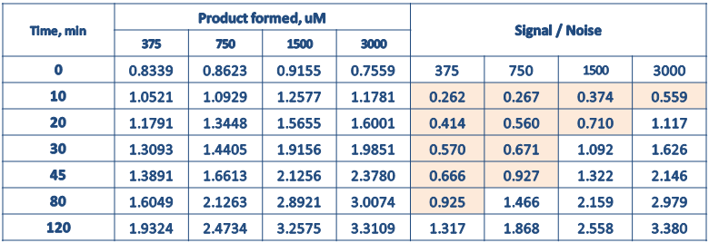

For 250uM FdL2 peptide, the background fluorescence (AMC leakage) was 0.8-0.9 uM. Therefore, the s/n for lower [NAD] at lower time points become poor. In other word, the conditions, in which uM product formed need to be greater than 1.2 – 1.35uM to get s/n >1.5, is the proper/reliable conditions. Two ways to resolve this problem:

1. Increase the enzyme concentration used
2. Increase the [NAD+]

**Q: What is detection limitation of HPLC method?**

**A:** Results from previous experiments PMC-XG1, 2, and 3 indicated that the uM product formed can go as low as 0.17 uM with good cv%. This creates a room for high [NAM] Expts.

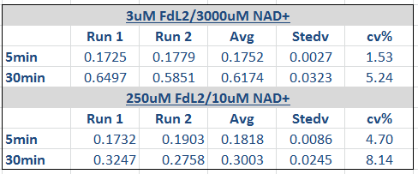

In-house Sirt3 was used in the above experiments.

**Q: Why 0, 10, 30, 45, 120min?**

**A:** The analysis of different combination of time points (3000uM different timepoint.ppt) indicated for high NAM/200HKL, the combination of 0, 30, 45, 120min was the closet to full time range. The addition of 10 min was to spot the curvature for those conditions.

**Q: Can Enzo Sirt3 be used for this experiment?**

**A:** XG Batch II is preferable to be used if we have enough enzyme.

**Q: Is the old HPLC still on working condition?**

**A:** Form 5.18.17, the test has being on. Old HPLC works fine.

**Q: Which method will be used for this experiment?**

**A:** HPLC method is recommended. Though HPLC takes longer time, as shown above, HPLC provide better range of product form which is suitable for high [NAM] experiments.

**FdL high NAM Expt. plan**

[FdL2 peptide]=250 uM

[NAD+] =obtain from Step I

[NAM]=0, 5000, 7000, 12000, 15000 uM

[HKL]=0, 200 uM

Time point=0, 10, 30, 45, 120min

* HPLC method

XG Batch II enzyme = 5U

Total reaction = 5*2*4=40 reactions

Total amount of enzyme needed = 200 U

Time needed= 7 days

* FdL kit-TeCan

XG Batch II enzyme = 10U

Total reaction = 5*2*4 = 40 reactions

Total amount of enzyme needed = 400 U

Time needed= 2 days

Please indicate which method should be used.

**Q & A:**

**Q: Enzo sirt3 or XG Batch II?**

**A:** The reason to use Enzo Sirt3 is to save XG Batch II for important experiments. If we have enough XG Batch II, XG Batch II will be used. Otherwise, Enzo Sirt3 will be used.

**Q: Which method will be used for this experiment?**

**A:** As mentioned above, HPLC takes longer time but save enzyme. HPLC provides better range of product form which is suitable for high [NAM] experiments. In other word, 10U enzyme is not required for HPLC method since s/n issue were only raised up in FdL kit-TeCan method due to the high background.

On another hand, FdL-kit-TeCan method takes 1/3 of the time that HPLC does. However, 2X amount of enzyme need to be used to improve s/n value.

If the old HPLC works well, HPLC method is preferable.

**Q: Do we have enough XG Batch II enzyme for all the planned experiments?**

**A:** We have enough XG Batch II for the currently planned experiments.

The planned experiments-Total amount of enzyme needed = 1075 U

1. FdL high NAD experiments

Total enzyme needed = 80 U

1. FdL high NAM experiments

Total enzyme needed = 200 U

1. OAADPr Expt.

Total reaction = 16

Total enzyme needed = 80 U

1. 2XE0 Expt.

Total reaction = 12

Total enzyme needed = 75 U

1. Repeat Sirt3.MnSOD.NAM.HKL experiments (4 time points no include 0min)

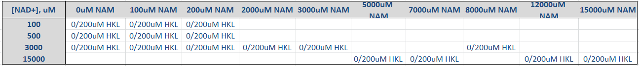

Total reaction = 16 * 4 *2 =128

Total enzyme needed = 640 U

The total XG Batch II available = (40 Tubes) *(50 ul/tube )* (0.6 U/ul)= 1200 U

Correction: The volume per tube is 50 ul instead of 25 ul.

**2xE0 Expt. plan**

[K122] = 600 uM

[NAD] = 3000 uM

[NAM]= 100 uM

[HKL]= 200 uM

[In-house Sirt3] = 5U and 10U, **XG Batch II**

Time points = 0, 10, 30, 40, 80, 120 min

Total Reaction = 3 x 4 = 12

Total amount of enzyme needed = 75U

* HPLC method: 2-3 days

**Q & A:**

**Q: Why 3000uM NAD+?**

**A:** Looking at the fitting below, four functions were used to fit the data (100uM NAM, 200uM HKL, 600uM MnSOD, 100/3000uM NAD+). It was noticed that the 10 min data point can’t fit well. Both 100, and 3000uM NAD+ at 10 min provide similar curvature.

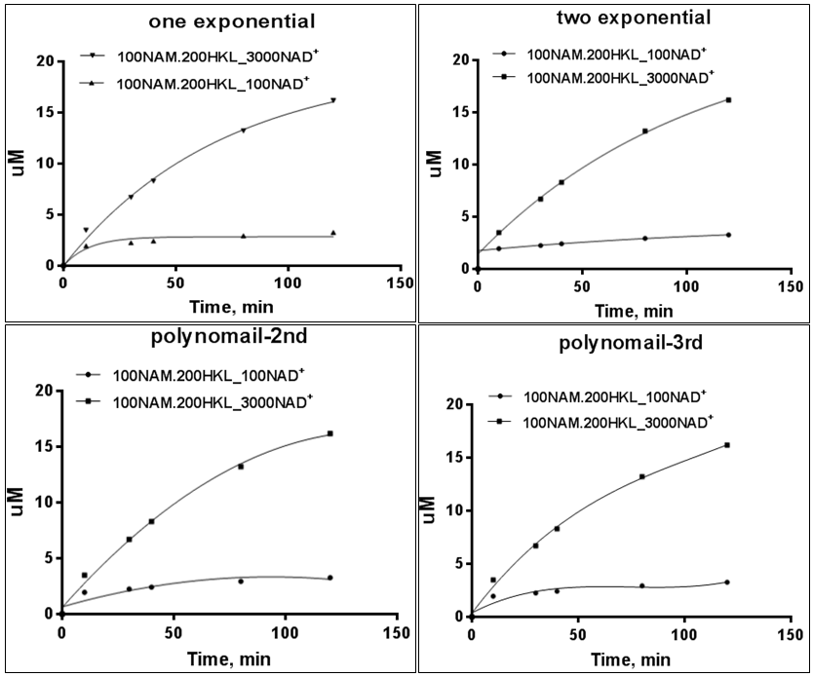

In terms of uM product formed,

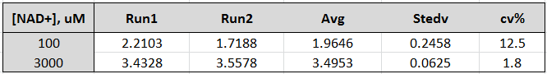

The cv% is much higher at 100uM NAD+.

**Q: How much Truncated Sirt3 is available in PMC-AT lab?**

**A:** Provide by Sudipto.

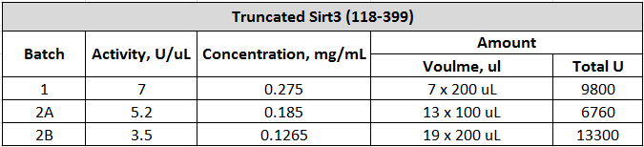

**Q: Is the Sirt3 sequence of published crystal structure the same as truncated sirt3 purified in PMC-AT lab?**

**A:** Yes. In Jin et al. JBC 2009 paper, crystal structure of Human Sirt3 (118-399) was reported. Truncated Sirt3 (118-399) purified in PMC-At lab has the same sequence.

**Q: Do we have enough Truncated Sirt3 enzyme for all the planned experiments?**

**A:** We have enough Truncated Sirt3 enzyme for all the planned experiments.

The current planned experiments are

1. Repeat Sirt3.MnSOD.NAM.HKL initial rate experiments with 4 time points (no 0min).
2. Repeat Sirt3. FdL. NAM.HKL high NAM experiments

Total amount of enzyme needed = 920 U

**Dose response Expt.-Step 2**

[MnSOD] = 600uM

[NAD+] = 100uM

[NAM] = 100uM

[HKL] = 50, 100, 200 uM

Time point = 0, 10 min

Duplicate

Total reaction = 8

* + HPLC method: 2 days

**Q & A**

**Q: Why 100uM NAM?**

**A:** In the presence of 200uM HKL, the addition of 100 and 200uM NAM further inhibit ~7.5 and 15% activity, respectively.

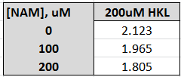

Dixon plot at 100uM NAD+ for Eq1. Fitting, [NAM] < 100uM, in the presence of 200uM HKL show activation compare to 0uM HKL.

