**OAADPr Expt. plan**

|  |  |  |  |  |  |
| --- | --- | --- | --- | --- | --- |
| **Expt. #** | **[MnSOD], uM** | **[NAD+], uM** | **[HKL], uM** | **[NAM], uM** | **[OAADPr], uM** |
| **1a** | 600 | 100 | 0 | 0 | 0 |
| **1b** | 0 | 0 | 2.5 |
| **2a** | 200 | 0 | 0 |
| **2b** | 200 | 0 | 2.5 |
| **3a** | 0 | 100 | 0 |
| **3b** | 0 | 100 | 2.5 |
| **4a** | 200 | 100 | 0 |
| **4b** | 200 | 100 | 2.5 |

Time point = 0, 10 min

In-house Sirt3 = 5U, **XG Batch II**

Total Reaction = 8

Total amount of enzyme needed=40U

* HPLC method: 1.5 days

**Q & A:**

**Q: Why 1, 2, 3, 4?**

**A:** 1: new batch (XG Batch II) control; 2, 3, 4: check OAADPr effect in the presence of NAM/HKL.

RC: Explain what will be achieved by the control. Isn’t 0 OAADPR for any given exptl pair a control for the purposes of this expt?

-You think product inhibition effects may not be revealed under one set of conditions of HKL and NAM with curvature, because it may be more difficult to detect inhibition effects in experiments with curvature? Or, do you want to present all the results in the paper to show that product inhibition doesn’t play a role in any case?

**XG:** MST results (2 run data) shown that

|  |  |  |  |
| --- | --- | --- | --- |
|  | **Sirt3** | **Sirt3+OAADPr+DeAc-MnSOD** | **Sirt3+OAADPr+DeAc-MnSOD+NAM** |
| **Target molecule** | OAADPr | Honokiol | Honokiol |
| **Kd, uM** | 105.8/88.3 | 0.352/0.226 | 0.059/0.054 |

1. OAADPr binds to Sirt3
2. With or without NAM, Kd_HKL changed. In another word, in the presence of NAM, or HKL, or NAM+HKL, OAADPr may have different binding event since HKL / NAM might occupy some binding spots.
3. At 100NAM/10 min, there is noise. It is important to have control for direct comparison.

RC: Which pair of expts is the highest priority given the goal discussed – showing whether product inhibition is responsible for observed curvature in an expt? Do this one first.

**XG:** The most curvature observed was under NAM+HKL in HPLC results. Therefore, Expt. 1 and 4 can be prioritized. For experiments 1 and 4 (total 4 reactions) will use 20 U. Since XG Batch II enzyme was aliquot into 50ul/tube (0.6U/ul), which was 30 U per tube. To avoid frozen/thaw cycle, I suggest to do the Expt. 2 (two reactions/ 10 U) at the same time. To save HPLC running time, we can run Expts. 1 and 4 samples and save Expt. 2 sample. In case we need to check Expt.2, we don’t need to run another set of experiment and open another aliquot of enzyme.

**Q: Why [OAADPr]=2.5 uM**

**A:** The uM product formed under current condition (Alok’s initial rate-SM Batch 3 enzyme) is listed as following:

|  |  |  |  |  |  |
| --- | --- | --- | --- | --- | --- |
| **Expt. #**  **SM Batch 3** | **[MnSOD], uM** | **[NAD+], uM** | **[HKL],**  **uM** | **[NAM],**  **uM** | **Product formed, uM**  **AU’s result** |
| **10min** |
| **1** | 600 | 100 | 0 | 0 | 3.982 |
| **2** | 200 | 0 | 2.123 |
| **3** | 0 | 100 | 2.142 |
| **4** | 200 | 100 | 1.965 |

The expected uM product formed using XG Batch II (based on R1/R2 experiments’ results) will be half amount of the current value.

|  |  |
| --- | --- |
| **Batch# (500uM NAD+, 0uM NAM/ 0uM HKL)** | **Product formed in 10 min, uM** |
| Alok initial rate | 7.1050 |
| XG-Batch II | 3.6093 |

Therefore, 2.5 uM of OAADPr will be suitable value to use for this set of experiments.

RC: Explain why specifically 2.5uM. Give more detail on why you chose the amount formed at 10 mins as the reference point. Is it because if you add more, then this would not be an accurate rep of product in effect occurring at 10 min, where you start to see curvature?

If you added more OAADPR (e.g., same amount formed at 30 or 40 mins) and saw no effect, would that be a more conclusive demonstration that product inhibition is not occurring? In this case, you would say that there was no effect over e.g. 0-40 mins even though the final amount formed was present from the start. It may be ok to do it either way (esp since the amount of product formation may not be very different) -- just requesting clarification. I’d like a detailed statement of what the conclusions would be from the possible results of the expt. Make sure whatever value of OAADPR you choose is a good choice for the priority exptl pair I asked about above.

**XG:** Please see the flow chart below:

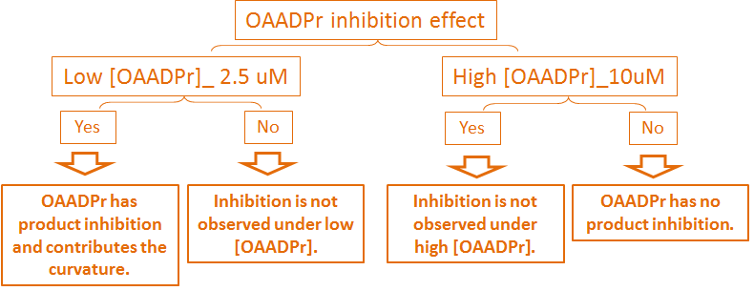

At [OAADPr] = 2.5uM, we can find out if low [OAADPr] has product inhibition effect and if it contributes to curvature. If we only want to find out these, the priority expt are enough. However, if inhibition is not observed at 2.5 uM, we can’t conclude that OAADPr has no product inhibition effect. We need to go higher for the conclusive remark. Therefore, if we want to find out the OAADPr inhibition , we should choose higher [OAADPr] for longer time point to

1. Reduce the error (noise)
2. Draw an conclusion that OAADPr has or has not product inhibition.

**Q: Why 10 min?**

**A:** It was planned for 10, 30 min. However, for the first glance, 10 min is OK.

RC: You need to explain why even 10, 30 is enough to detect curvature or product inhibition effect on rate. First glance is not what I meant. I meant that the preliminary expts should establish whether product is having an effect (specifically, on the estimated rates) and if not we need not do more expts. You are saying any reduction in activity at 10 mins is product inhibition. May be true, but the data is noisy and do we want to be able to compare the initial rates? If so should we not include more time points (enough to get rate) for the priority pair of expts, and fewer “expt #s” above?

XG: The existing results shown only 10 min time point does not fit well for most of the curve fitting functions. The original plan suggested doing 10 and 30 min timepoints, which would cover the curvature region. The preliminary expts should establish **(A) whether product has an effect and whether it contributes the curvature**. Therefore, lower time point is needed. If we only want to know **(B) if OAACPr has product inhibition effect**, higher [OAADPr] and longer time point are recommended.

If an effect is observed, we could then consider further expts from the table above (though those expts would not be critical, since our goal is not to characterize product inhibition for every condition). Provide your comments and finalize the plan without need for further input from RC.

**XG: Please confirm what your interest is (A) or (B).**

**FdL high NAD Expt. plan**

[FdL2 peptide]=250 uM

[NAD+] = 10000, 12500, 15000, 20000 uM (10XKm~950)

[NAM]=0 uM

[HKL]=0 uM

Time point=0, 10, 30, 45, 120min

In-house Sirt3 = 5U, **XG Batch II**

Total reaction = 4*4=16 reactions

Total amount of enzyme needed=80U

* HPLC method: 4 days
* FdL kit-TeCan: 1 day

Please indicate which method should be used.

RC: HPLC is ok since you prefer It and gave reasons for the preference. However, do reply to questions below. When you refer to HPLC, I assume you mean with AMC labeled substrate? I don’t recall if we used unlabeled FdL2 substrate with HPLC in the past. AMC is required here for consistency.

**XG:** Yes. AMC is required for consistency. When I refer to HPLC, AMC labeled FdL2 will be used in the reaction.

**Q & A:**

**Q: What is the s/n for data obtained using FdL kit –TeCan?**

**A:** With 25uM NAM, 200uM HKL, the uM product formed is listed as following.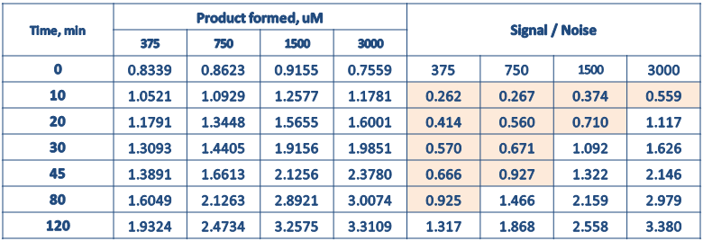

For 250uM FdL2 peptide, the background fluorescence (AMC leakage) was 0.8-0.9 uM. Therefore, the s/n for lower [NAD] at lower time points become poor. In other word, the conditions, in which uM product formed need to be greater than 1.2 – 1.35uM to get s/n >1.5, is the proper/reliable conditions. Two ways to resolve this problem:

1. Increase the enzyme concentration used

RC: I assume 10U would be enough.

1. Increase the [NAD+]

RC: I assume you are saying the s/n will be <1.5 for the amount of product formation predicted by the model under the high NAM conditions planned below. This is the critical issue. You did not explicitly mention that here, though perhaps it was part of your previous ppt.

It sounds like you are saying this was already an issue for the low NAM expts. If so, do you anticipate the problem to be more severe for high NAM experiments? If not, why are you only raising the issue now?

**XG:** Due to the high background, s/n issue raised up under low NAD. When NAD concentration increased from 3000 to 15000uM, the signal should increase at constant background (250uM FdL no change). Then high NAM experiments become possible. For how much s/n can be improved, need to wait the results from high NAD experiments.

**Q: What is detection limitation of HPLC method?**

**A:** Results from previous experiments PMC-XG1, 2, and 3 indicated that the uM product formed can go as low as 0.17 uM with good cv%. This creates a room for high [NAM] Expts.

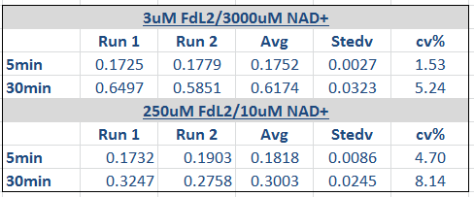

In-house Sirt3 was used in the above experiments.

RC: In PMC XG-1,2,3 was there ever a direct comparison done between HPLC and FdL readout for the same experiments? I assume it would not be convenient to do a direct comparison between the results for just one of the [NAD] above?

**XG:** The aim of XG1.2.3 was to find out the HAPC detect limitation. Yes. It was not convenient to do a direct comparison between the results for just one [NAD] above. For example, at 10 uM NAD + 250uM FdL2, the product formed should be ~ 0.2 uM, which is way lower than the background ~0.8 uM. It will be not detected by TeCan.

**Q: Why 0, 10, 30, 45, 120min?**

**A:** The analysis of different combination of time points (3000uM different timepoint.ppt) indicated for high NAM/200HKL, the combination of 0, 30, 45, 120min was the closet to full time range. The addition of 10 min was to spot the curvature for those conditions.

RC: Just to confirm, you never found under any conditions tested for FdL that 10 mins was needed, correct?

**XG:** I never found under any conditions tested for FdL that 10 mins was needed. Because the 10 min data points does not fit well in any function, the full time range fitting normally ignore the 10 min data point (The fitting curves do not pass 10 min data point). Therefore the combination of less time point including 10 min data point, is always not close to the full time range.

**Q: Can Enzo Sirt3 be used for this experiment?**

**A:** XG Batch II is preferable to be used if we have enough enzyme.

**Q: Is the old HPLC still on working condition?**

**A:** Form 5.18.17, the test has being on. Old HPLC works fine.

**Q: Which method will be used for this experiment?**

**A:** HPLC method is recommended. Though HPLC takes longer time, as shown above, HPLC provide better range of product form which is suitable for high [NAM] experiments.

**FdL high NAM Expt. plan**

[FdL2 peptide]=250 uM

[NAD+] =obtain from Step I

[NAM]=0, 5000, 7000, 12000, 15000 uM

[HKL]=0, 200 uM

Time point=0, 10, 30, 45, 120min

* HPLC method

XG Batch II enzyme = 5U

Total reaction = 5*2*4=40 reactions

Total amount of enzyme needed = 200 U

Time needed= 7 days

* FdL kit-TeCan

XG Batch II enzyme = 10U

Total reaction = 5*2*4 = 40 reactions

Total amount of enzyme needed = 400 U

Time needed= 2 days

Please indicate which method should be used.

RC: HPLC is ok. Compare to model prediction after doing the first [NAM] expt above.

As noted, you will be responsible for making sure we can get K1 from these expts, and you should bear in mind throughout the expts that if that is not possible, the time committed to the expts will not be useful.

**Q & A:**

**Q: Enzo sirt3 or XG Batch II?**

**A:** The reason to use Enzo Sirt3 is to save XG Batch II for important experiments. If we have enough XG Batch II, XG Batch II will be used. Otherwise, Enzo Sirt3 will be used.

**Q: Which method will be used for this experiment?**

**A:** As mentioned above, HPLC takes longer time but save enzyme. HPLC provides better range of product form which is suitable for high [NAM] experiments. In other word, 10U enzyme is not required for HPLC method since s/n issue were only raised up in FdL kit-TeCan method due to the high background.

RC: Ok, this is a reasonable point.

On another hand, FdL-kit-TeCan method takes 1/3 of the time that HPLC does. However, 2X amount of enzyme need to be used to improve s/n value.

RC: If any issues of consistency between FdL and HPLC results arise, we should revert to FdL with more enzyme (I assume 10U is predicted to be enough, that could then be validated through a single time pt measurement under one of the high NAM conditions). We can also consider its use in future experiments for higher throughput.

If the old HPLC works well, HPLC method is preferable.

**Q: Do we have enough XG Batch II enzyme for all the planned experiments?**

**A:** We have enough XG Batch II for the currently planned experiments.

The planned experiments-Total amount of enzyme needed = 1075 U

1. FdL high NAD experiments

Total enzyme needed = 80 U

1. FdL high NAM experiments

Total enzyme needed = 200 U

1. OAADPr Expt.

Total reaction = 16

Total enzyme needed = 80 U

1. 2XE0 Expt.

Total reaction = 12

Total enzyme needed = 75 U

1. Repeat Sirt3.MnSOD.NAM.HKL experiments (4 time points no include 0min)

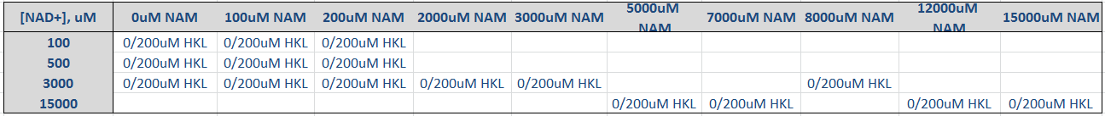

Total reaction = 16 * 4 *2 =128

Total enzyme needed = 640 U

The total XG Batch II available = (40 Tubes) *(50 ul/tube )* (0.6 U/ul)= 1200 U

Correction: The volume per tube is 50 ul instead of 25 ul.

**2xE0 Expt. plan**

[K122] = 600 uM

[NAD] = 3000 uM

[NAM]= 100 uM

[HKL]= 200 uM

[In-house Sirt3] = 5U and 10U, **XG Batch II**

Time points = 0, 10, 30, 40, 80, 120 min

Total Reaction = 3 x 4 = 12

Total amount of enzyme needed = 75U

* HPLC method: 2-3 days

**Q & A:**

**Q: Why 3000uM NAD+?**

**A:** Looking at the fitting below, four functions were used to fit the data (100uM NAM, 200uM HKL, 600uM MnSOD, 100/3000uM NAD+). It was noticed that the 10 min data point can’t fit well. Both 100, and 3000uM NAD+ at 10 min provide similar curvature.

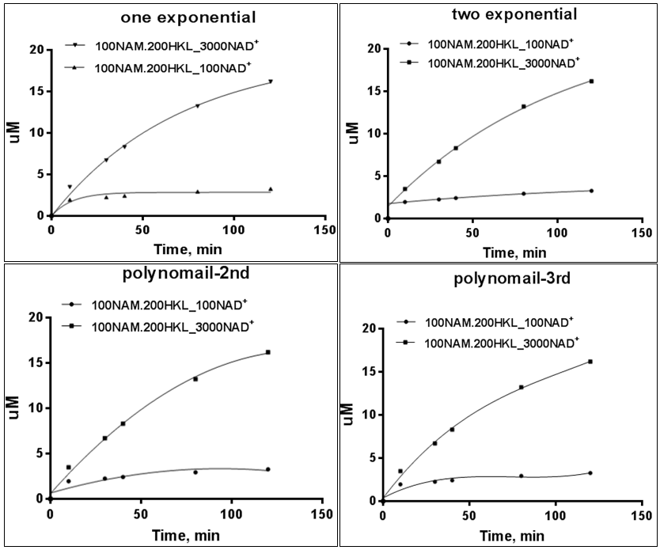

In terms of uM product formed,

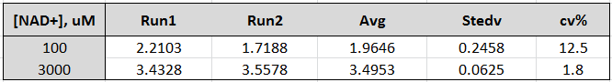

The cv% is much higher at 100uM NAD+.

RC: Remember the main point is not whether the 10 min time point fits well – it is whether the initial rate calculations differ sufficiently, because that is what will allow us to choose one time series fitting method over another. As I recall at 3000 NAD/100 NAM/200 HKL there is very little difference in the initial rates between the various time series functions. If I am right about this, it is not the right choice of condition. Rather, you would then need to find a condition (e.g., 100 NAD/200 NAM/0 HKL or 500/100/200 – you need to find a suitable one) where the initial rates differ sufficiently and the cv’s are not too high. 100/100/200 may have a large difference in initial rates between different fitting functions, but if you think the noise is too high it is fine to choose another where the initial rates differ sufficiently.

**XG:** Based on the calculation below, 100uM NAD/200uM NAM/0uM HKL provides the most significate difference. This combination will be used for the 2XE0 experiments.

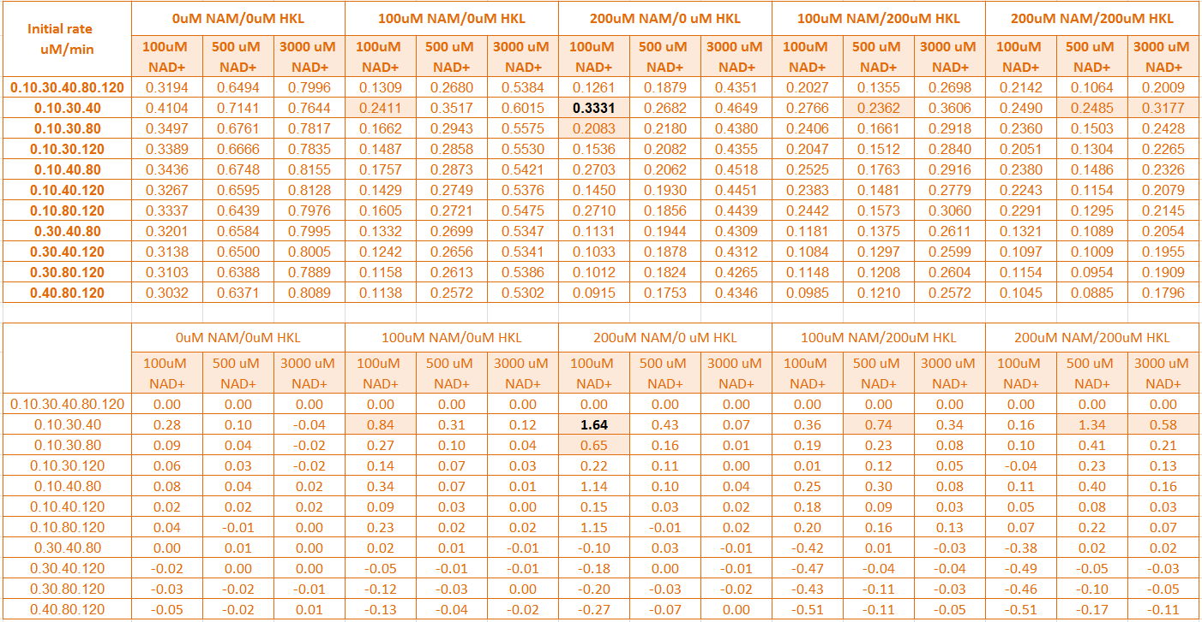

RC: One remaining question regarding choice of times: please confirm that 5 mins has never been used by you in initial rate studies.

**XG:** No. 5 min has never been used for initial rate studies.

**Q: How much Truncated Sirt3 is available in PMC-AT lab?**

**A:** Provide by Sudipto.

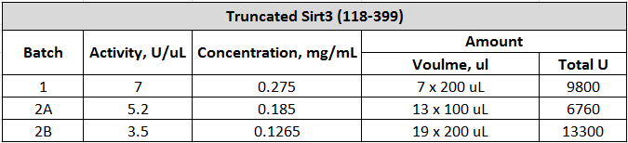

RC: AU and SM posted a SOP for batch characterization. Have the above been characterized in terms of Km? If not, make sure we do need to use more than one batch above for planned expts, or consider characterizing and combining some of the batches if they are sufficiently close in Km.

However, it appears we have far more than enough in each batch above; as we discussed, T-SIRT3 yields of active protein appear much higher and should help resolve resource issues in future work.

**XG:** Will double check with Sudipto for the status listed enzyme (Km, Vmax).

**Q: Is the Sirt3 sequence of published crystal structure the same as truncated sirt3 purified in PMC-AT lab?**

**A:** Yes. In Jin et al. JBC 2009 paper, crystal structure of Human Sirt3 (118-399) was reported. Truncated Sirt3 (118-399) purified in PMC-At lab has the same sequence.

**Q: Do we have enough Truncated Sirt3 enzyme for all the planned experiments?**

**A:** We have enough Truncated Sirt3 enzyme for all the planned experiments.

The current planned experiments are

1. Repeat Sirt3.MnSOD.NAM.HKL initial rate experiments with 4 time points (no 0min).

Total amount of enzyme needed = 920 U

RC: Ok. (2) above is not part of plan.

Let me know roughly how long you anticipate (1) and Repeat Sirt3.MnSOD.NAM.HKL experiments (4 time points no include 0min) would take if AU and SM worked on them, respectively, in parallel. (1) will start with repeating the high NAM expts with 10 min time pt, as discussed. More details on this plan will be provided shortly.

**XG: 4 time points no 0min.**

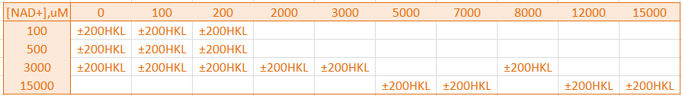

1. XGBatchII-Sirt3-MnSOD-NAM-HKL (high NAM experiments with 10 min time point)
2. Truncated Sirt3-MnSOD-NAM-HKL.

AU and SM can split the work and do (a) and (b) in parallel:

a: AU

b: SM

Each of them has total 128 reactions and takes 21 days for using one HPLC for one person.

Total 21 days all the experiments will be finished at the same time.

If AU and SM work on (a) together using 2 HPLC first then (b), then the 11 days to finish (a) and another 11 days to finish (b). Total 22 days for the accomplishment of the aforementioned experiments.

**Dose response Expt.-Step 2**

[MnSOD] = 600uM

[NAD+] = 100uM

[NAM] = 100uM

[HKL] = 50, 100, 200 uM

Time point = 0, 10 min

Duplicate

Total reaction = 8

* + HPLC method: 2 days

**Q & A**

**Q: Why 100uM NAM?**

**A:** In the presence of 200uM HKL, the addition of 100 and 200uM NAM further inhibit ~7.5 and 15% activity, respectively.

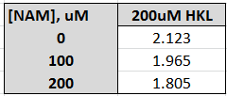

Dixon plot at 100uM NAD+ for Eq1. Fitting, [NAM] < 100uM, in the presence of 200uM HKL show activation compare to 0uM HKL.

RC: I agree. Please confirm that 100uM NAD rather than 50uM NAD is the best choice of NAD considering s/n and consistency in presentation (the previous values used). Consider how results from dose response curves will be presented in paper.

**XG:** The data presented below was done at 0uM NAM + 200uM HKL. At 50uM NAD+, the cv% was good. However, if we add 100uM NAM as for dose response experiments, the uM product formed will go lower. To be on safe side, 75 uM NAD+ will be the lowest we can go.

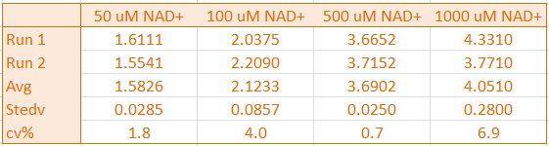

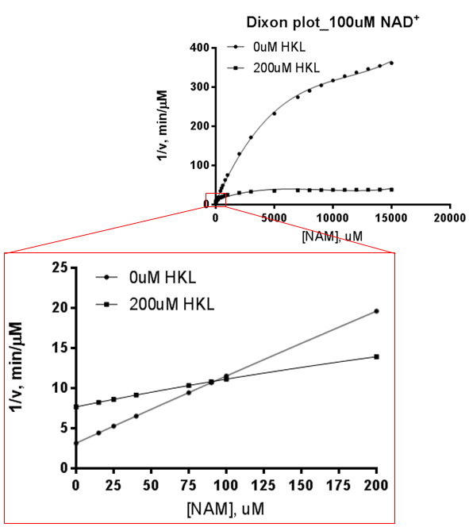

RC: As I believe you mentioned before, AU and SM can complete work on OAADPR, 2xE0 and dose response (plan for remaining initial rate expts with urea and T-SIRT3 will be finalized thereafter). 2xE0 and dose response were in previous schedule, OAADPR is new. Any order of those expts is ok (the order you listed above is fine), and they can work on diff expts in parallel if desired (both don’t need to work on the same expts). XG can work on high NAM FdL expts.

**XG:** The updated plan is listed below

|  |  |  |
| --- | --- | --- |
| **Currently Planned Experiments** | **Time needed** | **Scientists** |
| **OAADPr Expt.**  (1a) 600uM MnSOD, 100uM NAD+, 0 uM HKL, 0uM NAM, 0uM OAADPr  (1b) 600uM MnSOD, 100uM NAD+, 0 uM HKL, 0uM NAM, 2.5uM OAADPr  (4a) 600uM MnSOD, 100uM NAD+, 200 uM HKL, 100uM NAM, 0uM OAADPr  (4b) 600uM MnSOD, 100uM NAD+, 200 uM HKL, 100uM NAM, 2.5uM OAADPr  (2a) 600uM MnSOD, 100uM NAD+, 200 uM HKL, 0uM NAM, 0uM OAADPr  (2b) 600uM MnSOD, 100uM NAD+, 200 uM HKL, 0uM NAM, 2.5uM OAADPr  Time point = 0, 10, 30 min  In-house Sirt3 = 5U, **XG Batch II**  **Note: RC please confirm that low [OAADPr] is our current interest.** | 2 days | AU and SM  2 HPLC |
| **2xE0 Expt.**  [K122] = 600 uM  [NAD] = 100 uM  [NAM]= 200 uM  [HKL]= 0 uM  Time points = 0, 10, 30, 40, 80, 120 min  [In-house Sirt3] = 5U and 10U, **XG Batch II**  **Note: 100uM NAD/200uM NAM/0uM HKL will be used for this experiments** | 3 days | AU and SM  2 HPLC |
| **Dose response Expt.-Step 2**  [MnSOD] = 600uM  [NAD+] = 75uM  [NAM] = 100uM  [HKL] = 50, 100, 200 uM  Time point = 0, 10 min  [In-house Sirt3] = 5U, **XG Batch II**  Duplicate  **Note: 75uM is going to use in the experiments.** | 2 days | AU and SM  2 HPLC |
| **FdL high NAD Expt.**  [FdL2 peptide]=250 uM  [NAD+] = 10000, 12500, 15000, 20000 uM (10XKm~950)  [NAM]=0 uM  [HKL]=0 uM  Time point=0, 10, 30, 45, 120min  In-house Sirt3 = 5U, **XG Batch II** | 4 days | XG  Old HPLC |
| **FdL high NAM Expt.**  [FdL2 peptide]=250 uM  [NAD+] =obtain from Step I  [NAM]=0, 5000, 7000, 12000, 15000 uM  [HKL]=0, 200 uM  Time point=0, 10, 30, 45, 120min | 7 days | XG  Old HPLC |
| **AE-Sirt3.MnSOD.NAM.HKL****-4 time point (no 0min)**  Start with high NAM, 10 min time point. | 21 days | AU  One HPLC |
| **Truncated Sirt3.MnSOD.NAM.HKL-4 time point (no 0min)** | 21 days | SM  One HPLC |

XG will also continue the fittings and simulations aimed at finalizing plan for the remaining initial rate expts – RC will advise shortly on that. She may also work on pending paper figures (Praba may also assist w that if needed).

When you listed the required times for OAADPR, 2xE) and dose response expts above, did you assume 1 or 2 people were working on the expts? How much speedup is possible with 2 vs 1? Just want to make sure one person is not sitting idle/not useful.

**XG:** The days listed is for both of them work together. For the consistency, AU does all the reactions and SM helps running the HPLC. For the repeat Sirt.MnSOD.NAM.HKL experiments, they can work on their own as mentioned before.

If time remains for AU/SM they should work on planning the Dropix experiments for purpose of demo using the assays we discussed. They can also be involved in direct communication with Dolomite if needed. They should touch base with Praba about this this week.