Inhibition mechanism of known sirtuin inhibitors:

Currently, inhibition mechanism is studied mainly through crystallographic approach and/or kinetic method. The following summarize inhibitors based on their inhibition mechanisms.

1. Inhibition by competing with (displacing) NAD+:

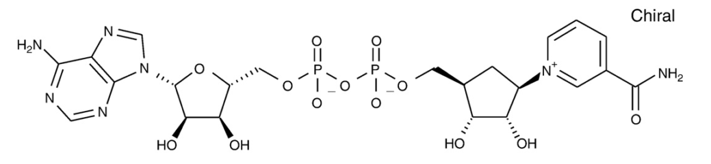Carbamido-NAD works this way. [1] And Carbo-NAD is found to co-crystalize with peptide substrate and SIRT3 (4FVT).

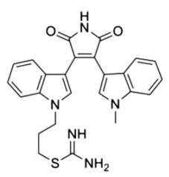Kinase inhibitors generally act through blockage of the adenosine binding region of ATP binding sites by chemically mimicking adenosine or adenine. For example, this molecule (below) is found to be competitive with NAD+. [2]

Inhibitors in this mode can place acetylate peptide in its binding site to harvest the stabilization due to its binding, and/or its interaction with inhibitor.

[1] J. Landry, J.T. Slama, R. Sternglanz, Role of NAD+in the deacetylase activity of the SIR2-like proteins, Biochem. Biophys. Res. Commun. 278 (3) (2000) 685–690.

[2] J. Trapp, A. Jochum, R. Meier, L. Saunders, B. Marshall, C. Kunick, E. Verdin, P. Goekjian, W. Sippl, M. Jung, Adenosine mimetics as inhibitors of NAD+- dependent histone deacetylases, from kinase to sirtuin inhibition, J. Med. Chem. 49 (2006) 7307–7316.

1. Inhibition by competing with (displacing) acetylated peptide substrate:

Cambinol is competitive with acetylated peptide but not NAD+. [3]

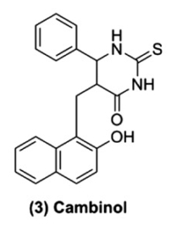

Thioacetyllysine peptides also belong to the same category. [4]

ELT inhibitors [5] (left below) bound to C pocket and peptide binding pocket as found in the crystal structures (4JSR, 4JT8, 4JT9). It is not known if it competes with NAD+ or not.

And anilinobezamide (middle below) is found to be competitive with peptide substrate as well [6].

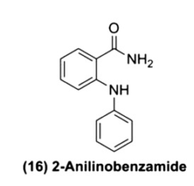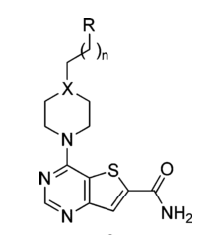

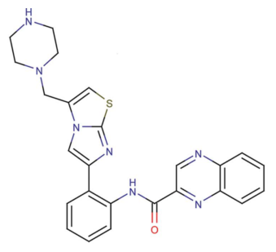

SRT1720 (right above) is reported SIRT1 activator, but found to inhibit SIRT3 in a competitive mode with acetylated peptide.[7] Crystal structure reveals that it partially occupies the acetyl-Lys binding site while binds together with NAD+. (4BN5)

[3] B. Heltweg, T. Gatbonton, A.D. Schuler, J. Posakony, H. Li, S. Goehle, R. Kollipara, R.A. Depinho, Y. Gu, J.A. Simon, A. Bedalov, Antitumor activity of a small- molecule inhibitor of human silent information regulator 2 enzymes, Cancer. Res. 66 (2006) 4368–4377.

[4] B.C. Smith, J.M. Denu, Mechanism-based inhibition of Sir2 deacetylases by thioacetyl-lysine peptide, Biochemistry 46 (2007) 14478–14486.

[5) Disch, J. S. *et al.* Discovery of thieno[3,2-d]pyrimidine-6-carboxamides as potent inhibitors of SIRT1, SIRT2, and SIRT3. *J. Med. Chem.* **56,** 3666–79 (2013)

[6] T. Suzuki, K. Imai, H. Nakagawa, N. Miyata, 2-Anilinobenzamides as SIRT inhibitors, ChemMedChem 1 (2006) 1059–1062

[7] Nguyen, G. & Schaefer, S. Structures of human sirtuin 3 complexes with ADP-ribose and with carba-NAD+ and SRT1720: binding details and inhibition mechanism. Acta Crystallogr. Sect. D Biol. Crystallogr. 69, 1423–32 (2013)

1. Noncompetitive or mixed inhibition with both NAD+ and acetylated peptide substrate:

Noncompetitive or mixed inhibition suggested that substrates can still bind to the enzyme but with modified binding affinity upon inhibitor binding (probably as a different binding mode.)

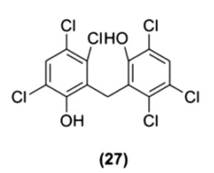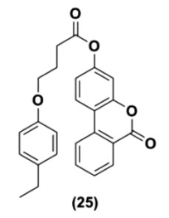

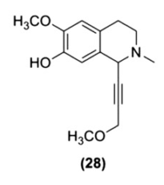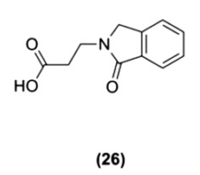

Molecule (25)-(27) is noncompetitive inhibitors to NAD+ and (28) is in mixed inhibition mode to NAD+. [8]

Molecule (26) and (28) noncompetitively inhibit acetylated peptide, (25) is a partially noncompetitive inhibitor, (27) is mixed inhibitor vs. acetylated peptide.

There is no structural information on how they bind with ternary structural. It is possible we can dock in sequential order of inhibitor, NAD+ and acetylated peptide to understand the inhibition mechanism.

[8] Sanders, B. D. et al. Identification and characterization of novel sirtuin inhibitor scaffolds. Bioorg. Med. Chem. 17, 7031–41 (2009)

1. Enhanced inhibition with co-factor: Ex-527

Ex-527 is a special case, but can also lead to a whole new class of inhibitors.

Ex-527 doesn’t bind strongly to enzyme by itself (as suggested by microscale thermophoresis), but binds much stronger together with NAD+. It also show noncompetitive behavior for acetylated peptide, but is uncompetitive to NAD+, indicating NAD+ assisted inhibition. (This mode can be explored to find new inhibitors, and may be the inhibition mechanism for some inhibitors.)

Ex-527 doesn’t block the reaction from the beginning. It was found that reaction stops once the co-product 2’-O-acetyl-ADP ribose is formed. It is suggested that 2’-OAADPR and Ex-527 work together as a strong inhibitor. [9]

Ex-527 bound together with NAD+ in SIRT1 (4I5I) and it occupied the C-pocket while nicotinamide moiety of NAD+ occupied a different pocket (not B). [10]

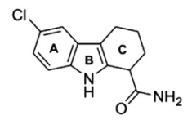

[9] Gertz, M. & Fischer, F. Ex-527 inhibits Sirtuins by exploiting their unique NAD+-dependent deacetylation mechanism. Proc. Natl. Acad. Sci. U. S. A. 110, E2772–81 (2013)

[10] Zhao, X., Allison, D. & Condon, B. The 2.5 Å crystal structure of the SIRT1 catalytic domain bound to nicotinamide adenine dinucleotide (NAD+) and an indole (EX527 analogue) reveals a novel mechanism. J. Med. Chem. 56, 963–969 (2013)

1. Inhibitor for base-exchange reaction.

Nicotinamide inhibits deacetylation reaction mainly through reverse the first step in the reaction through base-exchange reaction. Iso-nicotinamide is found to relief such inhibition at high concentration. More inhibitors/activators can be discovered by targeting this binding mode.

1. In the crystal structures of SIRT3/peptide/piceatannol (4HD8) and SIRT5/peptide/resveratrol (4HDA), these molecules are found to cover the pepide binding pocket and may act by affecting the details of peptide binding. The ligand binding outside the regular binding pockets are certainly something not explored. [11]
2. There are also some inhibitors studied by computational approach only, (docking and simulation), i.e.splitomicin derivatives. [12] These studies investigated mainly the binding mode of the inhibitors and relate the binding affinity to the inhibition potency.

[11] Gertz, M., Nguyen, G. & Fischer, F. A molecular mechanism for direct sirtuin activation by resveratrol. PLoS One 7, e49761 (2012)

[12] Neugebauer, R. C. et al. Structure-activity studies on splitomicin derivatives as sirtuin inhibitors and computational prediction of binding mode. J. Med. Chem. 51, 1203–13 (2008)