Inhibition mechanism of known sirtuin inhibitors:

Currently, inhibition mechanism is studied mainly through crystallographic approach and/or kinetic method. The following summarize inhibitors based on their inhibition mechanisms.

1. Inhibition by competing with (displacing) NAD+:

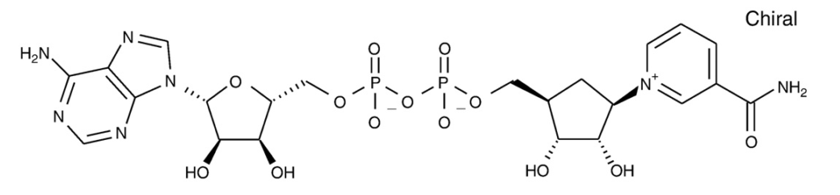Carbamido-NAD works this way. [1] And Carbo-NAD is found to co-crystalize with peptide substrate and SIRT3 (4FVT).

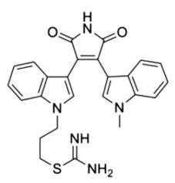Kinase inhibitors generally act through blockage of the adenosine binding region of ATP binding sites by chemically mimicking adenosine or adenine. For example, this molecule (below) is found to be competitive with NAD+. [2]

Inhibitors in this mode can place acetylate peptide in its binding site to harvest the stabilization due to its binding, and/or its interaction with inhibitor.

[1] J. Landry, J.T. Slama, R. Sternglanz, Role of NAD+in the deacetylase activity of the SIR2-like proteins, Biochem. Biophys. Res. Commun. 278 (3) (2000) 685–690.

[2] J. Trapp, A. Jochum, R. Meier, L. Saunders, B. Marshall, C. Kunick, E. Verdin, P. Goekjian, W. Sippl, M. Jung, Adenosine mimetics as inhibitors of NAD+- dependent histone deacetylases, from kinase to sirtuin inhibition, J. Med. Chem. 49 (2006) 7307–7316.

1. Inhibition by competing with (displacing) acetylated peptide substrate:

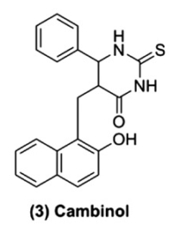Cambinol is competitive with acetylated peptide but not NAD+. [3]

Thioacetyllysine peptides also belong to the same category. [4]

ELT inhibitors [5] (left below) bound to C pocket and peptide binding pocket as found in the crystal structures (4JSR, 4JT8, 4JT9). It is not known if it competes with NAD+ or not.

And anilinobezamide (right below) is found to be competitive with peptide substrate as well [6].

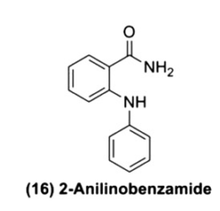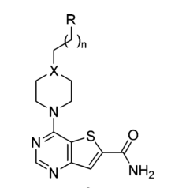

[3] B. Heltweg, T. Gatbonton, A.D. Schuler, J. Posakony, H. Li, S. Goehle, R. Kollipara, R.A. Depinho, Y. Gu, J.A. Simon, A. Bedalov, Antitumor activity of a small- molecule inhibitor of human silent information regulator 2 enzymes, Cancer. Res. 66 (2006) 4368–4377.

[4] B.C. Smith, J.M. Denu, Mechanism-based inhibition of Sir2 deacetylases by thioacetyl-lysine peptide, Biochemistry 46 (2007) 14478–14486.

[5) Disch, J. S. *et al.* Discovery of thieno[3,2-d]pyrimidine-6-carboxamides as potent inhibitors of SIRT1, SIRT2, and SIRT3. *J. Med. Chem.* **56,** 3666–79 (2013)

[6] T. Suzuki, K. Imai, H. Nakagawa, N. Miyata, 2-Anilinobenzamides as SIRT inhibitors, ChemMedChem 1 (2006) 1059–1062