Overview
Microscale thermophoresis (MST) is an emerging technique that has been broadly applied to investigate biomolecular interaction of a variety of drug targets. MST detects the directed movement of fluorescent molecules in microscopic temperature gradients in microliter-volume capillaries to quantify interaction affinities. Each molecule has distinct thermophoretic properties, which are determined by its size, charge, and hydration shell. Binding of ligands typically change at least one of these parameters, resulting in changes in the thermophoretic movement of the molecule. The change in thermophoresis can be used to derive dissociation constants (K_{d}) within minutes by sequentially scanning capillaries with varying ligand concentrations. MST has been shown to be well suited to detect binding of small molecules, fragments, or even ions to biomolecules. Moreover, since movement of fluorescent molecules through detection volume is monitored over time, additional information about protein aggregation and denaturation can be derived from the shape of MST traces.

The MST instrument
The experimental setup consists of an infrared (IR)-Laser coupled into the path of fluorescence excitation/emission using an IR dichroic mirror (Fig. 1A and 1B). The IR-Laser is focused into the sample through the same optics that is used for fluorescence detection. This setup allows for the mechanically robust and thus very precise observation of thermophoresis, since IR and visible optics are well aligned. IR-Laser induced heating is one of the prerequisites for a successful MST analysis, since it has various advantages over conventional contact heating. The IR-Laser can be focused into the sample. This allows for a localized temperature increase on the order of a few hundred micrometers. The microscopic scale of the temperature distribution is essential for fast MST analysis. The motion of molecules is essentially diffusion limited and restricting the temperature distribution to the mm scale enables one to quantify changes in thermophoretic properties in < 30 s. For this work, the spatial temperature distribution and the timescales of sample heating and thermophoresis were simulated by a three-dimensional finite element calculation using Comsol Multiphysics (Fig. 1C and 1D). It shows the dominant physical effects in an MST experiment for a molecule with diffusion coefficient of D = 150 mm2/s and a thermophoretic mobility of DT = 5.6 mm2/(sK). After this fast increase in temperature (MST temperature jump or MST T-Jump), thermophoresis sets in and builds up a concentration gradient in the solution.

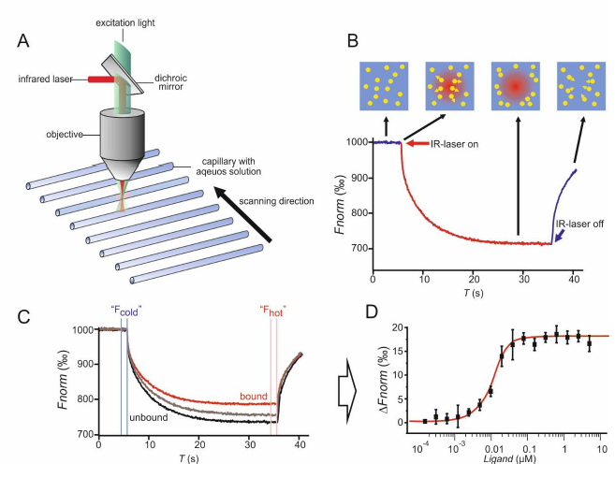
Figure1 (A) Schematic representation of MST instrumentation. MST is measured in capillaries with a total volume of 10 μL. The fluorescence within the capillary is excited and detected through the same objective, and coupled with an IR-Laser to locally heat a defined sample volume. Thermophoresis of fluorescent molecules through the temperature gradient is detected over time. (B) Schematic MST trace. Prior to IR laser activation, fluorescent molecules are homogeneously distributed and a constant initial fluorescence is detected. Within the first second after activation of the IR laser, the “MST T-Jump” is observed, followed by a slower thermophoretic redistribution of the fluorescent labeled molecules. The thermophoretic movement is detected for a defined time period. Deactivation of the IRAn Automated Microscale Thermophoresis Screening Approach for Fragment-Based Lead Discovery 5 Laser leads to backdiffusion of molecules, which is solely driven by mass diffusion. MST, MicroScale Thermophoresis; IR, infra-red; T-Jump, temperature jump. (C) Typical MST binding experiment. The thermos-phoretic movement of a fluorescent molecule (black trace; “unbound”) changes upon binding to a non-fluorescent ligand (red trace; “bound”). (D) For analysis, the change in thermophoresis is expressed as the change in the normalized fluorescence (ΔFnorm), which is defined as Fhot/Fcold (F-values correspond to average fluorescence values between defined areas marked by the red and blue cursors, respectively). Titration of the non-fluorescent ligand results in a gradual change in thermophoresis, which is plotted as ΔFnorm versus ligand concentration to yield a binding curve which can be fitted to derive binding constants.

THEORETICAL BACKGROUND OF THERMOPHORESIS
A temperature gradient in an aqueous solution of (bio-) molecules induces not only a flow of heat but also a flow of molecules. This coupling between a heat-flow and mass flow is known as Ludwig-Soret effect or thermophoresis. It was first observed by Carl Ludwig in 1856. While thermophoresis in gases was theoretically predicted before it was experimentally observed, the origin of thermophoresis in liquids remained obscure. The first systematic studies of thermophoresis of salts in aqueous solution were carried out in 1879. Today, it is commonly argued that thermophoresis is a local nonequilibrium effect that requires fluid dynamics, force fields, or particle–solvent potentials. Other approaches assume molecules in a local thermodynamic equilibrium and apply equilibrium thermodynamics to describe thermophoresis in liquids. Most approaches have in common that the solvent particle interface and particle charges are of great importance to explain the thermophoretic effect. Notably, the temperature dependence of the diffusion coefficient through the Einstein relation does not suffice to describe thermophoresis as it is typically 10-fold smaller than the measured thermophoresis.

In general, the movement of molecules in a temperature gradient is described phenomeno-logically with a linear drift response. The molecule velocity v = -D_{Ti}GradT is linearly dependent on the temperature gradient (GradT) with a proportionality constant D_{Ti}, termed thermal diffusion coefficient or thermophoretic mobility. We have indexed the different states and types of the solved molecules with index i. In steady state, this drift is counterbalanced by mass diffusion. For low molecule concentrations—here on the nanomolar scale—the balance of molecule flow densities becomes
j_{i} = - c_{i}D_{Ti}Grad T - D_{i} Gradc_{i} (1)
with diffusion coefficient D_{i} and concentration c_{i}. Full integration of Equation (1) with temperature independent DTi and Di would yield a steady state concentration of
c_{Ti} =c_{i} exp ( - S_{Ti}dT) (2)
at the position where the temperature is increased by dT above ambient temperature level. The Soret coefficient S_{Ti} is defined by the ratio S_{Ti} = D_{Ti}/D_{i} of mobility over the diffusion coefficient Di. Typically, the concentration c_{Ti} is depleted and lower than the initial concentration c_{i}. In other words, the thermophoretic mobility D_{Ti} and the Soret coefficient are typically positive. However, depending on the properties of a molecule, also an increase of concentration with respect to the initial concentration is observed for biomolecules. In general, the Soret coefficient depends on the size of a molecule, its charge, but also on its interaction with the solvent (i.e., conformation). Since at least one of these parameters is changed by a binding event, a wide range of molecular interactions can be analyzed.

