Mechanism of Human SIRT3 inhibition by Nicotinamide§
Xiangying Guan^{1}, Eric Knoll^{1}, Raj Chakrabarti^{2*}
¹ PMC Advanced Technology, LLC, NJ, USA
² Department of Chemical Engineering, College of Engineering,
Carnegie Mellon University, PA, USA
 Both authors contributed equally to the results of this work.
§This work was partially supported by NSF Grant, XXXXX

* To whom correspondence should be addressed:
Raj Chakrabarti, Ph.D.
Associate Professor of Chemical Engineering and
Center for Advanced Process Decision-Making

Department of Chemical Engineering
College of Engineering
Carnegie Mellon University

Doherty Hall 3122
5000 Forbes Avenue
Pittsburgh, PA 15213

Phone: (412) 268-8999
Email: rajc@andrew.cmu.edu

Acknowledgments: We thank Dr. Clarence E Schutt for valuable discussions.
ABSTRACT
Sirtuins are performing as key regulators of many cellular functions including metabolism, cell growth, apoptosis, and genetic control of ageing related diseases. In mammals there are seven sirtuin analogues, SIRT1 to SIRT7. Among them SIRT3 is unique because it is the only analogue whose increased expression has been found to be associated with extended lifespan of humans. As an NAD⁺-dependent deacetylase enzyme, SIRT3catalyzes the deaceylation reaction to generate O-acetyl-ADP-ribose, the deacetylated substrate, and nicotinamide (NAM), a form of vitamin B₃. We show here that physiological concentration of nicotinamide competitively inhibits human recombinant SIRT3. We discuss the possibility that nicotinamide is a physiologically relevant regulator of human SIRT3 enzyme…….

INTRODUCTION
Many sever diseases often occur later in life (e.g., diabetes, neurodegenerative diseases, cancer, cardiovascular disease, proinflammatory diseases, and osteoporosis) indicating that aging is an important risk factor for these conditions. The silent information regulator 2 (Sir2) is one of the proteins which function has been suggested to be related to the aging process and contribute to longevity. In mammals seven sirtuin genes - SIRT1 to SIRT7 – have been identified.
Human sirtuin type 3 (SIRT3), one of the seven mammalian sirtuins so far identified , is a major mitochondrial protein and has an NAD⁺ -dependent deacetylase activity regulating the globe mitochondrial lysine acetylation. . Given that SIRT3 expression decreased with aging , and that mitochondrial reactive oxygen species (ROS) are important in cancer, SIRT3 plays a role in oncogenic transformation. In addition, the tumor suppressor, p53 has been identified as a new target for SIRT3 deacetylation in bladder cancer .
Although the functions of SIRT3 have not yet been fully understood, as mentioned above, it has been suggested to be associated with various disease states, including cancer and cardiac disorders. Understanding the properties of theinhibitory mechanism will give support to the elucidation of themechanism of SIRT3 mediated deacetylation and allowimprovements in inhibitor selectivity and affinity . In this way, its inhibitors are of interest not only as tools for elucidating in detail the biological functions of the enzyme, but also as potential therapeutic agents.
Nicotinamide, a well known sirtuin inhibitor, is a water-soluble vitamin of the B complex, which together with nicotinic acid belongs to vitamin B3 or vitamin PP and it acts as constituent of the enzyme cofactors NAD (nicotinamide adenine dinucleotide) and NADP (nicotinamide adenine dinucleotide phosphate) (pyridine nucleotides). These molecules function as electron carriers in cell metabolism of carbohydrates, fatty acids and amino acids. Nicotinamide has been used to treat pellagra, osteoarthritis and is currently in trials as a therapy to prevent cancer recurrence and insulin-dependent (type I) diabetes. This vitamin is safe even when administered at high dosage (6 g/day) in human (Flodin, 1988; Sereno et al., 2005; Gazanion et al., 2011). Interstingly, NAM is the physiological regulator of human sirtuinsand is a reaction product and endogenous noncompetitive inhibitor of Sir2proteins. Mechanistically, NAM binds to a conserved region in the Sir2 catalytic site and favors a base-exchange reaction instead of deacetylation . However, a NAM analogue, isonicotinamide (isoNAM), that competes for free NAM binding but does not react appreciably with the enzyme intermediate, increases the Sir2 activity. NAM inhibition and isoNAM activation of Sir2 deacetylase activity is achieved without affecting substrate binding .
Low levels of NAM have been measured in several rat tissues, probably as a result of its rapid utilization in the synthesis of NAD⁺ and other pyridine nucleotides . However, NAM concentrations as high as 300 uM have been reported in brain f Tg2576 mice, providing evidence that NAM concentrations could be actually a factor regulating sirtuin activities in mammalian cells .
The identity of the binding site of the inhibitory NAM molecule has implications for the development of rational activators of Sir2/SIRT1 that exert their effect through reduction of NAM inhibition. However, no studies of nicotinamide inhibition of human SIRT3 have been done yet. Also the role of isoNAM as human SIRT3 modulatorneed to be investigates. The aim of this study is to identify the critical roles of NAM and isoNAM responsible to inhibit/activate the human SIRT3 activity.
Available experimental evidence such as x-ray structures and kinetic assays are limited in explaining mechanistic details of inhibition by NAM, isoNAM and other inhibitors; computational modeling can further describe the inhibitory mechanism as competitive or noncompetitive. The design of novel high affinity and specificity inhibitors and activators can be aided with docking and computational binding affinity estimates, such as MM-GBSA [docking and MM-GBSA reference].While the employed binding affinity methods do not produce an accurate ∆G of binding, order of magnitude comparisons in MM-GBSA binding affinity estimates often correlate well with a rank ordering of binding affinities when used with accurate substrate or inhibitor bound co-crystallized x-ray structures. Computational studies include docking and binding affinity estimates of the native NAD+ cofactor in the two different binding modes (AB vs. AC pockets) for Sir2 and SIRT3. The models support theexperimental results of the different inhibition modes between Sir2 and SIRT3, where Sir2 has noncompetitive inhibition and SIRT3 has competitive inhibition.
MATERIALS AND METHODS
Chemicals and reagents. The acetylated substrate peptide based on the sequence of Acetyl-coenzyme A synthetase 2 (AceCS2 638-649, H2N-TRSGK(Ac)VMRRLLR-OH) was synthesized at PEPTIDE 2.0 Inc (Chantilly, VA, USA). Human recombinant SIRT3 was purchased from Creative BioMart (Shirley, NY, USA). Glutamate dehydrogenase from Proteus was purchased from Sigma (St. Louis, MO, USA). PncA nicotinamidase from Salmonella enteric was expressed and purified from Escherichia coli in the lab (see Protein expression and purification for details). Protein was stored in Tris-HCl (50mM, pH 7.5, at 25 °C) containing KCl (100mM) and 20% (v/v) glycerol at -80 °C. Enzyme concentrations were determined using the method of Bradford with bovine serum albumin (BSA) as the standard. All other chemicals used were of the highest purity commercially available and were purchased from Sigma (St. Louis, MO, USA), and The Fisher Scientific (Pittsburgh, PA, USA).
Protein Expression and Purification. Salmonella enterica PncA was amplified using primers to add 5’-EcoR1 and 3’-Not1 restriction sites and cloned into plasmid pAB-6xHis-MBP to yield plasmid pPNC1, which encodes PncA protein with an N-terminal maltose-binding protein-hexahistidine (6xHis-MBP) tag. Plasmid pPNC1 was moved into Escherichia. Coli strain BL21 (DE3) by chemical transformation. The resulting strain was grown overnight and subcultured 1:100 (v/v) into 2 liters of lysogenic broth containing ampicillin (100 g/ml). The culture was grown shaking at 37 °C to A₆₀₀ ~0.7, and MBP-H6-PncA synthesis was induced with isopropyl-1-thio-β-D-galactopyranoside (1mM). The culture was grown overnight at 25 °C. Cells were harvested and MBP-H6-PncA purified as following: Cells expressing MBP-H6-PncA were harvested by centrifugation at 10,500 xg at 4ºC for 12 min in a SORVALL Legend x 1R centrifuge with a FiberLite F15-6x100y rotor (Thermo Scientific). Cell pellets were resuspended in buffer A (sodium phosphate buffer (20 mM, pH 7.5, at 24 °C), NaCl (0.5 M), imidazole (20 mM)) and broken by sonication using a CL-18 Sonic Dismembrator (Fisher Scientific) for 3 min (50% duty). Cell debris was removed by centrifugation at 35,000 xg for 30 minutes. MBP-H6-PncA was purified by affinity chromatography using a 5-ml HisTrap HP column. After equilibration with buffer A and loading of cell-free extract, the column was washed with 50 ml of buffer A, followed by 40 ml of 8% buffer B (sodium phosphate buffer (20 mM, pH 7.5, at 24 °C), NaCl (0.5M), imidazole (0.5 M)). A 50-ml linear gradient increased buffer B to 100%. PncA eluted at 30% buffer B and was xxx pure and was stored in tris(hydroxymethyl) amino methane buffer (Tris-HCl, 50mM, pH 7.5, at 25 °C) containing KCl (100 mM) and 50% glycerol (v/v) at -80 °C. MBP-h6-PncA-containing fractions were pooled and H6-rTEV protease added to reach a 1:50 H6-rTEV protease:MBP-H6-PncA ratio. The cleavage reaction mixture was incubated at room temperature for 3 h and dialyzed overnight against two liters of buffer A at 4ºC. Tagless PncA protein was resolved from the raction mixture using the 5-ml His Trap HP column, which did not bind tagless PncA. Protein was stored in Tris-HCL (50 mM, pH 7.5 at 25ºC) containing KCl (100 mM) and 20% (v/v) glycerol at –80ºC
Measurement of Deacetylation activity using a Fluorolabeled peptide. The steady state parameters (K_{m} and K_{cat}) and catalytic efficiency (K_{cat}/K_{m}) of deacetylase activity of recombinant human SIRT3 was determined using a fluorimetic assay. The deacetylation activity was measured by using the SIRT3 Fluorimetic Drug Discovery Kit (AK 557, Enzo Life Sciences). This assay system allows detection of a fluorescent signal upon deacetylateion of an acetylated substrate peptide, comprising amino acids 317-320 of human p53 (Gln-Pro-Lys-Lys (Ac)), when treated with developer. The Intensity of fluorescence was measured on a fluorometricmicroplate reader (Fluoroskan Ascent® FL, Thermo LabSystems) with excitation set at 355 nm and emission detection set at 460 nm. The initial rate of the NAD⁺-dependent deacetylation activity of SIRT3 enzyme was measured at different concentrations of nicotinamide adenine dinucleotide. The reactions were carried out at 37ºC in a 50 ul reaction volume containing 50 mMTris/Cl (pH=8), 137 mMNaCl, and 100 uMflourolabeled peptide substrate. The enzyme concentration of the SIRT3 was 50ug/ml. Unless otherwise indicated all initial rate measurements were means of three or more replicates, obtained with single incubation times, at which point 5% or less of the substrate initially present had been deacetylated. The raw data were fitted to the Michaelis-Menten equation by using GraphPad Prism (GraphPad Software, Inc, CA) to obtain the kinetic constants.
Measurement of IC50 values for SIRT3 inhibitor: Nicotinamide. This assay was also used to measure the inhibition by nicotinamide, isonicotinamide and combination of both. Reactions were performed in the presence of 100 uM NAD⁺, 100 uM of substrate peptide, and either nicotinamide (0, 12.5, 25, 50, 100, 200, 500 uM) or 50 uM of nicotinamide with isonicotinamide (0, 0.05, 0.1, 1, 5, and 10 mM). The initial rates were measured at different concentrations of nicotinamide and isonicotinamide, and the reaction conditions were the same as above. The data were fitted to Equation 1 by using Prism to calculate the IC₅₀ values:
v_{I}= v₀ (1-[1/(IC₅₀+I)]) (1)
Where v₀ is the initial rate of the uninhibited reaction and v_{I} is the initial rate of the reaction at concentration I of inhibitor.
Measurement of Deacetylation activity using an enzyme coupled continuous assay. SIRT3 activity was measured continuously using a Multiskan Ascent microplate reader (LabSystems; Franklin, MA, USA). Typical assay mixtures contained 20 to 800 μM AcH3, 20 to 1000 μM NAD⁺, 0.2 mM NAD(P)H, 1 mM dithiothreitol (DTT), 3.3 mM α-ketoglutarate, 1 to 2 μM MBP–PncA (nicotinamidase), 2 units of glutamate dehydrogenase from proteus (with 1 unit defined by the manufacturer as reducing 1.0 μmol of α-ketoglutarate to glutamate per minute), and 0.2 to 1 μM Sirt3 in 20 mM potassium phosphate at pH 7.5. Nicotinamide inhibition reactions contained 80 μM NAD⁺ and 100 μM AcH3, with inhibitor concentrations varying from 12.5 to 300 μM with 0.5 μM SIRT3 for the positive control and no SIRT3 for the negative control. SIRT3 reactions were carried out in a final volume of 300 μl per well in a clear, flat-bottomed, 96-well plate. All assay components except SIRT3 or NAD⁺ were pre-incubated at 25 ºC for 5 min or until absorbance at 340 nm stabilized, and the reaction was initiated by the addition of SIRT3 or NAD⁺. The rates were analyzed continuously for 10, 20, 30, or 60 min by measuring NAD(P)H consumption at 340 nm. Alternatively, NAD(P)H was quantified by its intrinsic fluorescence with excitation at approximately 340 nm and emission at 460 nm in a solid black, flat-bottomed, 96-well plate. Rates were determined from the slopes of the initial linear portion of each curve using an extinction coefficient for NAD(P)H of 6.22 mM⁻¹cm⁻¹ and a pathlength of 0.9 cm for 300 μl reactions. The background rates of reactions lacking either SIRT3 or NAD⁺ resulting from the spontaneous formation of nicotinamide or ammonia were subtracted from the initial velocities of the SIRT3-catalyzed reactions.
In Silico Docking and Binding affinity estimation:

In addition to the experimental assays, computational simulations elucidated the mechanism of SIRT3 compared to Sir2 through protein-ligand docking and a subsequent binding affinity estimation. These techniques allow for an approximation of binding affinity of the native NAD+ substrate and multiple known inhibitors. The Schrodinger suite of software, and in particular the docking program Glide along with the MM-GBSA protocol in the suite were used for the binding affinity estimates.
Although protein-ligand docking with Glide rank orders the resulting poses and outputs a docking score for each pose, these outputs are not reliable estimates for the binding affinity. Docking programs such as AUTODOCK , DOCK , and Glide were designed to distinguish actives from inactives when screening large databases of potential ligands to a given protein active site. The computational simulations in this study attempted to differentiate between the Sir2 and SIRT3 nicotinamide inhibition mechanism, for which subtle variations in absolute binding energy between the various binding modes of the native NAD+ cofactor needed to be estimated. While other groups have reported correlating docking scores to or developing a custom scoring function for binding affinity, these approaches are limited to cogeneric series of ligands for which dozens of experimentally determined binding affinities are used as a training set. These methods are not applicable, as we are concerned with a possible subtle difference between two binding modes of the native cofactor, NAD+ and two inhibitors.
MM-GBSA enhances docking scores by adding an estimation of the missing energy contributions of the solvent through the generalized Born implicit solvent model. MM-GBSA can be applied to the single protein-ligand minimized structure obtained directly from each Glide docking pose with implicit water, or to an ensemble of poses obtained after averaging over multiple MD snapshots. Correlations to free energy of binding for multiple test systems were found to be good for the single structure approach . Because the computationally more intensive combined MD MM-GBSA approach added little additional accuracy , we employed the simpler single structure method.
The single structure procedure does not mean that only one pose per protein-ligand docked complex is used. Rather, the docking algorithm, Glide, outputs multiple poses for each ligand, each with a slightly different conformation docked into the protein. All of these structures, even lower ranking ones, are re-scored with the MM-GBSA function, which may rearrange the original GlideScore rank order among poses for each ligand and among multiple ligands. This possible reordering is justified because the MM-GBSA method incorporates implicitly modeled solvent effects that are an important energy contribution completely missing from the docking scores [verify that GlideScore has no solvent contributions]. The scoring functions in Glide and other docking programs are optimized to minimize the RMSD difference between predicted and x-ray determined structures for a large database of co-crystallized protein-ligand structures [FIND REFERENCE FOR THIS], rather than optimized to predict binding affinity. Thus using the standard scoring functions to predict poses, then subsequently re-scoring those poses with MM-GBSA offers better correlation to actual binding affinities.
The first step in determining the MM-GBSA estimate for binding affinity between NAD+ binding in the AB vs. AC pockets for Sir2 and SIRT3 is to accurately dock this ligand in the two poses. While PDB structures are available for NAD+ co-crystallized in the AB and AC pockets of Sir2 (Sir2Af2, PDB:1YC2 chain A and B, respectively [note: verify which is A which is B]), no co-crystallized structures with NAD+ are publicly available for SIRT3.
Next, the docked poses were minimized using the local optimization feature in Prime, and the energies were calculated using the OPLS-AA force field and the GBSA continuum model. The binding free energy ∆G_{bind} is estimated as
∆G_{bind} = ∆E_{MM} ∆G_{SOLV} + ∆G_{SA}
where ∆E_{MM} is the difference in energy between the complex structure and the sum of the energies of the ligand and unliganded protein, using the OPLS force field, ∆G_{solv} is the difference in the GBSA solvation energy of the complex and the sum of the solvation energies for the ligand and unliganded protein, and ∆G_{SA} is the difference in the surface area energy for the complex and the sum of the surface area energies for the ligand and uncomplexed protein.
Estimating binding affinity with MM-GBSA involved starting with the crystal structure, prepping the x-ray structure for docking, docking the NAD+ in to either the AB or AC pockets with Glide or Induced Fit, then calculating the MM-GBSA energy. Multiple starting structures of SIRT3 (3GLT) and Sir2 (1YC2) with NAD+ co-crystallized in either the AB or AC pockets of the protein were prepared with the Schrodinger protein preparation protocol. Bond orders were assigned, missing hydrogens added, zero-order bonds to the zinc atoms created, missing side chains were filled in with the PRIME algorithm , and protein chain termini are capped. Protonation states for the ligands were generated with Epik for a pH range of 7.0 +/- 3.0. H-bond assignment was done using PROPKA at pH 7.0 and included sampling all water orientations, as well as using crystal symmetry information. A final restrained minimization was performed with heavy atoms converged to RMSD 0.30 Å with the OPLS 2005 forcefield.
Grids for docking were calculated with the grid box centered on the known NAD+ binding site, with partial charges for this ligand taken from the above-mentioned semi-empirical Epik calculation. For some docking simulations, which had difficulty reproducing the expected binding mode, such as the SIRT3 AB pocket docking, optional ligand positional constraints, H-bond or metal constraints, hydrophobic constraints, and excluded volumes were added.
Using the previously setup grid, Glide was run in both SP (standard precision) and XP (extra precision) modes. The XP mode output a handful of highly scored poses, which were re-ranked using MM-GBSA. The SP mode output up to 1024 more lower scored poses which were also re-reranked, allowing for a more comprehensive sampling of poses with scores slightly higeher in energy. Since Glide does not allow for receptor flexibility in docking, van der Waals (vdW) radius scaling softens the potential for nonpolar atoms in the receptor. The vdW radius was initially set at 0.85 (no scaling) with a partial charge cutoff of 0.15, then decreased to 0.50 in cases, such as SIRT3 AB pocket, where the ligand could not dock properly due to steric obstructions. Partial charges for the ligand were determined by the semi-emperical method, PROPKA, while partial charges on the protein default to the values in the OPLS 2005 force field. Glide constraints, which are receptor-ligand interactions that are believed to be important to the binding mode, were added for certain simulations, as specified later.
Most of the docking simulations used traditional docking, which is useful when the receptor structure does not change upon docking. A number of simulations used the Induced Fit protocol , which adds flexibility to the receptor. This protocol iteratively uses Glide and Prime to exhaustively consider possible binding modes and the associated conformational changes within receptor active site. Traditional Glide does not enumerate changes to the side chains or backbone of the receptor. Traditional docking for Sir2 and SIRT3 is not sufficient when the starting crystal structure is not from a co-crystallized structure with NAD+ in the desired binding mode because a loop as well as side chains move upon binding of NAD+ and upon NAD+ changing from the AC to the AB binding pocket. [show picture NAD+ AB / AC for Sir2Af2: note, the B pocket is very open in Sir2Af2, unlike in SIRT3; thus Sir2Af2 can do traditional docking, except for Arg36 which must move out of B pocket]
Unlike with traditional docking, Induced Fit has limited constraints available, such as requiring certain receptor hydrogen bond partners participate in docking. Excluded volumes and ligand positional or torsional constraints are currently not implemented in the Schrodinger protocol. As in traditional docking, a receptor region around the AB and AC binding pockets of around 18 Å a side is defined, and the ligand is docked flexibly, or, alternatively, rigidly in the expected conformation seen in the co-crystallized structures of NAD+ in the AB or AC pockets of Sir2Af2 (1YC2). Specified side chains are temporarily mutated to alanine to accommodate the ligand and improve side chain flexibility. In particular, Arg36 on Sir2Af2 (1YC2) sterically hinder the B pocket. Glu323, Arg158, and MET644 from Chain B (the acetyl-lysine peptide substrate) obstruct the B pocket of SIRT3 from the PDB structure 3GLT, as shown in illustration 5. Unlike for Sir2 which has co-crystallized structures with NAD+, 3GLT with the trapped thio-acetyl ADPR intermediate is the closest available to a co-crystallized structure of NAD+ either in the AB or AC pockets.
RESULTS
NAM inhibition at physiological concentration, Ki (Note: i=[I]/(Ki+[I]), IC50 is the substrate concentration observed at 50 % inhibition)
NAM is a known inhibitor of the deacetylationacetivity of sirtuins, but the inhibition mechanism of NAM toward its substrates for human SIRT3 has not been determined before. The inhibition of nicotinamideand isonicotinamidein hSIRT3 deacetylation was tested in the presence of different concentrations of NAM with 90 minutes incubation of 1mM NAD⁺ at 37 ºC with IC50 of 36.7uM and 13.8 mM, respectively. Their IC50 in hSIRT1 were also measured using current method. The IC50 of NAM is 68.1 uM and of isoNAM is 12.2 mM. They are in good agreement with reported data.
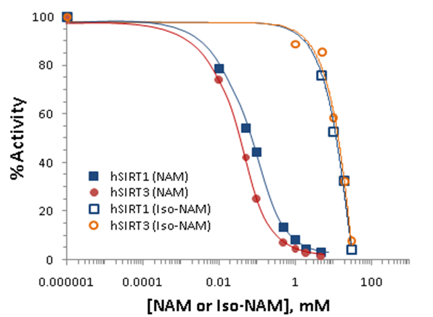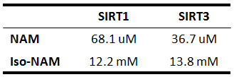
Figure 1. Nicotinamide inhibition assays showing percent change in deacetylation activity as a function of nicotinamide concentration. Data for the hSIRT1 enzyme are indicated with close square and a blue curve; data for the hSIRT3 are indicated with filled circles and a red line. The IC50 for the hSIRT3 enzyme is 36.7 uM, and that of the hSIRT1 enzyme is 68.1 uM.
Nicotinamide is a noncompetitive inhibitor of recombinant human SIRT1 and competitive inhibitor of recombinant human SIRT3 in vitro.
To gain more insight into the effects of nicotinamide on hSIRT3 activity, the in vitro hSIRT3 deacetylated activity was measured in the presence of varying amounts of nicotinamide. We utilized a novel deacetylated activity assay that generates a fluorescent signal upon deacetylation of a peptide substrate. When incubated with acetylated substrate and NAD⁺, recombinant human SIRT3 gives a strong fluorescent signal 10-fold greater than no enzyme and no NAD⁺controls (data not shown). Using this assay, we tested the ability of nicotinamide to inhibit deacetylation in the presence of varying concentrations of NAD⁺. To evaluate the reliability of the method, the in vitro hSIRT1 deactylated activity was measured as well. A double reciprocal Lineweaver-Burk plot of the data (Fig. 2A) shows that nicotinamide is a strong noncompetitive inhibitor of this reaction. We next tested whether the inhibitory effects of nicotinamide could be extended to inhibit human SIRT3 in vitro. Using recombinant hSIRT3, we monitored deacetylation of substrate in the presence of varying amounts of nicotinamide and NAD⁺. Differ to hSIRT1, interestingly, a Lineweaver-Burk plot of the data shows that nicotinamide inhibits SIRT3 in a competitive manner (Fig.2B). These results imply that nicotinamide does not inhibit hSIRT1 deacetylation by competing with NAD⁺ for binding to the enzyme, but does inhibit hSIRT3 deacetylation by competing with NAD⁺ for binding to the enzyme.
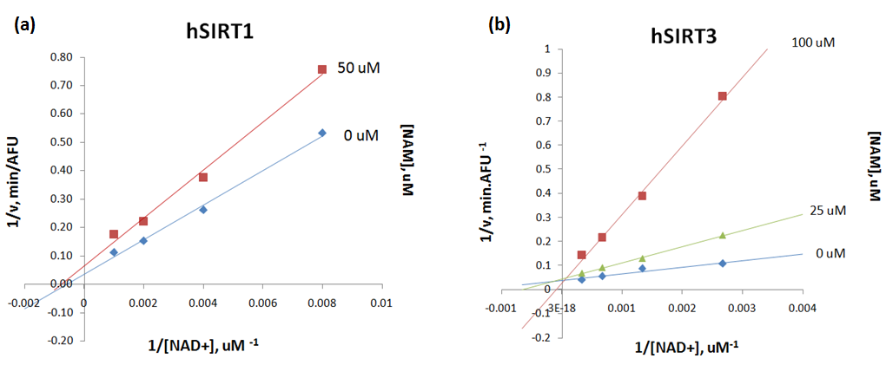
Figure 2. (A) Recombinant human SIRT1 was incubated with 50 uM of SIRT1 substrate for 0, 10, 20, 30, 60, 120, 180, and 240 min at 37ºC in the presence of 125, 250, 500, 1000 uM NAD⁺ and 0, 50, 100, and 300 uMnicotinamide. (B) Recombinant human SIRT3 was incubated with 100 uM of acetylated substrate for 40 min at 37ºC in the presence of 100, 375, 750, 1500, 3000 uM NAD⁺ and 0, 25, 100, and 200 uMnicotinamide. Reactions were terminated by the addition of developer and samples were analyzed by flourometry (excitation set at 355 nm and emission at 460 nm). Experiments were performed in triplicate. Data are shown as a Lineweaver-Burk double-reciprocal plot of arbitrary fluorescence units (AFU) min⁻¹ versus 1/[NAD⁺] uM⁻¹.
Human SIRT3 inhibition effect by nicotinamide in the presence of isonicotinamide.Isonicotinamide was reported as an activator of Sir2 activity . shown to directly compete with nicotinamide for binding. Nicotinamide is a potent inhibitor of the Sir2 reaction because of its ability to rebind with the enzyme and react with a high-energy intermediate, preventing deacetylation and regenerating starting materials . The basis for the observed activation is the relief of the inherent nicotinamide inhibition by competition with isonicotinamide, which does not readily react with the enzyme intermediate. Does the aforementioned rule of isoNAM fit on hSIRT3? The hSIRT3 inhibition effect by NAM was studied in the presence of different concentration of isoNAM. Figure 3 shows that in the presence of isonicotinamide (50 uM and 500 uM), hSIRT3 inhibition of NAM was slightly decreased.
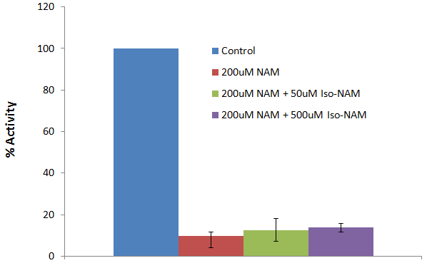
Figure 3. Recombinant human SIRT3 was incubated with 50, and 500 uM of isoNAM for 40 min at 37ºC in the presence of 500 uM NAD⁺, 50 uM of Acetylated substrate, and 200 uMnicotinamide. Reactions were terminated by the addition of developer and samples were analyzed by flourometry (excitation set at 355 nm and emission at 460 nm). Experiments were performed in triplicate.
Although the IC50 for isonicotinamide was about three orders of magnitude worse than nicotinamide binding, in vivo yeast studies showed that millimolar levels of isonicotinamide increased Sir2- dependent silencing of the telomeric URA3 gene. These results suggest that the development of higher affinity nicotinamide antagonists may provide a means to upregulate cellular sirtuins. However, great care will be needed to avoid cross reactivity with other nicotinamide utilizing enzymes, in particular, those involved in NAD⁺ salvage and synthesis.
Measurement of IC50 values for SIRT3 inhibitors. Few groups have identified synthetic compounds that inhibit Sir2-like proteins using high-throughput phenotypic screens of small molecule libraries. None of these compounds, however, has been examined for its ability to inhibit hSIRT3 activity. To compare the efficacy of inhibition of these compounds to that of nicotinamide we measured recombinant hSIRT3 activity in the presence of 50 uM of each of these inhibitors. We also included nicotinic acid and the class I/II HDAC inhibitor TSA for comparison. In support of our in vivo results, nicotinic acid had no effect on the activity of hSIRT3 in vitro, whereas nicotinamide inhibited SIRT3 with an IC50: 36.7uM, a value that was equal to, or lower than, that of all the other inhibitors tested (Fig. 4).
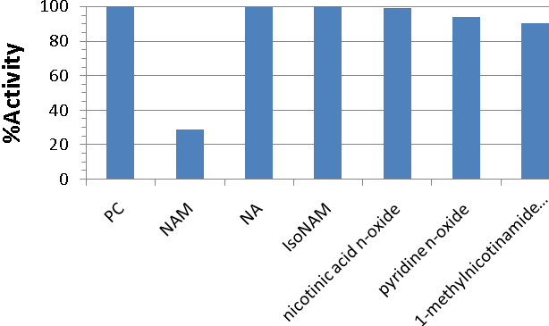
Figure 4. deacetylation reactions were performed in triplicate with 2.5 μg of SIRT1, 25 uM substrate peptide, 1 mM NAD⁺, and 50 uMnicotinamide, nicotinic acid, isonicotinamide, nicotinic acid n-oxide, pyridine n-oxide, 1-methyl nicotinamide chloride, and matched controls. Reactions were carried out at 37 °C for 90 min and fluorescence was measured (excitation set at 355 nm and emission at 460 nm).
General description of the enzyme-coupled assay. Sirtuins catalyze protein deacetylation using NAD⁺ as a co-substrate and generate the reaction products nicotinamide, deacetylatedprotein, and OAADPr. Here, we also applieda spectrophotometric assay that continuously measures nicotinamide formation. The rate of nicotinamide formation is measuredusing a coupled enzyme system with nicotinamidase and glutamate dehydrogenase. Nicotinamidase hydrolyzes nicotinamide tonicotinic acid and ammonia. Glutamate dehydrogenase then converts ammonia, α-ketoglutarate, and NAD(P)H to glutamate and NAD(P)⁺. NAD(P)H oxidation/consumption is measured spectrophotometrically at 340 nm.
Enzyme linearity.The utility of the coupled assay was initially tested by measuring NADPH consumption at 340 nm due to Sirt3-dependent nicotinamide formation at a variety of SIRT3 concentrations. Fig. 5Ashows the kinetic traces of the nicotinamidase /glutamate dehydrogenase
enzyme-coupled SIRT3 reactions. When the reaction was initiated by SIRT3 addition, robust steady-state initial velocities were measured; only low background rates were observed in the absence of SIRT3. After initiation with SIRT3, a lag phase of approximately xxx min was observed and was likely due to the necessary build up of nicotinamide from the SIRT3 reaction before a linear responseis achieved from the coupled enzyme system. Short lag phases in the kinetic traces are common in enzyme-coupled reactions. The initial velocities were calculated from the linear portion of the curves.
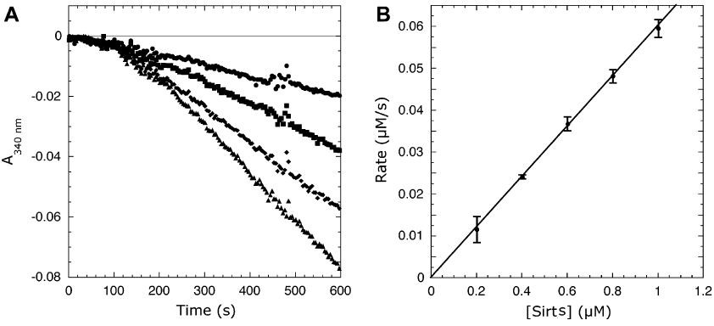
Example of Fig. 5. (A) Representative kinetic traces at increasing Sirt* concentrations. (B) Linear dependence of coupled assay on SIRT* concentration
To verify the accuracy of the coupled assay and that the observed rates are not limited by the coupled reaction, initial velocities were measured with increasing Sirt3 concentrations. Fig. 5B demonstrates a linear relationship between the NADPH consumption rate and Sirt3 concentration; that is, the observed rate depends only onSIRT3 activity, not nicotinamidase or glutamate dehydrogenase. To further demonstrate that the coupled assay does not limit the observed rate, concentrations of the coupled reaction components (i.e., a-ketoglutarate, nicotinamidase, and glutamate dehydrogenase) were decreased two- to fourfold and the reactions were repeated. Decreasing a-ketoglutarate concentrations from xxx to xxxmM, glutamate dehydrogenase levels two-fold, or nicotinamidase concentrations from xxx to xxxuM did not significantly affect the observed rates, indicating that the original conditions were sufficient and that the couple dreaction does not limit the observed initial rates.
Determination of SIRT3 saturation kinetics. Having demonstrated that SIRT3 activity could be measured accurately, the relevant steady-state rate constants were measured. First, we measured the ability of a 12-mer acetyl-lysine peptide based on the N-terminal tail of acetyl-CoA synthetase 2to saturate SIRT3-catalyzedreactions.
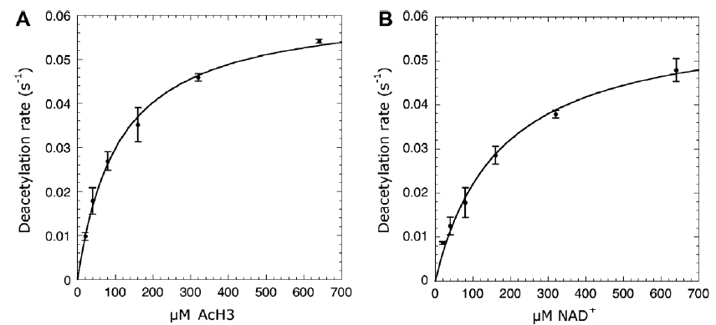
Example of Fig. 6. Steady-state kinetics of Sirt* varying substrate peptide (A) or NAD+ (B) concentrations.
The concentration of substrate peptide was varied at saturating NAD⁺ concentrations, and the initial velocities were determined by measuring the continuous consumption of NADPH at 340 nm. Background rates in the absence of substrate peptide were subtracted from the rates determined in the presence of substrate peptide. The data were fitted to the Michaelis–Menten equation to yield kcat and Km values of xxx and xxx, compared with corresponding values that we obtained with the Fluorolabeled assay. We also measured the ability of NAD⁺ to saturate Sirt3activity. NAD⁺concentrations were varied, and the resulting initial velocities were fitted to the Michaelis–Menten equation (Fig. 6B), yielding kcat and Km values of xxx and xxx, respectively. These measured steady-state kinetic parameters revealexcellent agreement between the coupled and Flurecsence assays.
Evaluation of sirtuin inhibitors. The coupled assay was evaluated further for use in the analysisof sirtuin inhibitors. Using substrate peptide and NAD⁺ concentrations below their respective Km values, the potency of nicotinamide as a SIRT3inhibitor was determined. With the coupled assay using absorbance detection, NAM inhibited Sirt3 with an IC50 value of xxx (Fig. 7). This IC50 value is consistent with the value of 36.7μM determined by Fluorecent assay(Figure 1 right).
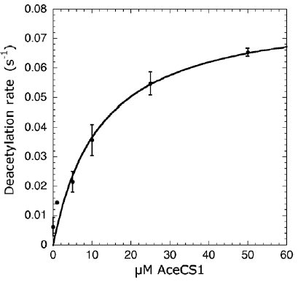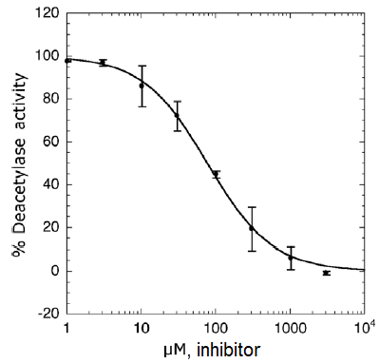
Example of Fig. 7 (left) Steady-state kinetics of Sirt* varying concentrations of native AceCS1. (right)Inhibition of Sirt* by ADP-ribose determined by the coupled assay.
It is important to use proper controls to ensure that the coupling enzymes are not inhibited by the addition of the small-molecule effectors being evaluated. A simple control would be to add a standard concentration of nicotinamide to the assay mixture and to assess whether the compound yields a lower rate compared with the mock-treated sample (e.g., DMSO).
Simulation Result
MM-GBSA predicted binding affinities for Sir2 support the non-competitive nicotinamide inhibitor experimental results. In non-competitive inhibition mechanistic models, when the inhibitor, such as nicotinamide, occupies the C pocket preventing NAD+ from occupying the productive AC pocket binding mode, NAD+ can equally bind to the AB pockets and wait for the noncompetitive inhibitor to leave. Binding affinity estimates of NAD+ binding in the two different modes are about equal, supporting the non-competitive mechanistic model.
Both in-place and cross docking estimates predicted approximately equal binding affinity for the AC or AB pocket mode. Cross docking validated the method with Sir2 (Sir2Af2, PDB:1YC2), in which NAD+ was docked into the AC pocket starting with the x-ray structure with the NAD+ originally in the AB pocket, and vice versa. These results were compared with the in-place MM-GBSA binding affinity estimate, in which the co-crystallized structure is used in-place for scoring without any docking, ligand or protein movement. As hypothesized for noncompetitive inhibition, the MM-GBSA predicted in place ∆G_{binding} is very similar for NAD+ in the AC pocket (-92.6) and the AB pocket (-95.2). Like the in place predicted binding, the cross-docked predicted ∆G_{binding} are similar at -xxx (find these results) and -yyy. Note that the units are proportional to kcal/mol, but have not been normalized to experimental binding affinities for this system. [should I normalize?]
Cross docking into the AC pocket worked well with no constraints, as shown in illustration 1. The above reported Sir2 cross-docking poses were degenerate for NAD+ binding in the AB pocket. Illustration 2 shows the acceptable results within about 2 ?RMSD from the known crystal structure when using Glide XP with only one constraint: an exclusion volume in the C pocket necessary to prevent re-docking to the starting structure. Illustrations 3 and 4, the protein-ligand interaction diagrams, show the adenine diphosphate side of the NAD+ held firmly in place by 11 intermolecular hydrogen bonds between the ligand and the protein in the A pocket for Sir2 either in the AB or AC pockets. Figure 4 shows that the C pocket is not exposed to solvent, and the docked structure is not degenerate. Illustration 3 shows no hydrogen bonds in the B pocket with the outer half of the pocket exposed to solvent allowing the nicotinamide to move. The amide hydrogen of the nicotinamide end of NAD+ in the AB pocket of the Sir2Af2 (1YC2) cocrystallized structure makes a hydrogen bond to the phosphotidyl oxygen. This intermolecular H-bond is never seen in the docking possibly because the energy is truly degenerate in this case where most of the nicotinamide is exposed to solvent., or a systematic bias against ligand intermolecular H-bonds. In addition, the nicotinamide in the B pocket must move to the C pocket, and this degenerate flexibility in solvent could facilitate this motion.

Above Figure: the two top ranked Glide XP docked results of NAD+ docked to the SIRT3 AC pocket (orange), with the co-crystallized comparison structure from 2H4F (Sir2Tm) in green. The NAD+ in the AC pocket conformation is shown in red. GlideScores ranged from -15.0 to -17.5.
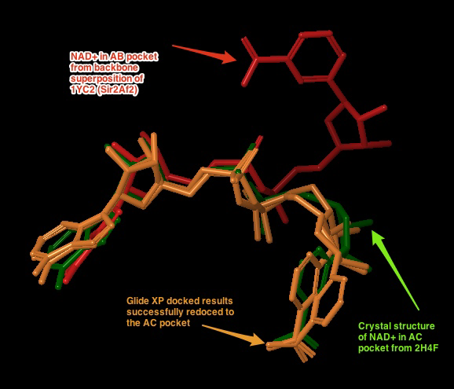
Illustration 1

Above Figure: Cross docking of NAD+ into the AB pocket of the crystal structure of 1YC2 with NAD+ originally in the AC pocket. The red pose is from the AB pocket co-crystallized structure. The blue are the degenerate top ranked and only output from Glide XP with an excluded volume in the C pocket and a completely flexible ligand. The RMSD of the closest structure is 1.98 Å, and the GlideScores for all 5 degenerate structures ranged from -9.9 to -12.2.
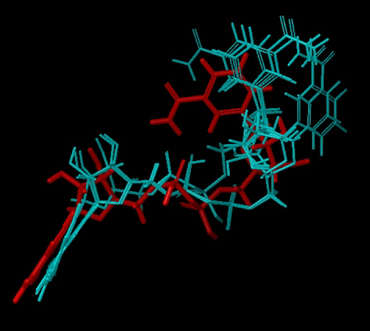Illustration 2

Sir2Af2 (1YC2 chain A) NAD+ in AB pocket
Above figure: Intermolecular protein-ligand diagram of Sir2Af2 (1YC2 chain A) with NAD+ in the AB pocket. In this flattened 2D reppresentation of the protein-ligand interactions, residues are represented as colored spheres, where: red=acidic, green=hydrophobic, blue=polar, light gray=(Gly,water), dark gray=metal atoms. Solid pink lines are H-bonds to the protein backbone; dotted pink are H-bonds to the side chains; green are pi-pi stacking interactions; orange are pi-cation interactions. Protein and water residues within 3.0 Å of the NAD+ are shown. The lack of a protein "pocket" line around the nicotinamide end and the grey spheres around those atoms indicate that the nicotinamide end is exposed to solvent. The B pocket (show as a yellow circle) is a crevice open to solvent, while the C-pocket (lower yellow circle) is protected by a loop from the solvent (shown in the next diagram). The C-pocket is empty or collapsed in this structure. Also note that there are no H-bonds or other specific intermolecular interactions between the protein and the nicotinamide end of NAD+. Images produced in Maestro.
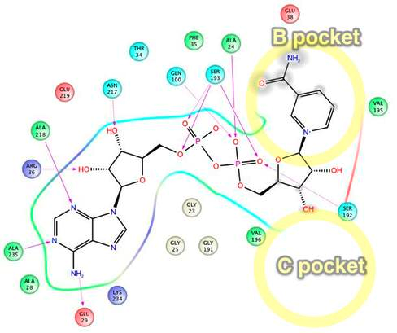Illustration 3
Sir2Af2 (1YC2 chain B) NAD+ in AC pocket
Above figure: Intermolecular protein-ligand diagram of Sir2Af2 (1YC2 chain B) with NAD+ in the AC pocket. Protein and water residues within 3.0 Å of the NAD+ are shown. Unlike in the AB pocket, the NAD+ molecule is completely surrounded by protein residues in the entire A and C pockets. The nicotinamide is not exposed to solvent, unlike in the B pocket. The approximate location of the B pocket is shown due to distortions created by transforming the 3D protein-ligand picture into a simple 2D diagram. There is a backbone H-bond between the protein ILE102 and the nicotinamide end of NAD+.
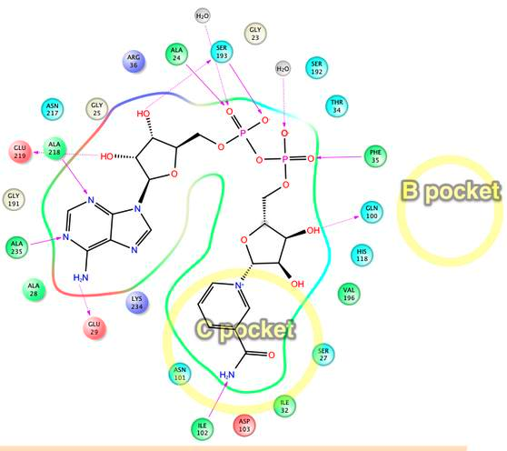Illustration 4
Induced Fit
While traditional and Induced Fit docking succeeded in placing NAD+ into the AC pockets of SIRT3 without the use of constraints or reduced vdW radius, all docking attempts, with or without Induced Fit, failed to dock NAD+ into the AB pocket when starting with the best available crystal structure for SIRT3 (3GLT). The top ranked docked poses for the AC productive pocket had RMSD of 2.1 and 2.0 [verify these numbers!] with respect to the backbone aligned co-crystallized structure of 1YC2 with NAD+ in the AC pockets. We conjecture that AB pocket docking did not work for SIRT3 because the side chains and backbone movements could not sufficiently open up the B pocket for the nicotinamide end of NAD+, as shown in illustration 5.
Above figure: Steric clashes between NAD+ in the AB conformation and SIRT3 (from the thio-acetyl ADPR intermediate). This is a top view of the NAD+, where the B pocket is oriented on top of the C pocket within the axis perpendicular to the figure. The steric clashes are labeled in aqua, and the B pocket is labeled with the yellow oval. Comparable Sir2Af2 residues within 6 ?of the nicotinamide in the B pocket are in red. The Sir2Af2 structure is from the NAD+ co-crystallized PDB file 1YC2 chain A with NAD+ in the AB pockets. This structure is aligned to the SIRT3 protein backbone from 3GLT. 3GLT has the thio-acetyl ADPR intermediate, which has the nicotinamide cleaved off. The depicted NAD+ cofactor is from the Sir2Af2 co-crystallized structure. Note that Sir2 does not obstruct the B pocket. For example, the ARG 36 in Sir2Af2 is moved back and its side chain rotated out of the way in comparison to SIRT3 ARG 158. While SIRT3 has GLU 323 which obstructs the nicotinamide, Sir2Af2 has a Val 195 pushed farther back leaving room for the nicotinamide. There are no steric clashes with peptide substrate residues, like there is with the SIRT3 MET.
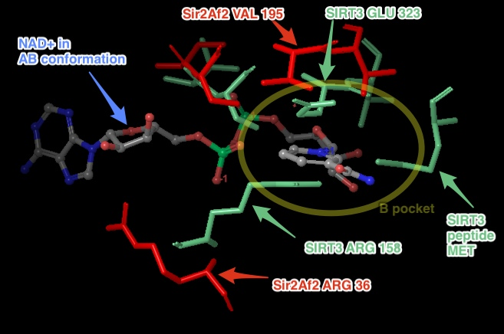Illustration 5
On the experimental side related to the unsuccessful docking attempts, crystallographers failed multiple different protocols to co-crystallize NAD+ into either the SIRT3 productive or unproductive binding pocket, with or without the acetyl-lysine substrate . While NAD+ has been observed to bind in the productive (AC) binding site for Sir2Af2 and Sir2Af1 and in the non-productive (AB) binding site for Sir2Af2, Sir2Af1 in the absence of the peptide substrate , NAD+ cannot bind to SIRT3 efficiently in the absence of this peptide . In addition, the experimental assays presented here show that SIRT3 inhibition by nicotinamide, which binds in the C pocket blocking the productive conformation of NAD+, is competitive, as compared to noncompetitive for Sir2. These results suggest that in SIRT3, unlike in Sir2, NAD+ either cannot adopt the comparable AB pocket non-productive conformation or this conformation is much higher in energy than the productive AC binding mode. We hypothesized that the MM-GBSA predicted binding affinity of NAD+ docked into the AB pocket would be significantly higher in energy than NAD+ docked into the AC pocket. As with the experimental crystallography, we were unable to dock NAD+ into the non-productive AB pocket.
Multiple docking methods were attempted, including variations of Glide and Induced fit. Various protocols included: using multiple excluded volumes in the C pocket and surrounding (but not in) the B pocket to direct the nicotinamide end to the B pocket; rigidly docking an ensemble of low energy poses close to the AB pocket conformation seen in Sir2 with traditional docking and a softcore potential of 0.5, and Induced Fit with the above mentioned amino acids mutated to Ala to make room in the B pocket; creating torsional constraints to impose an AB-like conformation on the flexible ligand; increasing the number of output poses above 1000 and accepting higher energy levels to look for higher energy poses; energy minimizing of the SIRT3 protein with NAD+ frozen in the AB conformation from Sir2Af2 aligned to SIRT3 to push the side chains and backbone out of the way, then subsequently using Induced Fit.
Failure to dock into the AB pocket supports, but not strongly, that this non-productive binding is much higher in energy or prohibited. Future simulations to obtain more reliable estimates of binding affinity differences between the AB and AC pockets could involve more sophisticated molecular dynamics techniques. Accurate computational affinity predictions using more sophisticated simulations beyond docking are known to be challenging . MM-GBSA method provides a fast and simpler first estimation to more accurately rank order the raw protein-ligand docking results , but the underlying docking protocol did not work for SIRT3 AB pocket docking. More computationally intensive molecular dynamics based simulations such as linear interaction energy (LIE), thermodynamic integration (TI) or free energy perturbation (FEP) have been shown to be more accurate and include more degrees of freedom to dock to the AB pocket.
Above Figure: The best docking starting structure for SIRT3 is 3GLT, which has the thio-intermediate of the acetyl-lysine peptide. The nicotinamide has been cleaved and a bond to the thioacetyl is trapped. SIRT3, 3GLT with the trapped thio-acetyl lysine ADPR intermediate. The B and C pockets are unoccupied because of the intermediate . H-bonds between the ADPR and the protein residues within 3 of the ligand are shown here.
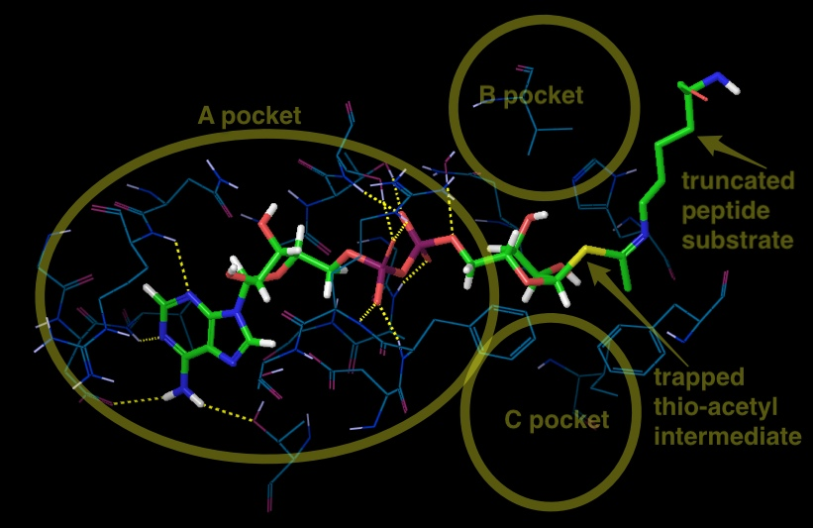Illustration 6
DISCUSSION
SIRT3 is a member of the sirtuin family of protein deacetylases that is preferentially localized to mitochondria. Prominent among the proteins targeted by SIRT3 are enzymes involved in energy metabolism processes, including the respiratory chain, tricarboxylic acid cycle, fatty acid β-oxidation and ketogenesis . Through these actions, SIRT3 controls the flow of mitochondrial oxidative pathways and, consequently, the rate of production of reactive oxygen species (ROS). The involvement of SIRT3 in processes closely associated with human pathologies, from the metabolic syndrome to cancer, as well as in many other aging-related diseases (cardiac dysfunction and neural degeneration), raises the enormous interests in SIRT3 function and regulation in the context of biomedical research. As with other sirtuins, SIRT3 holds great promise as a ‘druggable protein’, i.e. a protein target capable of binding drug-like molecules. In this scenario, SIRT3 and its subsequent biological effects may be modulated by small molecules or nutrient pharmaceuticals (nutriceuticals) that influence the deacetylase activity of SIRT3.
Whether SIRT3 serves as a tumor promoter or suppressor has been wildly discussed. On one hand, increased levels of SIRT3 associated with node-positive breast cancer versus non-malignant breast tissue as well as with oral squamlors cell carcinoma, suggesting that SIRT3 could function as a tumor promoter. On the other hand, SIRT3 expression is decreased in many different types of human cancers, and heterozygous loss of SIRT3 occurs in 40% of human breast malignancies. Much work will be needed to pinpoint the precise molecular mechanisms governing SIRT3 functions in cancer. But one thing is sure: these proteins clearly link DNA repair and metabolism, two hallmarks of cancer. As such, it is tempting to envision that modulators of SIRT3 activity could provide future beneficial alternatives against this devastating disease.
Other than cancer, SIRT3 plays a role in the emerging cardiac pathologies associated with diabetes, obesity, and cardiac ischemia . Direct investigations have shown that SIRT3 plays an important ameliorative role in preventing pathology form pressure overload and aging-associated decline in cardiac function. The direct pharmacological modulation of SIRT3 may confer greater benefit compared with the disappointing results to date of other antioxidant approaches in cardiac disease is an intriguing concept, although the inhibition of SIRT3 activity is the interest of current paper.
The inhibition of enzyme activity is one of the major regulatory devices of living cells, and one of the most important diagnostic procedures of the enzymologist. Inhibition studies often tell us something about the specificity of an enzyme, the physical and chemical architecture of the active site, and the kinetic mechanism of the reaction. In our everyday life enzyme inhibitors can be found masquerading as drugs, antibiotics, preservatives, poisons, and toxins.
Given the potential roles in metabolic, neurodegenerative, and aging-related diseases of sirtuins, the potent and selective inhibitors are investigated with different inhibition modes, like, suramin is a noncompetitive SIRT1inhibitor respect to NAD⁺; cambinol competitively inhibits SIRT1/SIRT2 against to acetyllysine peptide substrate. Three potential modes of inhibitor interactions with enzymes are defined as: (A) competitive inhibitors that bind exclusively to the free enzyme form; (B) noncompetitive inhibitors that bind with some affinity to both the free enzyme and to the enzyme-substrate complex (ES complex); (C) uncompetitive inhibitors that bind exclusively to the ES complex or subsequent species.
An inhibitor that binds exclusively to the free enzyme is said to be competitive because the binding of the inhibitor and the substrate to the enzyme are mutually exclusive; hence these inhibitors compete with the substrate for the pool of free enzyme molecules.
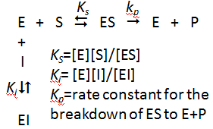
Because competitive inhibitors bind to the free enzyme to the exclusion of substrate binding, it is easy to assume that this results from a direct competition of the two ligands (substrate and inhibitor) for a common binding pocket (i.e., the active site) on the enzyme molecule. As shown in equation 2,
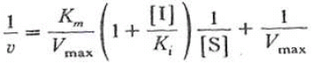 (Eq. 2)
in the presence of competitive inhibitor, the V_{max} remains unchanged but the apparent K_{m} for the substrate increased. There are a very large number of drugs in clinical use today that function as competitive enzyme inhibitors.
A noncompetitive inhibitor is one that displays binding affinity for both the free enzyme and the enzyme-substrate complex or subsequent species.
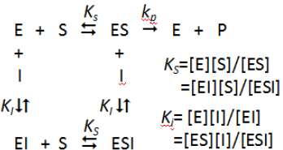
In the presence of noncompetitive inhibitor, the V_{max}, decreases but has no effect on the K_{m} value (Eq. 3). The degree of inhibition in the presence of a non-competitive inhibitor depends only upon
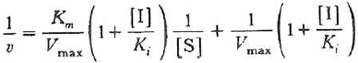 (Eq. 3)
[I] and K_{i}. The inhibited velocity (vi) is always a constant fraction of v₀, regardless of the substrate concentration or the value of K_{m} (Eq. 4). An increase in [S] causes both v₀ and vi to
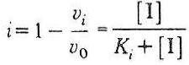 (Eq. 4)
increase by the same factor. A diagnostic signature of noncompetitive inhibition is that the double reciprocal plot displays a nest of lines that intersect at a point other than the y-axis. Relative to competitive inhibitors, there are fewer examples of noncompetitive inhibitors in clinical use as drugs today. This reflects the historic approaches to drug discovery that have been largely focused on active-site directed inhibitors. With a greater emphasis on compound library screening as a mechanism of lead identification, more examples of noncompetitive inhibitors are likely to emerge, especially if attention is paid to designing screening assays that balance the opportunities for identifying the greatest diversity of inhibitor modalities.
An inhibitor that binds exclusively to the ES complex, or a subsequent species, with little or no affinity for the free enzyme is referred to as uncompetitive. Inhibitors of this modality require the prior formation of the ES complex for binding and inhibition. An uncompetitive inhibitor decreases V_{max and} K_{m} value to the same extent.
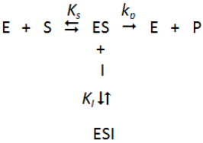
The degree of inhibition depends on the substrate concentration, but, unlike competitive inhibition, the degree of inhibition increases as [S] increase (Eq. 5).
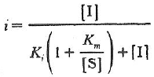 (Eq. 5)
As with noncompetitive inhibitors, uncompetitive inhibition cannot be overcome by high substrate concentrations; in fact the affinity of uncompetitive inhibitors is greatest at saturating concentrations of substrate. Depending on the physiological conditions experienced by the target enzyme, this inability of high-substrate concentrations to overcome noncompetitive and uncompetitive inhibitors may offer some clinical advantage to these inhibition modalities.
Human SIRT3 crystal structure has been solved in 2009, promoting us to use computer-based design methods to identify novel inhibitors or to establish structure-activity relationships for known inhibitors. Ligand docking methods have provided insights into the binding mode of Sir2 inhibitors.
Nicotinamide is the physiological sirtuin inhibitor. The IC50 values of nicotinamide inhibition of bacterial, yeast, mouse, human SIRT1, SIRT2 and SIRT3 were 26, 120, 160, 50, 100, 36.7*uM, respectively *current work 2012). Nuclear nicotinamide levels has been estimated to be 10-150 uM , which most likely make NAM as Sirtuin activity regulator in vivo. Early studies reported nicotinamide bind an allosteric site , however more recent work observed that NAM inhibition depends on its ability to condense with the high-energy enzyme: ADP ribose:acetyl-lysine intermediate to reverse the reaction, reforming NAD⁺. And NAM non-competitively inhibits deacetylation reaction of sirtuins with a single binding pocket C (Avalos et al, 2005), the same site which binds the nicotinamide of NAD⁺. The structural evidences indicates that tight binding at the C pocket and the subsequent attack of NAM on the O-alkylamidate intermediate to regenerate NAD and acetylated peptide are involved into NAM inhibition of sirtuin deacetylation. If a small molecule could compete with free NAM binding without reacting appreciably with the enzyme intermediate, it would be predicted to have a stimulatory effect on the overall deacetylation rate in the presence of nicotinamide. Taking into account of the above criteria, isoNAM, the NAM analog, was found as a Sir2 activator . Because of the requirement of high millimolar concentrations of isoNAM (up to 100mM) for a detectable effect (; *current work), it is necessary to improve this strategy to provide better affinity and specificity.
A mechanistically understood SIRT3 activator, in contrast, is isonicotinamide. Nicotinamide is the first product of the Sir2 catalyzed reaction, released from NAD⁺ during formation of the alkylimidate intermediate. Rebinding of nicotinamide to the Sir2/intermediate complex can promote the reverse reaction to reform the substrates, and thus inhibits the deacetylation reaction . Sir2 thus appear to be affected by physiological nicotinamide concentrations, assumed to be up to 0.1mM, and a role of nicotinamide as endogenous Sir2 regulators supported by in vivo studies in yeast, flies, and mammalian cells . Isonicotinamide can compete with nicotinamide for binding but cannot initiate the reverse reaction, thereby leading to apparent activation through relief of nicotinamide inhibition . Assuming that all Sirtuins are equally inhibited by nicotinamide, isonicotinamide would be a general Sirtuin activator? However, data from Steegborn’s lab suggest that some Sirtuins show nicotinamide insensitive eacetylase activity (unpublished), indicating that nicotinamide and isonicotinamide employ isoform discriminating binding sites or modulation mechanisms. Structural and further biochemical studies on these compounds and mechanisms might enable the development of isoform selective modulators.

Eric part-----
In summary, SIRT3 is the major sirtuin deacetylase in mitochondria, where bioenergetics, oxidative stress, and apoptosis are controlled. In order to have better understanding of the basic cell biology processes as well as a pharmacological and/or nutritional target for intervention, the extensive efforts for development of SIRT3 modulators are needed.
Experimental results reported here indicate that NAM, a noncompetitive inhibitor of Sir2 and SIRT1, competitively inhibits hSIRT3 by competing the binding site at C pocket with NAD⁺, which reveals a different strategy for SIRT3 inhibitor design. Molecular docking is performed in current study. X-ray crystal structures of Sir2Af2 and human SIRT3 are employed as the starting point for docking analysis. In addition, incorporation of protein flexibility and backbone conformation change upon ligand association are taking into consideration. Simulation data show that ………………………………………… Computer-assisted drug design coupled with experimental confirmation has become an attractive alternative to the tradition in vitro and in vivo screenings. Taken together, we anticipate that the structural elucidation of the NAM inhibitory for hSIRT3 enzymes reported here will provide the direction for designing a new generation of SIRT3 modulator.
RFERENCES
Adams, J. D. and L. K. Klaidman (2007). "Sirtuins, nicotinamide and aging: A critical review." Letters in Drug Design & Discovery 4(1): 44-48.
Sirtuins are enzymes that deacetylate proteins at the expense of NAD. The nuclear forms of sirtuins have generated an enormous amount of interest due to their putative regulation of lifespan. Yeast sirtuins and human sirtuins are involved in very different biochemical processes that make extrapolation of yeast results to the human situation difficult. This review critically examines the issues of NAD biochemistry in relation to nuclear sirtuin activity. Putative sirtuin inhibitors and activators are discussed, especially in terms of lifespan extension by sirtuin activators.

Anderson, R. M., et al. (2003). "Nicotinamide and PNC1 govern lifespan extension by calorie restriction in Saccharomyces cerevisiae." Nature 423(6936): 181-185.
Calorie restriction extends lifespan in a broad range of organisms, from yeasts to mammals. Numerous hypotheses have been proposed to explain this phenomenon, including decreased oxidative damage and altered energy metabolism. In Saccharomyces cerevisiae, lifespan extension by calorie restriction requires the NAD(+)-dependent histone deacetylase, Sir2 (ref. 1). We have recently shown that Sir2 and its closest human homologue SIRT1, a p53 deacetylase, are strongly inhibited by the vitamin B3 precursor nicotinamide2. Here we show that increased expression of PNC1 (pyrazinamidase/nicotinamidase 1), which encodes an enzyme that deaminates nicotinamide, is both necessary and sufficient for lifespan extension by calorie restriction and low-intensity stress. We also identify PNC1 as a longevity gene that is responsive to all stimuli that extend lifespan. We provide evidence that nicotinamide depletion is sufficient to activate Sir2 and that this is the mechanism by which PNC1 regulates longevity. We conclude that yeast lifespan extension by calorie restriction is the consequence of an active cellular response to a low-intensity stress and speculate that nicotinamide might regulate critical cellular processes in higher organisms.

Ashraf, N., et al. (2006). "Altered sirtuin expression is associated with node-positive breast cancer." British Journal of Cancer 95(8): 1056-1061.
Sirtuins are genes implicated in cellular and organismal ageing. Consequently, they are speculated to be involved in diseases of ageing including cancer. Various cancers with widely differing prognosis have been shown to have differing and characteristic expression of these genes; however, the relationship between sirtuin expression and cancer progression is unclear. In order to correlate cancer progression and sirtuin expression, we have assessed sirtuin expression as a function of primary cell ageing and compared sirtuin expression in normal, 'nonmalignant' breast biopsies to breast cancer biopsies using real-time polymerase chain reaction (PCR). Levels of SIRT7 expression were significantly increased in breast cancer (P < 0.0001). Increased levels of SIRT3 and SIRT7 transcription were also associated with node-positive breast cancer (P < 0.05 and P < 0.0001, respectively). This study has demonstrated differential sirtuin expression between nonmalignant and malignant breast tissue, with consequent diagnostic and therapeutic implications.

Avalos, J. L., et al. (2005). "Mechanism of sirtuin inhibition by nicotinamide: Altering the NAD(+) cosubstrate specificity of a Sir2 enzyme." Molecular Cell 17(6): 855-868.

Avalos, J. L., et al. (2004). "Structural basis for the mechanism and regulation of Sir2 enzymes." Molecular Cell 13(5): 639-648.

Bedalov, A., et al. (2001). "Identification of a small molecule inhibitor of Sir2p." Proceedings of the National Academy of Sciences of the United States of America 98(26): 15113-15118.
Sir2p is an NAD(+)-dependent histone deacetylase required for chromatin-dependent silencing in yeast. In a cell-based screen for inhibitors of Sir2p, we identified a compound, splitomicin, that creates a conditional phenocopy of a sir2 deletion mutant in Saccharomyces cerevisiae. Cells grown in the presence of the drug have silencing defects at telomeres, silent mating-type loci, and the ribosomal DNA. In addition, whole genome microarray experiments show that splitomicin selectively inhibits Sir2p. In vitro, splitomicin inhibits NAD+-dependent histone deacetylase activity (HIDA) of the Sir2 protein. Mutations in SIR2 that confer resistance to the drug map to the likely acetylated histone tail binding domain of the protein. By using splitomicin as a chemical genetic probe, we demonstrate that continuous HDA of Sir2p is required for maintaining a silenced state in nondividing cells.

Bell, E. L., et al. (2011). "SirT3 suppresses hypoxia inducible factor 1 alpha and tumor growth by inhibiting mitochondrial ROS production." Oncogene 30(26): 2986-2996.
It has become increasing clear that alterations in cellular metabolism have a key role in the generation and maintenance of cancer. Some of the metabolic changes can be attributed to the activation of oncogenes or loss of tumor suppressors. Here, we show that the mitochondrial sirtuin, SirT3, acts as a tumor suppressor via its ability to suppress reactive oxygen species (ROS) and regulate hypoxia inducible factor 1 alpha (HIF-1 alpha). Primary mouse embryo fibroblasts (MEFs) or tumor cell lines expressing SirT3 short-hairpin RNA exhibit a greater potential to proliferate, and augmented HIF-1a protein stabilization and transcriptional activity in hypoxic conditions. SirT3 knockdown increases tumorigenesis in xenograft models, and this is abolished by giving mice the anti-oxidant N-acetyl cysteine. Moreover, overexpression of SirT3 inhibits stabilization of HIF-1 alpha protein in hypoxia and attenuates increases in HIF-1 alpha transcriptional activity. Critically, overexpression of SirT3 decreases tumorigenesis in xenografts, even when induction of the sirtuin occurs after tumor initiation. These data suggest that SirT3 acts to suppress the growth of tumors, at least in part through its ability to suppress ROS and HIF-1 alpha. Oncogene (2011) 30, 2986-2996; doi:10.1038/onc.2011.37;published online 28 February 2011

Bitterman, K. J., et al. (2002). "Inhibition of silencing and accelerated aging by nicotinamide, a putative negative regulator of yeast Sir2 and human SIRT1." Journal of Biological Chemistry 277(47): 45099-45107.
The Saccharomyces cerevisiae Sir2 protein is an NAD(+)-dependent histone deacetylase that plays a critical role in transcriptional silencing, genome stability, and longevity. A human homologue of Sir2, SIRT1, regulates the activity of the p53 tumor suppressor and inhibits apoptosis. The Sir2 deacetylation reaction generates two products: O-acetyl-ADP-ribose and nicotinamide, a precursor of nicotinic acid and a form of niacin/vitamin B-3. We show here that nicotinamide strongly inhibits yeast silencing, increases rDNA recombination, and shortens replicative life span to that of a sir2 mutant. Nicotinamide abolishes silencing and leads to an eventual delocalization of Sir2 even in G(1)-arrested cells, demonstrating that silent heterochromatin requires continual Sir2 activity. We show that physiological concentrations of nicotinamide noncompetitively inhibit both Sir2 and SIRT1 in vitro. The degree of inhibition by nicotinamide (IC50 < 50 muM) is equal to or better than the most effective known synthetic inhibitors of this class of proteins. We propose a model whereby nicotinamide inhibits deacetylation by binding to a conserved pocket adjacent to NAD(+), thereby blocking NAD(+) hydrolysis. We discuss the possibility that nicotinamide is a physiologically relevant regulator of Sir2 enzymes.

Bradford, M. M. (1976). "RAPID AND SENSITIVE METHOD FOR QUANTITATION OF MICROGRAM QUANTITIES OF PROTEIN UTILIZING PRINCIPLE OF PROTEIN-DYE BINDING." Analytical Biochemistry 72(1-2): 248-254.

Cen, Y. (2010). "Sirtuins inhibitors: The approach to affinity and selectivity." Biochimica Et Biophysica Acta-Proteins and Proteomics 1804(8): 1635-1644.
Accumulating evidence has indicated the importance of sirtuins (class III histone deacetylases) in various biological processes. Their potential roles in metabolic and neurodegenerative diseases have encouraged scientists to seek potent and selective sirtuin inhibitors to investigate their biological functions with a view to eventual new therapeutic treatments. This article surveys current knowledge of sirtuin inhibitors including those discovered via high-throughput screening (HST) or via mechanism-based drug design from synthetic or natural sources. Their inhibitory affinity, selectivities, and possible inhibition mechanisms are discussed. (C) 2009 Elsevier B.V. All rights reserved.

Cen, Y., et al. (2011). "Advances in Characterization of Human Sirtuin Isoforms: Chemistries, Targets and Therapeutic Applications." Current Medicinal Chemistry 18(13): 1919-1935.
Since the discovery in 2000 that the yeast sirtuin called "Sir2" catalyzes NAD(+) dependent histone deacetylation, a wave of research has focused on evaluating the biochemical and biological functions of sirtuins. Sirtuins are activated by low calorie diets in numerous organisms and are found throughout biology in species from archaea to humans. There are seven human sirtuin isoforms called SIRT1-SIRT7. The biochemical functions of SIRT1, SIRT2, SIRT3, SIRT5 and SIRT6 have been reported and NAD(+) dependent deacetylase activities confirmed. In some instances the biological target substrates for each isoform have been identified, helping to connect distinct biological processes to sirtuin regulation. This knowledge has informed potential drug design strategies that target distinct sirtuin isoforms. This review presents current knowledge of biochemical activities of SIRT1-7 in humans and the biological consequences of these sirtuin activities. Regulatory principles that govern sirtuin deacetylation activity in cells are discussed as well as strategies for how sirtuins can be targeted by small molecules. Finally, this review updates research on pharmacologic sirtuin activation and allostery on sirtuins and considers new developments for detection and isolation of sirtuins in complex mixtures.

Chang, J. H., et al. (2002). "Structural basis for the NAD-dependent deacetylase mechanism of Sir2." Journal of Biological Chemistry 277(37): 34489-34498.
The NAD-dependent histone/protein deacetylase activity of Sir2 (silent information regulator 2) accounts for its diverse biological roles including gene silencing, DNA damage repair, cell cycle regulation, and life span extension. We provide crystallographic evidence that 2'-O-acetyl ADP-ribose is the reaction product that is formed at the active site of Sir2 from the 2.6-Angstrom co-crystal structure of 2'-O-acetyl-ADP-ribose and Sir2 from Archaeoglobus fulgidus. In addition, we show that His-116 and Phe-159 play critical roles in the catalysis and substrate recognition. The conserved Ser-24 and Asp-101 contribute to the stability for NAD binding rather than being directly involved in the catalysis. The crystal structures of wild type and mutant derivatives of Sir2, in conjunction with biochemical analyses of the mutants, provide novel insights into the reaction mechanism of Sir2-mediated deacetylation.

Chen, W. Y. and S. B. Baylin (2005). "Inactivation of tumor suppressor genes - Choice between genetic and epigenetic routes." Cell Cycle 4(1): 10-12.
Inactivation of tumor suppressor genes can occur via epigenetic or genetic mechanisms. The reasons underlying this choice of gene inactivation routes during tumorigenesis have not been clarified, nor have the precise roles in cancer evolution for genes which are solely affected by epigenetically mediated loss of function. Here we discuss a mouse model in which the disruption of Hic1, a gene solely involved with epigenetic silencing in human cancer, can markedly influence the disruption of the powerful tumor suppressor gene, p53, in determining malignant tumor incidence, spectrum and virulence. Furthermore, the mechanism for inactivation of Hic1 in tumors produced can be switched from an epigenetic to a genetic mode depending on how the Hic1 and p53 knockouts are localized on mouse chromosome 11. The value of such a model and the implications of the findings for choice of epigenetically versus genetically determined loss of gene function in cancer are discussed.

Finley, L. W. S., et al. (2011). "SIRT3 Opposes Reprogramming of Cancer Cell Metabolism through HIF1 alpha Destabilization." Cancer Cell 19(3): 416-428.
Tumor cells exhibit aberrant metabolism characterized by high glycolysis even in the presence of oxygen. This metabolic reprogramming, known as the Warburg effect, provides tumor cells with the substrates required for biomass generation. Here, we show that the mitochondria! NAD-dependent deacetylase SIRT3 is a crucial regulator of the Warburg effect. Mechanistically, SIRT3 mediates metabolic reprogramming by destabilizing hypoxia-inducible factor-1 alpha (HIF1 alpha), a transcription factor that controls glycolytic gene expression. SIRT3 loss increases reactive oxygen species production, leading to HIF1 alpha stabilization. SIRT3 expression is reduced in human breast cancers, and its loss correlates with the upregulation of HIF1 alpha target genes. Finally, we find that SIRT3 overexpression represses glycolysis and proliferation in breast cancer cells, providing a metabolic mechanism for tumor suppression.

Frye, R. A. (1999). "Characterization of five human cDNAs with homology to the yeast SIR2 gene: Sir2-like proteins (sirtuins) metabolize NAD and may have protein ADP-ribosyltransferase activity." Biochemical and Biophysical Research Communications 260(1): 273-279.
The yeast Sir2 protein regulates epigenetic gene silencing and as a possible antiaging effect it suppresses recombination of rDNA. Studies involving cobB, a bacterial SIR2-like gene, have suggested it could encode a pyridine nucleotide transferase. Here five human sirtuin cDNAs are characterized. The SIRT1 sequence has the closest homology to the S. cerevisiae Sir2p. The SIRT4 and SIRT5 sirtuins more closely resemble prokaryotic sirtuin sequences. The five human sirtuins are widely expressed in fetal and adult tissues. Recombinant E. coli cobT and cobB proteins each showed a weak NAD-dependent mono-ADP-ribosyltransferase activity using 5,6-dimethylbenzimidazole as a substrate. Recombinant E. coli cobB and human SIRT2 sirtuin proteins were able to cause radioactivity to be transfered from [P-32]NAD to bovine serum albumin (BSA). When a conserved histidine within the human SIRT2 sirtuin was converted to a tyrosine, the mutant recombinant protein was unable to transfer radioactivity from [P-32]NAD to BSA. These results suggest that the sirtuins may function via mono-ADP-ribosylation Of proteins. (C) 1999 Academic Press.

Frye, R. A. (2000). "Phylogenetic classification of prokaryotic and eukaryotic Sir2-like proteins." Biochemical and Biophysical Research Communications 273(2): 793-798.
Sirtuins (Sir2-like proteins) are present in prokaryotes and eukaryotes, Here, two new human sirtuins (SIRT6 and SIRT7) are found to be similar to a particular subset of insect, nematode, plant, and protozoan sirtuins. Molecular phylogenetic analysis of 60 sirtuin conserved core domain sequences from a diverse array of organisms (including archaeans, bacteria, yeasts, plants, protozoans, and metazoans) shows that eukaryotic Sir2-like proteins group into four main branches designated here as classes I-IV. Prokaryotic sirtuins include members of classes II and III. A fifth class of sirtuin is present in gram positive bacteria and Thermotoga maritima. Saccharomyces cerevisiae has five class I sirtuins. Caenorhabditis elegans and Drosophila melanogaster have sirtuin genes from classes I, II, and TV. The seven human sirtuin genes include all four classes: SIRT1, SIRT2, and SIRT3 are class I, SIRT4 is class II, SIRT5 is class III, and SIRT6 and SIRT7 are class IV. (C) 2000 Academic Press.

Garrity, J., et al. (2007). "N-Lysine propionylation controls the activity of propionyl-CoA synthetase." Journal of Biological Chemistry 282(41): 30239-30245.
Reversible protein acetylation is a ubiquitous means for the rapid control of diverse cellular processes. Acetyltransferase enzymes transfer the acetyl group from acetyl-CoA to lysine residues, while deacetylase enzymes catalyze removal of the acetyl group by hydrolysis or by an NAD(+)-dependent reaction. Propionylcoenzyme A (CoA), like acetyl-CoA, is a high energy product of fatty acid metabolism and is produced through a similar chemical reaction. Because acetyl-CoA is the donor molecule for protein acetylation, we investigated whether proteins can be propionylated in vivo, using propionyl-CoA as the donor molecule. We report that the Salmonella enterica propionyl-CoA synthetase enzyme PrpE is propionylated in vivo at lysine 592; propionylation inactivates PrpE. The propionyl-lysine modification is introduced by bacterial Gcn-5- related N-acetyltransferase enzymes and can be removed by bacterial and human Sir2 enzymes (sirtuins). Like the sirtuin deacetylation reaction, sirtuincatalyzed depropionylation is NAD(+)-dependent and produces a byproduct, O-propionyl ADP-ribose, analogous to the O-acetyl ADP-ribose sirtuin product of deacetylation. Only a subset of the human sirtuins with deacetylase activity could also depropionylate substrate. The regulation of cellular propionyl-CoA by propionylation of PrpE parallels regulation of acetylCoA by acetylation of acetyl-CoA synthetase and raises the possibility that propionylation may serve as a regulatory modification in higher organisms.

Giralt, A. and F. Villarroya (2012). "SIRT3, a pivotal actor in mitochondrial functions: metabolism, cell death and aging." Biochemical Journal 444: 1-10.
SIRT3 is a member of the sirtuin family of protein deacetylases that is preferentially localized to mitochondria. Prominent among the proteins targeted by SIRT3 are enzymes involved in energy metabolism processes, including the respiratory chain, tricarboxylic acid cycle, fatty acid beta-oxidation and ketogenesis. Through these actions, SIRT3 controls the flow of mitochondrial oxidative pathways and, consequently, the rate of production of reactive oxygen species. In addition, SIRT3-mediated deacetylation activates enzymes responsible for quenching reactive oxygen species, and thereby exerts a profound protective action against oxidative stress-dependent pathologies, such as cardiac hypertrophy and neural degeneration. SIRT3 also plays a role in multiple additional metabolic processes, from acetate metabolism to brown adipose tissue thermogenesis, often by controlling mitochondrial pathways through the deacetylation of target enzymes. In general, SIRT3 activity and subsequent control of enzymes involved in energy metabolism is consistent with an overall role of protecting against age-related diseases. In fact, experimental and genetic evidence has linked SIRT3 activity with increased lifespan. In the coming years, the identification of drugs and nutrients capable of increasing SIRT3 expression or modulating SIRT3 activity can be expected to provide promising strategies for ameliorating the metabolic syndrome and other oxidative stress-related diseases that appear preferentially with aging, such as cancer, cardiac dysfunction and neural degeneration. SIRT3 is a member of the sirtuin family of protein deacetylases that is preferentially localized to mitochondria. Prominent among the proteins targeted by SIRT3 are enzymes involved in energy metabolism processes, including the respiratory chain, tricarboxylic acid cycle, fatty acid beta-oxidation and ketogenesis. Through these actions, SIRT3 controls the flow of mitochondrial oxidative pathways and, consequently, the rate of production of reactive oxygen species. In addition, SIRT3-mediated deacetylation activates enzymes responsible for quenching reactive oxygen species, and thereby exerts a profound protective action against oxidative stress-dependent pathologies, such as cardiac hypertrophy and neural degeneration. SIRT3 also plays a role in multiple additional metabolic processes, from acetate metabolism to brown adipose tissue thermogenesis, often by controlling mitochondrial pathways through the deacetylation of target enzymes. In general, SIRT3 activity and subsequent control of enzymes involved in energy metabolism is consistent with an overall role of protecting against age-related diseases. In fact, experimental and genetic evidence has linked SIRT3 activity with increased lifespan. In the coming years, the identification of drugs and nutrients capable of increasing SIRT3 expression or modulating SIRT3 activity can be expected to provide promising strategies for ameliorating the metabolic syndrome and other oxidative stress-related diseases that appear preferentially with aging, such as cancer, cardiac dysfunction and neural degeneration.

Goodsell, D. S., et al. (1996). "Automated docking of flexible ligands: Applications of AutoDock." Journal of Molecular Recognition 9(1): 1-5.
AutoDock is a suite of C programs used to predict the bound conformations of a small, flexible ligand to a macromolecular target of known structure, The technique combines simulated annealing for conformation searching with a rapid grid-based method of energy evaluation, This paper reviews recent applications of the technique and describes the enhancements included in the current release.

Grozinger, C. M., et al. (2001). "Identification of a class of small molecule inhibitors of the sirtuin family of NAD-dependent deacetylases by phenotypic screening." Journal of Biological Chemistry 276(42): 38837-38843.
The yeast transcriptional repressor Sir2p silences gene expression from the telomeric, rDNA, and silent mating-type loci and may play a role in higher order processes such as aging. Sir2p is the founding member of a large family of NAD-dependent deacetylase enzymes, named the sirtuins. These proteins are conserved from prokaryotes to eukaryotes, but most remain uncharacterized, including all seven human sirtuins. A reverse chemical genetic approach would be useful in identifying the biological function of sirtuins in a wide variety of experimental systems, but no cell-permeable small molecule inhibitors of sirtuins have been reported previously. Herein we describe a high throughput, phenotypic screen in cells that led to the discovery of a class of sirtuin inhibitors. All three compounds inhibited yeast Sir2p transcriptional silencing activity in vivo, and yeast Sir2p and human SIRT2 deacetylase activity in vitro. Such specific results demonstrate the utility and robustness of this screening methodology. Structure-activity relationship analysis of the compounds identified a key hydroxy-napthaldehyde moiety that is necessary and sufficient for inhibitory activity. Preliminary studies using one of these compounds suggest that inhibition of sirtuins interferes with body axis formation in Arabidopsis.

Henrich, S., et al. (2010). "Comparative binding energy analysis for binding affinity and target selectivity prediction." Proteins-Structure Function and Bioinformatics 78(1): 135-153.
A major challenge in drug design is to obtain compounds that bind selectively to their target receptors and do not cause side-effects by binding to other similar receptors. Here, we investigate strategies for applying COMBINE (COMparative BINding Energy) analysis, in conjunction with PIPSA (Protein Interaction Property Similarity Analysis) and ligand docking methods, to address this problem. We evaluate these approaches by application to diverse sets of inhibitors of three structurally related serine proteases of medical relevance: thrombin, trypsin, and urokinase-type plasminogen activator (uPA). We generated target-specific scoring functions (COMBINE models) for the three targets using training sets of ligands with known inhibition constants and structures of their receptor-ligand complexes. These COMBINE models were compared with the PIPSA results and experimental data on receptor selectivity. These scoring functions highlight the ligand-receptor interactions that are particularly important for binding specificity for the different targets. To predict target selectivity in virtual screening, compounds were docked into the three protein binding sites using the program GOLD and the docking solutions were re-ranked with the target-specific scoring functions and computed electrostatic binding free energies. Limits in the accuracy of some of the docking solutions and difficulties in scoring them adversely affected the predictive ability of the target specific scoring functions. Nevertheless, the target-specific scoring functions enabled the selectivity of ligands to thrombin versus trypsin and uPA to be predicted.

Jackson, M. D., et al. (2003). "Mechanism of nicotinamide inhibition and transglycosidation by Sir2 histone/protein deacetylases." Journal of Biological Chemistry 278(51): 50985-50998.
Silent information regulator 2 ( Sir2) enzymes catalyze NAD(+)- dependent protein/ histone deacetylation, where the acetyl group from the lysine epsilon- amino group is transferred to the ADP- ribose moiety of NAD(+), producing nicotinamide and the novel metabolite O- acetyl- ADPribose. Sir2 proteins have been shown to regulate gene silencing, metabolic enzymes, and life span. Recently, nicotinamide has been implicated as a direct negative regulator of cellular Sir2 function; however, the mechanism of nicotinamide inhibition was not established. Sir2 enzymes are multifunctional in that the deacetylase reaction involves the cleavage of the nicotinamide- ribosyl, cleavage of an amide bond, and transfer of the acetyl group ultimately to the 2'- ribose hydroxyl of ADP- ribose. Here we demonstrate that nicotinamide inhibition is the result of nicotinamide intercepting an ADP- ribosylenzyme- acetyl peptide intermediate with regeneration of NAD(+) ( transglycosidation). The cellular implications are discussed. A variety of 3- substituted pyridines was found to be substrates for enzyme- catalyzed transglycosidation. A Bronsted plot of the data yielded a slope of + 0.98, consistent with the development of a nearly full positive charge in the transition state, and with basicity of the attacking nucleophile as a strong predictor of reactivity. NAD(+) analogues including beta-2'-deoxy-2'- fluororibo-NAD(+) and a His- to- Ala mutant were used to probe the mechanism of nicotinamide- ribosyl cleavage and acetyl group transfer. We demonstrate that nicotinamide-ribosyl cleavage is distinct from acetyl group transfer to the 2'-OH ribose. The observed enzyme- catalyzed formation of a labile 1'- acetylated- ADP- fluororibose intermediate using beta-2'- deoxy-2'- fluororibo- NAD(+) supports a mechanism where, after nicotinamide- ribosyl cleavage, the carbonyl oxygen of acetylated substrate attacks the C-1' ribose to form an initial iminium adduct.

Jin, L., et al. (2009). "Crystal Structures of Human SIRT3 Displaying Substrate-induced Conformational Changes." Journal of Biological Chemistry 284(36): 24394-24405.
SIRT3 is a major mitochondrial NAD(+)-dependent protein deacetylase playing important roles in regulating mitochondrial metabolism and energy production and has been linked to the beneficial effects of exercise and caloric restriction. SIRT3 is emerging as a potential therapeutic target to treat metabolic and neurological diseases. We report the first sets of crystal structures of human SIRT3, an apo-structure with no substrate, a structure with a peptide containing acetyl lysine of its natural substrate acetyl-CoA synthetase 2, a reaction intermediate structure trapped by a thioacetyl peptide, and a structure with the dethioacetylated peptide bound. These structures provide insights into the conformational changes induced by the two substrates required for the reaction, the acetylated substrate peptide andNAD(+). In addition, the binding study by isothermal titration calorimetry suggests that the acetylated peptide is the first substrate to bind to SIRT3, before NAD(+). These structures and biophysical studies provide key insight into the structural and functional relationship of the SIRT3 deacetylation activity.

Kim, R. and J. Skolnick (2008). "Assessment of programs for ligand binding affinity prediction." Journal of Computational Chemistry 29(8): 1316-1331.
The prediction of the binding free energy between a ligand and a protein is an important component in the virtual screening and lead optimization of ligands for drug discovery. To determine the quality of current binding free energy estimation programs, we examined FlexX, X-Score, AutoDock, and BLEEP for their performance in binding free energy prediction in various situations including cocrystallized complex structures, cross docking of ligands to their non-cocrystallized receptors, docking of thermally unfolded receptor decoys to their ligands, and complex structures with "randomized" ligand decoys. In no case was there a satisfactory correlation between the experimental and estimated binding free energies over all the datasets tested. Meanwhile, a strong correlation between ligand molecular weight-binding affinity correlation and experimental predicted binding affinity correlation was found. Sometimes the programs also correctly ranked ligands' binding affinities even though native interactions between the ligands and their receptors were essentially lost because of receptor deformation or ligand randomization, and the programs could not decisively discriminate randomized ligand decoys from their native ligands; this suggested that the tested programs miss important components for the accurate capture of specific ligand binding interactions. (C) 2008 Wiley Periodicals, Inc.

Lara, E., et al. (2009). "Salermide, a Sirtuin inhibitor with a strong cancer-specific proapoptotic effect." Oncogene 28(6): 781-791.
Sirtuin 1 (Sirt1) and Sirtuin 2 (Sirt2) belong to the family of NAD+(nicotinamide adenine dinucleotide-positive)dependent class III histone deacetylases and are involved in regulating lifespan. As cancer is a disease of ageing, targeting Sirtuins is emerging as a promising antitumour strategy. Here we present Salermide (N-{3-[(2-hydroxynaphthalen-1-ylmethylene)-amino]-phenyl}-2-phenyl-propionamide), a reverse amide with a strong in vitro inhibitory effect on Sirt1 and Sirt2. Salermide was well tolerated by mice at concentrations up to 100 mu M and prompted tumour-specific cell death in a wide range of human cancer cell lines. The antitumour activity of Salermide was primarily because of a massive induction of apoptosis. This was independent of global tubulin and K16H4 acetylation, which ruled out a putative Sirt2-mediated apoptotic pathway and suggested an in vivo mechanism of action through Sirt1. Consistently with this, RNA interference-mediated knockdown of Sirt1, but not Sirt2, induced apoptosis in cancer cells. Although p53 has been reported to be a target of Sirt1, genetic p53 knockdowns showed that the Sirt1-dependent proapoptotic effect of Salermide is p53-independent. We were finally able to ascribe the apoptotic effect of Salermide to the reactivation of proapoptotic genes epigenetically repressed exclusively in cancer cells by Sirt1. Taken together, our results underline Salermide's promise as an anticancer drug and provide evidence for the molecular mechanism through which Sirt1 is involved in human tumorigenesis.

Li, S. D., et al. (2010). "p53-Induced Growth Arrest Is Regulated by the Mitochondrial SirT3 Deacetylase." Plos One 5(5).
A hallmark of p53 function is to regulate a transcriptional program in response to extracellular and intracellular stress that directs cell cycle arrest, apoptosis, and cellular senescence. Independent of the role of p53 in the nucleus, some of the anti-proliferative functions of p53 reside within the mitochondria [1]. p53 can arrest cell growth in response to mitochondrial p53 in an EJ bladder carcinoma cell environment that is naive of p53 function until induced to express p53 [2]. TP53 can independently partition with endogenous nuclear and mitochondrial proteins consistent with the ability of p53 to enact senescence. In order to address the role of p53 in navigating cellular senescence through the mitochondria, we identified SirT3 to rescue EJ/p53 cells from induced p53-mediated growth arrest. Human SirT3 function appears coupled with p53 early during the initiation of p53 expression in the mitochondria by biochemical and cellular localization analysis. Our evidence suggests that SirT3 partially abrogates p53 activity to enact growth arrest and senescence. Additionally, we identified the chaperone protein BAG-2 in averting SirT3 targeting of p53-mediated senescence. These studies identify a complex relationship between p53, SirT3, and chaperoning factor BAG-2 that may link the salvaging and quality assurance of the p53 protein for control of cellular fate independent of transcriptional activity.

Lombard, D. B., et al. (2007). "Mammalian sir2 homolog SIRT3 regulates global mitochondrial lysine acetylation." Molecular and Cellular Biology 27(24): 8807-8814.
Homologs of the Saccharomyces cerevisiae Sir2 protein, sirtuins, promote longevity in many organisms. Studies of the sirtuin SIRT3 have so far been limited to cell culture systems. Here, we investigate the localization and function of SIRT3 in vivo. We show that endogenous mouse SIRT3 is a soluble mitochondrial protein. To address the function and relevance of SIRT3 in the regulation of energy metabolism, we generated and phenotypically characterized SIRT3 knockout mice. SIRT3-deficient animals exhibit striking mitochondrial protein hyperacetylation, suggesting that SIRT3 is a major mitochondrial deacetylase. In contrast, no mitochondrial hyperacetylation was detectable in mice lacking the two other mitochondrial sirtuins, SIRT4 and SIRT5. Surprisingly, despite this biochemical phenotype, SIRT3-deficient mice are metabolically unremarkable under basal conditions and show normal adaptive thermogenesis, a process previously suggested to involve SIRT3. Overall, our results extend the recent finding of lysine acetylation of mitochondrial proteins and demonstrate that SIRT3 has evolved to control reversible lysine acetylation in this organelle.

Lu, Z. P., et al. (2009). "The Emerging Characterization of Lysine Residue Deacetylation on the Modulation of Mitochondrial Function and Cardiovascular Biology." Circulation Research 105(9): 830-841.
There is emerging recognition of a novel fuel and redox sensing regulatory program that controls cellular adaptation via nonhistone protein lysine residue acetyl posttranslation modifications. This program functions in tissues with high energy demand and oxidative capacity and is highly enriched in the heart. Deacetylation is regulated by NAD(+)-dependent activation of the sirtuin family of proteins, whereas acetyltransferase modifications are controlled by less clearly delineated acetyltransferases. Subcellular localization specific protein targets of lysine-acetyl modification have been identified in the nucleus, cytoplasm, and mitochondria. Despite distinct subcellular localizations, these modifications appear, in large part, to modify mitochondrial properties including respiration, energy production, apoptosis, and antioxidant defenses. These mitochondrial regulatory programs are important in cardiovascular biology, although how protein acetyl modifications effects cardiovascular pathophysiology has not been extensively explored. This review will introduce the role of nonhistone protein lysine residue acetyl modifications, discuss their regulation and biochemistry and present the direct and indirect data implicating their involvement in the heart and vasculature. (Circ Res. 2009; 105: 830-841.)

Moustakas, D. T., et al. (2006). "Development and validation of a modular, extensible docking program: DOCK 5." Journal of Computer-Aided Molecular Design 20(10-11): 601-619.
We report on the development and validation of a new version of DOCK. The algorithm has been rewritten in a modular format, which allows for easy implementation of new scoring functions, sampling methods and analysis tools. We validated the sampling algorithm with a test set of 114 protein-ligand complexes. Using an optimized parameter set, we are able to reproduce the crystal ligand pose to within 2 angstrom of the crystal structure for 79% of the test cases using our rigid ligand docking algorithm with an average run time of 1 min per complex and for 72% of the test cases using our flexible ligand docking algorithm with an average run time of 5 min per complex. Finally, we perform an analysis of the docking failures in the test set and determine that the sampling algorithm is generally sufficient for the binding pose prediction problem for up to 7 rotatable bonds; i.e. 99% of the rigid ligand docking cases and 95% of the flexible ligand docking cases are sampled successfully. We point out that success rates could be improved through more advanced modeling of the receptor prior to docking and through improvement of the force field parameters, particularly for structures containing metal-based cofactors.

Nakagawa, T., et al. (2005). "Cyclophilin D-dependent mitochondrial permeability transition regulates some necrotic but not apoptotic cell death." Nature 434(7033): 652-658.
Mitochondria play an important role in energy production, Ca2+ homeostasis and cell death. In recent years, the role of the mitochondria in apoptotic and necrotic cell death has attracted much attention(1,2). In apoptosis and necrosis, the mitochondrial permeability transition (mPT), which leads to disruption of the mitochondrial membranes and mitochondrial dysfunction, is considered to be one of the key events, although its exact role in cell death remains elusive. We therefore created mice lacking cyclophilin D (CypD), a protein considered to be involved in the mPT, to analyse its role in cell death. CypD-deficient mice were developmentally normal and showed no apparent anomalies, but CypD-deficient mitochondria did not undergo the cyclosporin A-sensitive mPT. CypD-deficient cells died normally in response to various apoptotic stimuli, but showed resistance to necrotic cell death induced by reactive oxygen species and Ca2+ overload. In addition, CypD-deficient mice showed a high level of resistance to ischaemia/reperfusion-induced cardiac injury. Our results indicate that the CypD-dependent mPT regulates some forms of necrotic death, but not apoptotic death.

Neubauer, S. (2007). "Mechanisms of disease - The failing heart - An engine out of fuel." New England Journal of Medicine 356(11): 1140-1151.

Onyango, P., et al. (2002). "SIRT3, a human SIR2 homologue, is an NAD-dependent deacetylase localized to mitochondria." Proceedings of the National Academy of Sciences of the United States of America 99(21): 13653-13658.
The SIR2 (silent information regulator 2) gene family has diverse functions in yeast including gene silencing, DNA repair, cell-cycle progression, and chromosome fidelity in meiosis and aging. Human homologues, termed sirtuins, are highly conserved but are of unknown function. We previously identified a large imprinted gene domain on 11p15.5 and investigated the 11p15.5 sirtuin SIRT3. Although this gene was not imprinted, we found that it is localized to mitochondria, with a mitochondrial targeting signal within a unique N-terminal peptide sequence. The encoded protein was found also to possess NAD(+)-dependent histone deacetylase activity. These results suggest a previously unrecognized organelle for sirtuin function and that the role of SIRT3 in mitochondria involves protein deacetylation.

Pound, K. M., et al. (2009). "Substrate-Enzyme Competition Attenuates Upregulated Anaplerotic Flux Through Malic Enzyme in Hypertrophied Rat Heart and Restores Triacylglyceride Content Attenuating Upregulated Anaplerosis in Hypertrophy." Circulation Research 104(6): 805-812.
Recent work identifies the recruitment of alternate routes for carbohydrate oxidation, other than pyruvate dehydrogenase (PDH), in hypertrophied heart. Increased carboxylation of pyruvate via cytosolic malic enzyme (ME), producing malate, enables "anaplerotic" influx of carbon into the citric acid cycle. In addition to inefficient NADH production from pyruvate fueling this anaplerosis, ME also consumes NADPH necessary for lipogenesis. Thus, we tested the balance between PDH and ME fluxes in hypertrophied hearts and examined whether low triacylglyceride (TAG) was linked to ME-catalyzed anaplerosis. Sham-operated (SHAM) and aortic banded rat hearts (HYP) were perfused with buffer containing either (13)C-palmitate plus glucose or (13)C glucose plus palmitate for 30 minutes. Hearts remained untreated or received dichloroacetate (DCA) to activate PDH and increase substrate competition with ME. HYP showed a 13% to 26% reduction in rate pressure product (RPP) and impaired dP/dt versus SHAM (P < 0.05). DCA did not affect RPP but normalized dP/dt in HYP. HYP had elevated ME expression with a 90% elevation in anaplerosis over SHAM. Increasing competition from PDH reduced anaplerosis in HYP + DCA by 18%. Correspondingly, malate was 2.2-fold greater in HYP than SHAM but was lowered with PDH activation: HYP = 1419 +/- 220 nmol/g dry weight; HYP + DCA = 343 +/- 56 nmol/g dry weight. TAG content in HYP (9.7 +/- 0.7 mu mol/g dry weight) was lower than SHAM (13.5 +/- 1.0 mu mol/g dry weight). Interestingly, reduced anaplerosis in HYP + DCA corresponded with normalized TAG (14.9 +/- 0.6 mu mol/g dry weight) and improved contractility. Thus, we have determined partial reversibility of increased anaplerosis in HYP. The findings suggest anaplerosis through NADPH-dependent, cytosolic ME limits TAG formation in hypertrophied hearts. (Circ Res. 2009; 104: 805-812.)

Qin, W. P., et al. (2006). "Neuronal SIRT1 activation as a novel mechanism underlying the prevention of Alzheimer disease amyloid neuropathology by calorie restriction." Journal of Biological Chemistry 281(31): 21745-21754.
Nicotinamide adenine dinucleotide(NAD)(+)-dependent sirtuins have been identified to be key regulators in the lifespan extending effects of calorie restriction (CR) in a number of species. In this study we report for the first time that promotion of the NAD(+)-dependent sirtuin, SIRT1-mediated deacetylase activity, may be a mechanism by which CR influences Alzheimer disease (AD)-type amyloid neuropathology. Most importantly, were port that the predicted attenuation of beta-amyloid content in the brain during CR can be reproduced in mouse neurons in vitro by manipulating cellular SIRT1 expression/activity through mechanisms involving the regulation of the serine/threonine Rho kinase ROCK1, known in part for its role in the inhibition of the non-amyloidogenic alpha-secretase processing of the amyloid precursor protein. Conversely, we found that the expression of constitutively active ROCK1 in vitro cultures significantly prevented SIRT1-mediated response, suggesting that alpha-secretase activity is required for SIRT1-mediated prevention of AD-type amyloid neuropathology. Consistently we found that the expression of exogenous human ( h) SIRT1 in the brain of hSIRT1 transgenics also resulted in decreased ROCK1 expression and elevated alpha-secretase activity in vivo. These results demonstrate for the first time a role for SIRT1 activation in the brain as a novel mechanism through which CR may influence AD amyloid neuropathology. The study provides a potentially novel pharmacological strategy for AD prevention and/or treatment.

Qiu, X. L., et al. (2010). "Calorie Restriction Reduces Oxidative Stress by SIRT3-Mediated SOD2 Activation." Cell Metabolism 12(6): 662-667.
A major cause of aging and numerous diseases is thought to be cumulative oxidative stress, resulting from the production of reactive oxygen species (ROS) during respiration. Calorie restriction (CR), the most robust intervention to extend life span and ameliorate various diseases in mammals, reduces oxidative stress and damage. However, the underlying mechanism is unknown. Here, we show that the protective effects of CR on oxidative stress and damage are diminished in mice lacking SIRT3, a mitochondrial deacetylase. SIRT3 reduces cellular ROS levels dependent on superoxide dismutase 2 (SOD2), a major mitochondrial antioxidant enzyme. SIRT3 deacetylates two critical lysine residues on SOD2 and promotes its antioxidative activity. Importantly, the ability of SOD2 to reduce cellular ROS and promote oxidative stress resistance is greatly enhanced by SIRT3. Our studies identify a defense program that CR provokes to reduce oxidative stress and suggest approaches to combat aging and oxidative stress-related diseases.

Rastelli, G., et al. (2010). "Fast and Accurate Predictions of Binding Free Energies Using MM-PBSA and MM-GBSA." Journal of Computational Chemistry 31(4): 797-810.
In the drug discovery process, accurate methods of computing the affinity of small molecules with a biological target are strongly needed. This is particularly true for molecular docking and virtual screening methods, which use approximated scoring functions and struggle in estimating binding energies in correlation with experimental Values. Among the various methods, MM-PBSA and MM-GBSA are emerging as useful and effective approaches. Although these methods are typically applied to large collections of equilibrated structures of protein-ligand complexes sampled during molecular dynamics in water, the possibility to reliably estimate ligand affinity using a single energy-minimized structure and implicit solvation models has not been explored in sufficient detail. Herein, we thoroughly investigate this hypothesis by comparing different methods for the generation of protein-ligand complexes and diverse methods for free energy prediction for their ability to correlate with experimental values. The methods were tested on a series of structurally diverse inhibitors of Plasmodium falciparum DHFR with known binding mode and measured affinities. The results showed that correlations between MM-PBSA or MM-GBSA binding free energies with experimental affinities were in most cases excellent. Importantly, we found that correlations obtained with the use of a single protein-ligand minimized structure and with implicit solvation models were similar to those obtained after averaging over multiple MD snapshots with explicit water molecules, with consequent save of computing time without loss Of accuracy. When applied to a virtual screening experiment, such an approach proved to discriminate between true binders and decoy molecules and yielded significantly better enrichment Curves. (C) 2009 Wiley Periodicals, Inc. J Comput Chem 31: 797-810, 2010

Sauve, A. A. (2010). "Sirtuin chemical mechanisms." Biochimica Et Biophysica Acta-Proteins and Proteomics 1804(8): 1591-1603.
Sirtuins are ancient proteins widely distributed in all lifeforms of earth. These proteins are universally able to bind NAD(+), and activate it to effect ADP-ribosylation of cellular nucleophiles. The most commonly observed sirtuin reaction is the ADP-ribosylation of acetyllysine, which leads to NAD(+)-dependent deacetylation. Other types of ADP-ribosylation have also been observed, including protein ADP-ribosylation, NAD(+) solvolysis and ADP-ribosyltransfer to 5,6-dimethylbenzimidazole, a reaction involved in eubacterial cobalamin biosynthesis. This review broadly surveys the chemistries and chemical mechanisms of these enzymes. (C) 2010 Elsevier B.V. All rights reserved.

Sauve, A. A., et al. (2005). "Chemical activation of Sir2-dependent silencing by relief of nicotinamide inhibition." Molecular Cell 17(4): 595-601.
Sir2 is a nicotinamide adenine dinucleotide (NAD(+)) dependent protein deacetylase involved in gene silencing and longevity. Cellular stresses affect Sir2 activity, but the mechanisms of Sir2 regulation are debated. Nicotinamide has been proposed as a physiological regulator that inhibits Sir2 deacetylase activity by chemical reversal of a covalent reaction intermediate. We demonstrate a chemical strategy to activate Sir2-dependent transcriptional silencing and present evidence that the endogenous level of nicotinamide limits Sir2 activity in wild-type (wt) yeast cells. Nicotinamide inhibition of Sir2 is antagonized in vitro by isonicotinamide, which causes an increase in Sir2 deacetylation activity. Isonicotinamide also substantially increases transcriptional silencing at Sir2-regulated loci in wt strains and in strains lacking key NAD(+) salvage pathway enzymes (PNC1 and NPT1). Thus, a nicotinamide antagonist is a Sir2 agonist in vitro and in vivo.

Sauve, A. A. and V. L. Schramm (2003). "Sir2 regulation by nicotinamide results from switching between base exchange and deacetylation chemistry." Biochemistry 42(31): 9249-9256.
Life span regulation and inhibition of gene silencing in yeast have been linked to nicotinamide effects on Sir2 enzymes. The Sir2 enzymes are NAD(+)-dependent protein deacetylases that influence gene expression by forming deacetylated proteins, nicotinamide and 2'-O-acetyl-ADPR. Nicotinamide is a base-exchange substrate as well as a biologically effective inhibitor. Characterization of the base-exchange reaction reveals that nicotinamide regulates sirtuins by switching between deacetylation and base exchange. Nicotinamide switching is quantitated for the Sir2s from Archeaglobus fulgidus (Sir2Af2), Saccharomyces cerevisiae (Sir2p), and mouse (Sir2alpha). Inhibition of deacetylation was most effective for mouse Sir2alpha, suggesting species-dependent development of this regulatory mechanism. The Sir2s are proposed to form a relatively stable covalent intermediate between ADPR and the acetyl oxygen of the acetyllysine-protein substrate. During, the lifetime of this intermediate, nicotinamide occupation of the catalytic site determines the fate of the covalent complex. Saturation of the nicotinamide site for mouse, yeast, and bacterial Sir2s causes 95, 65, and 21% of the intermediate, respectively, to return to acetylated protein. The fraction of the intermediate committed to deacetylation results from competition between the nicotinamide and the neighboring 2'-hydroxyl group at the opposite stereochemical face. Nicotinamide switching supports the previously proposed Sir2 catalytic mechanism and the existence of a 1'-O-peptidyl-ADPR-Sir2 intermediate. These findings suggest a strategy for increasing Sir2 enzyme catalytic activity in vivo by inhibition of chemical exchange but not deacetylation.

Sauve, A. A., et al. (2006). The biochemistry of sirtuins. Annual Review of Biochemistry. 75: 435-465.
Sirtuins are a family of NAD(+)-dependent protein deacetylascs widely distributed in all phyla of life. Accumulating evidence indicates that sirtuins are important regulators of organism life span. In yeast, these unique enzymes regulate gene silencing by histone deacetylation and via formation of the novel compound 2'-O-acetylADP-ribose. In multicellular organisms, sirtuins deacetylate histones and transcription factors that regulate stress, metabolism, and survival pathways. The chemical mechanism of sirtuins provides novel opportunities for signaling and metabolic regulation of protein deacetylation. The biological, chemical, and structural characteris tics of these unusual enzymes are discussed in this review.

Schmidt, M. T., et al. (2004). "Coenzyme specificity of Sir2 protein deacetylases - Implications for physiological regulation." Journal of Biological Chemistry 279(38): 40122-40129.
Sir2 (silent information regulator 2) enzymes catalyze a unique protein deacetylation reaction that requires the coenzyme NAD(+) and produces nicotinamide and a newly discovered metabolite, O-acetyl-ADP-ribose (OAADPr). Conserved from bacteria to humans, these proteins are implicated in the control of gene silencing, metabolism, apoptosis, and aging. Here we examine the role of NAD(+) metabolites/derivatives and salvage pathway intermediates as activators, inhibitors, or coenzyme substrates of Sir2 enzymes in vitro. Also, we probe the coenzyme binding site using inhibitor binding studies and alternative coenzyme derivatives as substrates. Sir2 enzymes showed an exquisite selectivity for the nicotinamide base coenzyme, with the most dramatic losses in binding affinity/reactivity resulting from relatively minor changes in the nicotinamide ring, either by reduction, as in NADH, or by converting the amide to its acid analogue. Both ends of the dinucleotide NAD(+) are shown to be critical for high selectivity and high affinity. Among the NAD(+) metabolites tested none were able to allosterically activate, although all led to various extents of inhibition, consistent with competition at the coenzyme binding site. Nicotinamide was the most potent inhibitor examined, suggesting that cellular nicotinamide levels would provide an effective small molecule regulator of protein deacetylation and generation of OAADPr. The presented findings also suggest that changes in the physiological NAD(+):NADH ratio, without a change in NAD(+), would yield little alteration in Sir2 activity. That is, NADH is an extremely ineffective inhibitor of Sir2 enzymes (average IC50 of 17 mM). We propose that changes in both free nicotinamide and free NAD(+) afford the greatest contribution to cellular activity of Sir2 enzymes but with nicotinamide having a more dramatic effect during smaller fluctuations in concentration.

Schwartz, D. R. and M. N. Sack (2008). "Targeting the mitochondria to augment myocardial protection." Current Opinion in Pharmacology 8(2): 160-165.
The dynamic regulation of the structure, function and turnover of mitochondria is recognized as an immutable control node maintaining cellular integrity and homeostasis. The term 'mitohormesis' has recently been coined to describe the adaptive reprogramming of mitochondrial biology in response to low levels of metabolic substrate deprivation to augment subsequent mitochondrial and cellular tolerance to biological stress. Disruption of these regulatory programs gives rise to cardiovascular and neurodegenerative diseases, and augmentation or fine-tuning of these programs may ameliorate mitochondrial and global cellular stress tolerance. This is in part via the regulation of reactive oxygen species, calcium homeostasis, and in response to caloric restriction, the capacity to augment DNA repair. The objective of this manuscript is to briefly review these regulatory programs and to postulate novel therapeutic approaches with the primary goal of modulating mitochondria to enhance tolerance to cardiac ischemic stress.

Shelley, J. C., et al. (2007). "Epik: a software program for pK (a) prediction and protonation state generation for drug-like molecules." Journal of Computer-Aided Molecular Design 21(12): 681-691.
Epik is a computer program for predicting pK(a) values for drug-like molecules. Epik can use this capability in combination with technology for tautomerization to adjust the protonation state of small drug-like molecules to automatically generate one or more of the most probable forms for use in further molecular modeling studies. Many medicinal chemicals can exchange protons with their environment, resulting in various ionization and tautomeric states, collectively known as protonation states. The protonation state of a drug can affect its solubility and membrane permeability. In modeling, the protonation state of a ligand will also affect which conformations are predicted for the molecule, as well as predictions for binding modes and ligand affinities based upon protein-ligand interactions. Despite the importance of the protonation state, many databases of candidate molecules used in drug development do not store reliable information on the most probable protonation states. Epik is sufficiently rapid and accurate to process large databases of drug-like molecules to provide this information. Several new technologies are employed. Extensions to the well-established Hammett and Taft approaches are used for pK(a) prediction, namely, mesomer standardization, charge cancellation, and charge spreading to make the predicted results reflect the nature of the molecule itself rather just for the particular Lewis structure used on input. In addition, a new iterative technology for generating, ranking and culling the generated protonation states is employed.

Sherman, W., et al. (2006). "Novel procedure for modeling ligand/receptor induced fit effects." Journal of Medicinal Chemistry 49(2): 534-553.
We present a novel protein-ligand docking method that accurately accounts for both ligand and receptor flexibility by iteratively combining rigid receptor docking (Glide) with protein structure prediction (Prime) techniques. While traditional rigid-receptor docking methods are useful when the receptor structure does not change substantially upon ligand binding, success is limited when the protein must be "induced" into the correct binding conformation for a given ligand. We provide an in-depth description of our novel methodology and present results for 21 pharmaceutically relevant examples. Traditional rigid-receptor docking for these 21 cases yields an average RMSD of 5.5 angstrom. The average ligand RMSD for docking to a flexible receptor for the 21 pairs is 1.4 angstrom; the RMSD is <= 1.8 angstrom for 18 of the cases. For the three cases with RMSDs greater than 1.8 A, the core of the ligand is properly docked and all key protein/ligand interactions are captured.

Sundaresan, N. R., et al. (2008). "SIRT3 is a stress-responsive deacetylase in cardiomyocytes that protects cells from stress-mediated cell death by deacetylation of Ku70." Molecular and Cellular Biology 28(20): 6384-6401.
There are seven SIRT isoforms in mammals, with diverse biological functions including gene regulation, metabolism, and apoptosis. Among them, SIRT3 is the only sirtuin whose increased expression has been shown to correlate with an extended life span in humans. In this study, we examined the role of SIRT3 in murine cardiomyocytes. We found that SIRT3 is a stress-responsive deacetylase and that its increased expression protects myocytes from genotoxic and oxidative stress-mediated cell death. We show that, like human SIRT3, mouse SIRT3 is expressed in two forms, a similar to 44-kDa long form and a similar to 28-kDa short form. Whereas the long form is localized in the mitochondria, nucleus, and cytoplasm, the short form is localized exclusively in the mitochondria of cardiomyocytes. During stress, SIRT3 levels are increased not only in mitochondria but also in the nuclei of cardiomyocytes. We also identified Ku70 as a new target of SIRT3. SIRT3 physically binds to Ku70 and deacetylates it, and this promotes interaction of Ku70 with the proapoptotic protein Bax. Thus, under stress conditions, increased expression of SIRT3 protects cardiomyocytes, in part by hindering the translocation of Bax to mitochondria. These studies underscore an essential role of SIRT3 in the survival of cardiomyocytes in stress situations.

Tervo, A. J., et al. (2004). "An in silico approach to discovering novel inhibitors of human sirtuin type 2." Journal of Medicinal Chemistry 47(25): 6292-6298.
Type 2 human sirtuin (SIRT2) is a NAD(+)-dependent cytoplasmic protein that is colocalized with HDAC6 on microtubules. SIRT2 has been shown to deacetylate alpha-tubulin and to control mitotic exit in the cell cycle. To date, some small molecular inhibitors of SIRT2 have been identified; however, more inhibitors are still needed to improve the understanding of SIRT2 biological function and to discover its possible therapeutic indications. In this paper, an in silico identification procedure is described for discovering novel SIRT2 inhibitors. Molecular modeling and virtual screening were utilized to find potential compounds, which were then subjected to experimental tests for their SIRT2 inhibitory activity. Five of the 15 compounds tested in vitro showed inhibitory activity toward SIRT2, yielding a hit ratio of 33% in a micromolar level and thus demonstrating the usefulness of this procedure in finding new bioactive compounds. Two of the five compounds yielded in vitro IC50 values of 56.7 and 74.3 muM, and these can be considered as novel inhibitors of SIRT2. On the basis of our results, a phenol moiety on the active compound is suggested to be important for SIRT2 inhibitory activity. This phenol group, together with a hydrophobic moiety and hydrogen-bonding features, is suggested to form an active SIRT2 pharmacophore.

