Mechanism of Human SIRT3 inhibition by Nicotinamide§
Xiangying Guan^{1}, Eric Knoll^{1}, Raj Chakrabarti^{2*}
¹ PMC Advanced Technology, LLC, NJ, USA
² Department of Chemical Engineering, College of Engineering,
Carnegie Mellon University, PA, USA
 Both authors contributed equally to the results of this work.
§This work was partially supported by NSF Grant 1157446

* To whom correspondence should be addressed:
Raj Chakrabarti, Ph.D.

Associate Professor of Chemical Engineering and

Center for Advanced Process Decision-Making

Department of Chemical Engineering

College of Engineering

Carnegie Mellon University

Doherty Hall 3122

5000 Forbes Avenue

Pittsburgh, PA 15213

Phone: (412) 268-8999

Email: rajc@andrew.cmu.edu

Acknowledgments: We thank Dr. Clarence E Schutt for valuable discussions.
ABSTRACT
Sirtuins are performing as key regulators of many cellular functions including cell growth, apoptosis, metabolism, and genetic control of age-related diseases. In mammals there are seven sirtuin analogues, SIRT1 to SIRT7. Among them, only SIRT3 has been reported to be associated with an extended lifespan of man by increasing expression. The kinetics and mechanism of inhibition of hSIRT3, as well as that of Sir2, were investigated in vitro and computationally. Physiological concentrations of nicotinamide competitively inhibit human recombinant hSIRT3 versus NAD⁺. The critical roles of nicotinamide and its analogue (iso-nicotinamide) as inhibitor/activator of hSIRT3 were discussed as well. Induced fit protein-ligand docking along with a subsequent binding affinity estimation using molecular mechanics /generalized born surface area (MM/GBSA) calculations show that nicotinamide binds approximately equally well to the two alternate binding sites of Sir2, known as the B or C pockets, and that nicotinamide preferentially binds to the C pockets of hSIRT3. These results provide important insights for the development of SIRT3-specific modulators.

INTRODUCTION
Many severe diseases often occur later in life (e.g., diabetes, neurodegenerative diseases, cancer, cardiovascular disease, pro-inflammatory diseases, and osteoporosis) indicating that aging is an important risk factor for these conditions . The silent information regulator 2 (Sir2) is one of the proteins which function has been suggested to be related to the aging process and contribute to longevity. In mammal seven sirtuin genes - SIRT1 to SIRT7 – have been identified .
Human sirtuin type 3 (SIRT3), one of the seven mammalian sirtuins so far identified, is a major mitochondrial protein and has an NAD⁺ -dependent deacetylase activity regulating the globe mitochondrial lysine acetylation . It has been reported that SIRT3 promotes cell survival and protects cells from cellular damage. Given that SIRT3 expression decreased with aging , and that mitochondrial reactive oxygen species (ROS) are important in cancer, SIRT3 plays a role in cancer development or prevention. Understanding the properties of the inhibitory mechanism will give support to the elucidation of the mechanism of SIRT3 mediated deacetylation and allow improvements in inhibitor selectivity and affinity . In this way, its inhibitors are of interest not only as tools for elucidating in detail the biological functions of the enzyme, but also as potential therapeutic agents.
Nicotinamide, a well known sirtuin inhibitor, is a water-soluble vitamin of the B complex, which together with nicotinic acid belongs to vitamin B3 and it acts as constituent of the enzyme cofactors NAD (nicotinamide adenine dinucleotide) and NADP (nicotinamide adenine dinucleotide phosphate) (pyridine nucleotides) . These molecules function as electron carriers in cell metabolism of carbohydrates, fatty acids and amino acids. Nicotinamide has been used to treat pellagra and is the most powerful neuroprotective agent in clinical use .
Interestingly, NAM is the physiological regulator of human sirtuins and is a reaction product and endogenous noncompetitive inhibitor of yeast Sir2 protein. Mechanistically, NAM binds to a conserved region in the Sir2 catalytic site and favors a base-exchange reaction instead of deacetylation . However, a NAM analogue, isonicotinamide (isoNAM), that competes for free NAM binding but does not react appreciably with the enzyme intermediate, increases the Sir2 activity. NAM inhibition and isoNAM activation of Sir2 deacetylase activity is achieved without affecting substrate binding .
Low levels of NAM have been measured in several rat tissues, probably as a result of its rapid utilization in the synthesis of NAD⁺ and other pyridine nucleotides . However, NAM concentrations as high as 300 uM have been reported in brain f Tg2576 mice, providing evidence that NAM concentrations could be actually a factor regulating sirtuin activities in mammalian cells .
The identity of the binding site of the inhibitory NAM molecule has implications for the development of rational activators of Sir2/SIRT1 that exert their effect through reduction of NAM inhibition. However, no studies of nicotinamide inhibition of human SIRT3 have been done yet. Also the role of isoNAM as human SIRT3 modulator needs to be investigated. The focus of the work described here was to identify the critical roles of NAM and isoNAM responsible to inhibit/activate the human SIRT3 activity.
Available experimental evidence such as x-ray structures and kinetic assays are limited in explaining mechanistic details of inhibition by NAM, isoNAM and other inhibitors; computational modeling can further describe the inhibitory mechanism as competitive or noncompetitive. The design of novel high affinity and specificity inhibitors and activators can be aided with docking and computational binding affinity estimates, such as MM-GBSA [docking and MM-GBSA reference].While the employed binding affinity methods do not produce an accurate ∆G of binding, order of magnitude comparisons in MM-GBSA binding affinity estimates often correlate well with a rank ordering of binding affinities when used with accurate substrate or inhibitor bound co-crystallized x-ray structures. Computational studies include docking and binding affinity estimates of the native NAD⁺ cofactor in the two different binding modes (AB vs. AC pockets) for Sir2 and SIRT3. The models support the experimental results of the different inhibition modes between Sir2 and SIRT3, where Sir2 has noncompetitive inhibition and SIRT3 has competitive inhibition.
MATERIALS AND METHODS
Chemicals and reagents. The acetylated substrate peptide based on the sequence of Acetyl-coenzyme A synthetase 2 (AceCS2 638-649, H2N-TRSGK (Ac)VMRRLLR-OH) was synthesized at PEPTIDE 2.0 Inc (Chantilly, VA, USA). Human recombinant SIRT3 was purchased from Creative BioMart (Shirley, NY, USA). Enzyme concentrations were determined using the method of Bradford with bovine serum albumin (BSA) as the standard. All other chemicals used were of the highest purity commercially available and were purchased from Sigma (St. Louis, MO, USA), and The Fisher Scientific (Pittsburgh, PA, USA).
Measurement of Deacetylation activity using a Fluorolabeled peptide. The steady state parameters (K_{m} and K_{cat}) and catalytic efficiency (K_{cat}/K_{m}) of deacetylase activity of recombinant human SIRT3 was determined using a fluorimetic assay. The deacetylation activity was measured by using the SIRT3 Fluorimetic Drug Discovery Kit (AK 557, Enzo Life Sciences). This assay system allows detection of a fluorescent signal upon deacetylateion of an acetylated substrate peptide, comprising amino acids 317-320 of human p53 (Gln-Pro-Lys-Lys (Ac)), when treated with developer. The Intensity of fluorescence was measured on a fluorometric microplate reader (Fluoroskan Ascent® FL, Thermo LabSystems) with excitation set at 355 nm and emission detection set at 460 nm. The initial rate of the NAD⁺-dependent deacetylation activity of SIRT3 enzyme was measured at different concentrations of nicotinamide adenine dinucleotide. The reactions were carried out at 37ºC in a 50ul reaction volume containing 50 mM Tris/Cl (pH=8), 137 mM NaCl, and 100 uM flourolabeled peptide substrate. The enzyme concentration of the SIRT3 was 50ug/ml. Unless otherwise indicated all initial rate measurements were means of three or more replicates, obtained with single incubation times, at which point 5% or less of the substrate initially present had been deacetylated. The raw data were fitted to the Michaelis-Menten equation by using GraphPad Prism (GraphPad Software, Inc, CA) to obtain the kinetic constants.
Measurement of IC50 values for SIRT3 inhibitor: Nicotinamide. This assay was also used to measure the inhibition by nicotinamide, isonicotinamide and combination of both. Reactions were performed in the presence of 100 uM NAD⁺, 100 uM of substrate peptide, and either nicotinamide (0, 12.5, 25, 50, 100, 200, 500 uM) or 50 uM of nicotinamide with isonicotinamide (0, 0.05, 0.1, 1, 5, and 10 mM). The initial rates were measured at different concentrations of nicotinamide and isonicotinamide, and the reaction conditions were the same as above. The data were fitted to Equation 1 by using Prism to calculate the IC₅₀ values:
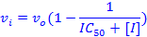 (1)
Where v₀ is the initial rate of the uninhibited reaction and v_{I} is the initial rate of the reaction at concentration I of inhibitor.
In Silico Docking and Binding affinity estimation:

In addition to the experimental assays, computational simulations elucidated the mechanism of SIRT3 compared to Sir2 through protein-ligand docking and subsequent binding affinity estimation. These techniques allow for an approximation of binding affinity of the native NAD⁺ substrate and multiple known inhibitors. Protein-ligand docking, and the MM-GBSA protocol , as well as a customized induced fit protocol were used for the binding affinity estimates, as described below.
Although protein-ligand docking programs such as Glide , AUTODOCK , or DOCK rank order ligand poses based on a docking score, these outputs are not reliable estimates for the binding affinity. Docking programs were designed to distinguish actives from inactives when screening large databases of potential ligands to a given protein active site. The computational simulations in this study attempted to differentiate between the Sir2 and SIRT3 nicotinamide inhibition mechanism, for which subtle variations in absolute binding energy between the various binding modes of the native NAD+ cofactor needed to be estimated. While other groups have reported correlating docking scores to or developing a custom scoring function for binding affinity, these approaches are limited to cogeneric series of ligands for which dozens of experimentally determined binding affinities are used as a training set. These methods are not applicable, as we are concerned with a possible subtle difference between two binding modes of the native cofactor, NAD+ and two inhibitors.
MM-GBSA enhances docking scores by adding an estimation of the missing energy contributions of the solvent through the generalized Born implicit solvent model. Because correlations to free energy of binding for multiple test systems were found to be good for a single structure approach and because the computationally more intensive combined molecular dynamics ensemble averaged MM-GBSA approach added little additional accuracy , we employed the simpler single structure method. The docking algorithm outputs multiple poses for each ligand, each with a slightly different conformation docked into the same starting protein. All of these structures, even lower ranking ones, are re-scored and re-ranked with the MM-GBSA function. The single highest ranked MM-GBSA score is used as the final binding affinity energy estimate.
Using the standard scoring functions to predict poses, then subsequently re-scoring those poses with MM-GBSA offers better prediction of binding affinities. The scoring functions in Glide and other docking programs are optimized to minimize the RMSD difference between predicted and x-ray determined structures for a large database of co-crystallized protein-ligand structures , rather than optimized to predict binding affinity. Re-ranking the poses with MM-GBSA method incorporates implicitly modeled solvent effects that are an important energy contribution and that are not modeled well in standard docking scores.
The first step in estimating binding affinity with MM-GBSA is prepping the raw crystal structure PDB file for docking. Multiple starting structures of SIRT3 (3GLT) and Sir2 (1YC2) with NAD+ co-crystallized in either the AB or AC pockets of the protein were prepared with the Schrodinger protein preparation protocol . Bond orders were assigned, missing hydrogens added, zero-order bonds to the zinc atoms created, missing side chains were filled in with the PLOP algorithm (Jacobson, Friesner et al. 2002) , and protein chain termini are capped. Protonation and tautomer states for the ligands were generated with Epik for a pH range of 7.0 +/- 3.0. H-bond assignment was done using PROPKA at pH 7.0 and included sampling all water orientations, as well as using crystal symmetry information. A final restrained minimization was performed with heavy atoms converged to RMSD 0.30 Å with the OPLS 2005 force field.
Three different protocols were used for docking, depending on the availability of NAD+ co-crystallized structures: (A) traditional docking, (B) induced fit docking, and (C) template induced fit docking. For Sir2, which has optimal x-ray structures with NAD+ co-crystallized in both the AB and AC pockets (PDB:1YC2 chains A and B, respectively), standard Glide XP docking (A) was used for both NAD+ docking into the AB and AC pockets and inhibitor/activator docking into the C pocket. This traditional docking is useful when the receptor structure does not change upon docking. Since SIRT3 had no publically available co-crystallized structures with NAD+ in the AB or AC pockets, the induced fit protocol (B) , which increases sampling by adding flexibility to the receptor, was used to dock NAD+ into the AC pocket. Neither traditional docking nor the induced fit protocol were sufficient to dock NAD+ into the AB pocket, thus a template induced fit method (C) was used to dock inhibitors/activators and NAD+ into the AB pocket. Below are details of each method A, B, and C.
Standard Docking method (A). Before docking, docking grids were calculated with the grid box centered on the known NAD+ binding site. For docking simulations which had difficulty reproducing the expected binding mode observed in crystal structures, such as the Sir2 AB pocket docking, optional ligand positional constraints, H-bond or metal constraints, hydrophobic constraints, and excluded volumes were added. In particular, an excluded volume was place in the C pocket for AB docking.
Glide was run in both SP (standard precision) and XP (extra precision) modes. Since Glide does not allow for receptor flexibility in docking, van der Waals (vdW) radius scaling softens the potential for nonpolar atoms in the receptor. The vdW radius was initially set at 0.85 (no scaling) with a partial charge cutoff of 0.15, then decreased to 0.50 in cases to minimize steric obstructions. Partial charges for the ligand and receptor are based on the OPLS 2005 force field along with the Epik determined ionization states on the ligand and the PROPKA ionization states on the receptor.
Induced Fit docking method (B). A number of similar implementations of induced fit docking are available which take advantage of side chain rotamer libraries to add protein receptor flexibility . We used the Schrodinger Induced Fit protocol, which iteratively uses Glide and a side chain optimization algorithm called PLOP to exhaustively consider possible binding modes and the associated conformational changes within the receptor. Traditional Glide docking with a static receptor for Sir2 and SIRT3 is not sufficient when the starting crystal structure is not from a co-crystallized structure with NAD+ in the desired binding mode because a loop as well as side chains move upon binding of NAD+ and upon NAD+ changing from the AC to the AB binding pocket. For example, Figure 8 and Figure 13 show steric clashes in docking NAD+ into Sir2 and SIRT3, respectively.
The induced fit method first docks the ligand into an inflexible receptor, similar to standard Glide docking. The collection of generated poses is then used as templates to refine the receptor, in which the ligand is kept frozen in its docked conformation and the protein side chains are optimized with PLOP. Next, the ligand and receptor from each of the structures refined with PLOP are energy minimized, allowing for both ligand relaxation and slight backbone/sidechain protein movement. The backbone movement only occurs through this relaxation step, rather than through extensive rotomer sampling as done with the side chains. The docking score, as well as receptor OPLSA energy and solvation are used to rank order each of these protein-ligand structures. Top ranked structures are then used iteratively as input back into the first step until the change in docking score is less than 0.5. Unlike with traditional docking, the Schrodinger Induced Fit protocol has limited constraints available. Excluded volumes and ligand positional or torsional constraints are currently not implemented in the protocol. As in traditional docking, a receptor region around the AB and AC binding pockets of around 18 Å a side is defined, and the ligand is docked flexibly, or, alternatively, rigidly in the expected conformation seen in the co-crystallized structures of NAD+ in the AB or AC pockets of Sir2Af2 (1YC2). Specified side chains are temporarily mutated to alanine to accommodate the ligand and improve side chain flexibility. In particular, Arg36 on Sir2Af2 (1YC2) sterically hinder the B pocket as shown in Figure 8.
Template Induced Fit method (C). Large steric clashes and loop minimization for docking NAD+ into the AB pocket of SIRT3 that the standard induced fit protocol could not accommodate were handled with a template based induced fit method. Unlike for Sir2 which has cocrystallized structures with NAD+, 3GLT with the trapped thio-acetyl ADPR intermediate is the closest available to a cocrystallized structure of NAD+ either in the AB or AC pockets. Glu323, Arg158, and MET644 from Chain B (the acetyl-lysine peptide substrate) obstruct the B pocket of SIRT3, as shown in Figure 13.
This method used NAD+ in the AB co-crystallized conformation from Sir2 as a template. First, the NAD+ intermediate and the bound peptide substrate, which are co-crystallized in 3GLT, were deleted. Next, the backbone of 1YC2 chain A (Sir2Af2) was superimposed into SIRT3, and the NAD+ from Sir2 was inserted into the nascent AB pocket of SIRT3 as the template. Side chains and backbone residues of the sterically clashing residues (A:157 to A:160 AND A:320 to A:324, and A:365 to A:367) were optimized with PLOP. This algorithm minimizes only these specified clashing residues around the fixed, superimposed NAD+ in the AB conformation by exhaustively considering sidechain and backbone rotamers based on a rotamer library. Additionally, sidechains are refined for residues within 6.0 Å of the clashing residues, while all other residues remain fixed. A dielectric constant of 1.00 internal and 80.0 external was used. Following this minimization, standard Glide docking is performed without any constraints as previously described.
The docked poses generated by any of the three above described docking protocols were used to calculate the MM-GBSA binding affinity estimate. Glide XP mode output a handful of highly scored poses, which were re-ranked using MM-GBSA. The SP mode output up to 1024 more lower scored poses which were also re-reranked, allowing for a more comprehensive sampling of poses with scores slightly higher in energy. The energies were calculated using the OPLS-AA force field and the GBSA continuum model. The binding free energy ∆G_{bind} is estimated as
∆G_{bind} = ∆E_{MM} - ∆G_{SOLV} + ∆G_{SA}
where ∆E_{MM} is the difference in energy between the complex structure and the sum of the energies of the ligand and unliganded protein, using the OPLS force field, ∆G_{solv} is the difference in the GBSA solvation energy of the complex and the sum of the solvation energies for the ligand and unliganded protein, and ∆G_{SA} is the difference in the surface area energy for the complex and the sum of the surface area energies for the ligand and uncomplexed protein.
A final correction to the MM-GBSA energy is the Monte Carlo multiple minimum (MCMM) ensemble average energy for the free ligand. The above-described MM-GBSA method uses a single unbound ligand pose determined from a simple local energy minimization from the bound docked complex. The single pose could be particularly misleading for a large, flexible ligand like NAD+ because the unbound state for the AC docked pose would have a different energy than the unbound state for the AB docked pose. The unbound energy should be the same for both of these structures. MCMM improves this single estimate by including an ensemble average of the 200 lowest energy unbound conformations found in the MC minimization in implicit water. The MCMM correction uses the single conformation of the highest MM-GBSA scoring docked protein-ligand complex rather than an ensemble average. While the inclusion of a protein-ligand ensemble average, which requires a full MD or MC method such as free energy perturbation (FEP) or thermodynamic integration (TI), is an important future direction, the MCMM method with MM-GBSA has been shown to be a good binding affinity estimate .
RESULTS
NAM inhibition at physiological concentration, Ki (Note: i=[I]/(Ki+[I]), IC50 is the substrate concentration observed at 50 % inhibition)
NAM is a known inhibitor of the deacetylation activity of sirtuins, but the inhibition mechanism of NAM toward its substrates for human SIRT3 has not been determined yet. The inhibition of nicotinamide and isonicotinamide in hSIRT3 deacetylation was tested in the presence of different concentrations of NAM with 90 minutes incubation of 1mM NAD⁺ at 37 ºC with IC50 of 36.7uM and 13.8 mM, respectively. Their IC50 in hSIRT1 were also measured using current method. The IC50 of NAM is 68.1 uM and of isoNAM is 12.2 mM (Figure 1). They are in good agreement with reported data.
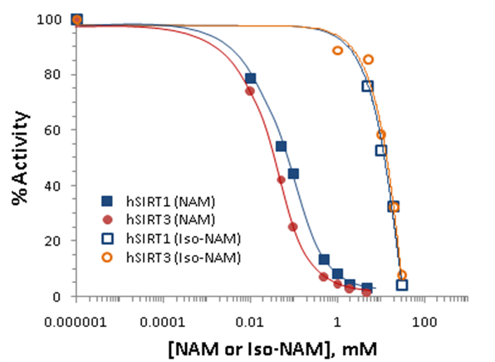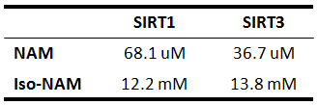

Figure 1: Nicotinamide inhibition assays showing percent change in deacetylation activity as a function of nicotinamide concentration. Data for the hSIRT1 enzyme are indicated with close square and a blue curve; data for the hSIRT3 are indicated with filled circles and a red line. The IC50 for the hSIRT3 enzyme is 36.7 uM, and that of the hSIRT1 enzyme is 68.1 uM (inset table).
Nicotinamide is a noncompetitive inhibitor of recombinant human SIRT1 and competitive inhibitor of recombinant human SIRT3 in vitro.
To gain more insight into the effects of nicotinamide on hSIRT3 activity, the in vitro hSIRT3 deacetylated activity was measured in the presence of varying amounts of nicotinamide. We utilized a novel deacetylated activity assay that generates a fluorescent signal upon deacetylation of a peptide substrate. When incubated with acetylated substrate and NAD⁺, recombinant human SIRT3 gives a strong fluorescent signal 10-fold greater than no enzyme and no NAD⁺controls (data not shown). Using this assay, we tested the ability of nicotinamide to inhibit deacetylation in the presence of varying concentrations of NAD⁺. To evaluate the reliability of the method, the in vitro hSIRT1 deactylated activity was measured as well. A double reciprocal Lineweaver-Burk plot of the data (Figure 2A) shows that nicotinamide is a strong noncompetitive inhibitor of this reaction. We next tested whether the inhibitory effects of nicotinamide could be extended to inhibit human SIRT3 in vitro. Using recombinant hSIRT3, we monitored deacetylation of substrate in the presence of varying amounts of nicotinamide and NAD⁺. Differ to hSIRT1, interestingly, a Lineweaver-Burk plot of the data shows Figure 2B). These results imply that nicotinamide does not inhibit hSIRT1 deacetylation by competing with NAD⁺ for binding to the enzyme, but does inhibit hSIRT3 deacetylation by competing with NAD⁺ for binding to the enzyme.
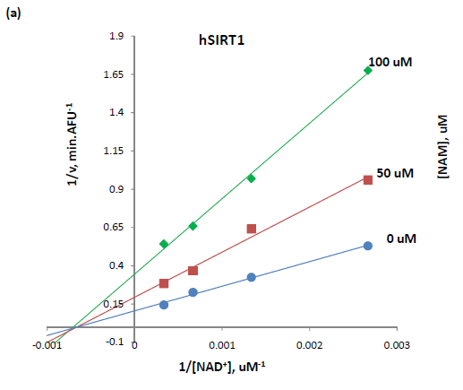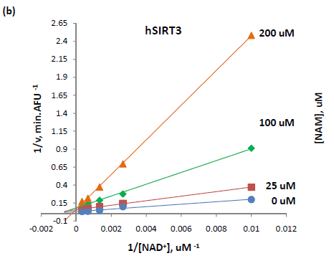
Figure 2: (A) Recombinant human SIRT1 was incubated with 50 uM of SIRT1 substrate for 0, 10, 20, 30, 60, 120, 180, and 240 min at 37ºC in the presence of 125, 250, 500, 1000 uM NAD⁺ and 0, 50, and 100uM nicotinamide. (B) Recombinant human SIRT3 was incubated with 100 uM of acetylated substrate for 40 min at 37ºC in the presence of 100, 375, 750, 1500, 3000 uM NAD⁺ and 0, 25, 100, and 200 uM nicotinamide. Reactions were terminated by the addition of developer and samples were analyzed by flourometry (excitation set at 355 nm and emission at 460 nm). Experiments were performed in triplicate. Data are shown as a Lineweaver-Burk double-reciprocal plot of arbitrary fluorescence units (AFU) min⁻¹ versus 1/[NAD⁺] uM⁻¹.
Human SIRT3 inhibition effect by nicotinamide in the presence of isonicotinamide. Isonicotinamide was reported as an activator of Sir2 activity shown to directly compete with nicotinamide for binding. Nicotinamide is a potent inhibitor of the Sir2 reaction because of its ability to rebind with the enzyme and react with a high-energy intermediate, preventing deacetylation and regenerating starting materials . The basis for the observed activation is the relief of the inherent nicotinamide inhibition by competition with isonicotinamide, which does not readily react with the enzyme intermediate. Does the aforementioned rule of isoNAM fit on hSIRT3? The hSIRT3 inhibition effect by NAM was studied in the presence of different concentration of isoNAM. Figure 3 shows that in the presence of isonicotinamide (50 uM - 900 uM), hSIRT3 inhibition of NAM was about 20% decreased.
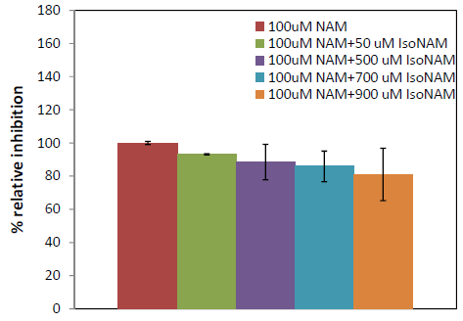
Figure 3: Recombinant human SIRT3 was incubated with 50, 500, 700 and 900 uM of isoNAM for 40 min at 37ºC in the presence of 500 uM NAD⁺, 50 uM of Acetylated substrate, and 100 uM nicotinamide. Reactions were terminated by the addition of developer and samples were analyzed by flourometry (excitation set at 355 nm and emission at 460 nm). Experiments were performed in triplicate.
Although the IC50 for isonicotinamide was about three orders of magnitude worse than nicotinamide binding, in vivo yeast studies showed that millimolar levels of isonicotinamide increased Sir2- dependent silencing of the telomeric URA3 gene. These results suggest that the development of higher affinity nicotinamide antagonists may provide a means to upregulate cellular sirtuins. However, great care will be needed to avoid cross reactivity with other nicotinamide utilizing enzymes, in particular, those involved in NAD⁺ salvage and synthesis.
Measurement of IC50 and Ki values for hSIRT3 inhibitors. Since nicotinamide is a strong inhibitor of hSIRT1 and hSIRT3, 5 pyridine analogues, which have structural similarity with nicotinamdie, were tested for its ability to inhibit hSIRT3 activity. The results indicated that none of these small molecules are strong inhibitors of hSIRT3. The values of IC₅₀ and K_{i} are listed in Table 1. The K_{i} value was determined by substituting the IC50 value for NAD⁺ and Km value for NAD⁺ (1mM) into
(Competitive inhibition) and (noncompetitive inhibition)

where [NAD⁺] is the concentration of NAD⁺ used in the assay.
Table1. The IC₅₀ and K_{i} values of hSIRT1 and hSIRT3 by 6 pyridine analogues.
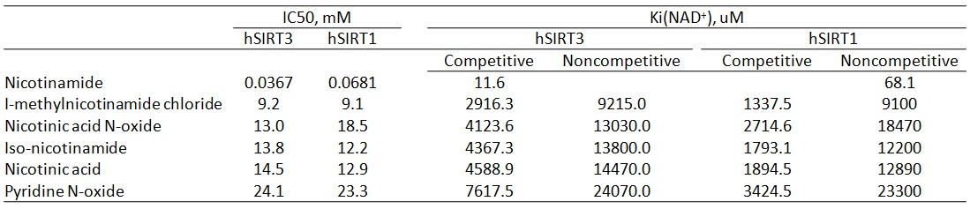
Simulation Result – Sir2
MM-GBSA predicted binding affinities for Sir2 support the noncompetitive nicotinamide inhibitor experimental results. In noncompetitive inhibition mechanistic models, when the inhibitor, such as nicotinamide, occupies the C pocket preventing NAD+ from occupying the productive AC pocket binding mode, NAD+ can equally bind to the AB pockets and wait for the noncompetitive inhibitor to leave. Binding affinity estimates of NAD+ binding in the two different modes are about equal, supporting the noncompetitive mechanistic model.
Both in-place and cross docking estimates predicted approximately equal binding affinity for the AC or AB pocket mode. Cross docking validated the method with Sir2 (Sir2Af2, PDB:1YC2), in which NAD+ was docked into the AC pocket starting with the x-ray structure with the NAD+ originally in the AB pocket, and vice versa. These results were compared with the in-place MM-GBSA binding affinity estimate, in which the co-crystallized structure is used in-place for scoring without any docking, ligand or protein movement. As hypothesized for noncompetitive inhibition, the MM-GBSA predicted in place ∆G_{binding} is very similar for NAD+ in the AC pocket (-92.6) and the AB pocket (-95.2). Like the in place predicted binding, the cross-docked predicted ∆G_{binding} are similar at -xxx (find these results) and -yyy. Note that the units are proportional to kcal/mol, but have not been normalized to experimental binding affinities for this system. [should I normalize?]
Cross docking into the AC pocket worked well with no constraints, as shown in Figure 5. The above reported Sir2 cross-docking poses were degenerate for NAD+ binding in the AB pocket. Figure 6 shows the acceptable results within about 2 ?RMSD from the known crystal structure when using Glide XP with only one constraint: an exclusion volume in the C pocket necessary to prevent re-docking to the starting structure. Figure 6Figure 7, the protein-ligand interaction diagrams, show the adenine diphosphate side of the NAD+ held firmly in place by 11 intermolecular hydrogen bonds between the ligand and the protein in the A pocket for Sir2 either in the AB or AC pockets. Figure 7 shows that the C pocket is not exposed to solvent, and the docked structure is not degenerate.
ARG:36 from the protein in the AC conformation sterically clashed with the nicotinamide end of NAD+ in the AB conformation in the cross docking. Figure 8 shows the superposition of the AB and AC conformations of the protein, highlighting how the sidechain of the ARG rotates about 90° into the B pocket. In addition, the backbone significantly moves starting at residue 36 and culminating at more than 6 Å with TRP:42. Induced fit docking was needed to move this ARG out of the B pocket during cross docking.
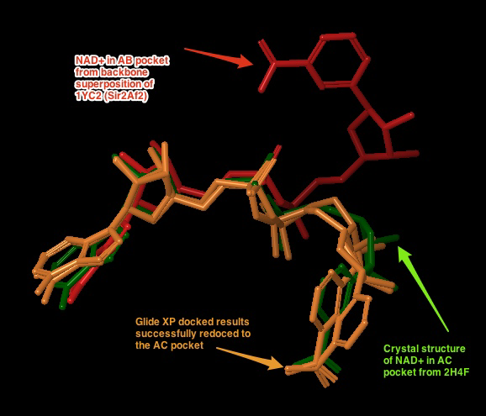
The nicotinamide end of NAD+ adopts two flipped conformations in the crystal structures: one with amide hydrogen of the nicotinamide end of NAD+ in the AB pocket of the Sir2Af2 (1YC2 chain D) making an intramolecular hydrogen bond to the ligand phosphotidyl oxygen, and another with this amide pointed towards the solvent (1YC2 chain A). Figure 6 shows no hydrogen bonds in the B pocket with the outer half of the pocket exposed to solvent allowing the nicotinamide to move. This intramolecular H-bond is never seen in the docking, possibly because the energy is truly degenerate in this case where most of the nicotinamide is exposed to solvent, or Glide has systematic bias against ligand intramolecular H-bonds. In addition, the nicotinamide in the B pocket must move to the C pocket, and this degenerate flexibility in solvent could facilitate this motion.

Figure 4: the two top ranked Glide XP docked results of NAD+ docked to the Sir2 AC pocket (orange), with the co-crystallized comparison structure from 2H4F (Sir2Tm) in green. The NAD+ in the AC pocket conformation is shown in red. GlideScores ranged from -15.0 to -17.5.

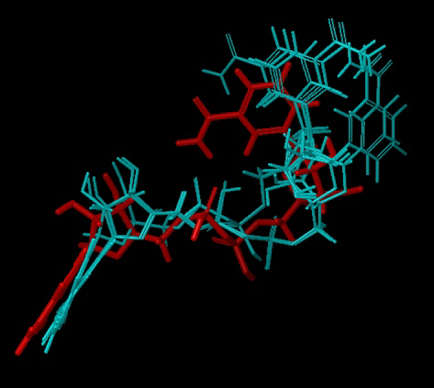
Figure 5: Cross docking of NAD+ into the AB pocket of the crystal structure of 1YC2 (Sir2) with NAD+ originally in the AC pocket. The red pose is from the AB pocket co-crystallized structure. The blue are the degenerate top ranked and only output from Glide XP with an excluded volume in the C pocket and a completely flexible ligand. The RMSD of the closest structure is 1.98 Å, and the GlideScores for all 5 degenerate structures ranged from -9.9 to -12.2.

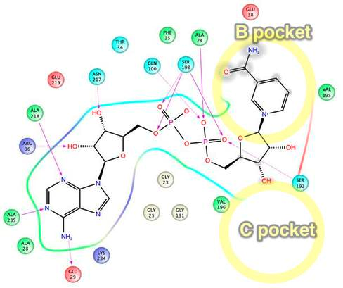
Figure 6: Sir2Af2 NAD+ in AB pocket
Intermolecular protein-ligand diagram of Sir2Af2 (1YC2 chain A) with NAD+ in the AB pocket. In this flattened 2D reppresentation of the protein-ligand interactions, residues are represented as colored spheres, where: red=acidic, green=hydrophobic, blue=polar, light gray=(Gly,water), dark gray=metal atoms. Solid pink lines are H-bonds to the protein backbone; dotted pink are H-bonds to the side chains; green are pi-pi stacking interactions; orange are pi-cation interactions. Protein and water residues within 3.0 Å of the NAD+ are shown. The lack of a protein "pocket" line around the nicotinamide end and the grey spheres around those atoms indicate that the nicotinamide end is exposed to solvent. The B pocket (show as a yellow circle) is a crevice open to solvent, while the C-pocket (lower yellow circle) is protected by a loop from the solvent (shown in the next diagram). The C-pocket is empty or collapsed in this structure. Also note that there are no H-bonds or other specific intermolecular interactions between the protein and the nicotinamide end of NAD+. Images produced in Maestro.
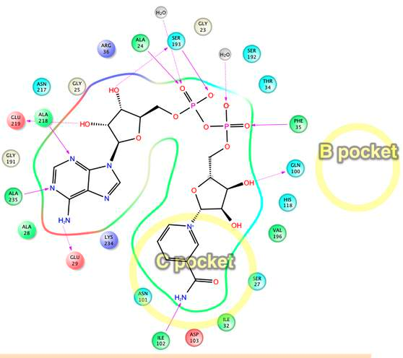
Figure 7: Sir2Af2 NAD+ in AC pocket
Intermolecular protein-ligand diagram of Sir2Af2 (1YC2 chain B) with NAD+ in the AC pocket. Protein and water residues within 3.0 Å of the NAD+ are shown. Unlike in the AB pocket, the NAD+ molecule is completely surrounded by protein residues in the entire A and C pockets. The nicotinamide is not exposed to solvent, unlike in the B pocket. The approximate location of the B pocket is shown due to distortions created by transforming the 3D protein-ligand picture into a simple 2D diagram. There is a backbone H-bond between the protein ILE102 and the nicotinamide end of NAD+.

Figure 8: Movement of the ARG36 side chain. The crystal structure of NAD+ in the AB cpockets (blue) cocrystallized with Sir2 (aqua). The backbone superimposed structure from the AC conformation shows this same ARG:36 in red. This ARG clashes with the superimposed nicotinamide (blue)

Simulation Result – SIRT3
SIRT3 NAD+ and inhibitor protein-ligand MM-GBSA binding estimates support a competitive inhibition mechanism, which agrees with the experimental results. NAD+ binding estimates show that the ligand binds more favorably to the AC pockets vs the AB pockets. The top ranked AB pocket binding approximation is -84.4 with an RMSD of 1.82 Å from the backbone-superimposed structure of NAD+ cocrystallized in Sir2 (1YC2 chain A) (Figure 10). The top ranked AC pocket customized induced fit docking result was much more favorable at -107.9. Figure 11 shows this top ranked pose along with seven other top ten docked ligands, all within 3.4 Å RMSD of the superimposed crystal structure NAD+ from 1YC2. Standard docking of the nicotinamide and iso-nicotinamide place these inhibitors/activators in the C pocket (Figure 12). These results corroborate the competitive inhibitor mechanism in which the nicotinamide blocks NAD+ from binding to the C pocket, while the AB pocket binding of NAD+ is not equally favored as it is in Sir2.
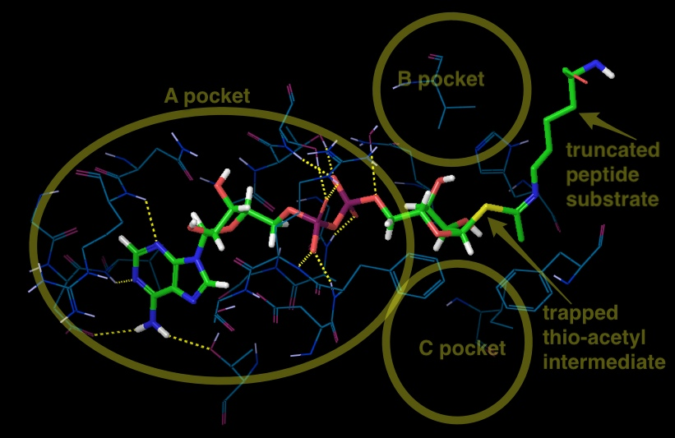
Figure 9: The best docking starting structure for SIRT3 is 3GLT, which has the thio-intermediate of the acetyl-lysine peptide. The nicotinamide has been cleaved and a bond to the thioacetyl is trapped. SIRT3, 3GLT with the trapped thio-acetyl lysine ADPR intermediate. The B and C pockets are unoccupied because of the intermediate . H-bonds between the ADPR and the protein residues within 3 of the ligand are shown here.

Figure 10: 4 out of the top 20 (based on the emodel glide score; colored white) docked the NAD+ into the AB pocket of SIRT3. Similar to the other figure with AC pocket docking from this same simulation, NAD+ in the AC pocket from the co-crystallized structure of 1YC2:B is red. The 2 structures from 1YC2 (chains A and D) with NAD+ in the AB pocket are pink. The rank order of these 4 structures was 11, 13, 17, and 18 with RMSD to the superimposed 1YC2:A NAD+ of 2.18, 1.82, 2.17, 2.48 Å, respectively.
Figure 11: 8 out of top 10 (based on emodel glide score) docked the NAD+ into the AC pocket of SIRT3. Green are these 8 molecules. Red is the NAD+ in the AC pocket from the co-crystallized structure of 1YC2:B. Pink are the 2 structures from 1YC2 (chains A and D) with NAD+ in the AB pocket. The amide from the nicotinamide is pointing in both directions.
Figure 12: Docking of iso-NAM and NAM without constraints into 3GLR, human SIRT3 with acetyl-lysine AceCS2 peptide, but no NAD+ or intermediate co-crystallized. The custom induced fit structure as used in the above SIRT3 AB NAD+ docking was used.

The above results use the template based induced fit method because of the difficulty in docking NAD+ into the AB pocket of SIRT3. While traditional and induced fit docking succeeded in placing NAD+ in Sir2 and into the AC pockets of SIRT3, these docking methods failed for the AB pocket when starting with the best available crystal structure for SIRT3 (3GLT) (see figure 6). AB pocket docking did not work for SIRT3 because the standard induced fit side chain and backbone optimization could not sufficiently open the B pocket for the nicotinamide end of NAD+, as shown in Figure 13. Only the customized template based induced fit method successfully docked NAD+ into the AB pocket. This method mainly moved the side chains shown in Figure 13, and it also minimally moved the backbone for residues 320 to 324, while maintaining identical backbone structure for the remaining residues (see Figure 14).
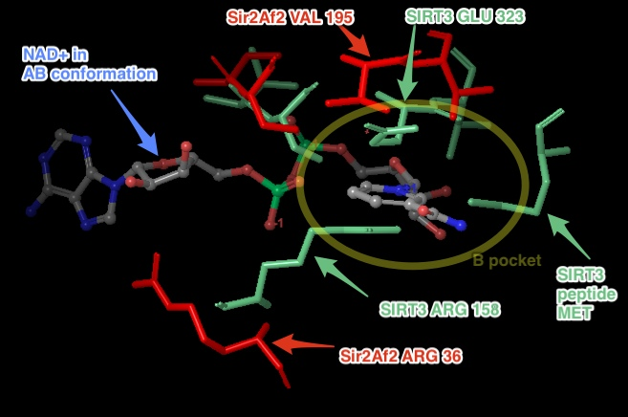
Figure 13: Steric clashes between NAD+ in the AB conformation and SIRT3 (from the thio-acetyl ADPR intermediate). This is a top view of the NAD+, where the B pocket is oriented on top of the C pocket within the axis perpendicular to the figure. The steric clashes are labeled in aqua, and the B pocket is labeled with the yellow oval. Comparable Sir2Af2 residues within 6 ?of the nicotinamide in the B pocket are in red. The Sir2Af2 structure is from the NAD+ co-crystallized PDB file 1YC2 chain A with NAD+ in the AB pockets. This structure is aligned to the SIRT3 protein backbone from 3GLT. 3GLT has the thio-acetyl ADPR intermediate, which has the nicotinamide cleaved off. The depicted NAD+ cofactor is from the Sir2Af2 co-crystallized structure. Note that Sir2 does not obstruct the B pocket. For example, the ARG 36 in Sir2Af2 is moved back and its side chain rotated out of the way in comparison to SIRT3 ARG 158. While SIRT3 has GLU 323 which obstructs the nicotinamide, Sir2Af2 has a Val 195 pushed farther back leaving room for the nicotinamide. There are no steric clashes with peptide substrate residues, like there is with the SIRT3 MET.
Figure 14: SIRT3 backbone movement after PLOP minimization with the template NAD+ in the AB conformation was minimal. In the constrained minimization, only residues 157 to 160, 320 to 324, and 365 to 367 were free to move. The backbone moved only for residues 320 to 324, while the remaining backbone for other residues were either constrained or did not move.

Although the use of the template of the AB docked NAD+ from Sir2 superimposed onto SIRT3 may bias the resulting docking to the AB pocket, a few factors justify this method. One, all other docking attempts with and without multiple constraints failed. Two, the possibly biased result still remained less favorable than AC pocket binding estimates. Even if AB pocket docking is precluded in the real system, the mechanistic conclusion for competitive inhibition is the same. Thirdly, crystallographers failed with multiple protocols to cocrystallize NAD+ into either the SIRT3 productive or unproductive binding pocket, with or without the acetyl-lysine substrate . While NAD+ has been observed to bind in the productive (AC) binding site for Sir2Af2 and Sir2Af1 and in the non-productive (AB) binding site for Sir2Af2, Sir2Af1 in the absence of the peptide substrate , NAD+ cannot bind to SIRT3 efficiently in the absence of this peptide .
Glide XP docked nicotinaimde and iso-nicotinamide (figure 7) into the C pocket, but not the ligand is not perfectly aligned with the nicotinamide end of the backbone aligned 1YC2:B NAD+. The iso-NAM has the amide end pointing in a different direction than the NAM. It is not clear why the two inhibitors adopt different conformations from the superimposed nicotinamide end of the NAD+. The side chains in the C pocket in the crystal structures could be slightly different than that of the C pocket in Sir2 which has NAD+ co-crystallized in the AC pockets. When nicotinamide was docked into this Sir2 structure, the NAM almost exactly aligned with the crystal structure nicotinamide end of the NAD+. At a minimum, the iso-NAM and NAM docked in the general C pocket volume, which is an open void allowing much wiggle room for these small molecules.
DISCUSSION
SIRT3 is a member of the sirtuin family of protein deacetylases that is preferentially localized to mitochondria. Many proteins targeted by SIRT3 are enzymes involved in energy metabolism processes, including the respiratory chain, fatty acid β-oxidation, and tricarboxylic acid (TCA) cycle . Through these actions, SIRT3 controls the flow of mitochondrial oxidative pathways and, consequently, the rate of production of reactive oxygen species (ROS). The involvement of SIRT3 in processes closely associated with human pathologies, from the metabolic syndrome to cancer, as well as in many other aging-related diseases (cardiac dysfunction and neural degeneration), raises the enormous interests in SIRT3 function and regulation in the context of biomedical research. As with other sirtuins, SIRT3 holds great promise as a ‘druggable protein’, i.e. a protein target capable of binding drug-like molecules. In this scenario, SIRT3 and its subsequent biological effects may be modulated by small molecules or nutrient pharmaceuticals (nutriceuticals) that influence the deacetylase activity of SIRT3.
Whether SIRT3 serves as a tumor promoter or suppressor has been wildly discussed. On one hand, increased levels of SIRT3 associated with node-positive breast cancer versus non-malignant breast tissue as well as with oral squamlors cell carcinoma, suggesting that SIRT3 could function as a tumor promoter. On the other hand, SIRT3 expression is decreased in many different types of human cancers, and heterozygous loss of SIRT3 occurs in 40% of human breast malignancies. Much work will be needed to pinpoint the precise molecular mechanisms governing SIRT3 functions in cancer. But one thing is sure: these proteins clearly link DNA repair and metabolism, two hallmarks of cancer. As such, it is tempting to envision that modulators of SIRT3 activity could provide future beneficial alternatives against this devastating disease.
Other than cancer, SIRT3 plays a role in the emerging cardiac pathologies associated with diabetes, obesity, and cardiac ischemia . Direct investigations have shown that SIRT3 plays an important ameliorative role in preventing pathology form pressure overload and aging-associated decline in cardiac function. The direct pharmacological modulation of SIRT3 may confer greater benefit compared with the disappointing results to date of other antioxidant approaches in cardiac disease is an intriguing concept, although the inhibition of SIRT3 activity is the interest of current paper.
The inhibition of enzyme activity is one of the major regulatory devices of living cells, and one of the most important diagnostic procedures of the enzymologist. Inhibition studies often tell us something about the specificity of an enzyme, the physical and chemical architecture of the active site, and the kinetic mechanism of the reaction. Three potential modes of inhibitor interactions with enzymes are defined as: (A) competitive inhibitors that bind exclusively to the free enzyme form; (B) noncompetitive inhibitors that bind with some affinity to both the free enzyme and to the enzyme-substrate complex (ES complex); (C) uncompetitive inhibitors that bind exclusively to the ES complex or subsequent species.
Given the potential roles in metabolic, neurodegenerative, and aging-related diseases of sirtuins, the potent and selective inhibitors are investigated with different inhibition modes, like, 1)suramin is a noncompetitive SIRT1 inhibitor respect to NAD⁺ by binding into the B- and C- pockets of the NAD⁺-binding site as well as the substrate-binding site; and 2) cambinol competitively inhibits SIRT1/SIRT2 against to acetyl lysine peptide substrate.
To gain a better understanding of inhibition modes, it is worthy to review some of its theory. An inhibitor that binds exclusively to the free enzyme is said to be competitive because the binding of the inhibitor and the substrate to the enzyme are mutually exclusive; hence these inhibitors compete with the substrate for the pool of free enzyme molecules.
k_{s} k_{p}
E + S  ES  E + P
+
I ks = [E][S]/[ES]
k_{i}  ki = [E][I]/[EI]
EI kp = rate constant for the breakdown of ES to E + P

Because competitive inhibitors bind to the free enzyme to the exclusion of substrate binding, it is easy to assume that this results from a direct competition of the two ligands (substrate and inhibitor) for a common binding pocket (i.e., the active site) on the enzyme molecule. As shown in equation 2,
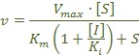 (Eq. 2)
when [I] = IC₅₀, initial velocity is twice of velocity in the presence of inhibitor, then 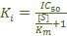 . In the presence of competitive inhibitor, the V_{max} remains unchanged but the apparent K_{m} for the substrate increased. There are a very large number of drugs in clinical use today that function as competitive enzyme inhibitors.
A noncompetitive inhibitor is one that displays binding affinity for both the free enzyme and the enzyme-substrate complex or subsequent species.
k_{s} k_{p}
E + S  ES  E + P
+ +
I I ks = [E][S]/[ES]=[EI][I]/[ESI]
k_{i}  k_{s}  k_{i} ki = [E][I]/[EI]=[ES][I]/[ESI]
EI + S  ESI

In the presence of noncompetitive inhibitor, the V_{max}, decreases but has no effect on the K_{m} value (Eq. 3). The degree of inhibition in the presence of a noncompetitive inhibitor depends only upon
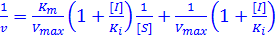 (Eq. 3)
[I] and K_{i}. The inhibited velocity (vi) is always a constant fraction of v₀, regardless of the substrate concentration or the value of K_{m} (Eq. 4). An increase in [S] causes both v₀ and vi to
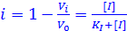 (Eq. 4)
increase by the same factor. When [I] = IC₅₀, v₀=2v_{i} then K_{i} = IC₅₀. A diagnostic signature of noncompetitive inhibition is that the double reciprocal plot displays a nest of lines that intersect at a point other than the y-axis. Relative to competitive inhibitors, there are fewer examples of noncompetitive inhibitors in clinical use as drugs today. This reflects the historic approaches to drug discovery that have been largely focused on active-site directed inhibitors. With a greater emphasis on compound library screening as a mechanism of lead identification, more examples of noncompetitive inhibitors are likely to emerge, especially if attention is paid to designing screening assays that balance the opportunities for identifying the greatest diversity of inhibitor modalities.
An inhibitor that binds exclusively to the ES complex, or a subsequent species, with little or no affinity for the free enzyme is referred to as uncompetitive. Inhibitors of this modality require the prior formation of the ES complex for binding and inhibition. An uncompetitive inhibitor decreases V_{max and} K_{m} value to the same extent.
k_{s} k_{p}
E + S  ES  E + P
+
I ks = [E][S]/[ES]
 k_{i} ki = [ES][I]/[ESI]
ESI
The degree of inhibition depends on the substrate concentration, but, unlike competitive inhibition, the degree of inhibition increases as [S] increase (Eq. 5).
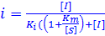 (Eq. 5)
When [I] = IC₅₀, v₀=2v_{i} then K_{i} = IC₅₀. As with noncompetitive inhibitors, uncompetitive inhibition cannot be overcome by high substrate concentrations; in fact the affinity of uncompetitive inhibitors is greatest at saturating concentrations of substrate. Depending on the physiological conditions experienced by the target enzyme, this inability of high-substrate concentrations to overcome noncompetitive and uncompetitive inhibitors may offer some clinical advantage to these inhibition modalities.
Human SIRT3 crystal structure has been solved in 2009, promoting us to use computer-based design methods to identify novel inhibitors or to establish structure-activity relationships for known inhibitors. Ligand docking methods have provided insights into the binding mode of Sir2 inhibitors.
Nicotinamide is the physiological sirtuin inhibitor. The IC50 values of nicotinamide inhibition of bacterial Sir2, yeast Sir2, mouse Sir2, human SIRT1, SIRT2 and human SIRT3 were 26, 120, 160, 50, 100, 36.7*uM, respectively *current work 2012). Nuclear nicotinamide levels has been estimated to be 10-150 uM , which most likely make NAM as Sirtuin activity regulator in vivo. Early studies reported nicotinamide bind an allosteric site , however more recent work observed that NAM inhibition depends on its ability to condense with the high-energy enzyme: ADP ribose:acetyl-lysine intermediate to reverse the reaction, reforming NAD⁺ (Scheme 1). And NAM noncompetitively inhibits deacetylation reaction of sirtuins with a single
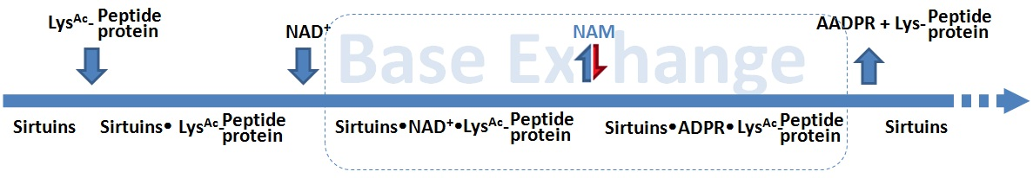
Scheme 1. Sirtuins deacetylase reaction follows ordered sequential mechanism.
binding pocket C (Avalos et al, 2005), the same site that binds the nicotinamide of NAD⁺. Rebinding of nicotinamide to the Sir2/intermediate complex can promote the reverse reaction to reform the substrates, and thus inhibits the deacetylation reaction . Sir2 thus appear to be affected by physiological nicotinamide concentrations, assumed to be up to 0.1mM, and a role of nicotinamide as endogenous Sir2 regulators supported by in vivo studies in yeast, flies, and mammalian cells .
Few groups have been reported that NAM can react to regenerate acetyllysine and NAD⁺ in a nicotinamide exchange reaction, in which the imidate intermediate is emptied during normal steady-state turnover, directing NAM inhibition of deacetylation. By using [carbonyl-¹⁴C] nicotinamide the Base Exchange reaction for Sir2 was extensively studied (Scheme 2).
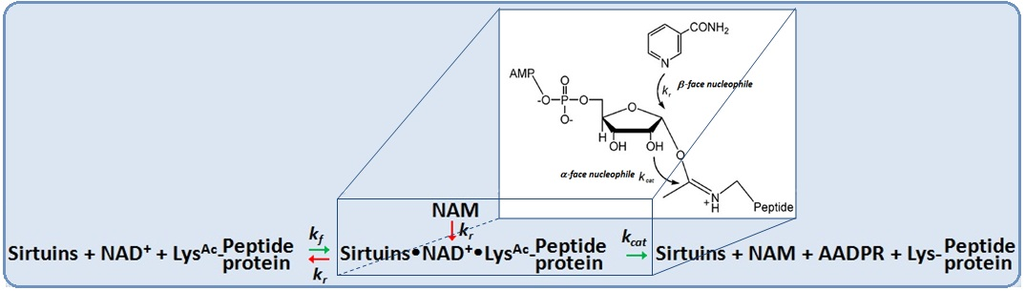
Scheme 2.The competitive nucleophilic attacks on the Sir2 intermediate occur from both stereochemical faces.
The reactivity between Base Exchange and deacetylation reactions occurs when NAM is cound. This competition partitions the intermediate forward and backward to provide inhibition of deacetylation. The independence of the deacetylation and base exchange reactions establishes that base exchange is a β-face nucleophile process, whereas deacetylation is an α-face nucleophilic process.NAM partition ratios are controlled by the relative rates of nucleophilic chemistry at the β-face versus the α-face of the intermediate. The exchange and deacetylation reactions share the intermediate forming step, and the ratio is determined by the chemical processes. It seems likely that unreactive isosteres of NAM that interfere with NAM binding could derepress sirtuin enzymatic activity and increase sirtuin function
Isonicotinamide can compete with nicotinamide for binding but cannot initiate the reverse reaction, thereby leading to apparent activation through relief of nicotinamide inhibition . Similar findings were observed in current study. The addition of 900uM isonicotinamide decreases the hSIRT3 inhibition by 20% in the presence of 100uM NAM. Structural and further biochemical studies on these compounds and mechanisms might enable the development of isoform selective modulators. Combining computational docking results, a proposed mechanism of activation of hSIRT3 deacetylation by isoNAM is described in Scheme 3. IsoNAM has minor inhibition effect of hSIRT3 with IC50 = 13.8 mM. IsoNAM does not compete with NAD+ or acetyl lysine binding to hSIRT3, and it does not react with the imidate. However, isoNAM competitively inhibit NAM-exchange reaction thereby activates hSIRT3 activity by reliefing NAM inhibition. The compound isoNAM is a weak binding to hSIRT3 and only derepresses NAM inhibition at millimolar concentrations. The effect of isoNAM on yeast Sir2 has been reported to enhance gene silencing and correct for deletion of PNC1. IsoNAM is relatively non-toxic to mammalian cells, readily penetrates cells, very stable, and highly soluble in water, which make it a suitable starting compound to study with for design of sirtuin activator.
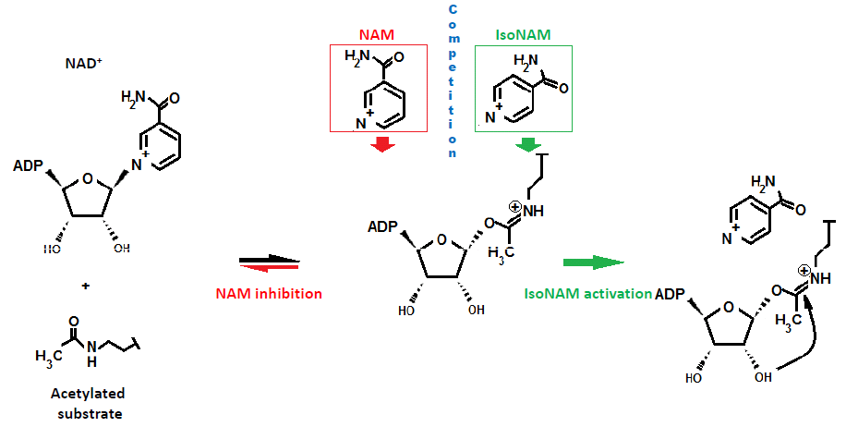
Scheme 3: Mechanism of activation of hSIRT3 deacetylation by isoNAM. IsoNAM compete with NAM to block position above β-face of imidate in which NAM induces chemical reversal of the imidate.

Eric part-----
Rational computational design of activators more effective than iso-NAM requires prediction of reaction rates for iso-NAM and NAM dissociation from the C pocket. The possible key to isoNAM's activation of Sir2/SIRT3 in the presence of the more potent nicotinamide inhibitor is isoNAM's ability to antagonize nicotinamide binding to the sirtuin. Nicotinamide inhibition has been shown to be linked not only to binding in the C pocket, but also to reversal of the reaction of the intermediate imidate to the re-formation of the NAD+[8]. IsoNAM is an unreactive isostere, which binds to the C pocket, but cannot participate in the reversal of the reaction because of the shifted location of the nitrogen on the pyridine ring of nicotinamide. This shift disrupts covalent binding to the imidate intermediate, preventing reformation of NAD+.
One path to computationally design these types of activators is to balance increased C-pocket affinity with design of compounds that are non-reactive with the imidate intermediate. A more potent C-pocket binding, but non-reactive species to the imidate, must also be able to leave upon the next reaction cycle - either by movement in the C-pocket due to the deaceylated peptide leaving or the the product 2’-O-acetyl-ADPR leaving. Alternatively, one could imagine a high affinity activator leaving when the next NAD+ that bound to the AB pocket shifts it's nicotinamide end, booting out the activator. While these possible mechanisms are conjecture, this activator must, at some point dissociate from the C pocket so the NAD+ can react with the acetyl-lysine peptide.
There are a few key limitations of the docking/MM-GBSA method. Protein structural changes other than localized side chain or small backbone movements are ignored. Allosteric inhibition or activation by nicotinamide or iso-nicotinamide binding cannot be tested. MM-GBSA method provides a fast, first estimation to more accurately rank order the raw protein-ligand docking results than docking alone . While sufficient in detecting relatively similar binding affinities (as between AB and AC binding in Sir2) or large differences (as between AB and AC binding in SIRT3), MM-GBSA ignores a number of important dynamic contributions to binding affinity and mechanistic studies. (list specific limiataions?)
Future simulations to obtain more reliable estimates of binding affinity differences between the AB and AC pockets could involve more sophisticated techniques. Accurate computational affinity predictions using more sophisticated simulations beyond docking are known to be challenging . For example, the customized template based induced fit protocol used for docking NAD+ into the AB pocket of SIRT3 could be extended to iteratively incorporate template based loop/side chain prediction with a flexible ligand. More computationally intensive molecular dynamics based simulations such as linear interaction energy (LIE), thermodynamic integration (TI) or free energy perturbation (FEP) have been shown to be more accurate and include more degrees of freedom to dock to the AB pocket. TI or FEP studies are critical next steps, especially amenable to the manageably low number of protein-ligand complexes studied in this paper.
In summary, SIRT3 is the major sirtuin deacetylase in mitochondria, where bioenergetics, oxidative stress, and apoptosis are controlled. In order to have better understanding of the basic cell biology processes as well as a pharmacological and/or nutritional target for intervention, the extensive efforts for development of SIRT3 modulators are needed. Experimental results reported here indicate that NAM, a noncompetitive inhibitor of Sir2 and SIRT1, competitively inhibits hSIRT3 by competing the binding site at C pocket with NAD⁺, which reveals a different strategy for SIRT3 inhibitor design. Molecular docking is performed in current study. X-ray crystal structures of Sir2Af2 and human SIRT3 are employed as the starting point for docking analysis. In addition, incorporation of protein flexibility and backbone conformation change upon ligand association are taking into consideration. Simulation data show that ……………………………… Computer-assisted drug design coupled with experimental confirmation has become an attractive alternative to the tradition in vitro and in vivo screenings. Taken together, we anticipate that the structural elucidation of the NAM inhibitory for hSIRT3 enzymes reported here will provide the direction for designing a new generation of SIRT3 modulator.
RFERENCES
1. Minino, A. M., Murphy, S. L., Xu, J., and Kochanek, K. D. (2011) Deaths: final data for 2008, National vital statistics reports : from the Centers for Disease Control and Prevention, National Center for Health Statistics, National Vital Statistics System 59, 1-126.
2. Frye, R. A. (1999) Characterization of five human cDNAs with homology to the yeast SIR2 gene: Sir2-like proteins (sirtuins) metabolize NAD and may have protein ADP-ribosyltransferase activity, Biochemical and Biophysical Research Communications 260, 273-279.
3. Frye, R. A. (2000) Phylogenetic classification of prokaryotic and eukaryotic Sir2-like proteins, Biochemical and Biophysical Research Communications 273, 793-798.
4. Onyango, P., Celic, I., McCaffery, J. M., Boeke, J. D., and Feinberg, A. P. (2002) SIRT3, a human SIR2 homologue, is an NAD-dependent deacetylase localized to mitochondria, Proceedings of the National Academy of Sciences of the United States of America 99, 13653-13658.
5. Lombard, D. B., Alt, F. W., Cheng, H. L., Bunkenborg, J., Streeper, R. S., Mostoslavsky, R., Kim, J., Yancopoulos, G., Valenzuela, D., Murphy, A., Yang, Y., Chen, Y., Hirschey, M. D., Bronson, R. T., Haigis, M., Guarente, L. P., Farese, R. V., Weissman, S., Verdin, E., and Schwer, B. (2007) Mammalian sir2 homolog SIRT3 regulates global mitochondrial lysine acetylation, Molecular and Cellular Biology 27, 8807-8814.
6. Lara, E., Mai, A., Calvanese, V., Altucci, L., Lopez-Nieva, P., Martinez-Chantar, M. L., Varela-Rey, M., Rotili, D., Nebbioso, A., Ropero, S., Montoya, G., Oyarzabal, J., Velasco, S., Serrano, M., Witt, M., Villar-Garea, A., Inhof, A., Mato, J. M., Esteller, M., and Fraga, M. F. (2009) Salermide, a Sirtuin inhibitor with a strong cancer-specific proapoptotic effect, Oncogene 28, 781-791.
7. Kim, H. S., Patel, K., Muldoon-Jacobs, K., Bisht, K. S., Aykin-Burns, N., Pennington, J. D., van der Meer, R., Nguyen, P., Savage, J., Owens, K. M., Vassilopoulos, A., Ozden, O., Park, S. H., Singh, K. K., Abdulkadir, S. A., Spitz, D. R., Deng, C. X., and Gius, D. (2010) SIRT3 Is a Mitochondria-Localized Tumor Suppressor Required for Maintenance of Mitochondrial Integrity and Metabolism during Stress, Cancer Cell 17, 41-52.
8. Cen, Y. (2010) Sirtuins inhibitors: The approach to affinity and selectivity, Biochimica Et Biophysica Acta-Proteins and Proteomics 1804, 1635-1644.
9. Berger, F., Ramirez-Hernandez, M. H., and Ziegler, M. (2004) The new life of a centenarian: signalling functions of NAD(P), Trends in Biochemical Sciences 29, 111-118.
10. Chang, M. L., Yang, J., Kem, S., Klaidman, L., Sugawara, T., Chan, P. H., and Adams, J. D. (2002) Nicotinamide and ketamine reduce infarct volume and DNA fragmentation in rats after brain ischemia and reperfusion, Neuroscience Letters 322, 137-140.
11. Yang, J., Klaidman, L. K., and Adams, J. D. (2002) Medicinal chemistry of nicotinamide in the treatment of ischemia and reperfusion, Mini reviews in medicinal chemistry 2, 125-134.
12. Yang, J., Klaidman, L. K., Chang, M. L., Kem, S., Sugawara, T., Chan, P., and Adams, J. D. (2002) Nicotinamide therapy protects against both necrosis and apoptosis in a stroke model, Pharmacology Biochemistry and Behavior 73, 901-910.
13. Avalos, J. L., Boeke, J. D., and Wolberger, C. (2004) Structural basis for the mechanism and regulation of Sir2 enzymes, Molecular Cell 13, 639-648.
14. Sauve, A. A., Moir, R. D., Schramm, V. L., and Willis, I. M. (2005) Chemical activation of Sir2-dependent silencing by relief of nicotinamide inhibition, Molecular Cell 17, 595-601.
15. Adams, J. D., and Klaidman, L. K. (2007) Sirtuins, nicotinamide and aging: A critical review, Letters in Drug Design & Discovery 4, 44-48.
16. Qin, W. P., Yang, T. L., Ho, L., Zhao, Z., Wang, J., Chen, L. H., Zhao, W., Thiyagarajan, M., MacGrogan, D., Rodgers, J. T., Puigserver, P., Sadoshima, J., Deng, H. T., Pedrini, S., Gandy, S., Sauve, A. A., and Pasinetti, G. M. (2006) Neuronal SIRT1 activation as a novel mechanism underlying the prevention of Alzheimer disease amyloid neuropathology by calorie restriction, Journal of Biological Chemistry 281, 21745-21754.
17. Bradford, M. M. (1976) RAPID AND SENSITIVE METHOD FOR QUANTITATION OF MICROGRAM QUANTITIES OF PROTEIN UTILIZING PRINCIPLE OF PROTEIN-DYE BINDING, Analytical Biochemistry 72, 248-254.
18. Rastelli, G., Del Rio, A., Degliesposti, G., and Sgobba, M. (2010) Fast and Accurate Predictions of Binding Free Energies Using MM-PBSA and MM-GBSA, Journal of Computational Chemistry 31, 797-810.
19. Goodsell, D. S., Morris, G. M., and Olson, A. J. (1996) Automated docking of flexible ligands: Applications of AutoDock, Journal of Molecular Recognition 9, 1-5.
20. Moustakas, D. T., Lang, P. T., Pegg, S., Pettersen, E., Kuntz, I. D., Brooijmans, N., and Rizzo, R. C. (2006) Development and validation of a modular, extensible docking program: DOCK 5, Journal of Computer-Aided Molecular Design 20, 601-619.
21. Kim, R., and Skolnick, J. (2008) Assessment of programs for ligand binding affinity prediction, Journal of Computational Chemistry 29, 1316-1331.
22. Henrich, S., Feierberg, I., Wang, T., Blomberg, N., and Wade, R. C. (2010) Comparative binding energy analysis for binding affinity and target selectivity prediction, Proteins-Structure Function and Bioinformatics 78, 135-153.
23. Unknown. FIND REFERENCE FOR THIS.
24. Avalos, J. L., Bever, K. M., and Wolberger, C. (2005) Mechanism of sirtuin inhibition by nicotinamide: Altering the NAD(+) cosubstrate specificity of a Sir2 enzyme, Molecular Cell 17, 855-868.
25. Schrodinger Suite 2012, Schrodinger, Inc, New York, NY.
26. Shelley, J. C., Cholleti, A., Frye, L. L., Greenwood, J. R., Timlin, M. R., and Uchimaya, M. (2007) Epik: a software program for pK (a) prediction and protonation state generation for drug-like molecules, Journal of Computer-Aided Molecular Design 21, 681-691.
27. Sherman, W., Day, T., Jacobson, M. P., Friesner, R. A., and Farid, R. (2006) Novel procedure for modeling ligand/receptor induced fit effects, Journal of Medicinal Chemistry 49, 534-553.
28. Carlson, H. A., and McCammon, J. A. (2000) Accommodating protein flexibility in computational drug design, Molecular pharmacology 57, 213-218.
29. Schaffer, L., and Verkhivker, G. M. (1998) Predicting structural effects in HIV-1 protease mutant complexes with flexible ligand docking and protein side-chain optimization, Proteins 33, 295-310.
30. Nabuurs, S. B., Wagener, M., and de Vlieg, J. (2007) A Flexible Approach to Induced Fit Docking, Journal of Medicinal Chemistry 50, 6507-6518.
31. Jacobson, M. P., Kaminski, G. A., Friesner, R. A., and Rapp, C. S. (2002) Force Field Validation Using Protein Side Chain Prediction, The Journal of Physical Chemistry B 106, 11673-11680.
32. Cardozo, C. R. W. G., and Mario. (2008) MM-GB/SA Rescoring of Docking Poses in Structure-Based Lead Optimization, J. Chem. Inf. Model.
33. Jackson, M. D., Schmidt, M. T., Oppenheimer, N. J., and Denu, J. M. (2003) Mechanism of nicotinamide inhibition and transglycosidation by Sir2 histone/protein deacetylases, Journal of Biological Chemistry 278, 50985-50998.
34. Sauve, A. A., and Schramm, V. L. (2003) Sir2 regulation by nicotinamide results from switching between base exchange and deacetylation chemistry, Biochemistry 42, 9249-9256.
35. Grozinger, C. M., Chao, E. D., Blackwell, H. E., Moazed, D., and Schreiber, S. L. (2001) Identification of a class of small molecule inhibitors of the sirtuin family of NAD-dependent deacetylases by phenotypic screening, Journal of Biological Chemistry 276, 38837-38843.
36. Bedalov, A., Gatbonton, T., Irvine, W. P., Gottschling, D. E., and Simon, J. A. (2001) Identification of a small molecule inhibitor of Sir2p, Proceedings of the National Academy of Sciences of the United States of America 98, 15113-15118.
37. Jin, L., Wei, W. T., Jiang, Y. B., Peng, H., Cai, J. H., Mao, C., Dai, H., Choy, W., Bemis, J. E., Jirousek, M. R., Milne, J. C., Westphal, C. H., and Perni, R. B. (2009) Crystal Structures of Human SIRT3 Displaying Substrate-induced Conformational Changes, Journal of Biological Chemistry 284, 24394-24405.
38. Giralt, A., and Villarroya, F. (2012) SIRT3, a pivotal actor in mitochondrial functions: metabolism, cell death and aging, Biochemical Journal 444, 1-10.
39. Ashraf, N., Zino, S., MacIntyre, A., Kingsmore, D., Payne, A. P., George, W. D., and Shiels, P. G. (2006) Altered sirtuin expression is associated with node-positive breast cancer, British Journal of Cancer 95, 1056-1061.
40. Bell, E. L., Emerling, B. M., Ricoult, S. J. H., and Guarente, L. (2011) SirT3 suppresses hypoxia inducible factor 1 alpha and tumor growth by inhibiting mitochondrial ROS production, Oncogene 30, 2986-2996.
41. Chen, W. Y., and Baylin, S. B. (2005) Inactivation of tumor suppressor genes - Choice between genetic and epigenetic routes, Cell Cycle 4, 10-12.
42. Qiu, X. L., Brown, K., Hirschey, M. D., Verdin, E., and Chen, D. (2010) Calorie Restriction Reduces Oxidative Stress by SIRT3-Mediated SOD2 Activation, Cell Metabolism 12, 662-667.
43. Finley, L. W. S., Carracedo, A., Lee, J., Souza, A., Egia, A., Zhang, J. W., Teruya-Feldstein, J., Moreira, P. I., Cardoso, S. M., Clish, C. B., Pandolfi, P. P., and Haigis, M. C. (2011) SIRT3 Opposes Reprogramming of Cancer Cell Metabolism through HIF1 alpha Destabilization, Cancer Cell 19, 416-428.
44. Nakagawa, T., Shimizu, S., Watanabe, T., Yamaguchi, O., Otsu, K., Yamagata, H., Inohara, H., Kubo, T., and Tsujimoto, Y. (2005) Cyclophilin D-dependent mitochondrial permeability transition regulates some necrotic but not apoptotic cell death, Nature 434, 652-658.
45. Neubauer, S. (2007) Mechanisms of disease - The failing heart - An engine out of fuel, New England Journal of Medicine 356, 1140-1151.
46. Pound, K. M., Sorokina, N., Ballal, K., Berkich, D. A., Fasano, M., LaNoue, K. F., Taegtmeyer, H., O'Donnell, J. M., and Lewandowski, E. D. (2009) Substrate-Enzyme Competition Attenuates Upregulated Anaplerotic Flux Through Malic Enzyme in Hypertrophied Rat Heart and Restores Triacylglyceride Content Attenuating Upregulated Anaplerosis in Hypertrophy, Circulation Research 104, 805-812.
47. Schwartz, D. R., and Sack, M. N. (2008) Targeting the mitochondria to augment myocardial protection, Current Opinion in Pharmacology 8, 160-165.
48. Sundaresan, N. R., Samant, S. A., Pillai, V. B., Rajamohan, S. B., and Gupta, M. P. (2008) SIRT3 is a stress-responsive deacetylase in cardiomyocytes that protects cells from stress-mediated cell death by deacetylation of Ku70, Molecular and Cellular Biology 28, 6384-6401.
49. Lu, Z. P., Scott, I., Webster, B. R., and Sack, M. N. (2009) The Emerging Characterization of Lysine Residue Deacetylation on the Modulation of Mitochondrial Function and Cardiovascular Biology, Circulation Research 105, 830-841.
50. Schuetz, A., Min, J. R., Antoshenko, T., Wang, C. L., Allali-Hassani, A., Dong, A. P., Loppnau, P., Vedadi, M., Bochkarev, A., Sternglanz, R., and Plotnikov, A. N. (2007) Structural basis of inhibition of the human NAD(+)-dependent deacetylase SIRT5 by suramin, Structure 15, 377-389.
51. Heltweg, B., Gatbonton, T., Schuler, A. D., Posakony, J., Li, H. Z., Goehle, S., Kollipara, R., DePinho, R. A., Gu, Y. S., Simon, J. A., and Bedalov, A. (2006) Antitumor activity of a small-molecule inhibitor of human silent information regulator 2 enzymes, Cancer Research 66, 4368-4377.
52. Schmidt, M. T., Smith, B. C., Jackson, M. D., and Denu, J. M. (2004) Coenzyme specificity of Sir2 protein deacetylases - Implications for physiological regulation, Journal of Biological Chemistry 279, 40122-40129.
53. Tervo, A. J., Kyrylenko, S., Niskanen, P., Salminen, A., Leppanen, J., Nyronen, T. H., Jarvinen, T., and Poso, A. (2004) An in silico approach to discovering novel inhibitors of human sirtuin type 2, Journal of Medicinal Chemistry 47, 6292-6298.
54. Bitterman, K. J., Anderson, R. M., Cohen, H. Y., Latorre-Esteves, M., and Sinclair, D. A. (2002) Inhibition of silencing and accelerated aging by nicotinamide, a putative negative regulator of yeast Sir2 and human SIRT1, Journal of Biological Chemistry 277, 45099-45107.
55. Sauve, A. A., Wolberger, C., Schramm, V. L., and Boeke, J. D. (2006) The biochemistry of sirtuins, In Annual Review of Biochemistry, pp 435-465.
56. Sauve, A. A. (2010) Sirtuin chemical mechanisms, Biochimica Et Biophysica Acta-Proteins and Proteomics 1804, 1591-1603.
57. Anderson, R. M., Bitterman, K. J., Wood, J. G., Medvedik, O., and Sinclair, D. A. (2003) Nicotinamide and PNC1 govern lifespan extension by calorie restriction in Saccharomyces cerevisiae, Nature 423, 181-185.
58. Cen, Y., Youn, D. Y., and Sauve, A. A. (2011) Advances in Characterization of Human Sirtuin Isoforms: Chemistries, Targets and Therapeutic Applications, Current Medicinal Chemistry 18, 1919-1935.
59. Chang, J. H., Kim, H. C., Hwang, K. Y., Lee, J. W., Jackson, S. P., Bell, S. D., and Cho, Y. (2002) Structural basis for the NAD-dependent deacetylase mechanism of Sir2, Journal of Biological Chemistry 277, 34489-34498.

