**RC: Determine of solubility with respect to needs of MST on c-NAD w/,w/o HKL (comments have already been provided) (Sudipto)**

***STEP1-1****---DONE (3.21.2017)*

Prepare 3 mM Carba-NAD in 5% DMSO-HDAC solution. He needs 1mg of Carba-NAD and 500ul of 5% DMSO-HDAC solution. At room temperature and see if it’s clear solution. We can also try to centrifuge 10min at room temp. and check deposit.

**Results**: (See “Overall conclusion regarding CarbaNAD solubility.docx” on wiki/ Task List from Sudipto for details.)

1. No pellet was found in 3mM Carba-NAD H2O solution.
2. Pellet was found in 3mM Carba-NAD HDAC solution
3. Pellet was found in 3mM Carba-NAD 5%DMSO-HDAC solution

**Conclusion:**

1. HDAC buffer has something to do with the pellet found in 3mM Carba-NAD HDAC solution.
2. 5% DMSO maybe also contribute the pellet found in 3mM Carba-NAD 5%DMSO-HDAC solution.

***STEP1-2: To find out if the pellet is undissolved Carba-NAD or something else. Sudipto purposed to do the comparison of Peak area among aforementioned three solutions A, B, and C.***

***Two ways***

1. CRO—Ask for quote prefer to Ascendex
   1. probably 2-3 days to obtain the quote---Done (SM)

The quote for this work is $800 with a lead time of 2-3 days.

* 1. 2-3 days to results upon obtaining samples

1. In-house --- HPLC is available in the lab---Starts at 3.23.2017, SM will provide the schedule
   1. Ask Dalton info of HPLC gradient program and running buffers
   2. Setup HPLC prepare solutions and optimize running conditions
   3. Running sample and prepare report
   4. Send sample to Dalton for LC-MS test (3.27.2017).

**Purposed next step**

1. If the Result from **STEP 1-2** indicates that the formation of pellet has not Carba-NAD content from the following solutions
   1. 3mM Carba-NAD HDAC solution
   2. 3mM Carba-NAD 5%DMSO-HDAC

And also since NAD saturating concentration based on MST results was around 600uM, then it is possible, Carba-NAD has similar behavior. The next MST experiment we need to do is Carba-NAD titration. Run Carba-NAD titration at the range from ~1.5mM to 200uM, to find out if saturating CarbaNAD concentration is close to NAD.

* If [c-NAD]Saturating is close to that of NAD, consider STEP2’s result, 3mM stock solution is enough for the planned MST experiments, then  **GOTO STEP 4.**

***STEP 1-3: New buffer choice(s)----Parallel with STEP 1-2***

1. Sudipto did literature search the reported buffer for making Carba-NAD solution.

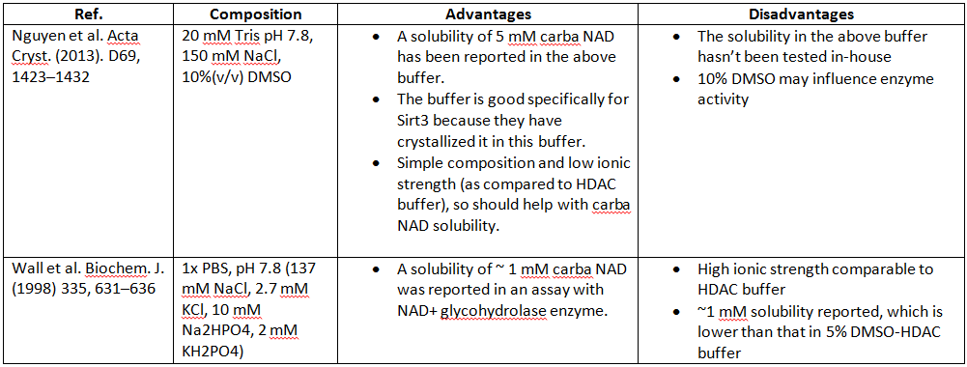

The current choice is **20 mM Tris-HCl, 150 mM NaCl, 5% (v/v) DMSO, pH 7.8. ------ Assigned to Thomas 3.22.2017.**

* 1. New buffer contents 10% DMSO which may influence protein activity.

1. Test out if the use of new buffer influence the MST outcome.
   1. Sirt3 + NAD +Saturating Deacetylated peptide binding in the new buffer (decided from A)
   2. If kd varies so much, this buffer cannot be used.
   3. If similar Kd results are obtained then we need to test if Carba-NAD dissolves in this buffer as they claimed-------in house
   4. Send some CarbaNAD to Thomas and pass the detailed protocol how to prepare Carba-NAD solution to him. **GOTO STEP 4**

***STEP2****-----DONE (3.20.17 - 3.21.17)*

With respect to 2bind fitting for Kd, to determine for NAD how low one can go in upper end of [NAD] range and still get a good fitting.

**Results:**

Refitting of Sirt3-NAD+ and T-Sirt3-NAD MST data have been done by XG (See “Refitting_3.21.2017.ppt” on wiki/Task list from Lab for details).

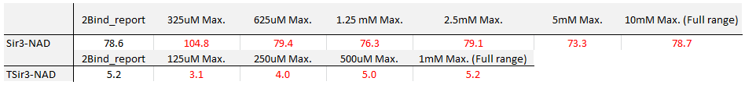

Refitting results showed kd does not change much using full range data set and lower range data set.

**Lower [CarbaNAD] range can serve our need.**

**STEP3. Solubility test. Since STEP2 suggests lower [CarbaNAD] range can serve our need, It’s not necessary to know the max solubility for Carba-NAD at this time.**

1. CRO ---
   1. Negotiate with Ascendex for the amount of Carba-NAD needed for such test ---Ongoing (SM)
   2. Consider Dalton’s quote?
   3. look for other quote ---- Not start yet
2. In-house ---
   1. Following Ascendex’s protocol
   2. May need more compound and have to purchase from Dalton again.

**STEP4.** Carrying out MST on c-NAD w,w/o HKL (and other proposed expts) per list sent to 2bind (full length and T-SIRT3)

