Progress Report Week of Nov. 4, 2013

(PL and XG)

**Discussions (PL and XG)**

* To get better understanding of the activation role of resveratrol played in Sirtuins, we searched the available publications. We found that, up to date, there are two available cocrystal structures (a. SIRT5/AMC-Peptide-ac/Resveratrol (Lime Ribbon + Green ball-and-stick) and b. SIRT3/AMC-Peptide-ac/Piceatannol). Interestingly, resveratrol is an activator for SIRT5 and an inhibitor for SIRT3.
* Structures of resveratrol and piceatannol

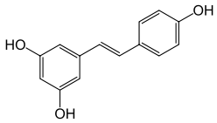 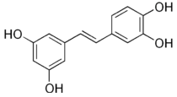

Resveratrol Piceatannol

* The structure alignment of aforementioned co-crystal structures was performed (Figure 1, 2 , and 3).
* The overlay of the two complexes shows that both acetylated FdL1 lysines are bound in the hydrophobic active site tunnel, but the neighboring fluorophore/modulator pairs are differently arranged. As a consequence, the entire FdL1-peptide is shifted in the Sirt5/ activator structure relative to the Sirt3/inhibitor complex, positioning the acetamide group deeper in the hydrophobic binding tunnel. It is tempting to speculate that the interaction of resveratrol/ piceatannol with the coumarin moiety is responsible for these differences, resulting in a productive substrate conformation in Sirt5 but in non-productive substrate binding in Sirt3.
* The Sirt3 structure shows that the resveratrol-like compound can bind on top of the substrate and directly interact with the C-terminal peptide fluorophore, apparently influencing the substrate binding mode and thereby inhibiting the subsequent reaction step.
* The reported activators (resveratrol, STACs) most likely target active peptide binding site. Our current interest of activator design is focused on relief of NAM inhibition.
* The combination of these two seems to bring new blood to this field (by Dr Raj_Wiki/Sirtuin Project 1/11-2 post).

**Figure 1**. Structural comparison between SIRT5/AMC-Peptide-ac/Resveratrol (Lime Ribbon + Green ball-and-stick) and SIRT3/AMC-Peptide-ac/Piceatannol(Red Ribbon + White ball-and-stick).

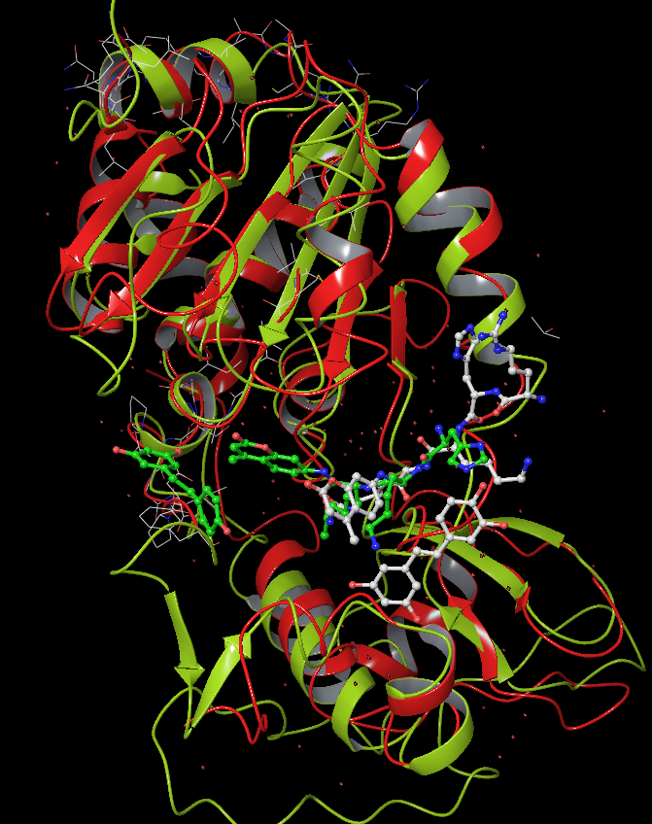

**Figure 2**. From above: Rotated by ~30 degree alone Z-axis.

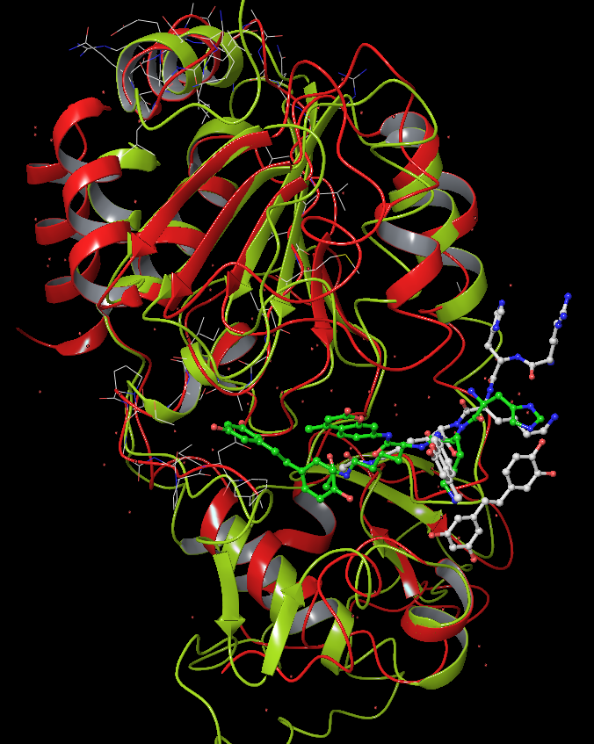

**Protein expression and purification (XG)**

* Flow through and elute steps were modified to achieve better yield.
* Equilibration/wash buffer, 10xGlutathione stock solution, and Elution buffer were prepared. The solutions should be stored at 4 oC.
* The used recombinant glutathione S-transferase (GST) per milliter of settled resin can be regenerated since Glutathione agarose can be used at least five times without affecting protein yield or purity.
* Float-A-Lyzer dialysis tube has been ordered for the next step for removing of glutathione.
* GST-tag will be cleaved from purified product (GST-tagged pGEX-6P3-PNCA).

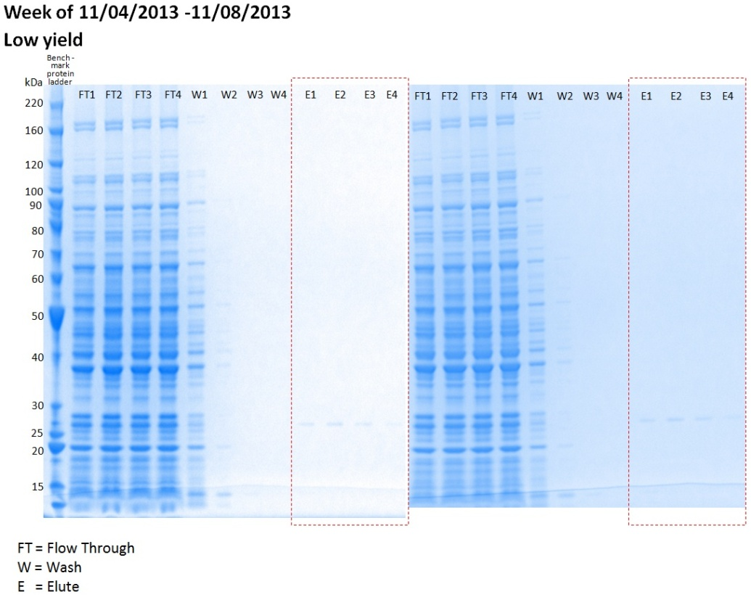

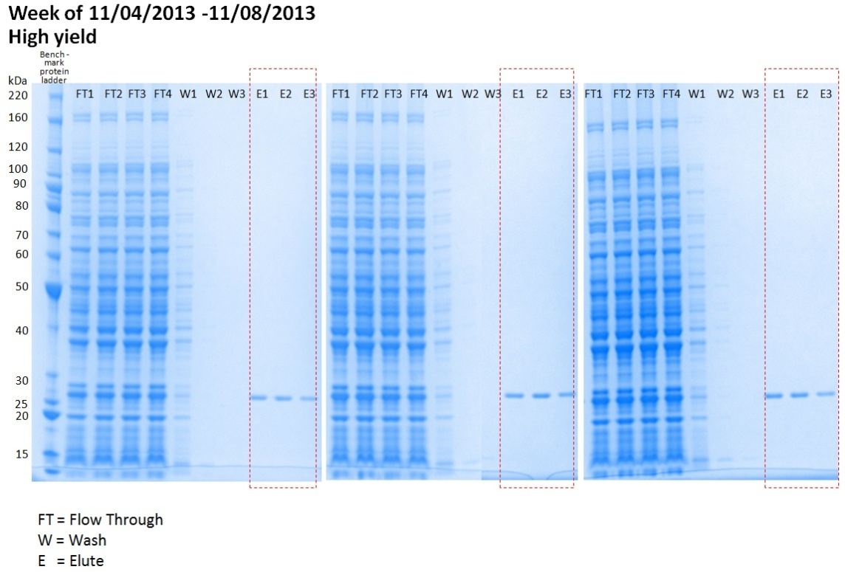

**Computational part (PL)**

* Calculated MM-GBSA values for top poses for selected small molecules (Week2)

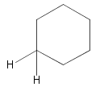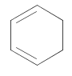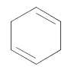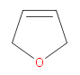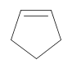

Using the above 5 substructure to search for small molecules with m.w. < 200, 95 unique compounds were found from hit2lead (ChemBridge), and 195 isomers were constructed. They are docked into both SIRT3 apo-enzyme and SIRT3 with intermediate (pdbID: 4BVG)

|  |  |  |
| --- | --- | --- |
| MM-GBSA (kcal/mol) | SIRT3 (4BVG) with Intermediate | SIRT3 (4BVG) as apo-enzyme |
| N,N,N'-trimethyl-N'-(4-methylcyclohexyl)-1,2-ethanediamine | -76.92 | -73.60 |
| 4-(bicyclo[2.2.1]hept-5-en-2-ylmethyl)morpholine | -76.87 | -72.03 |
| 1-(bicyclo[2.2.1]hept-5-en-2-ylmethyl)piperazine | -71.45 | -68.38 |
| 2-(2-azabicyclo[2.2.1]hept-5-en-2-yl)ethanol | -63.96 | -58.68 |
| 10,12-dioxatetracyclo[7.2.1.1~3,6~.0~2,7~]tridec-4-en-8-one | -58.21 | -57.11 |
| N,4,5,5-tetramethyl-2-oxo-2,5-dihydro-3-furancarboxamide | -57.74 | -54.69 |
| 3,4,4-trimethyl-3b,4,4a,5-tetrahydro-1H-cyclopropa[3,4]cyclopenta[1,2-c]pyrazole | -54.40 | -53.36 |
| 1',3'-dihydrospiro[cyclohexane-1,2'-imidazo[4,5-b]pyridine] | -53.04 | -51.90 |
| 4-[2-(2,4-cyclohexadien-1-yl)vinyl]aniline | -52.66 | -58.07 |
| 1-(2-cyclopenten-1-yl)-4-methoxybenzene | -52.44 | -51.95 |
| 5-methyl-4,5,6,7-tetrahydro-2,1-benzisoxazol-3-amine | -49.82 | -48.18 |
| 1-ethylbicyclo[2.2.1]heptan-2-one | -49.80 | -49.39 |
| 5,6,7,8-tetrahydro-3(2H)-cinnolinone | -49.66 | -48.72 |
| 3,5,6,7-tetrahydro-4H-cyclopenta[4,5]thieno[2,3-d]pyrimidin-4-one | -49.34 | -44.36 |
| 8-hydroxy-2,4-dimethyl-7H-chromen-7-one | -47.67 | -50.00 |
| 2-(1-aminoethylidene)-5,5-dimethyl-1,3-cyclohexanedione | -47.58 | -50.36 |
| 1-ethylbicyclo[2.2.1]heptan-2-one oxime | -47.39 | -44.01 |
| 3-(4,4-dimethyl-2,6-dioxocyclohexyl)propanenitrile | -47.26 | -46.89 |
| 3-pentyl-4,5,6,7-tetrahydro-2H-indazole | -47.19 | -57.32 |
| 7-chloro-2,1,3-benzothiadiazol-4-amine | -46.45 | -50.19 |
| 4-(methoxyimino)-3,6,6-trimethylbicyclo[3.1.0]hex-2-ene-2-carbonitrile | -46.42 | -46.94 |
| N'-2,1,3-benzoxadiazol-5-yl-N,N-dimethylimidoformamide | -46.37 | -45.92 |
| N-2,1,3-benzothiadiazol-4-ylacetamide | -46.12 | -46.15 |
| 7-methyl-8H-imidazo[4,5-e][2,1,3]benzothiadiazole | -45.94 | -48.57 |
| 5-chloro-2,1,3-benzoxadiazole 1-oxide | -45.91 | -45.01 |
| 7,8-dihydro-6H-cyclopenta[e][1,2,4]triazolo[1,5-a]pyrimidine | -45.84 | -45.84 |
| 5,5-dimethyl-4-phenyl-2(5H)-furanone | -45.44 | -50.21 |
| 4-(dichloromethyl)-4-methyl-2,5-cyclohexadien-1-one | -44.87 | -52.00 |
| 1,4,5,6-tetrahydrocyclopenta[c]pyrazole-3-carbohydrazide | -44.73 | -43.71 |
| 2-[3-(dimethylamino)-2-propen-1-ylidene]-1,3-cyclohexanedione | -44.55 | -58.40 |
| 4-(hydroxyimino)-3,6,6-trimethylbicyclo[3.1.0]hex-2-ene-2-carbonitrile | -44.21 | -50.18 |
| 6-methylfuro[3,4-c]pyridine-3,4(1H,5H)-dione | -44.11 | -44.43 |
| 2-methylbenzo-1,4-quinone 1-(O-acetyloxime) | -44.07 | -46.99 |
| 5-methyl-2,1,3-benzothiadiazol-4-amine | -43.98 | -44.95 |
| 2,2-dimethyl-2H-benzimidazol-4-amine 1-oxide | -43.79 | -45.80 |
| 5-methyl-1,4-dihydrocyclopenta[b]indol-3(2H)-one | -43.73 | -42.45 |
| 7-methyl-1,2,3,4-tetrahydrocyclopenta[b]indol-3-ol | -43.59 | -49.87 |
| 7-methyl-1,2,3,4-tetrahydrocyclopenta[b]indole-3-carboxamide | -43.58 | -45.12 |
| 4-chloro-2,1,3-benzoxadiazole | -43.29 | -40.05 |
| 1,3-dimethyl-6,7-dihydro-2-benzothiophen-4(5H)-one | -43.26 | -48.98 |
| 2,4-dimethyl-7H-chromen-7-one | -42.51 | -48.71 |
| 5,5-dimethyl-2-[(methylamino)methylene]-1,3-cyclohexanedione | -42.35 | -48.57 |
| 4,5,6,7-tetrahydro-2H-indazol-3-ol | -42.23 | -39.41 |
| 4-(2-cyclopenten-1-yl)phenol | -42.11 | -47.14 |
| N-(3,3-dimethyl-5-oxocyclohexylidene)glycine | -41.76 | -50.93 |
| 6,7-dihydro[1,4]dioxino[2,3-f][2,1,3]benzothiadiazole | -41.51 | -50.67 |
| 4,5,6,7-tetrahydro-2H-indazole-3-carboxamide | -41.45 | -48.74 |
| N-methyl-4-nitro-2,1,3-benzoxadiazol-5-amine | -41.40 | -50.01 |
| 2-aminocyclopent-1-ene-1-carbonitrile | -41.38 | -39.74 |
| 2,1,3-benzothiadiazole-4,5-diamine | -41.04 | -40.41 |
| 2,2-dimethyl-2,5,6,7-tetrahydro-4H-benzimidazol-4-one oxime 1-oxide | -40.92 | -41.58 |
| 1-methyl-1,4,5,6-tetrahydrocyclopenta[c]pyrazol-3-amine | -40.87 | -39.15 |
| 6,7-dihydro[1,4]dioxino[2,3-f][2,1,3]benzoxadiazole 1-oxide | -40.72 | -47.75 |
| 2,5-dimethyl-7,8-dihydro-6H-cyclopenta[e]pyrazolo[1,5-a]pyrimidine | -39.81 | -47.25 |
| 4-amino-6,6-dimethyl-6,7-dihydrocyclopenta[e][1,3]thiazin-2(5H)-one | -39.15 | -55.90 |
| 7-methyl-1,2,3,4-tetrahydrocyclopenta[b]indole-3-carbonitrile | -38.76 | -44.18 |
| 5,5-dimethyl-2-nitro-1,3-cyclohexanedione | -37.19 | -39.80 |
| 6,7-dihydro-2,1,3-benzoxadiazol-4(5H)-one O-2-propyn-1-yloxime | -37.08 | -48.95 |
| 2-methyl-7,8-dihydro-6H-cyclopenta[e][1,2,4]triazolo[1,5-a]pyrimidine | -37.07 | -51.00 |
| N-2,1,3-benzoxadiazol-4-ylacetamide | -36.80 | -41.26 |
| N,N-dimethyl-2,1,3-benzoxadiazole-4,7-diamine | -36.42 | -36.34 |
| 1-methyl-10-oxa-4-azatricyclo[5.2.1.0~2,6~]dec-8-ene-3,5-dione | -36.41 | -38.42 |
| 5-nitro-2,1,3-benzoxadiazol-4-amine | -35.95 | -34.97 |
| 5,6-difluoro-2,1,3-benzoxadiazole 1-oxide | -35.53 | -38.92 |
| 6,7-dihydro-2,1,3-benzoxadiazol-4(5H)-one hydrazone 1-oxide | -35.29 | -38.70 |
| 2-methyl-2H-indazol-6-amine | -34.72 | -40.04 |
| 2,1,3-benzoxadiazol-4-ylformamide | -34.55 | -37.63 |
| 6,6-dimethyl-2-methylenebicyclo[3.1.1]heptan-3-one oxime | -34.47 | -40.56 |
| 7-methylfuro[3,2-e][2,1,3]benzoxadiazole | -34.01 | -42.21 |
| 1-(hydroxymethyl)-10-oxa-4-azatricyclo[5.2.1.0~2,6~]dec-8-ene-3,5-dione | -33.78 | -35.14 |
| 1,7,7-trimethylbicyclo[2.2.1]heptan-2-one oxime | -33.70 | -23.10 |
| 2-(1-amino-2,2,2-trifluoroethylidene)cyclohexanone | -33.40 | -32.93 |
| 7-methyl-1,4-dihydrocyclopenta[b]indol-3(2H)-one | -32.85 | -37.73 |
| 10-oxa-4-azatricyclo[5.2.1.0~2,6~]dec-8-ene-3,5-dione | -32.57 | -34.43 |
| 6,7-dimethyl-6H-[1,2,5]oxadiazolo[3,4-e]indole | -30.79 | -48.20 |
| N-[(4-methylcyclohexyl)carbonyl]glycine | -29.36 | -50.77 |
| 1,7-dimethyl-10-oxa-4-azatricyclo[5.2.1.0~2,6~]dec-8-ene-3,5-dione | -28.13 | -32.43 |
| 2-[(dimethylamino)methylene]-5,5-dimethyl-1,3-cyclohexanedione | -26.98 | -44.83 |
| 1-bicyclo[2.2.1]hept-5-en-2-yl-1H-tetrazole-5-thiol | -24.18 | -36.52 |
| 5-phenyl-1,3-cyclohexanedione | -24.08 | -39.05 |
| 2-methyl-4,5,6,7-tetrahydro-8H-cyclopenta[d][1,2,4]triazolo[1,5-a]pyrimidin-8-one | -23.21 | -53.35 |
| [1,2,3]triazolo[4,5-f][1,2,3]benzotriazol-2(5H)-amine | -21.07 | -36.97 |
| 3-(4,5,6,7-tetrahydro-2H-indazol-3-yl)propanoic acid | -19.73 | -54.54 |
| 2-methyl-4,5,6,7-tetrahydro-2H-indazole-3-carboxylic acid | -16.52 | -31.66 |
| 7,9,10,12-tetraazatricyclo[4.3.3.0~1,6~]dodecane-8,11-dione | -16.18 | -27.73 |
| 2-oxo-2,5,6,7-tetrahydro-1H-cyclopenta[b]pyridine-3-carboxylic acid | -16.08 | -34.18 |
| 5-methyl-4,5,6,7-tetrahydro-2H-indazole-3-carboxylic acid | -13.92 | -30.77 |
| 7,7-dimethyl-2,3-dioxobicyclo[2.2.1]heptane-1-carboxylic acid | -13.69 | -16.03 |
| 4,5,6,7-tetrahydro-8H-cyclopenta[d][1,2,4]triazolo[1,5-a]pyrimidin-8-one | -9.45 | -28.68 |
| 2-tert-butyl-3-hydroxy-5-methylbenzo-1,4-quinone | -5.34 | -49.49 |
| 6,7,8,9-tetrahydro[1,2,4]triazolo[4,3-b]cinnolin-10-ol | -3.96 | -26.58 |
| 2-amino-4,5,6,7-tetrahydro-8H-cyclopenta[d][1,2,4]triazolo[1,5-a]pyrimidin-8-one | 15.14 | -30.03 |
| [1,2,3]triazolo[4,5-f][1,2,3]benzotriazole-4,8(1H,5H)-dione | 17.13 | -15.19 |
| 2H-1,2,3-benzotriazol-2-ylacetic acid | - | -45.92 |
| N'-(3-cyano-5,6-dihydro-4H-cyclopenta[b]thien-2-yl)imidoformamide | - | -48.71 |
|  | | |

*** Note: without intermediate, ligands don’t always bound to C-pockets

*** Note 2: Only deprotonated form of acids were considered in the above table, the acids in neutral (protonated) form were studied separately, only one isomer is selected for each compound.

The top 15 ranked compound (docked to SIRT3 with intermediate) structures are list below.

1: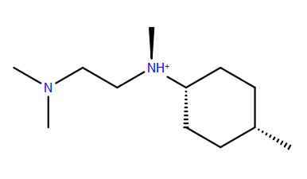2: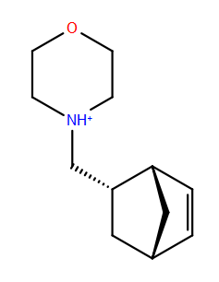3: 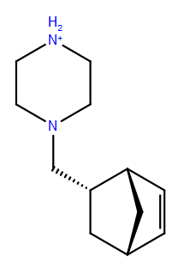

4: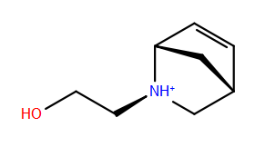5: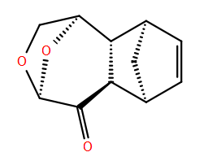6: 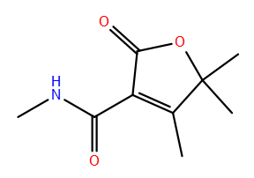

7: 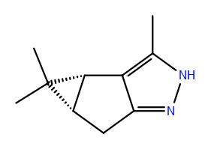8: 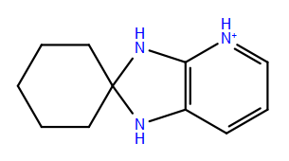9: 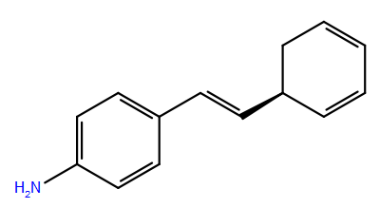

10: 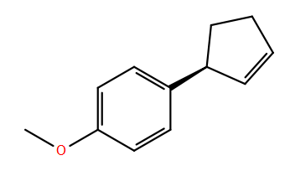11: 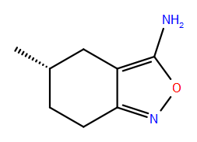12: 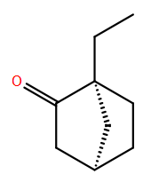

13: 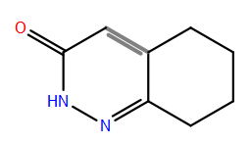14: 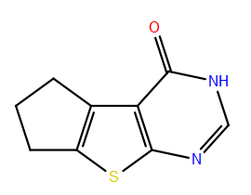15: 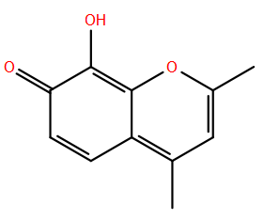

* More MD benchmarking was done. (NAMD, SIRT3 with NAD+ and acetylated peptide substrate (4FVT) in explicit water, total 45368 atoms, 2fs time step, PME)

Using all 16 cores, 2ns obtained in 24 hours. More simulations are underway to estimate the length of simulation required for equilibration.

