Proposed research

1. MM-GBSA, linear interaction approximation (LIA) method on ligands binding to SIRT3: successes, failures, and improvement

**Aim**: To come up with a computational protocol suitable for quantitative estimation of binding free energy of SIRT3-inhibitor interactions

Introduction:

Inhibitor-receptor binding affinity is often directly related to the effectiveness (potency) of the inhibitor. Therefore, it is of great interest to obtain quantitative estimation of binding free energy with minimum computational efforts. With rich structural information now available for SIRT3, we hope to come up with an efficient computational protocol that can be used to obtain quantitative estimation of binding free energy. Several methods will be used including docking, MM-GBSA, LIA and molecular dynamics (MD) simulations, and various settings and combinations will be put to test. The successes and failures will be evaluated and discussed. The final protocol will be validated using experimental results.

Method:

Computational approaches will be used and tested include Glide, Induced fit docking (maybe?), Prime (MM-GBSA module), Liasion from Schrodinger suite of program, NAMD for MD simulation, Amber Tools for MM-PB(GB)SA evaluation and quasi-harmonic approximation for entropy estimation.

Experimental approaches include

**Work flow:**

1. Selection of training set of inhibitors: other than those with available experimental IC50 values for SIRT3 (either measured in our lab or from reference), at least three more will be evaluated experimentally.

Currently, the following inhibitors are included:

N(1)-methylnicotinamide

IC50 (SIRT3): 9.2 mM *

Nicotinic Acid, 1-oxide

IC50 (SIRT3): 13.0 mM *

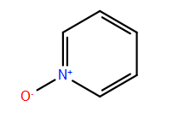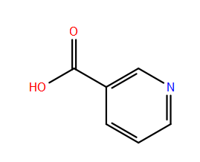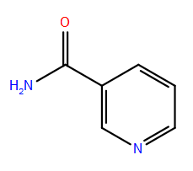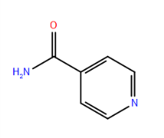

Pyridine, 1-oxide

IC50 (SIRT3): 24.1 mM*

Nicotinic Acid

IC50 (SIRT3): 14.5 mM*

Iso-Nicotinamide (IsoNAM)

IC50 (SIRT3): 13.8 mM*

Nicotinamide (NAM)

IC50 (SIRT3): 36.7 M *

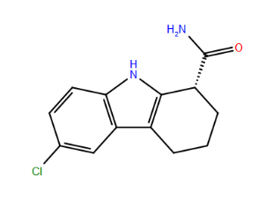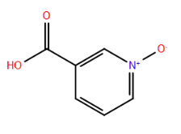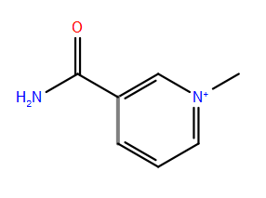

Ex527

IC50 (SIRT3): 174.9 M *

N(1)-methylnicotinamide

IC50 (SIRT3): 9.2 mM *

Nicotinic Acid, 1-oxide

IC50 (SIRT3): 13.0 mM *

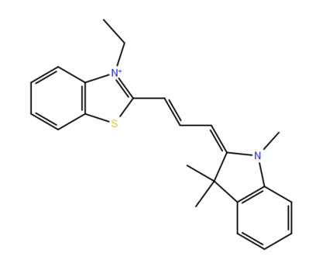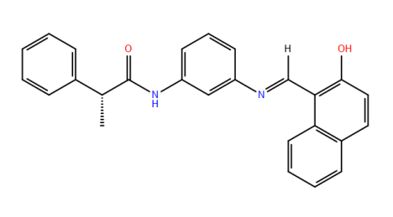

Salermide

IC50 (SIRT3): 27.2 M *

Ac93253

IC50 (SIRT3): 18.2 M *

1. Docking of inhibitors to selected SIRT3 structures, including the following structurally distinctive ones:

|  |  |  |
| --- | --- | --- |
| 4FVT | carba-NAD+ in AC Pocket, Acetylated Peptide Lys in place | |
| 3GLS | Apo-enzyme |  | |
| 4BVG | With alkylimidate intermediate | |
| 4JSR | With ELT inhibitor |  | |
| 4BN5 | With NAD+ and SRT1720 inhibitor | |

1. Evaluation of MM-GBSA using prime;
2. Fit to LIA model using Liasion;
3. Prepare ligand force field parameters (charges to be obtained using quantum mechanics calculations (Firefly 8.0), Amber generalized force field (GAFF), and antechamber to build topology file);
4. Run MD simulations (use NAMD and amber force field, periodic boundary condition with explicit solvent (TIP3P for water) in both equilibration and production runs);
5. Pick trajectories for MM-GBSA analysis and entropy contributions (~200 trajectories in the production run, 1ns for every 5 ps);
6. Compare the correlation with IC50 (or estimated pKi);
7. Test LIA model and MM-GBSA/MD approach on validation set of inhibitors (the validation set is yet to be determined.)
8. Discuss the successes and failures of the selected set and determine the applicability of the method.
9. Mechanism based inhibitor discovery:

**Aim**: To discover new leads specific to certain inhibition mechanism

Introduction:

Inhibitors work in different ways as we have found in sirtuin inhibitors, a general virtual high throughput screening may miss certain inhibitors that works when substrate/intermediate are bound. For example, Ex527 is found to bind stronger when NAD+ co-exist; and inhibitors specific to the base exchange reaction will bind tightly with the intermediate and may serve as activatos. Therefore, setting up a receptor other than apo-enzyme will broaden our ability to identify new leads suitable for inhibitors.

Methods:

Experimentally, IC50 can be determined and inhibition mechanism estimated from kinetics studies. Computationally, compound database and reference ligands can be used to prepare for ligand docking that specific to certain receptor models. Binding free energy can be estimated using MM-GBSA method (or other methods).

**Workflow**:

1. ZINC compound database + reference ligands (i.e. ligands to work like SRT1720) to generate a pre-selected compounds (using Phase in Schrodinger suite of program to create Pharmacophore model for filtering), ~50,000 in total;
2. With appropriate receptor model, carry out flexible ligand docking using Glide, ~100 compounds;
3. Do visual inspection and run MM-GBSA (using Prime) to re-rank the compounds, ~10 compounds;
4. Structural refinement and more accurate binding free energy evaluation to confirm their potential inhibition potency;
5. To be examined by experimental tests, and supplied as new reference for new round of selection/filtering.
6. Discovery of inhibitors specific to certain sirtuins:

**Aim**: To discover new leads specific to certain sirtuins (SIRT1-7)

Introduction:

With more and more structures of SIRT1-7 become available in 2013, it is possible to be the first one to test and discover inhibitors for certain sirtuins. Several inhibitors are found to work specifically well only to certain sirtuins, i.e. Ex527 works well on SIRT1, and salermide works better on SIRT2. Therefore it is of great interest to look into the structural difference among sirtuins and carry out sirtuin-specific inhibitor discovery.

More works are required to determine an effective approach to this project.