RC (7-21): I will have a look at the above; the comments below are based on reading the previous draft (though I suspect most of the comments will still apply):  
1) 1st two paras of letter - the second para is most important. Why do you refer to partial competitive but pure noncompetitive inhibition? There also needs to be some mention of the unique features of our model that do not correspond to the pictures shown. Pictures can only be shown if there is a clear indication of how our model differs from these pictures.

XG(7-24): The 1st para has been deleted. By fitting data into mixed noncompetitive inhibition model, the slope of the Dixon plot is given by If >1, the family of Dixon plots intersect above the horizontal axis, and the plot resembles that obtained for competitive inhibition.

If =1, the curves intersect on the horizontal axis, and the system is pure noncompetitive inhibition. If <1, the family of curves intersect below the horizontal axis, and the Dixon plot by itself is not sufficient to diagnose inhibition system.

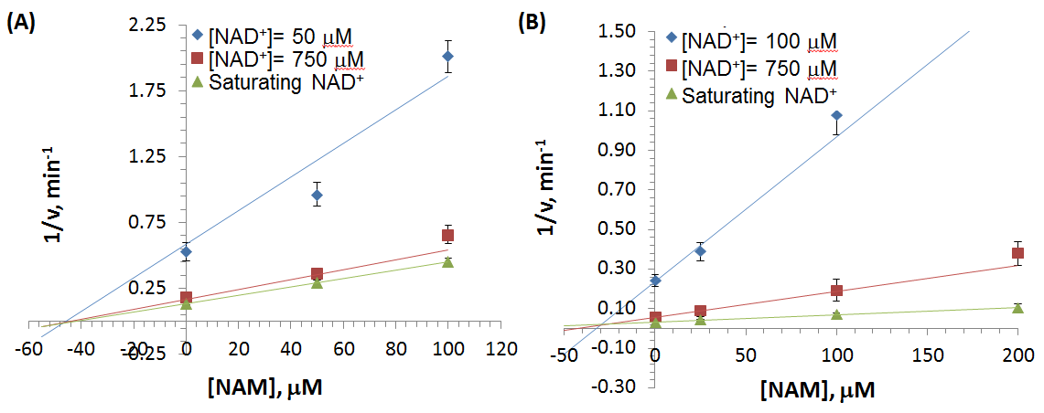

From Dixon plots above, we can tell that the curves intersect of SIRT3 (B) fell above the horizontal axis, which indicated competitive inhibition. While the curves intersect of SIRT1 (A) is on the horizontal axis suggesting noncompetitive inhibition.

2) Reviewer 2 1st point (before major comments) - should mention further details provided below. Also some grammatical errors.

XG(7-23): A higher degree of competitive inhibition for mouse SIRT3 by NAM was detected by Sirtris, a GSK company 2009. (Protein Science (2009) 18: 514-525.). In the current manuscript, similar inhibition feature was captured the first time on human SIRT3 with the first study to explain mechanistically the origin of greater competitive inhibition of SIRT3 by NAM.

The current results are therefore consistent with the results of mouse SIRT3 from Sirtris group. Prior work did not provide any mechanistic explanation and in fact speculated that the NAM inhibited SIRT3 via a wholly different mechanism compared to SIRT1. The authors have provided for the first time a generalized kinetic model for NAM inhibition of sirtuins that is capable of accommodating both SIRT1 and SIRT3 inhibition kinetics. These points are made in the paper (Page 32).

3) Reviewer 2 point 1 - have other papers using this kit mentioned purity? If not this should be noted.

XG(7-22): No. It would be nice to provide the purity of the enzymes if they were expressed and purified in house. However, I have checked 15 sirtuin research articles published on Biochemistry, JBC, PNAS, Protein Science, and Methods in Enzymology, only 2 of them had indicated the purity of the enzyme (one is on Biochemistry and another is on Protein Science). For those using kit, no one mentioned the purity. In the response letter, I have answered the reviewer’s question of “was it purchased? And where?” I also provide the page number, where these were addressed.

4) Reviewer 2 point 2 - should mention that the data in Table 1 establishes mixed noncompetitive inhibition (some explanation required).

XG(7-22): A paragraph is added for further explanation of mixed noncompetitive inhibition. Page number is added as well.

5) Reviewer 2 point 3 - It should be mentioned that the slope of the Dixon plot indicates the degree of competitive behavior. Also, in general there needs to be indication of the page number where we have addressed reviewer points - here the page where the Dixon discussion is provided. Some minor change may be made here explicitly indicating how the slope indicates the degree of competitive behavior.

XG(7-22): Page number was added with the indication of relationship between slope of the Dixon plot and degree of competitive behavior.

6) Reviewer 2 point 4 - we don't seem to mention anything about isoNAM activation assay conditions. This is required to address the question.

XG(7-23): On page 34, Materials and Methods section, the relative inhibition study (refer to isoNAM activation) was addressed.

7) Reviewer 2 minor point 1 - we don't seem to answer the question about the species origin of Sir2 Af2? Also there seems to be a typo regarding Sir3 vs Sir2. Author summary may not be considered a part of paper body.

XG(7-22): Added the species origin of Sir2Af2 in the manuscript and fixed the typo in the response letter.

8) Reviewer 2 point regarding URA3 - what is the conclusion here: that the sentence is ok as is? It should be indicated where we have added the original reference.

XG(7-23): The sentence has been rewritten (page9). The new references have been added.

9) Have Fig/Figure been corrected?

XG(7-22): Yes.

10) Reviewer 3: a) are the papers mentioned doing both types of assays, or is the comparison done with respect to a separate paper that used Fluor-de-Lys? b) The discussion of my point near the bottom needs to be moved up, as it is central to the argument. It should be integrated with the points regarding the artifacts, since those points alone seem to confuse the message. c) Bear in mind that the reviewer may have been referring to modulation by isoNAM (in addition to NAM). It should be stated that computational studies demonstrate that these molecules lie in the C pocket only and hence do not have the capacity to introduce the artifacts mentioned.

XG(7-23): Done with Dr Raj’s comments.

11) I looked over the highlighted words in the paper and believe that, after the above changes are made, some minor edits to the language regarding competitive/noncompetitive only in the abstract and intro may be warranted. Will look into to it after 1-10 are done.

XG(7-23): Will do.