Mechanism of Inhibition of the Human Sirtuin Enzyme SIRT3 by Nicotinamide:

Computational and Experimental Studies (PONE-D-14-20527)

PLOS ONE

Academic Editor

Prof. Pratul K. Agarwal

The inhibition of enzyme activity is one of the major regulatory devices of living cells, and one of the most important diagnostic procedures of the enzymologist. Inhibition studies provide important information about the specificity of an enzyme, the physical and chemical architecture of the active site, and the kinetic mechanism of the reaction. Three simple modes of enzyme inhibition are defined as follows: (A) *Competitive inhibition:* inhibitors bind exclusively to the free enzyme form. (B) *Noncompetitive inhibition*: inhibitors bind with some affinity to both the free enzyme (E) and to the enzyme-substrate complex (ES complex). When the inhibitor binds to E and ES with the same affinity, this is called pure noncompetitive inhibition. (C) *Uncompetitive inhibition:* inhibitors bind exclusively to the ES complex or subsequent species.

In the current manuscript, the authors have discussed a generalized kinetic model for NAM inhibition of sirtuins, which does not oversimplify into noncompetitive or competitive models, so-called mixed noncompetitive inhibition. This system may be considered a mixture of partial competitive inhibition and pure noncompetitive inhibition. When EI has a lower affinity than E for S (*KS>> KS*) and ESI complex is nonproductive, the mixed noncompetitive inhibition becomes competitive inhibition. When the inhibitor binds to E and ES with the same affinity (*Ki>> Ki)*, the mixed noncompetitive inhibition behaves as a pure noncompetitive inhibition, where *KS* and *KS* are the dissociation constants of the ES and ESI complex respectively (Figure below).

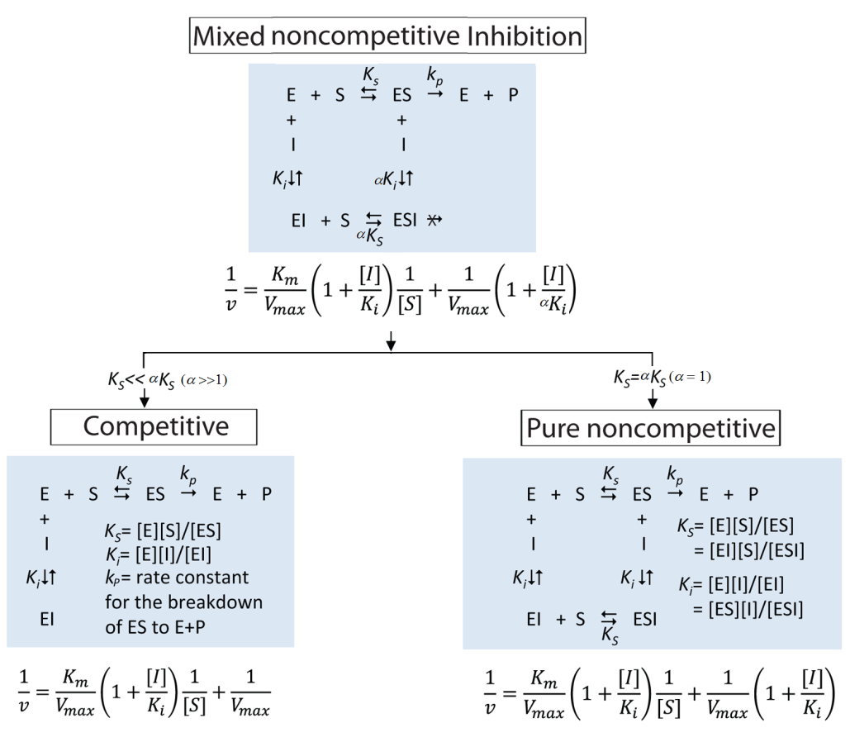

**Reviewer #2**

In the paper Guan et al., describe the mechanism of inhibition of SIRT3 by NAM by utilizing experimental and computational approaches. The conclusion is that unlike in the case of SIRT1, NAM inhibition of SIRT3 is more competitive.

In general I find the methodologies used and question of interest and importance but I believe that much of the conclusions are based on the experimental data that in the current form is not presented in a manner that supports all the points raised by the Authors. Improving the experimental data might shed more light into the true mechanistic aspect of NAM in inhibiting SIRT3.

* In the current manuscript, the authors reported the first time that NAM inhibition of human SIRT3 pertain some degrees of competitive behavior. which can fit into mixed noncompetitive inhibition model ($\frac{v}{{ v}_{max}}=\frac{{[NAD}^{+}]}{{K_{m,NAD^{+}}∙(1+\frac{\left[I\right]}{K_{i}})+[NAD}^{+}]∙(1+\frac{\left[I\right]}{{∝K}_{i}})}$). The observed reaction rates with respect to fixed concentrations of substrate and varying concentrations of inhibitors (NAM or isoNAM) were globally fit to the aforementioned equation. The mechanisms of inhibition are determined from the alpha constant value (See Table 1).  = 1, indicates noncompetitive inhibition,  >>1, competitive inhibition, and  << 1 uncompetitive inhibition. For human SIRT3, NAM=2.735 indicates that NAM inhibition of human SIRT3 pertain some degrees of competitive behavior. Recalled Sirtris’ 2009 work published on Protein Science, mouse SIRT3 was studied and it was found that mSIRT3 has a different mechanism of inhibition for NAM (NAM=2.84, competitive) to those in SIRT1, SIRT2, yeast and bacterial Sir2 (noncompetitive).

Major comments:

1. It is not clear in the results or the methods the source of the SIRT1 and Sir2 analyzed. Was it purified? If so what protocol was used? What degree of purity? Was it purchased? If so, where from? This is essential information given the fact that the conclusions are all based on the experimental data obtained from these proteins.

*Response*:

* The SIRT1 and SIRT3 proteins used in the experiments were purchased from Enzo Life Sciences, NY, USA. The recombinant enzyme was dissolved in assay buffer (25mM Tris, pH 7.5, 100 mM NaCl, 5 mM dithiothreitol and 10% glycerol). The enzymes was prepared into desired aliquots upon receiving to avoid freeze/thaw cycles and stored at -70oC till use.

1. In Figure 2 the authors mention that unlike SIRT1 SIRT3, exhibits “mixed noncompetitive” inhibition for NAM. It is hard to appreciate this as the Figure 2B the X-axis does not enable to see well the intersection of the different NAM concentrations it would be informative to have the X-axis in 2A and 2B to be the same to enable proper comparison. Otherwise the statement made is not supported by shown data.

Also a general remark it should be noted that the substrates used here are different for SIRT1 and SIRT3 this should be better addressed in the text. Is this accounted for in the models?

*Response*:

* x-axis has been changed to same scale. To be seen clearly on the intersection of the different NAM concentrations, Figures 2C and 2D have been added.
* On Table 1, SIRT1=0.848 and SIRT3=2.735.

1. There is no elaboration on Figure 3 in the text. For Figure 3 the Dixon should be shown with the intersection of the plots with the X-axis so information regarding the Ki can be analyzed and also a better understanding to the nature of inhibition (competitive or not) could be achieved. Without showing that it is hard to conclude much from the figure.

*Response*:

* Figure 3A and 3B, the intersectionof the plots with the x-axis has been included.

1. In Figure 5, the authors show that increasing the isoNAM does not alter NAM inhibition of SIRT3. But there is no positive control for these experimental conditions. For the statement to be valid it would be useful to show that under the same conditions NAM inhibition of Sir2 is alleviated by isoNAM (positive control) otherwise it is not clear if the result is due the experimental settings or due to the unique properties of SIRT3.

*Response*:

* Detailed experimental conditions on NAM inhibition of Sir2. In our experiment, we examed SIRT1 instead of Sir2. The detailed reported experimental conditions on NAM inhibition of Sir2 are listed below:

Sinclair, D (2002) JBC---Recombinant glutathione S-transferase-tagged yeast Sir2p (gift of D. Moazed) and recombinant human SIRT1 (48) were assayed for deacetylase activity using the HDAC fluorescent activity assay/drug discovery kit (AK-500, BIOMOL Research Laboratories). This assay system allows detection of a fluorescent signal upon deacetylation of a histone substrate when treated with developer. Fluorescence was measured on a fluorometric reader (Cytofluor II 400 series PerSeptive Biosystems) with excitation set at 360 nm and emission detection set at 460 nm. Reactions consisted of either 5 g of glutathione S-transferase-Sir2 or 2.5 g of SIRT1, incubated with 250 M acetylated histone substrate, 1 mM dithiothreitol, and a range of NAD concentrations as described. Reactions with the yeast and human proteins were carried out at 30 and 37 °C, respectively, for 30 min.

Sauve, AA (2005) Biochemsitry---Reaction mixtures of 50 L of 50 mM potassium phosphate (pH 7.8) containing 300 MKKGQSTSRHK(KAc)LMFKTEG peptide and 600 MNAD+ containing selected micromolar concentrations of [carbonyl-14C]nicotinamide at 60 Ci/mol (0, 10, 20, 30, 45, 60, 80, 90, 125, 250, 360, 600, and 1200) were reacted with 1 MSir2 enzyme added as a 1 L addition of concentrated enzyme. After 2 h, 10 L aliquots were removed at 0, 30, 60, 90, and 120 min. Each aliquot was combined with 50 L of 50 mM ammonium acetate (pH 5.0) to quench and assayed by HPLC for deacetylation products and NAD+. The chromatograms (260 nm) were obtained using 50 mM ammonium acetate (pH 5.0) as the eluanton a semipreparative Waters C-18 column (flow rate of 2.0 mL/min). Peaks for ADPR and 3’-O-acetyl-ADPR were quantified by integration. The peak for NAD+ was collected and the radiation counted. Plots of rate versus nicotinamide concentration were fit using the curve V ) kcat[S]/([S] + Km) with the curve-fitting feature of Kaleida graph. Plots of deacetylation rate versus nicotinamide concentration were fit to the equations described in the text. Experiments with 2 mM nicotinamide established the effects of this concentration on the deacetylation and exchange activity of the Sir2 enzyme.

* May want to show SIRT1:isoNAM data. Prefer to show them in the 2nd paper.

Minor comments:

• It would be nice to maintain better elaboration in the text the species origin of the Sirtuins discussed it is not clear to all what SIRT1, Sir2 or Sir2Af2 refers to. When first introducing the term it could be helpful to elaborate more.

*Response*:

* Human sirtuin enzyme SIRT3 was firstly mentioned in the title. Human sirtuin type 3 (hereafter referred to as SIRT3 unless otherwise specified) was first introduced on Page 4.
* SIRT1, SIRT3, and Sir3 were mentioned together in the “Author Summery” on page 3.

• On page 9 the authors mention that “Sir2-dependent silencing of the telomeric URA3 gene…” the citation used is the review that mentions it and not the research article. Also URA3 is not a telomeric gene but rather was used as a marker in a telomeric assay therefore this sentence is misleading and should be rewritten.

*Response*:

* The original experiments were reported firstly on 1991 Cell paper. (Aparicio, O. M., Billington, B. L., and Gottschling, D. E. (1991) Modifiers of position effect are shared between telomeric and silent mating-type loci in *S. cerevisiae*. *Cell* 66, 1279–1287)
* Then similar research was reported on 2000 Aging Cell journal. (Smith, D. L., Jr., Li, C., Matecic, M., Maqani, N., Bryk, M., and Smith, J. S. (2009) Calorie restriction effects on silencing and recombination at the yeast rDNA. *Aging Cell* 8, 633–642)
* In 2012 JBC paper, it was reported that “We were initially interested in using INAMas a tool to stimulate silencing and found that, with our standard SC growth medium, 25mM INAM had little effect on silencing of a telomeric *URA3* reporter gene or a *TRP1* reporter integrated at the silent *HMR* locus.”

• Throughout the text there is inconsistency in the use of “Fig” versus “Figure” low case versus capital in the panel description as well. Please change according to plos one standards and maintain consistency.

*Response*:

* Search for Fig/Figure and make changes to keep consistency.

**Reviewer #3**

It is well known that the structure of sirtuin substrates and specifically fluorophore labelled substrates may mislead sirtuin modulator research. Therefore kinetic analyses must be performed using unlabelled substrates and e.g. an HPLC assay. Thus, the whole basis of the interpretation is questionable and I cannot recommend the paper for a revision.

*Response*:

* **In 2013 PNAS paper, a continuous assay and a nonmodified peptides were applied for the measurement of IC50 of EX527 for SIRT1 and Sir2Tm. The IC50 values from continuous assay were in agreement with the FdL values.**

**Gertza,M; Fischera,F; Nguyena, GTT; et al. (2013) Ex-527 inhibits Sirtuins by exploiting their unique NAD+-dependent deacetylation mechanism. PNAS, E2772–E2781.**

“Ex-527 Is a Selective Sirtuin Inhibitor and Requires NAD+ for Inhibition. A first kinetic analysis of Sirt1 inhibition by Ex-527 was done with the Fluor-de-Lys (FdL) substrate, a peptide carrying a fluorophore that potentially causes artifacts. To investigate the molecular inhibition mechanism, we first tested selectivity and kinetics using a continuous assay and nonmodified peptides derived from physiological substrates for Sirt1 (p53), Sirt3 [acetyl-CoA synthetase 2 (ACS2)], and Sirt5 [carbamoyl phosphate synthethase 1 (CPS1)]. Because inhibition was proposed to be uncompetitive with NAD+, we adjusted NAD+ concentrations according to the respective KM values to allow comparisons. The IC50 values are 0.09 ± 0.03 μM for Sirt1 and 22.4 ± 2.7 μM for Sirt3 (Fig. 1C), in agreement with the FdL values (0.1 and 49 μM, respectively_*Napper AD, et al. (2005) Discovery of indoles as potent and selective inhibitors of the deacetylase SIRT1. J Med Chem 48(25):8045–8054*.). Because Sirt1 crystals became available only recently, we included the bacterial homolog Sir2 from Thermotoga maritima (Sir2Tm) in our investigation. Sir2Tm was efficiently inhibited by Ex-527 (IC50 0.9 ± 0.3; Fig. 1C), and we thus used it as a representative of the potently inhibited Sirtuins for structural studies. Furthermore, Ex-527 had no pronounced effect on Sirt5-dependent deacetylation, **consistent with FdL tests** *(Solomon JM, et al. (2006) Inhibition of SIRT1 catalytic activity increases p53 acetylation but does not alter cell survival following DNA damage. Mol Cell Biol 26(1):28–38.)*, and showed no inhibition of Sirt5-dependent desuccinylation (Fig. 1D), the dominant Sirt5 activity identified recently.”

* **In 2012 PLOS ONE paper, the weak inhibition caused by resveratrol on SIRT3 was detected using ELISA, which was consistent with FdL results.**

**Gertz M, et al. (2012) A molecular mechanism for direct sirtuin activation by resveratrol. PLoS ONE 7(11):e49761.**

Resveratrol caused weak inhibition when tested on Sirt3 in an analogous ELISA for glutamate dehydrogenase (GDH) deacetylation (Figure 4G), again consistent with the FdL results. These results show that the fluorophore label is not essential for the stimulatory effect of resveratrol on Sirtuin dependent deacetylation but can be replaced by a regular polypeptide chain, and consistently, that activation can also be observed with a complete protein as a substrate.

* Fluor-de-Lys assay used as substrates acetylated peptides conjugated to a fluorophore. It behaves as a natural SIRT1 substrates with a large hydrophobic amino acid residue [i..e, tryotophan (Trp), tyrosine (Tyr), or phenylalanine (Phe)] at positions +1 and +6.
* A publication in 2008 actually showed that the use of a different acetylated peptide as SIRT1 substrate led to quite different results: in their assay system, resveratrol and fisetin showed only marginal activation of SIRT1 (about 1.3-fold), and only piceatannol had a significant activating effect (about 3-fold). The other supposed activators actually behaved as inhibitors of SIRT1: Butein, isoliquiritigenin, and quercetin reduced the activities to 0.04, 0.32, and 0.38-fold, respectively.
* The so-called “artifact” is referred to the facts that “The existing STACs (identified by using FdL assay) only work with SIRT1 substrates that contain hydrophobic residues at position +1 to the acetylated lysine”. That is because they were identified via screening with a substrate that contained a hydrophobic residue mimetic–i.e., a fluorophore tag. In another word, we can call this group of STACs as “SIRT1 substrate-specific STACs”. For targeting drug design, practically, this might be a way to design/screen a candidate medicine who only targets the sirtuins for a specific disease without regulating nonspecific proteins. For example, SIRT3, as known, is a cancer suppressor and promoter. Because the substrates for this double edged sword are different, by using aformentioned method, we can design a specific STACs for the purpose of drug discovery.
* Therefore, a new screen that is not biased in this way might possibly identify STACs that exhibit selectivity for SIRT1 substrates that contain other sequence signatures. It is possible that such STACs might be better therapeutics for certain aging-related diseases than the current STACs being investigated by Sirtris/GSK.
* Back to our issue, like Dr Raj mentioned that the artifacts in some prior work were always due to interaction of fluorophore with hydrophobic moieities on the drugs (activators), whereas we did not apply it to discover new molecules, but rather the mechanism of the C pocket binder NAM.
* ***Computational validation***

**Reviewer #4**: Guan et al have investigated the mechanism of nicotinamide inhibition of human SIRT3 in a very detailed and scientifically sound way. There are only two minor issues

(a) Throughout the manuscript the writing of numbers and units should be harmonized (including a space between number and unit)

*Response*:

* Add a space between number and unit
* The position of equation number should keep the same.

(b) in Figure 3 write μM instead of uM

*Response*:

* The uM have been changed to M in revised Figure 3.