**SI preparation for standard curve**

* The purpose of Standard curve

Through the manuscript, the calculation of all the kinetic parameters and model fittings were based on the micro molar (uM) of deacetylated product (deacetylated peptide) within different time points. Fluorescence signal (AFU) was used as readout in the FdL assay. The use of correct correlation between AFU and uM becomes critical for the success of parameter calculation and model fitting. Therefore, a precise series of standard curves were used in the current manuscript for such purpose.

* The misleading by using wrong standard curve
  + Standard curve in assay buffer does not represent the real experimental behavior.
    - The component of reaction solution influence the outcome
      * NAD+
        + Show comparison of Standard curve in only assay buffer and in the presence of NAD+
      * DMSO

For compounds who have none or lower solubility in assay buffer, %DMSO was applied to the assay. It was noticed that the addition of %DMSO will interfere the correlation of AFU vs uM, which directs the misinterpretation of the experimental results. A comparison of standard curves in the presence of 0.5% and 5% DMSO were tested. In Table 1, the slope changes in the different % of DMSO, which indicates the addition of % DMSO influence the correlation between AFU and uM.

**Table 1**

|  |  |  |  |
| --- | --- | --- | --- |
|  | 0% DMSO | 0.5% DMSO | 5% DMSO |
| Slope | 224.2 | 236.2 | 258.3 |

**Figure 1**

DHP1c (N-Benzyl-3,5-dicarbethoxy-4-phenyl-1,4-dihydropyridine) is reported as a potent activator for SIRT1. It activates human SIRT3 as well. Combined with NAM (a product inhibitor), DHP1c was used to test our theory in current manuscript. The DHP1c intrinsic fluorescence overlaps with the emission of the readout fluorophore. It interferes the readout.

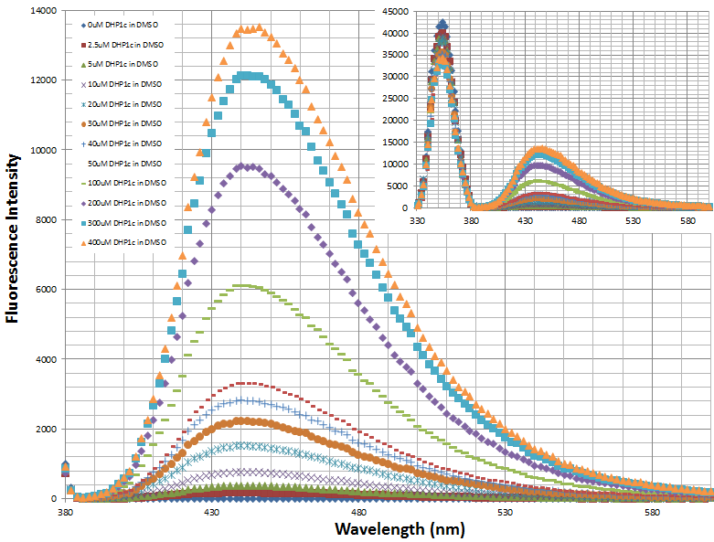

**Figure 2**

To eliminate the influence from this compound, a series of standard curves were applied. Figure 3 shows that the slopes of standard curves in the presence of different concentration of DHP1c vary in a big range. At lower [DHP], the intrinsic fluorescence can be subtracted for a baseline and there is approximate linearity of the AFU with respect to [standard].

**Figure 3**

Interestingly, no linearity is detected for standard curves in the presence of higher DHP1c concentration (Figure 4). This indicated that at higher concentrations the intrinsic fluorescence may be prone to quenching through undetermined mechanisms, as evidenced by the example of FdL standard.

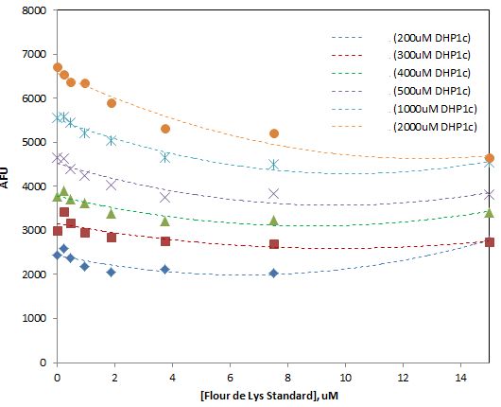

**Figure 4**

In the past decade, the discovery of SIRT1 activators with antiaging activities in yeast, mammalian cells, worms and flies have greatly motivated the researches to find both inhibitors and activators of SIRTs. The use of biochemical SIRT assays has become quite widespread for drug discovery.

In general, SIRTs activity assay development must be based on measuring the rates of one of three things: (1) appearance of free acetate, (2) disappearance of the acetylated substrate or (3) appearance of the deacetylated product. The traditional approaches used in SIRTs assays, such as MS, radioisotope detection and anti-acetylation antibodies are used, but particularly for compound screening and profiling applications, peptide-based fluorescence assays are far more popular. Among them, Fluor de Lys assay has been one of the most wildly used fluorescent assay systems (1-5).

Fluor de Lys is based on the unique Fluor de Lys substrate/developer combination with 2-step system. The Fluor de Lys substrate is incubated with human recombinant SIRT3 together eith the cosubstrate NAD+ first. In the second step, deacetylated peptide was treated with developer to produce a fluorophore.

SIRTainty is another assay used for SIRTs modulator screening(6). SIRTainty assay is a 3-step reaction system. First the acetylated peptide substrate is acted upon by the sirtuin enzyme to produce NAM. In a secondary reaction, the nicotinamidase enzyme converts the nicotinamide into nicotinic acid and NH3+ (free ammonia). To generate a signal for readout, a proprietary developer reagent is added and the signal is read using a fluorescent plate reader.

For both Fluor de Lys assay and SIRTainty assay, there are some similarities.

* They are applicable for high through put drug discovery.
* They all have fluorescence readout. The emission wavelength appears similar. Fluor de Lys assay use fluorophore labeled peptide and SIRTainty use non-labeled peptide substrate.
* They all need developer reagent to quench the reaction and release the fluorescence signal.
* For molecule with the intrinsic fluorescence like DHPs, there was significant background fluorescence in both assays.

In brief, SIRTainty assay does not overcome any of the problems that Fluor de Lys assay has to face to. To only subtracte intrinsic fluorescence from DHP background could not really get a rigorous estimate of % activation in many cases. Therefore, it is essential to run proper standard curves at these concentrations of [DHP].

Based on the above observations with FdL, we settled on the use of HPLC for studies of DHP activation at higher concentrations, esp saturating concentrations.

**References**

1. Avalos JL, Bever KM, & Wolberger C (2005) Mechanism of sirtuin inhibition by nicotinamide: Altering the NAD(+) cosubstrate specificity of a Sir2 enzyme. *Molecular Cell* 17(6):855-868.

2. Howitz KT*, et al.* (2003) Small molecule activators of sirtuins extend Saccharomyces cerevisiae lifespan. *Nature* 425(6954):191-196.

3. Bitterman KJ, Anderson RM, Cohen HY, Latorre-Esteves M, & Sinclair DA (2002) Inhibition of silencing and accelerated aging by nicotinamide, a putative negative regulator of yeast sir2 and human SIRT1. *The Journal of biological chemistry* 277(47):45099-45107.

4. Wood JG*, et al.* (2004) Sirtuin activators mimic caloric restriction and delay ageing in metazoans. *Nature* 430(7000):686-689.

5. Mai A*, et al.* (2009) Study of 1,4-Dihydropyridine Structural Scaffold: Discovery of Novel Sirtuin Activators and Inhibitors. *Journal of Medicinal Chemistry* 52(17):5496-5504.

6. Valente SM, Palol; Spallotta, Francesco (2015) 1,4-Dihydropyridines Active on the SIRT1/AMPK Pathway Ameliorate Skin Repair and Mitochondrial Function and Exhibit Inhibition of Proliferation in Cancer Cells. *Journal of Medicinal Chemistry*.