SIRT3 interactions with Ex-527 (Ex-243)
- Interaction scheme for Ex-243 in different structures:
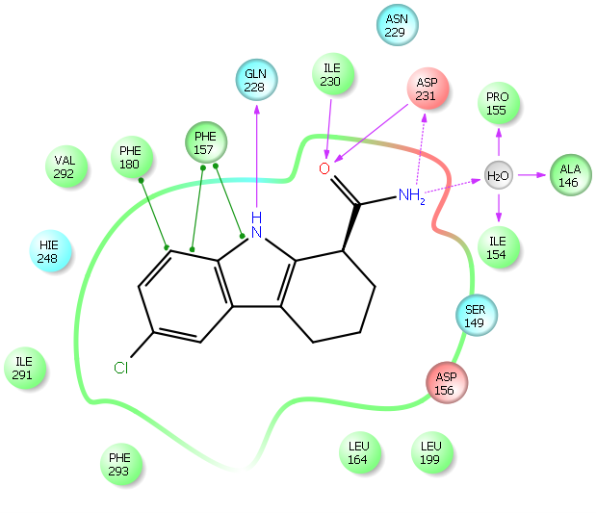
Taken from 4BV3 (SIRT3/NAD+/Ex-243 complex)
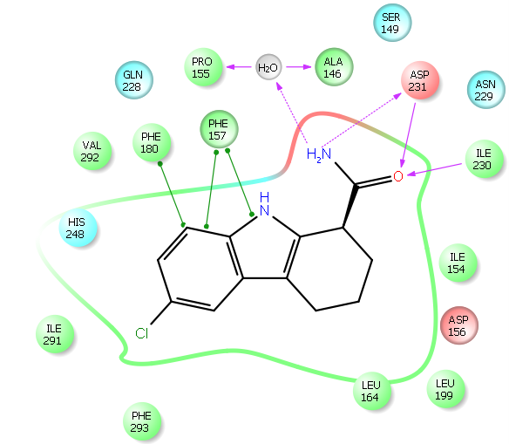
Taken from 4BVH(SIRT3/2’-O-acetyl-ADPR/Ex-243 complex)
Interactions for NAD+ and AADPR from these two structures are also included.
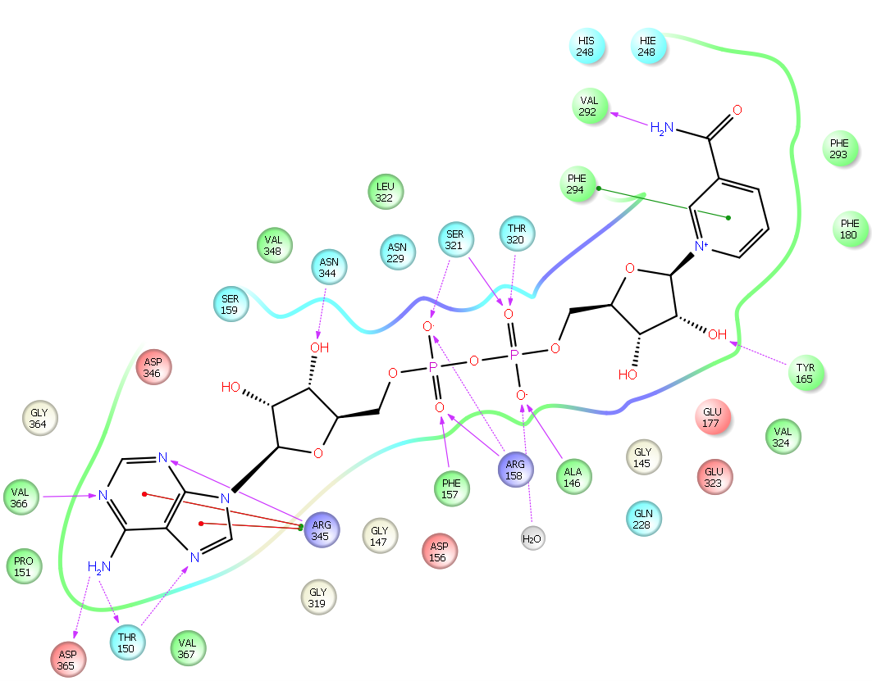
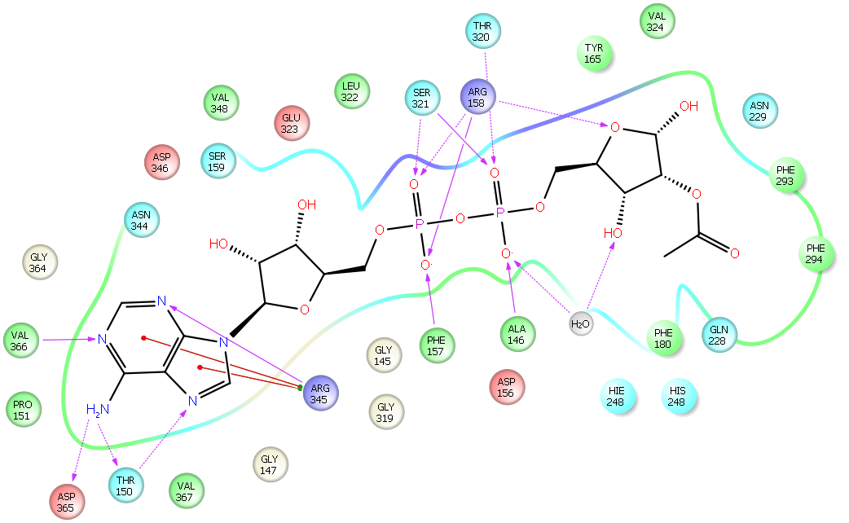

Only small SIRT3 structural changes occur in the complexes (4BV3 and 4BVH) with Ex-243 bound in the C-pocket.
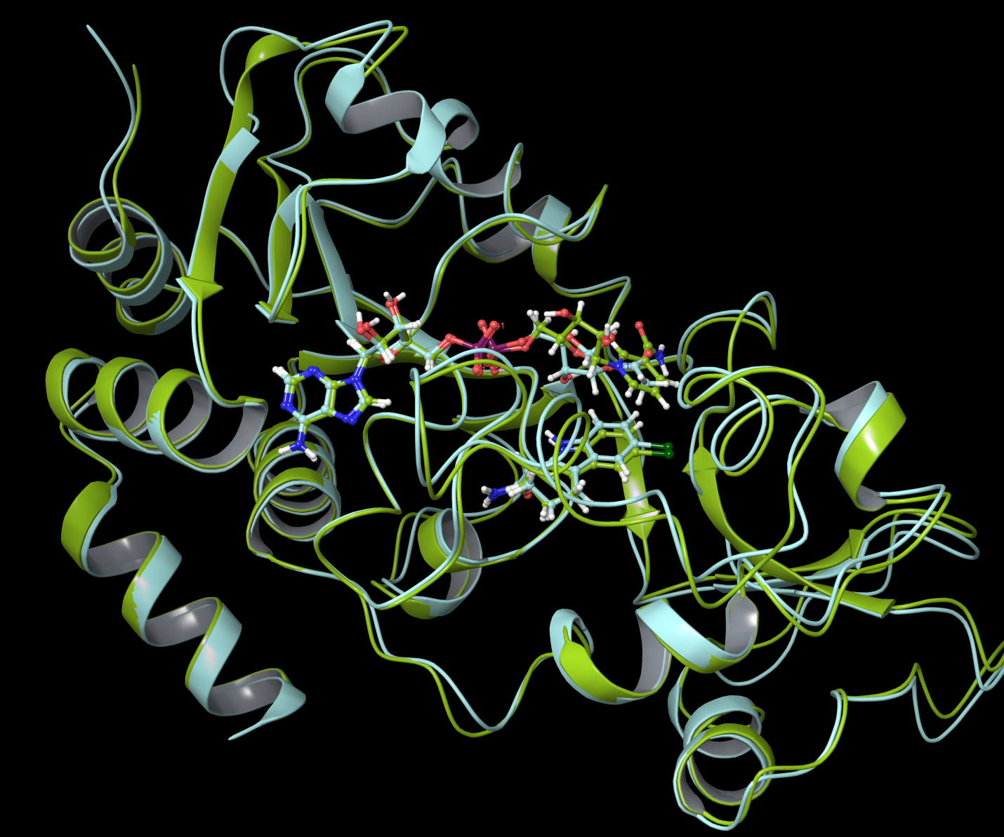
RMSD for whole protein is 0.677 Å.
RMSD for Ex-243 after protein structure alignment is 0.438 Å.
The local residue interactions with Ex-243 in SIRT3 are displayed below (same structure, two different views).
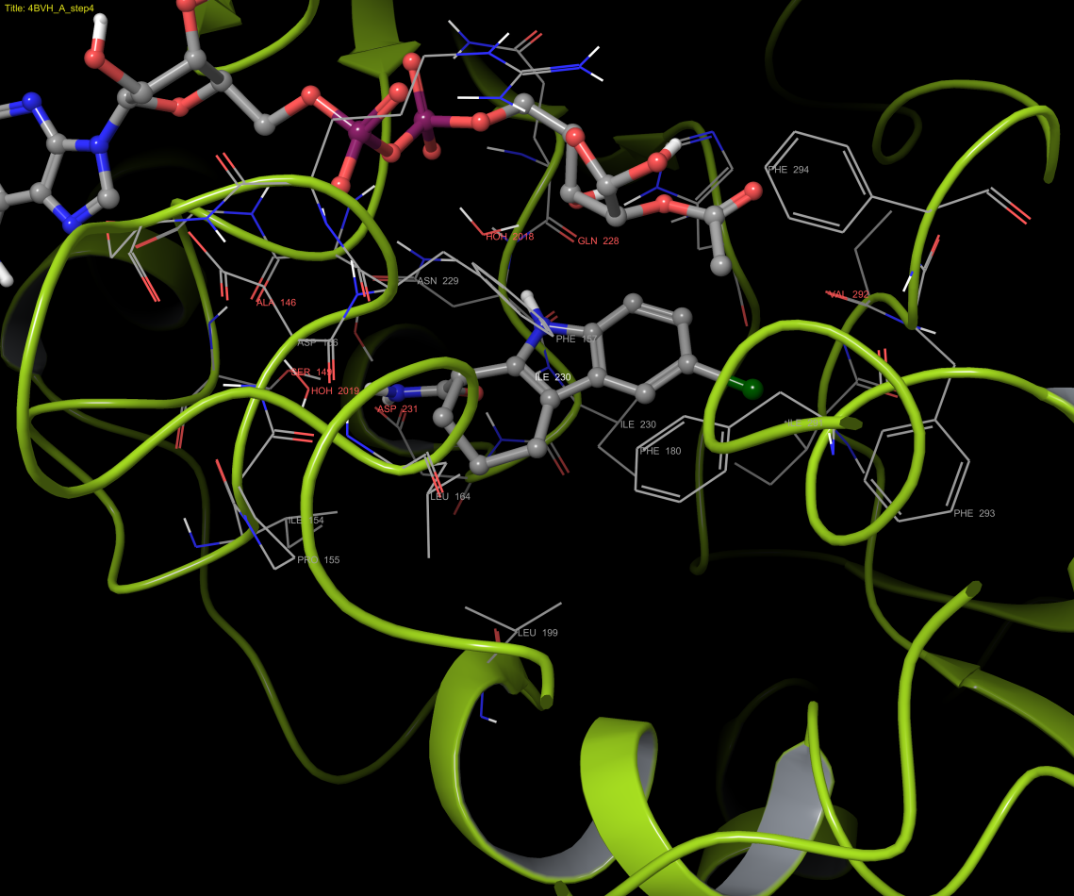
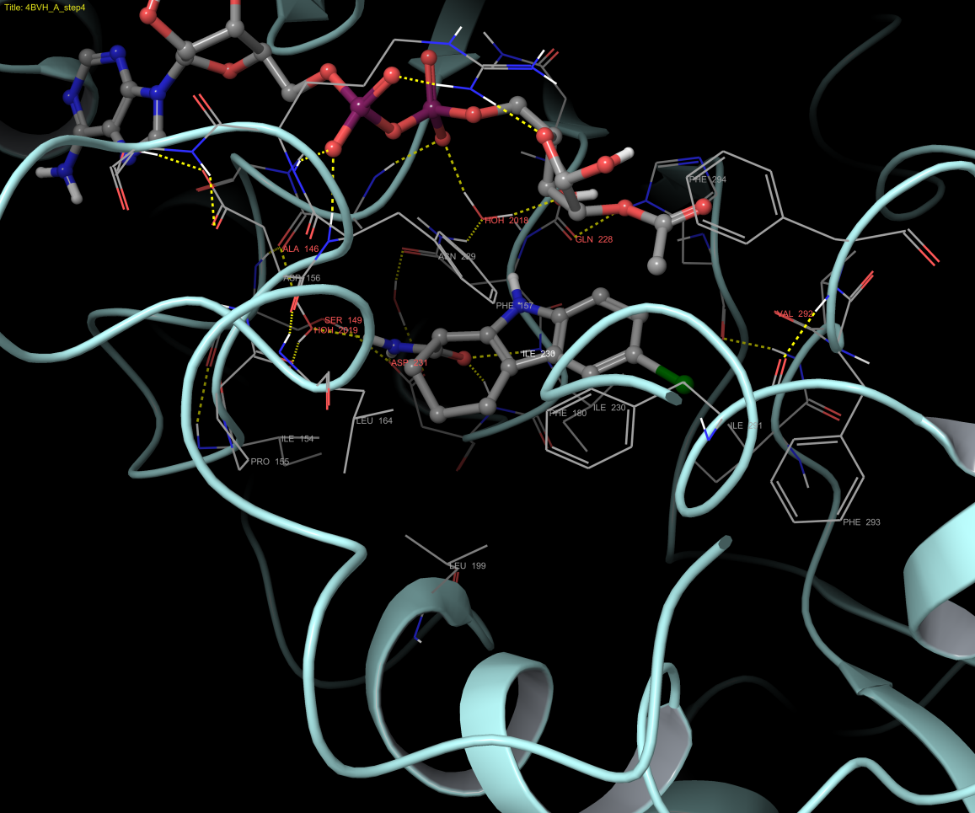

- Docking results (in-place and Glide XP, recalculated):
 | MM-GBSA (kcal/mol) | Ex-243
 | SIRT3 (4BV3) | -74.93
 | SIRT3 (4BV3), w/ NAD+ | -85.82
 | SIRT3 (4BV3), w/ NAD+ & water | -93.94
 | SIRT3 (4BVH) | -77.59
 | SIRT3 (4BVH), w/ AADPR | -89.62
 | SIRT3 (4BVH), w/ AADPR & 1 water | -97.31
 | SIRT3 (4BVH), w/ AADPR & 2 water | -101.70
 | SIRT3 (4BVG), w/ Intermediate (Glide XP)* | -46.76
 | SIRT3 (4BVH), w/ AADPR (Glide XP)* | -87.66

Note: 4BV3: SIRT3/NAD+/Ex-243 complex
4BVH: SIRT3/2’-O-acetyl-ADPR/Ex-243 complex
4BVG: SIRT3/Intermediate complex
AADPR: 2’-O-acetyl-ADPR
There is one water molecule near amide group of Ex-243 in 4BV3.
There are two water molecules near Ex-243 in 4BVH , one near amide group, one near the middle amine group.
The last two are results from Docking using Glide XP, no water is included.
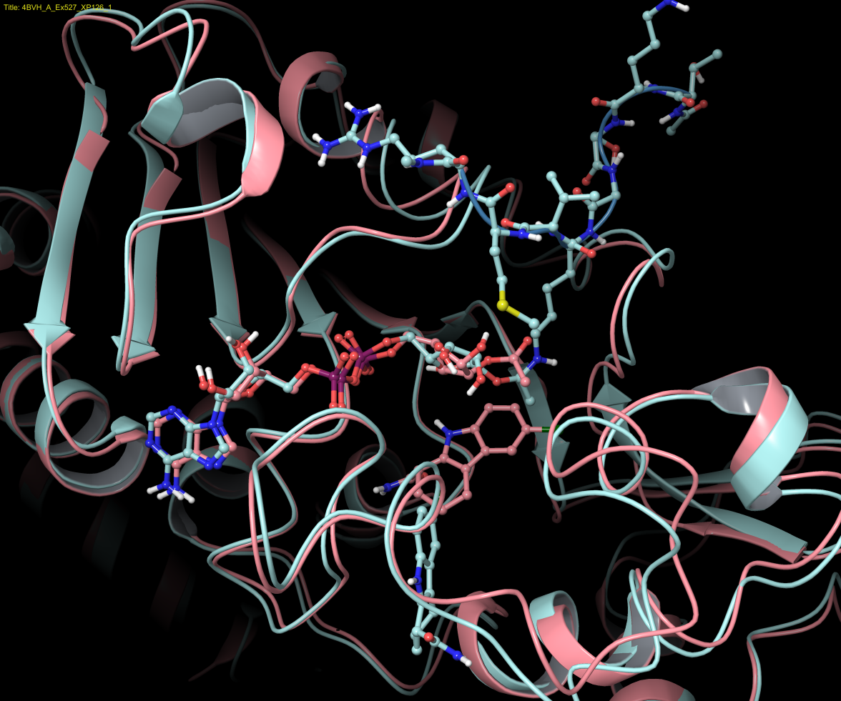
Comparison of results using 4BVG (light blue) and 4BVH (pink) as receptor shows Ex-243 was pushed out of the C pocket due to the clash with intermediate.

In-pace MM-GBSA results suggested that the acetyl- group of AADPR or nicotinamide group of NAD+ help stabilize the binding of Ex-243 in C-pocket. Using ADPR in the place of AADPR (as in 4BVB, results not shown in table) does little in stabilizing Ex-243 in the C-pocket (MM-GBSA values decrease from -76.34 to -78.52 kcal/mol).

