MolName | Structure | MMGBSA dG Bind | Substructure
Ex243 in SIRT3_OAADPR_1water_4BVH_A | 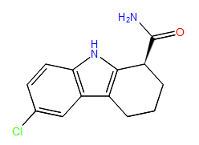 | -97.31212
Ex243 in SIRT3_AADPR_1water_4BV3_5 |  | -86.341836
4-[(trichloroacetyl)amino]benzamide | 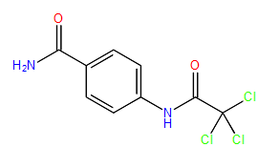 | -77.492745 | SSS_A_1
2-[(3-methyl-2-butenoyl)amino]benzamide | 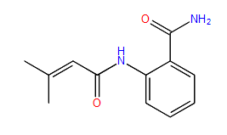 | -74.99934 | SSS_A_1
2-({[(3-chlorophenyl)amino]carbonyl}amino)benzamide | 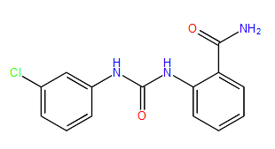 | -72.087047 | SSS_A_1
3-({[4-(aminocarbonyl)phenyl]amino}carbonyl)-7-oxabicyclo[2.2.1]heptane-2-carboxylic acid | 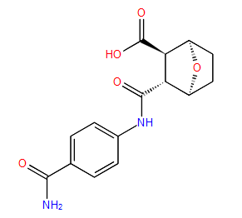 | -70.843851 | SSS_A_1
N-[4-(aminocarbonyl)phenyl]-5-chloro-2-thiophenecarboxamide | 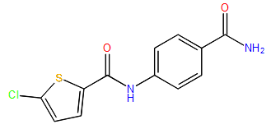 | -70.468438 | SSS_A_1
2-[(anilinocarbonyl)amino]benzamide | 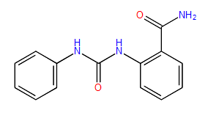 | -70.302862 | SSS_A_1
1,6-dimethyl-2,3,4,9-tetrahydro-1H-carbazole-1-carboxamide | 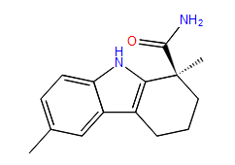 | -88.954033 | SSS_A_2
7-methyl-1,2,3,4-tetrahydrocyclopenta[b]indole-3-carboxamide | 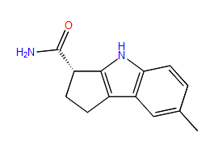 | -83.777736 | SSS_A_2
6,9-dimethyl-2,3,4,9-tetrahydro-1H-carbazole-1-carboxamide | 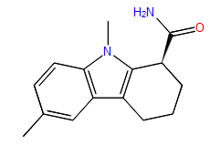 | -80.90636 | SSS_A_2
1,6-dimethyl-2,3,4,9-tetrahydro-1H-carbazole-1-carboxamide | 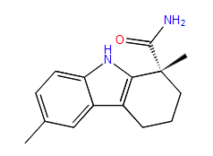 | -73.56296 | SSS_A_2
(1S,3R)-3-amino-N-(4-chloro-3-fluorophenyl)cyclopentanecarboxamide | 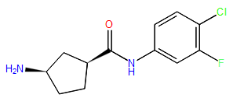 | -83.153259 | SSS_A_7
(1S,4R)-2-(3,4-dichlorobenzyl)-2-azabicyclo[2.2.1]heptan-3-one | 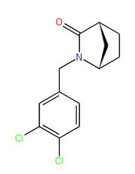 | -73.105783 | SSS_A_3
(1S*,3R*)-3-amino-N-(3-oxo-1,3-dihydro-2-benzofuran-5-yl)cyclopentanecarboxamide | 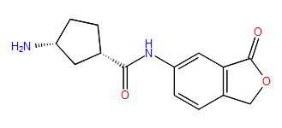 | -71.205785 | SSS_A_7
N-[(1R)-1-(aminocarbonyl)-2-methylpropyl]imidazo[1,2-a]pyrimidine-2-carboxamide | 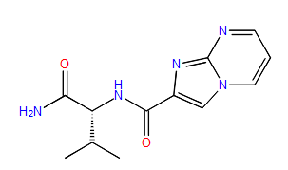 | -82.876988 | SSS_A_8
N~2~-[(2,5-dimethyl-3-thienyl)methyl]-L-alaninamide | 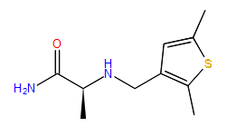 | -77.108601 | SSS_A_8
N~2~-{[2-(dimethylamino)-1,3-thiazol-5-yl]methyl}-D-alaninamide | 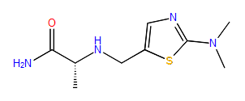 | -76.020931 | SSS_A_8
(2S)-2-(5-methyl-4-oxothieno[2,3-d]pyrimidin-3(4H)-yl)propanamide | 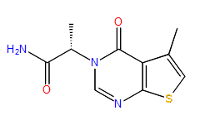 | -72.633096 | SSS_A_8
(2S)-2-(8-fluoro-4-oxoquinazolin-3(4H)-yl)-3-methylbutanamide | 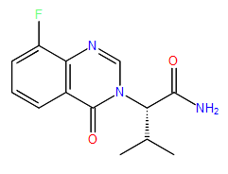 | -71.696717 | SSS_A_8
N~2~-{[5-(tetrahydro-2H-pyran-2-yl)-2-furyl]methyl}-L-alaninamide |  | -71.261914 | SSS_A_8

