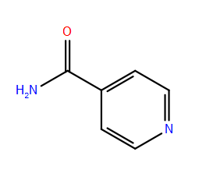* Calculated MM-GBSA values for top poses for selected small molecules (Week 1)

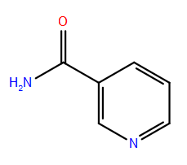

Nicotinamide (NAM)

|  |  |  |
| --- | --- | --- |
| MM-GBSA (kcal/mol) | SIRT3 (4BVG) with Intermediate | SIRT3 (4BVG) as apo-enzyme  Iso-Nicotinamide (IsoNAM) |
| NAM | -38.55 | -39.81 # |
| Iso-NAM | -32.36 | -34.68 # |
| Nicotinic Acid | -36.73 | -36.59 # |
| Pyridine, 1-oxide | -27.34 | -26.74 |
| N(1)-methylnicotinamide | -44.51 | -48.04  Pyridine, 1-oxide  Nicotinic Acid |
| Nicotinic Acid, 1-oxide | -34.16 | -33.06 |
| Ex527 | -37.88 |  |
| ligand 1 | -36.72 | -34.77 # |
| ligand 2 | -37.65 | -36.28 # |
| ligand 3 | -30.47 | -36.43 #  N(1)-methylnicotinamide |
| ligand 4 | -41.22 | -56.15 #  Nicotinic Acid, 1-oxide |
| ligand 5 | -49.04 | -50.26 # |
| ligand 6 | -48.95 | -46.47 # |
| ligand 7 | -45.74 | -46.08 # |
| ligand 8 | -47.73 | -46.45 |
| ligand 9 | -50.94 | -50.61 #  Ligand 1  Ex527 |
| ligand 10 | -47.30 | -46.89 # |
| ligand 11 | -49.19 | -48.03 # |
| ligand 12 | -47.10 | -49.96 # |
| ligand 13 | -52.42 | -48.80 # |
| ligand 14 | -46.32 | -49.23 #  Ligand 3  Ligand 2 |
| ligand 15 | -57.88 | -52.63 # |
| ligand 16 | -48.60 | -49.14 # |
|  |  | Ligand 4 |
| *** Note: without intermediate, ligands don’t always bound to C-pockets | | |
| # Most ligands 1-16 are not available from hit2lead (ChemBridge) except 8. | | |
| # Some is available from emolecules.com, but not sure if suitable as drug candidate.  Ligand 5 | | |
|  |  |  |
|  |  | Ligand 6 |
|  |  |  |
|  |  | Ligand 7 |
|  |  |  |
|  |  |  |
|  |  | Ligand 9  Ligand 10  Ligand 8 |
|  |  |  |
|  |  |  |
|  |  |  |
|  |  | Ligand 11 |
|  |  | Ligand 12 |
|  |  |  |
|  |  |  |
|  |  | Ligand 13 |

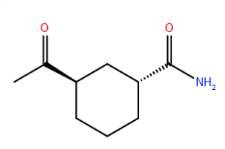* Fitting calculated MM-GBSA values to pIC50.

Ligand 14

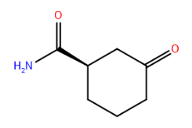4BVG: SIRT3 apo-enzyme taken from SIRT3/Intermediate complex

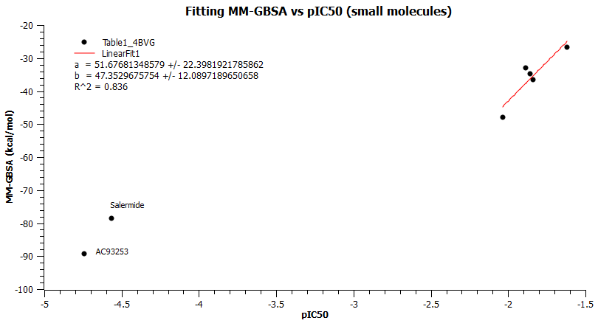4BVG_Int: SIRT3 with intermediate as receptor

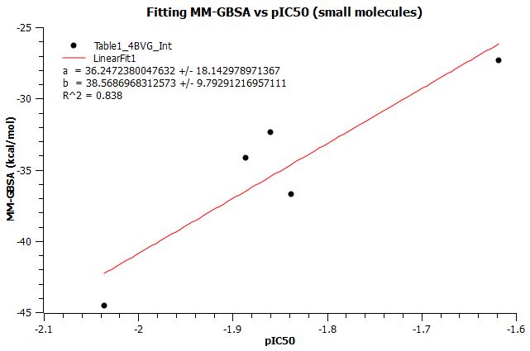

Ligand 16

Ligand 15

* More drug –like small molecules are selected from Hit2lead.com (Chembridge):

The following substructures were used, molecular weights were limited to <200, leading to 3698 unique small molecules.

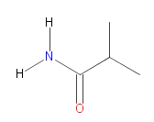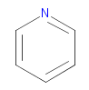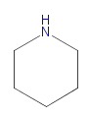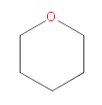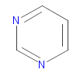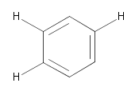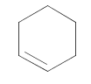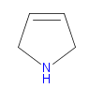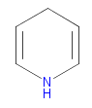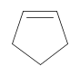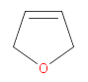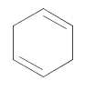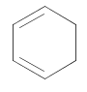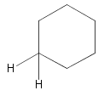

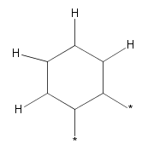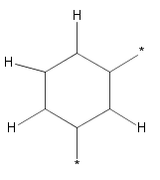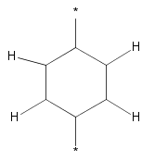

Further selection is under way to limit our library to a few hundreds.

* MD benchmark on slave006. (NAMD, SIRT3 apo-enzyme with explicit water, total 43587 atoms, 2fs time step, PME)

Using 8-cores, 2 ns simulation obtained in 28 hours.