**Solubility Measurement**

Solubility of DHP-2 and Honokiol in HDAC buffer and 5% DMSO/HDAC were 2.303 and 0.12 mg/ml, respectively. DHP-1 in up to 20% DMSO/HDAC was insoluble. In brief, HPLC (Agilent 1100 series) was used to perform the test. Calibration curves were established using concentration range covering the estimated solubility’s. The samples were then analyzed by a well-calibrated HPLC method. The linearity was measured by R-values at least >0.99. The estimated detection limit was around 0.002 mg/mL (2 μg/mL) based on acceptable N/S ratio. Over saturated samples were prepared by dosing excess compounds into the solvent mixtures of interest. The samples were equilibrated at ambient (24-25 oC) for 48 hours and then analyzed by the same HPLC method.

DHP-1 can be dissolved in reaction buffer at 50uM, but only in the form of a metastable solution. Measurement of DHP-1’s solubility using the above protocol revealed that it is thermodynamically insoluble. By mutating the ester groups in DHP-1 to carboxylic acid groups, we obtain the mutated compound DHP-2. In contrast to DHP-1, DHP-2 is thermodynamically soluble (**Table A**), and the solubility of Honokiol was also assessed with this protocol (**Table B**)-

**Table A: Solubility of DHP-2 in different % of DMSO-HDAC solution**-

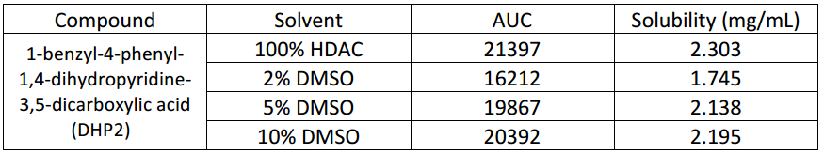

**Table B: Solubility of Honokiol in different % DMSO-HDAC solution**-

