Task003:

RC: specify in structure-based sequence alignment (meetings page) where the binding loop is and indicate the residue numbers for the loop residues for SIRT3 and Sir2Tm with numbering consistent with the reports;

report indicates there is a helical segment (162-170) within the binding loop for the ternary complex of SIRT3. It is not clear whether there is such a helix within the resolved loop residues of Sir2Tm and if so, where; this should be specified. highlight the helical segment in the ternary structures (e.g., 4FVT) in this alignment. please indicate whether the refined loops for 2H4F contained a helical segment (see also below) in the case that the sequence alignment suggests that the helical segment should lie within the range of missing residues (if not could specify helical constraint, if supported, to check the energy difference and validate sampling);

also indicate the residue in SIRT3 that is homologous to Phe33 in Sir2Tm. Is it Phe157 (noted from pptx below). Please do the same for Tyr40.

PL: Structure-based sequence alignment varies with the choice of structure used and reference used. Although the sequence identity is calculated at 35%, SIRT3 and Sir2TM bear significant structure similarity to suggest a consistent sequence alignment. Two alignments between Sir2TM and SIRT3 below use SIRT3 (4BVG) as reference. Some key residues PHE33/PHE157, TYR40/TYR165 are noted. End of flexible loop for SIRT3 (PRO174) and Sir2TM (VAL47) are also noted.

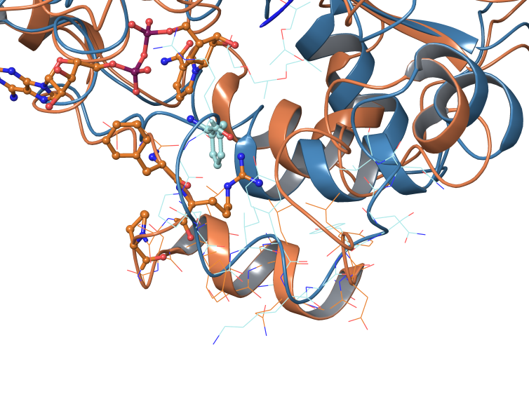In Sir2TM, GLY38-LYS42 was identified as 3/10 helix in crystal structure 2H2I. However, this helix doesn’t necessary line up well with the helix in 4FVT in SIRT3.

The loop refinement for 2H4F doesn’t result in any helical segment. Further testing with loop refinement using such constraints can be scheduled in a later time.

PHE33 in Sir2TM corresponds to PHE157 in SIRT3. TYR40 in Sir2TM corresponds to TYR165 in SIRT3.

Comparing helix in SIRT3 (4FVT) and Sir2TM (2H2I)

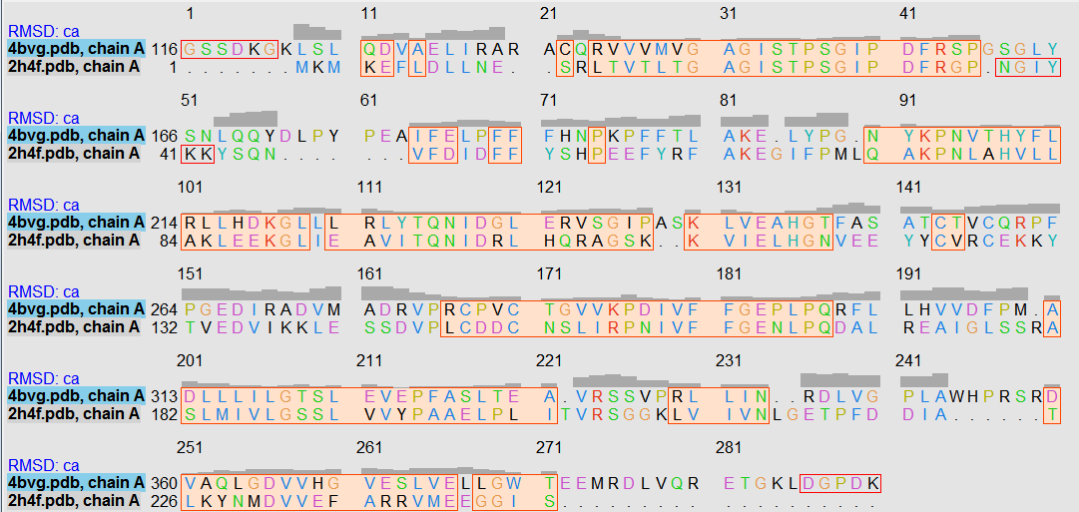

PRO174

VAL47

TYR40/TYR165

PHE33/PHE157

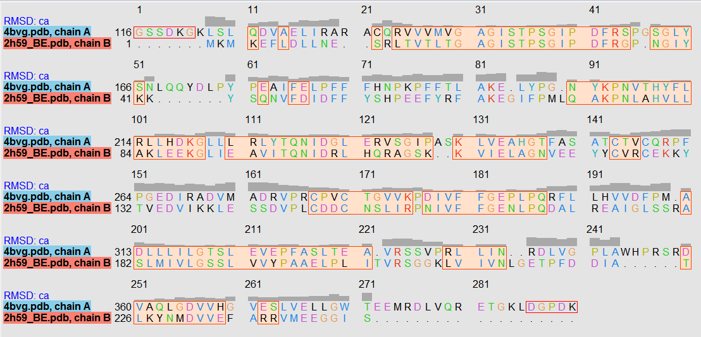

PRO174

VAL47

PHE33/PHE157

TYR40/TYR165

RC: Please provide a legend for notations in the alignment above. Also, please indicate the helical segment of the loop (SIRT3) and the turns in the alignments so we can identify the residues involved.

In the “comparing helix” figure of Sir2 and SIRT3 above, please indicate which structure is which and point out the loops.

\*XG has prepared a table of mutations in various sirtuins that includes specification of the role of each residue (esp in Sir2 enzymes) in the catalytic mechanism of the enzyme. Please point out each of those residues in the alignments above and where possible, indicate the homologous residue in SIRT3 that corresponds to each catalytic residue in Sir2 (in the event the data pertains to Sir2 enzymes other than Sir2Tm, e.g., Hst2, you can add that alignment). This can focus on the most critical residues listed in the table (for example, residues that simply play a minor role in substrate binding can be omitted).

Note that the table also lists, in certain cases, the pocket wherein a given catalytic residue lies. If possible, the numbers of the residues in the A,B,C pockets should be listed (for any one sirtuin included in the alignment).