Date: 3/10/2016

Tasks:

1. Mapping the remaining raw data files relevant to the information contained KT documents.

Status: Almost done, few more data on loop modelling needs to be mapped.

1. Create new B factor plots based on the MD data contained in

C:\Users\plin\Documents\MD_works \Flexible_Loop_Bfactor_Summary.xlsx

Two plots needs to be created.

**Status: Completed**

**Was not sure which plot you specifically need. So I created two plots here. I can always change the color of the plot, very easily because I have it saved in .agr format**

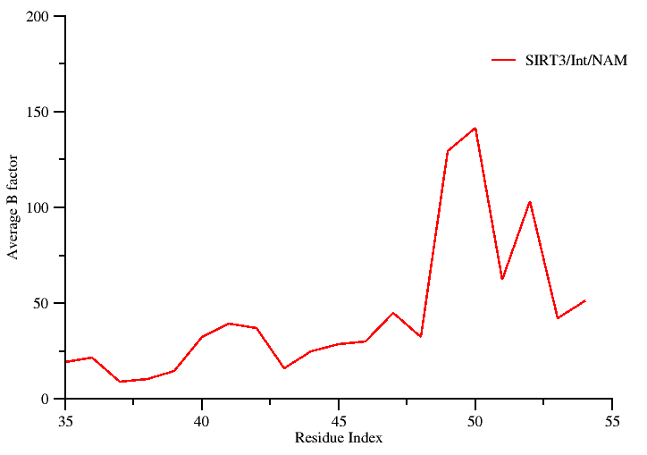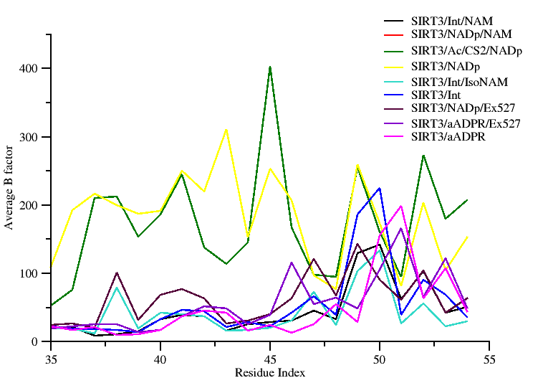

**Raw data used for generating the plot is contained in: C:\Users\plin\Documents\MD_works\Flexible_Loop_Bfactor_Summary.xlsx**

1. Perform a structure based sequence alignment using PROMALS3D to recreate the figure presented in Pling’s summary document.

The following PDB ids 4I5I, 3ZGV, 4FVT, 3RIY, 3ZG6, 2H59, 1YC2, and 1SZC will be considered for alignment and highlight regions containing the conserved residues critical for catalysis and their mutations.

RC: -- Task 3: is PROMALS3D what Ping used?

If so, please indicate some of the differences between the new alignment/presentation and the old one.

E.g., this might include focusing on a particular region.

RSK: Looking at the image and also digging through the files located in (user: Pling), I do see that Pling has some html result files generated using PROMALS3D. Further looking at the style of the data, I am confident that the alignment output must have been obtained using the PROMALS3D.

Looking at the footnote below that alignment image, I see that the whole point in having the sequence-structure alignment was to highlight residue conservation in the loop region (showing the short helix) and the beta turn region.

However, the image contains the entire sequence space, which looks to be slightly cluttered.

Hence, my suggestion is to use the alignment information provided by PROMALS3D and then filter the aligned region of interest and then proceed to create a sequence logo image to highlight the degree of conservation. Alternatively, a simple solution would be to edit the PROMALS3D image and the crop it to focus only on the region of interest.

**Status: Complete**

**Option A**

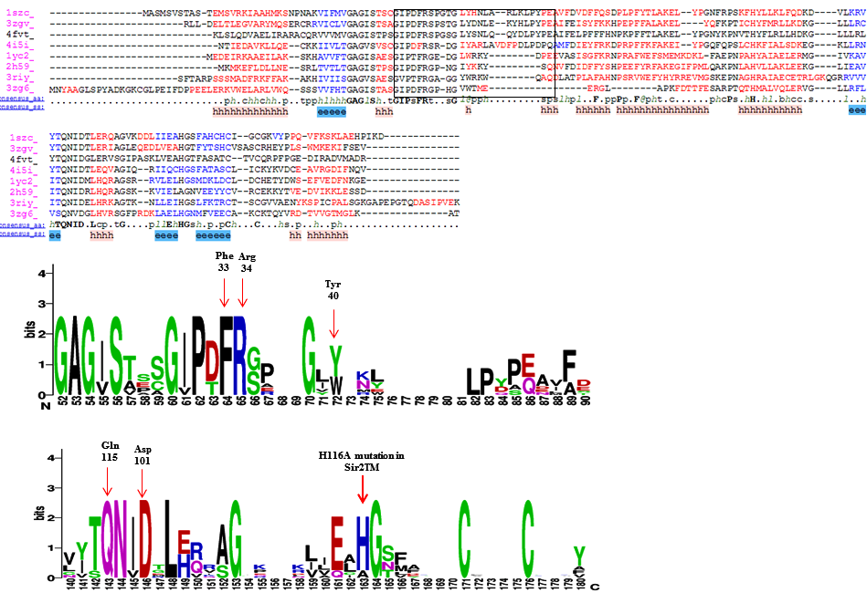

*Here, the relative sizes of the letters indicate their frequency in the sequences.*

**Option B**

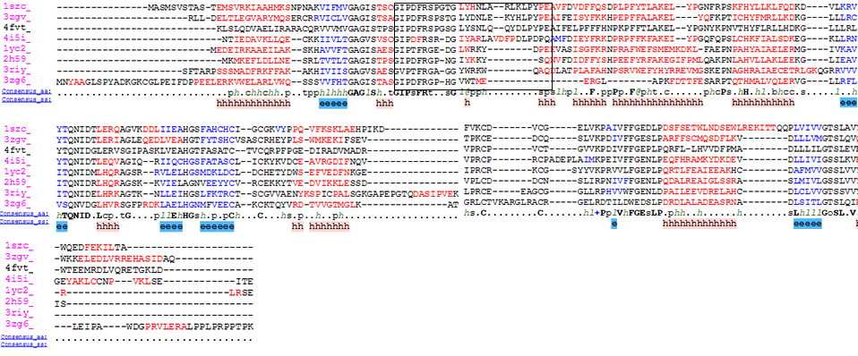

**Raw data: Not required. I completely redid it using the PDB entries mentioned in the previous figure prepared by Pling. I crosschecked and the alignment matches with the earlier figure.**

1. Pymol rendering showing the conformational heterogeneity of the cofactor binding loop (with and without the side chains displayed). The following PDB ids will be used to carry out a structural alignment. (4BVG, 4FVT, 4JSR, and 3GLS).

RC: -- Task 4: Structure alignment from pdbs. Yes, SIRT3 is the priority. I believe there was also a note about Sir2Tm in the Supporting Info. We should bear in mind that using 4 structures might lead to clutter. I believe the priorities were 4BVG and 4FVT? We can consider the others as well possibly for alternate versions of the Fig but with a plan.

RSK: I get your point. I will go ahead and prepare a session file with all four PDB entries. However, for generating image I will use only 4BVG and 4FVT in the display. Since, I will have everything saved in a pymol session file, we can always open the session file and juggle between the PDB entries, as required. A pymol session file will mitigate the need to create a quality rendering each time when required.

**Status: Completed**

**Option A (4BVG and 4FVT alone used for the display)**

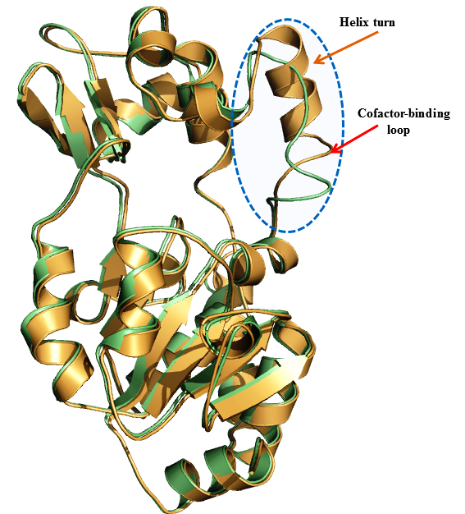

**Option B (All PDB ids used)**

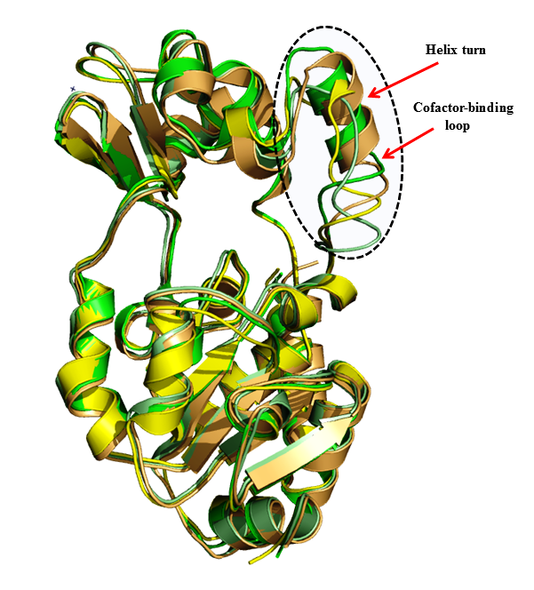

**Raw data: Not required. I used the PDB entries based mentioned in the previous figure prepared by Pling. Note: I have saved it as a pymol session file, so we can always make changes (like color, display style etc ) as desired easily.**

1. A new figure showing the comparison of SIRT3 complexes with cofactor binding loop modeled based on coordinates from ternary and intermediate complexes.

RC: Task 5: This is from MD data, right?

RSK: Yes, that’s right. It’s the MD averaged structure. I have located the pdb file of the MD averaged structure. ***However, the FOOT NOTE for the image provided by Pling in the original summary document says that “the native 4FVT structure after MD is aligned for comparison”. But looking at the image, I see the image to contain only one structure.* This needs to be reconciled. I think that 4FVT_isoNAM_v1_mds_avg10ps.pdb (native 4FVT simulation average structure) is the structure which Pling is alluding to.**

**Status: Not completed (I foresee an issue, need to discuss it)**

RC: Also, there were RMSD plots in one Fig that is later to be merged with either 4 or 5. Are we planning to use the old versions?

RSK: I will have to recreate one so that it match publication quality image standard and for consistency with the other plots. I have appended this item to the task list as item no 8.

**Status: Completed**

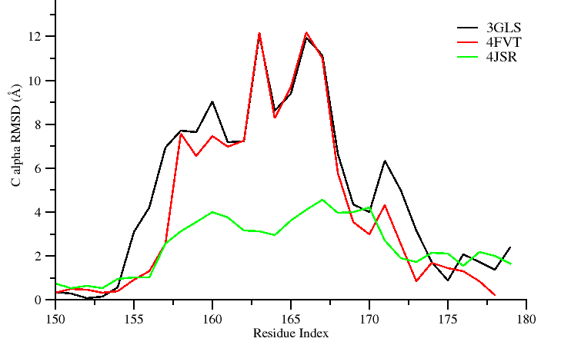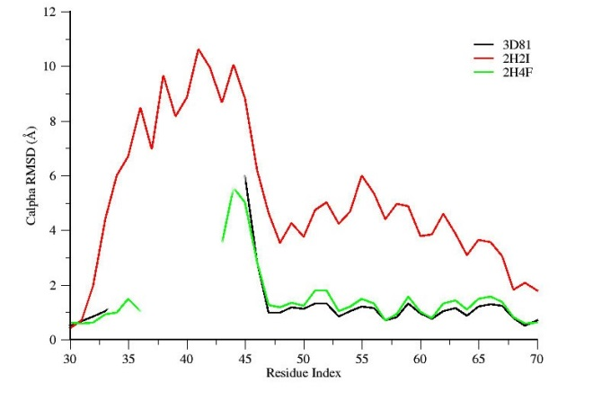

**The raw data used for the plot is located at**

**C:\Users\plin\Documents\MD_works\by-residue_RMSDs.xlsx**

1. Recreate new MM/GBSA and MM/PBSA tables similar to the previous PLOS ONE 2014 paper, reporting only binding energy values computed between 2-12 ns time scale. Two such tables need to be created.

**Status: completed**

|  |  |  |
| --- | --- | --- |
| Energy Components | SIRT3/INT/NAM prepared from 4FVT | SIRT3/INT/NAM prepared from 4FVT w/ loop (res 155-178) replacement from 4BVG |
| MM-GBSA (Complex) | -7146.48 ± 3.55 | -7201.58 ± 3.44 |
| MM-GBSA (Receptor) | -7050.17 ± 3.55 | -7105.13 ± 3.43 |
| MM-GBSA (Ligand) | -75.99 ± 0.18 | -75.95 ± 0.18 |
| **MM-GBSA (ΔGBind )** | **-20.33 ± 0.13** | **-22.50 ± 0.13** |
| MM-PBSA (Complex) | -5873.69 ± 3.87 | -5901.23 ± 3.76 |
| MM-PBSA (Receptor) | -5796.70 ± 3.89 | -5820.47 ± 3.74 |
| MM-PBSA (Ligand) | -73.03 ± 0.18 | -73.02 ± 0.18 |
| **MM-PBSA ( ΔGBind )** | -**3.96** **± 0.25** | **-7.73 ± 0.26** |

**The data used in this table is located at:**

**C:\Users\plin\Documents\SIRT\MM-GBPBSA_for_SIRT3complexes.xlsx.**

**REMARK: I see that you have commented that you need a table that’s similar to the PLOS 2014 paper. For that I would need the raw generated from the MMPBSA.py script**

**I tried to locate the raw .dat files obtained from the mmpbsa calculations in the gpu node, so that I could tabulate the energetic decomposition. I see that there are umpteen mmpbsa output files. Hence, I have written a shell script that will recursively go in to each directory and search for a .dat file and greps the value. (Will let you know if the script is able to locate a file having the exact ΔGBindvalues shown in the table)**

RC: Should we list the raw data required for each task under the task?

RSK: Yes, I think that would help in maintaining a good documentation. I have added it as item no 7 to the task list.

1. Add the location/path of the raw data used for completing the assigned task in “Task list1”

**Status: completed**

1. Replot the two RMSD plots contained in the KT document (manuscript computational section excerpts and task.doc)

**Status: completed (I have saved the plots in .agr format. In case if you need any modification, I can get it easily done (I will not have to redo the complete plotting again). Plot was generated using windows version of Xmgrace.**

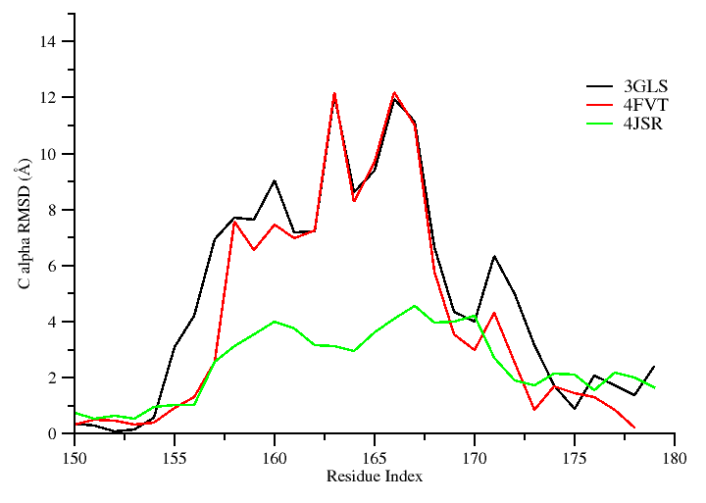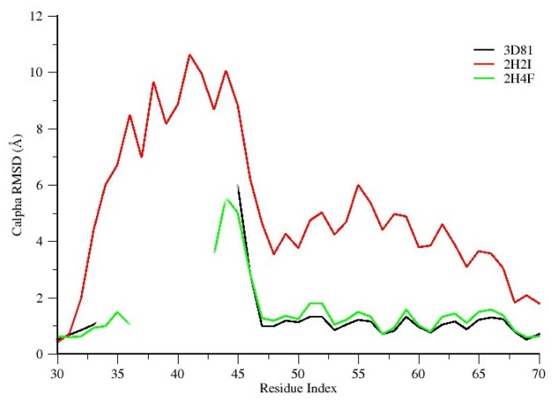

Should we list the raw data required for each task under the task?

RSK: Yes, I think that would be helpful for documentation purposes. Will add it.

**Status: has been incorporated now**