The new schedule is made based on the discussion of 8.03.2016 meeting
RC: Specify relation between AU, XG experiments #’s again. Make repeat plan directly analogous to that of AU per latest comments. Assuming triplicate is applied for initial rate experiments. Triplication for initial rate experiment is required.
Align AU# | Task # | Status | In-house Enzyme | Repeat
PMC-AU1 | PMC-XG1-1: Deacetylated FdL2 peptide to check the detection limitation of old HPLC  [Pep-3]=0.25, 0.5, 1.0, 1.5 uM | 7.26. 16 - 7.29. 16 Done. Minimum  [FdL2 peptide] is 3 uM. | No | Intra and inter-day
 | PMC-XG1-1’: DHP1c solution preparation  To validate how accurate the DHP1c solution concentration made different day for both Citizen MicroBalance and Sartorius Semi-MicroBalance. Weigh different mass of DHP1c sample, then prepare the solution, run on HPLC, find out the linear relationship between peak area and [DHP1c] | Done  Solubility test has been sent out. Waiting for the results. | No | Citizen Micro and  Sartorius Semi micro  Balance
PMC-AU2 | PMC-XG2: Deacetylation reactions condition modification within HPLC detection limitation-FdL2 peptide.  [FdL2 peptide] = 3uM  [NAD+] = 3000uM  [Enzo SIRT3 and in-house SIRT3] = 10 U  Time point = 5, 30 min | Done | 80 U (60ul)  SM previous batch_6+7 (no FPLC): 1.6U/ul | Duplicate
PMC-AU3 | PMC-XG3: Deacetylation reactions condition modification within HPLC detection limitation- NAD+.  [FdL2 peptide] = 250uM  [NAD+] = 10, 25, 50, 75, 100 uM  [Enzo SIRT3 and in-house SIRT3] = 10 U  Time point = 5, 30 min | Done. Minimum [NAD+] is 10 uM. | 200U  (150 ul)  SM batch_6+7 1.6U/ul | Duplicate
PMC-AU4 | PMC-XG4-1: DHP2c dose response experiment-HPLC  Condition 1: [FdL2 peptide] = 3uM  [NAD+] = 3000uM  Condition 2: [FdL2 peptide] = 250 uM  [NAD+] = 10 uM  Condition 3: [FdL2 peptide] = 250 uM  [NAD+] = 500uM  [DHP2c]=0, 5, 10, 25, 50, 100, 200, 400uM  [Enzo SIRT3 and in-house SIRT3] = 10 U  Time point = 30 min  Total 3x7x3=63 reactions for triplicate(9 days) | 8.31.16-9.13.16  Done  Note: Was held for the solubility results, which was completed by 8.30.16. The experiments are expecting to start on 8.31.16. DHP2c will be used to replace DHP1c. | 540U  (360 ul)  SM previous batch_6+7 (no FPLC): 1.6U/ul | Repeats  (N=3/4)
Patent Prep. | Patent preparation | 9.6.16-9.14.16. Done
PMC-AU4 | PMC-XG4-2: Standard curve with custom synthesized peptide in HDAC, and desired concentrations of DHP2c in HDAC buffer.  Peptide 3 (deacetylated FdL2 peptide) will be used as standard.  - The standard will be run under 8 different solution conditions (0.46875, 0.9375, 1.875, 3.75, 7.5, 15, 30uM). This will cover the conditions used in endpoint and initial rate experiments.  - Also, Enzo standard will be used for comparison. | 9.15.2016 – 9.19.2016  Done | No | Duplicate
PMC-AU4 | PMC-XG4-3: DHP1c dose response experiment-FdL assay on TeCan  Condition 1: [FdL2 peptide] = 3uM; [NAD+]=3000uM  Condition 2: [FdL2 peptide] = 250 uM; [NAD+] = 10uM.  Condition 3: [FdL2 peptide] = 250 uM; [NAD+] = 500uM  [DHP2c]=0, 5, 10, 25, 50, 100, 200, 400uM.  [Enzo/In-house SIRT3] = 10 U  Time points = 0, 60 min | 9.20.2016 – 9.26.2016  Done | 800U (800ul)  SM new FPLC batch  Combined Batch 2 1U/ul | Duplicate
Literature search | Literature search for “Screening assay for sirtuins’ modulator” | 9.21.2016-9.26.2016  Done | No other fluorogenic assay is available for our system.
PMC-XG 5  Initial rate Honokiol-in-house SIRT3 in the presence of NAM- Km, Vmax vs. [NAD⁺] | PMC-XG 5-1: Honokiol dose response experiment-FdL assay on TeCan  Condition 1: [FdL2 peptide] = 30uM; [NAD+]=3000uM  Condition 2: [FdL2 peptide] = 250 uM; [NAD+] = 25uM.  [DMSO]=5%  [Honokiol]=0, 5, 10, 25, 50, 100, 200, 350uM  [In-house SIRT3] = 10 U  Time points = 0, 60 min | 9.28.2016 – 9.30.2016  Done | 280U (280ul)  SM new FPLC batch  Combined Batch 2 1U/ul | Duplicate
 | PMC-XG 5-2: Honokiol dose response experiment-FdL assay on HPLC  Condition 1: [FdL2 peptide] = 30uM; [NAD+]=3000uM  Condition 2: [FdL2 peptide] = 250 uM; [NAD+] = 25uM.  [DMSO]=5%  [Honokiol]=0, 5, 10, 25, 50, 100, 200, 350uM  [In-house SIRT3] = 10 U  Time points = 0, 60 min | 10.03.2016 - 10.07.2016 | 280U (280ul)  SM new FPLC batch  Combined Batch 2 1U/ul | Duplicate
 | PMC-XG6-1: Minimum peptide concentration -SIRTainty assay-TeCan  [NAD+] = 2.5 mM  [MnSOD K122]= 0, 2.5, 5, 6.25, 12.5 uM  [In-house SIRT3]=10 U  %DMSO = 5%  Time point= 0, 10, 30 min | 2 days | Duplicate
 | PMC-XG6-2: Resveratrol dose response experiment-SIRTainty assay-TeCan  Condition 1: [MnSOD K122] = will obtain from XG6-1  [NAD+] = 2.5 mM  Condition 2: [MnSOD K122] = 600 uM  [NAD+] = 50 uM  %DMSO = 5%  [Resveratrol]=0, 5, 10, 25, 50, 100, 200, 400 uM  [Honokiol] = 0, 200uM  [in-house SIRT3] = 10 U  Time point = 60 min | 3 days | Duplicate
 | PMC-XG 5-3: Optimize suitable NAM concentration for initial rate study on TeCan  [In-house SIRT3]=10 U  [FdL2 peptide]=250 uM  [NAD+]= 25uM  [Honokiol]=200uM if the IC50 is similar to that in MnSOD experiments.  [DMSO]=5%  [NAM] = 0, 10, 25, 50, 100, 200 uM  Time point=0, 60 min | 10.10.2016 - 10.13.2016 | 200U (200 ul)  SM new FPLC batch  Combined Batch 2 1U/ul | Duplicate
 | PMC-XG 5-4: Initial rate Honokiol-in-house SIRT3- Km, Vmax vs. [NAD⁺] on TeCan  [In-house SIRT3]=10 U  [FdL2 peptide]=250 uM  [NAD+]= 50, 100, 375, 750, 1500, 3000uM  [Honokiol]=200uM  [DMSO]=5%  [NAM] = ? from result of PMC-XG 5-2.  Time point=0, 5, 10, 20, 30, 45, 60, 120min  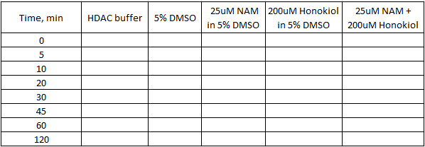 | 10.14.2016 - 11.04.2016  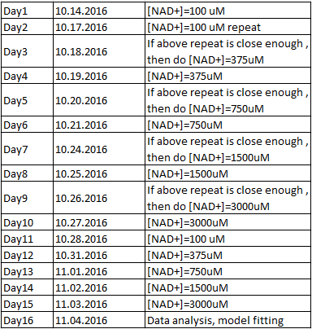  4800U (4800ul); Triplicate  At this point, more enzyme is needed

