1. “As you listed on misc tasks, should do another 1-2 high nam for mnsod at 3000uM nad, v soon using Enzo SIRT3. The goal is to see where a plateau occurs in 1/v Dixon plot (note this is not same as plateau in v), choose accordingly. I assume this can be done relatively quickly.

RC: The reply did not address this point: you only went up to 300uM NAM, whereas we did not see Dixon plateau at even 500uM NAM as I recall. Higher conc(s) needs to be checked @3000uM NAD @30min (in absence of any modulator of course).”

AU: 5% DMSO, Enzo SIRT3=5U/reaction, [NAD+] = 3000 uM, [MnSOD K122] = 600 uM, [NAM] = 1 and 3 mM, Time point=30 min.

**Experiment done on 12-6-2016:**

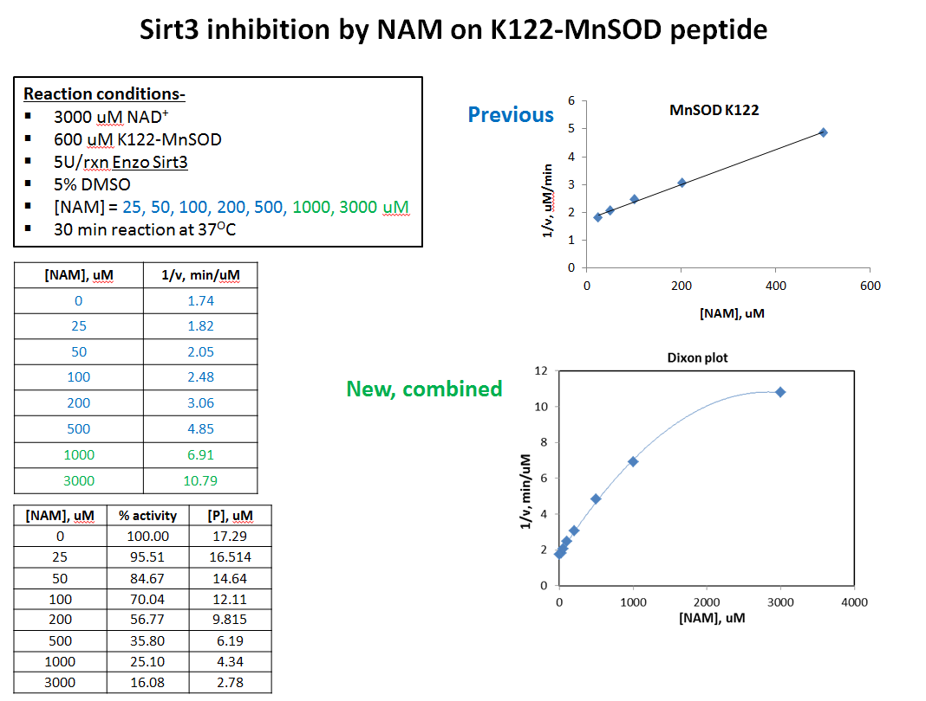

1. “RC: Given the data, unless Guan has some imp reasons why she chose a conc with 60% inhibition, we can go lower here. Also check the estimated combined effect of 200uM honokiol and NAM. Guan, please look at it closely.

RC: Also check the extent of inhibition by 200uM honokiol for FdL2 and MnSOD and consider whether the combination of your proposed [NAM] and 200uM honokiol will still leave measurable activity.”

XG: Yes. A combined inhibition effect of 200uM and NAM will be checked. 50, 100uM, and 200uM will be used. Will discuss with Alok for experimental details. [ One set each, No repeats]

The purpose of this experiment is to find out the suitable NAM concentration for initial rate studies (#4 below). Three concentrations of NAM are included to see that **1:** for two potential NAM concentrations for future studies (100 and 200 uM); **2:** 300 uM used to see if this concentration is in plateau range even after Honokiol combination. Two NAD concentrations (lowest and highest) will be used to see **1:** see if the product is accurately quantified **2:** see the effect of both saturating substrates.

* 1. **5% DMSO Only:** 30 min; [NAM] = 0 uM; [NAD] = 100, 3000 uM; [Honokiol] = 0 uM (2 Reactions)
  2. **5% DMSO + NAM:** 30 min; [NAM] = 100, 200, 300 uM; [NAD] = 100, 3000 uM; [Honokiol] = 0 uM (6 Reactions)
  3. **5% DMSO + NAM + Honokiol:** 30 min; [NAM] = 100, 200, 300 uM; [NAD] = 100, 3000 uM; [Honokiol] = 200 uM (6 Reactions)

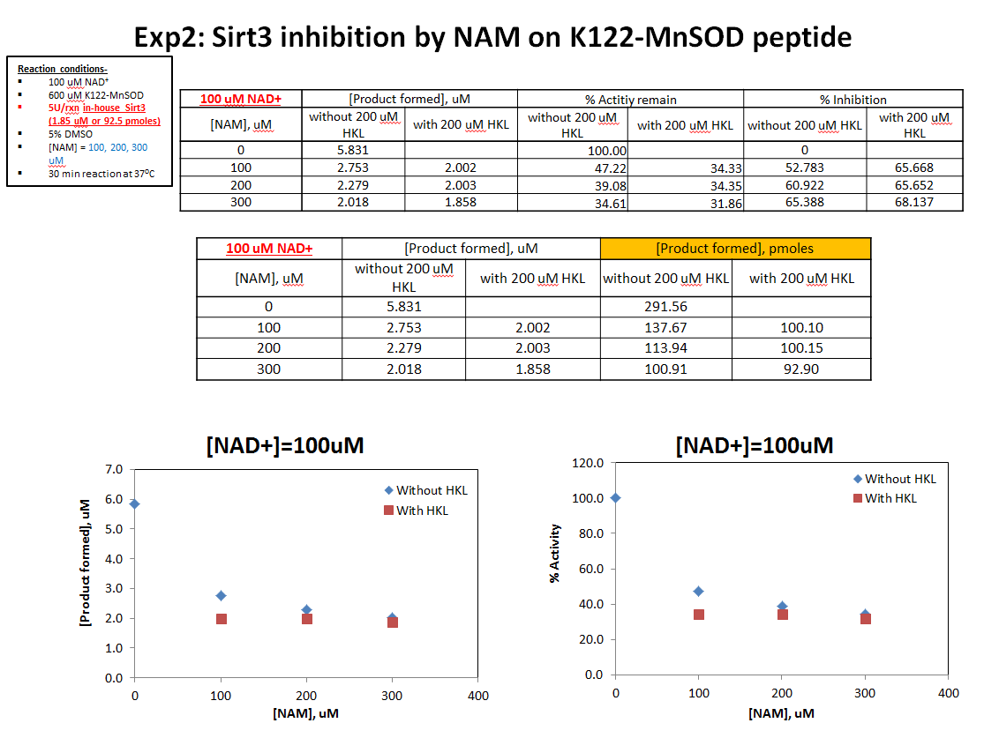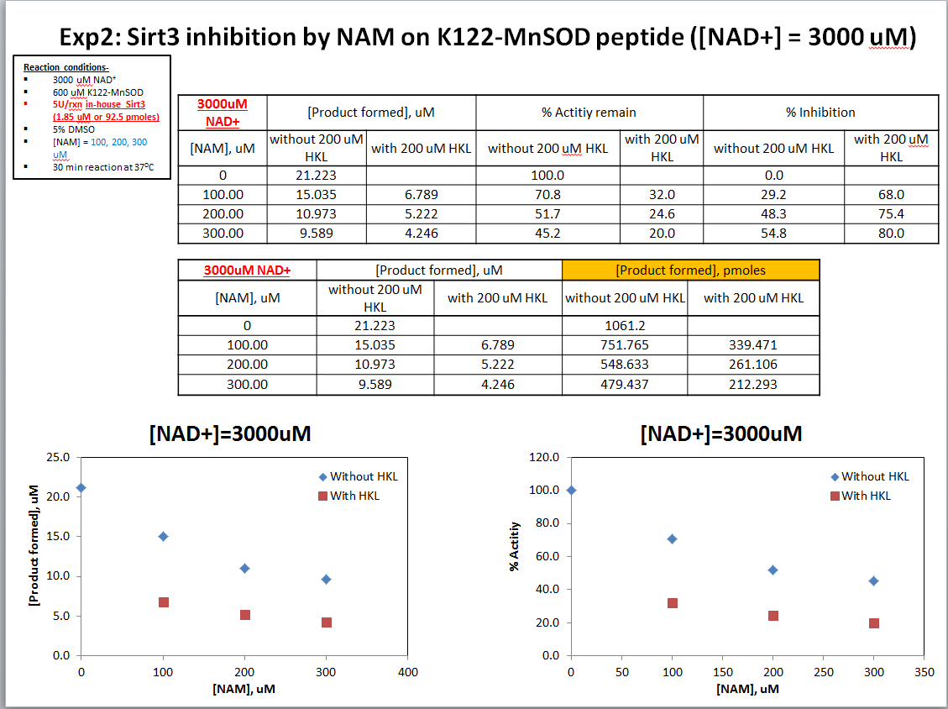

1. As you listed on misc tasks, should do another 1-2 high nam for mnsod at 3000uM nad, v soon using Enzo SIRT3. The goal is to see where a plateau occurs in 1/v Dixon plot (note this is not same as plateau in v), choose accordingly. I assume this can be done relatively quickly.

Please see # 1 experiments and feedback if that satisfies the criteria you mentioned in #3

1. Make a Dixon plot using the 25uM previous week data at a low nad   
   Compare to the 25uM NAM Dixon plot at 3000uM nad, add to doc file. We will upload the file once ready.
2. Actual experiments- (The [NAM] below is tentative, will decide based on #1
   1. **DMSO** = 5%**; [NAM]1** = 0 uM; **[K122-MnSOD]** = 600 uM; **[NAD]** = 100, 500, 3000 uM; **Time** = 10, 30, 40, 80, 120 min. (15 reactions)
   2. **DMSO** = 5%**; [NAM]1** = to be determined from Exp. 2; **[K122-MnSOD]** = 600 uM; **[NAD]** = 100, 500, 3000 uM; **Time** = 10, 30, 40, 80, 120 min. (15 reactions)
   3. **DMSO** = 5%**; [NAM]2** = to be determined from Exp. 2; **[K122-MnSOD]** = 600 uM; **[NAD]** = 100, 500, 3000 uM; **Time** = 10, 30, 40, 80, 120 min. (15 reactions)
   4. **DMSO** = 5%**; [NAM]1** = to be determined from Exp. 2; **[K122-MnSOD]** = 600 uM; **[NAD]** = 100, 500, 3000 uM; **Time** = 10, 30, 40, 80, 120 min; **[Honokiol]** = 200 uM. (15 reactions)
   5. **DMSO** = 5%**; [NAM]2** = to be determined from Exp. 2; **[K122-MnSOD]** = 600 uM; **[NAD]** = 50, 100, 500, 1000, 3000 uM; **Time** = 10, 20, 30, 40, 80, 120 min; **[Honokiol]** = 200 uM. (15 reactions)
   6. Repeat b, c, d, e, once, total duplicate.