Date: 4/1/2016

Task 1:

Mapping the remaining raw data files relevant to the information contained KT documents.

Status: I see that most of the important files necessary for the upcoming paper have been tracked down during the course of the completion of Task1 itself.

However, I need to document the location of the files as a part of the KT document. I will document it once the high priority tasks are done.

-----------------------------------------------------------------------------------------------------------------

Task 2:

Create new B factor plots based on the MD data contained in

C:\Users\plin\Documents\MD_works \Flexible_Loop_Bfactor_Summary.xlsx

Two plots needs to be created.

**Status: Completed**

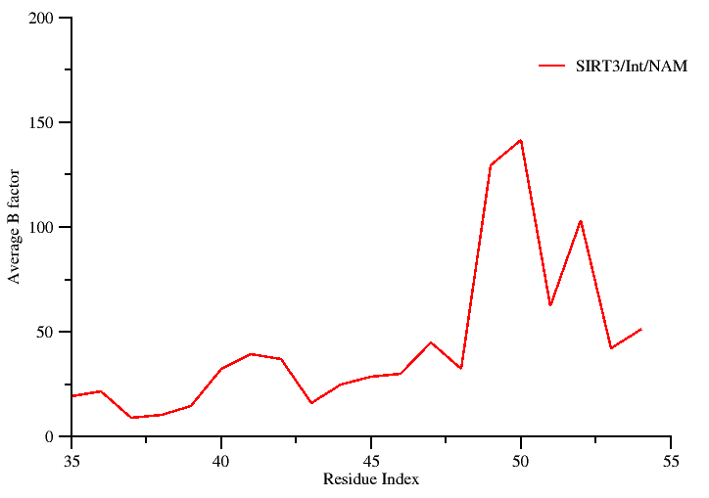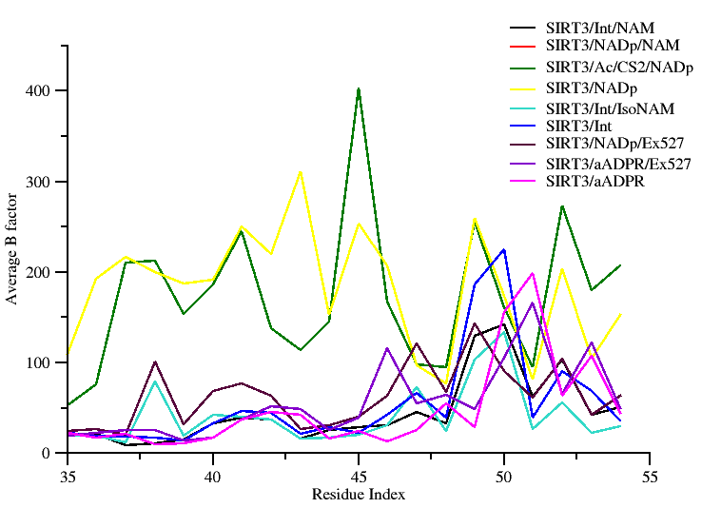

RSK: This figure was not present in Plin’s document. Hence, figure legend was not available.

Fig ------: Plot showing simulated B-factor values for the Cα atoms belonging to the co-factor binding loop region of SIRT3/Int/NAM complex.

**Comments:**

RSK: Not sure which plot you specifically need. So I created two plots here. I can always change the color of the plot, easily because I have them saved in .agr format.

Source of data: Raw data used for generating the above plot is contained in: C:\Users\plin\Documents\MD_works\Flexible_Loop_Bfactor_Summary.xlsx

RC (3/19): Why are the residues for the loop in SIRT3 numbered 35-55? These are not the loop residue numbers below. Please correct/comment.

RSK (4/1/2016): The raw data file which I got from Ping’s document had the residue ID column numbered form 35-55. Since, I used it for plotting, I retained these numbers.

However, ***looking at other relevant ppt presentations which Ping had prepared for the group meeting I realize that actual numbers for the flexible loop region should have been (155-175). The reason Ping had it numbered as 35-55 is because he has gone by the residue numbering convention using Sir2TM as the reference in this particular instance.***

I completely agree that for consistency purpose, these numbers needs to be corrected and it will be fixed in the revision.

RSK (4/1/2016): Latest Revised plot (consistency in numbering ensured)

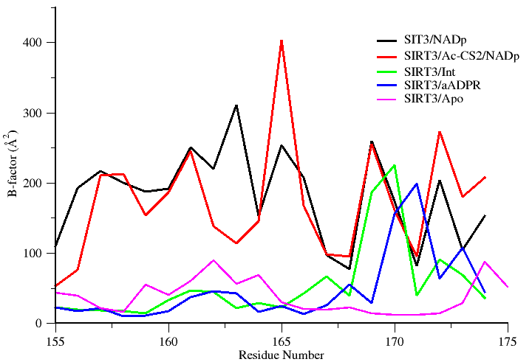

Fig ------: Plot showing simulated B-factor values for Cα atoms belonging to the co-factor binding loop region of various SIRT3 complexes. Residues (162-170) are known to adapt a helix conformation when bound to substrate.

RC (3/19): Please indicate whether the simulation parameters for the complexes in the 2nd plot above were all identical; otherwise indicate that they are not comparable due to different simulation parameters.

RSK (4/1/2016): I compared all the NAMD input parameter files (config files) used for the simulation using the “*diff”* command. I see that the MD parameters for all the simulation are same; however, the length of simulation time varies between systems. I still believe they are comparable, since an averaged property like B factor should be time-invariant assuming the system has attained equilibrium.

RC (3/19): You can remove the Ex-527, isoNAM and NAD/NAM B factors from the 2nd plot above. Please add the simulation B factors for SIRT3 apo (no NAD+ or peptide). Ping had done some simulations of the latter that showed increased flexibility of the loop in the absence of peptide substrate. You may ask XG about this if needed, she may have some of the old figures.

RSK (4/1/2016): Ex-527, isoNAM and NAD/NAM stands removed in the revised plot shown above (page 2). B factor for Sirt3 apo incorporated.

Comment: I was not able to locate the B factor data for the SIRT3 apo system prepared by Ping. However, I located the 3GLS apo MD trajectory which is essentially a Sirt3 apo structure (I cross checked to confirm if it’s an apo trajectory). Using this MD trajectory, I calculated the B factor values using the ptraj program available from Amber.

Secondly, you mentioned that Ping had stated that increased flexibility is evident for the co-factor loop region in the apo enzyme. However, my B-fac values (shown above in page 2) which is largely consistent with experimental Bfac values (shown below in page 3) proves otherwise.

Plots of the Xtal Bfac values for different Sirt3 systems clearly indicates that B fac values for the co-factor loop in the apo form (3GLS) is comparatively low over ternary and native intermediate complex (vide plot shown in page 3).

RC (3/19): Also, please provide a similar plot for experimental B factors from 4FVT, 4BVG and SIRT3 apo loops

RSK (4/1/2016): Plot showing experimental B factors added below

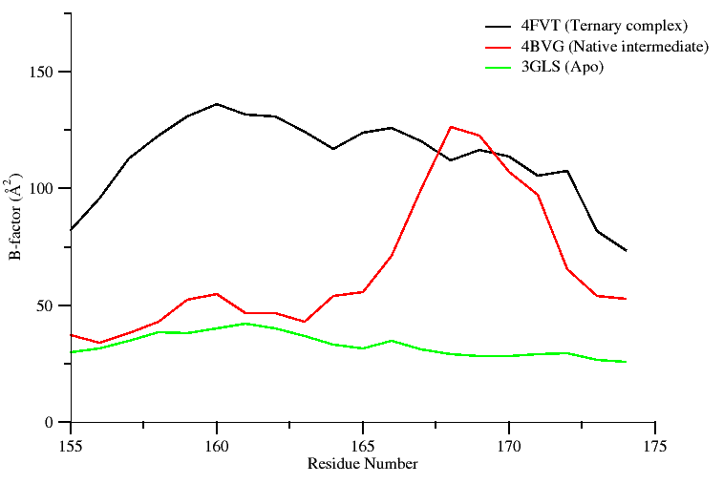

Fig ------: Plot showing crystallographic B-factor values of the Cα atoms belonging to the co-factor binding loop region of SIRT3 in different states. Residues (162-170) adapt a helix conformation when bound to co-factor.

RC (3/19): For earlier work on loop B factors, please see “PMC-AT Group Meeting 11112014 PLIN.ppt” on Workshops and Group Mtgs wiki page.

RSK (4/1/2016): Thanks, I looked at it.

I also realize the most relevant B factor data is located at PMC-AT Group Meeting 10172014 PLIN.ppt. However, Sirt3 apo structure values are not reported there. However, as mentioned above this task has been completed.

RC (3/19): Indicate which section of the loop corresponds to the short helix

RSK (3/25): The short helix region should be (162-170) as per Ping’s document (Task003_PL_RC_v3). This information has been added to the figured legend accompanying the revised plot shown above.

RC (3/19): The B factor figs will most likely not be included in body of paper so they are of somewhat lower priority. We will most likely use the by-residue RMSD plots instead

RSK (3/21): Okay, got it.

---------------------------------------------------------------------------------------------------------------

Task 3:

Perform a structure based sequence alignment using PROMALS3D to recreate the figure presented in Pling’s summary document.

The following PDB ids 4I5I, 3ZGV, 4FVT, 3RIY, 3ZG6, 2H59, 1YC2, and 1SZC will be considered for alignment and highlight regions containing the conserved residues critical for catalysis and their mutations.

**Status: Completed**

RC: -- Task 3: is PROMALS3D what Ping used?

If so, please indicate some of the differences between the new alignment/presentation and the old one.

E.g., this might include focusing on a particular region.

RSK: Looking at the image and also digging through the files located in (user/plin), I do see that Plin has some html result files generated using PROMALS3D. Further looking at the style of the data, I am confident that the alignment output must have been obtained using the PROMALS3D.

Looking at the footnote below that alignment image, I see that the whole point in having the sequence-structure alignment was to highlight residue conservation in the loop region (showing the short helix) and the beta turn region. However, the image contains the entire sequence space, which looks to be slightly cluttered.

Hence, my suggestion is to use the alignment information provided by PROMALS3D and then filter the aligned region of interest and then proceed to create a sequence logo image to highlight the degree of conservation. Alternatively, a simple solution would be to edit the PROMALS3D image and the crop it to focus only on the region of interest.

RC: Regarding the sequence alignments and annotations of catalytically important residues in other figures: please get the table from Guan on the roles of these residues and include some version of this at the end of the document so it is self-contained and so the captions can later be revised to include some mention of the roles of these residues if desired.  
This should also be available on the wiki.

RSK: I have added a summary note based on Plin’s document. Also, I have revised the figure incorporating such information’s which I picked up form literatures.

Basically from a review article titles “*Structural basis for sirtuin function: What we know and what we don’t*” which appeared in BBA.

RC: Regarding caption for sequence alignment, I didn't see a draft of the condensed/revised version of the original caption that Ping apparently borrowed from the sequence alignment program.

RSK: A condensed and revised version of the figure legend has now been incorporated.

**Option A (new revised figure)**

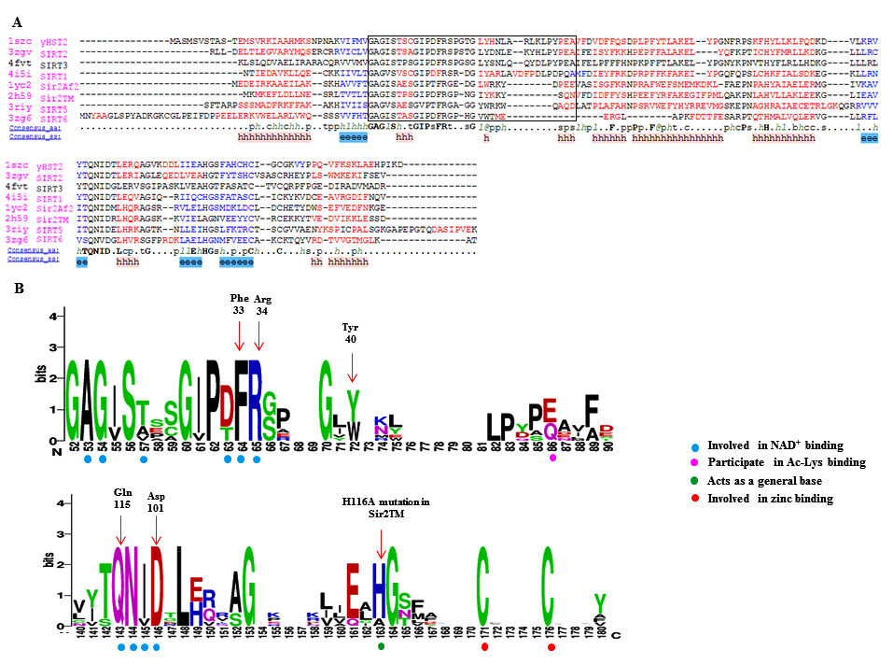

**RSK: figure legend revised appropriately based on your comments.**

**Fig ……. :** Panel A shows a PROMALS3D sequence alignment of sirtuin proteins.  Residues shown in the alignment are colored according to their predicted secondary structure elements (red: α-helix, blue: β-strand). The black box indicates the boundaries of the co-factor binding loop region. The consensus sequence (consensus_aa) and the consensus predicted secondary structure (consensus_aa) are shown at the bottom of the alignment. Consensus amino acid symbols are represented by: conserved amino acids are in bold and uppercase letters; aliphatic (I, V, L): l; aromatic (Y, H, W, F): @; hydrophobic (W, F, Y, M, L, I, V, A, C, T, H): h; alcohol (S, T): o; polar residues (D, E, H, K, N, Q, R, S, T): p; tiny (A, G, C, S): t; small (A, G, C, S, V, N, D, T, P): s; bulky residues (E, F, I, K, L, M, Q, R, W, Y): b; positively charged (K, R, H): +; negatively charged (D, E): −; charged (D, E, K, R, H): c. The global consensus predicted secondary structure are represented by alpha helix (h) and beta strand (e).

Panel B shows a portion of sequence logo that corresponds to co-factor binding loop region and other key residues of the catalytic core region. Here, the relative height of the letters indicates amino acid frequency at that position. Residues important for co-factor, substrate binding and catalysis are highlighted using colored circles. Amino acids residues in the logos are colored according to their chemical properties (neutral polar – green, basic – blue, acidic – red and hydrophobic – black).

RC (3/19): There may not be space for both a,b. Panel b does not indicate what residues form the loop?

RSK (4/1/2016): A revised figure (Option B) containing only the panel A of the previous figure (shown above) along with all necessary annotations is provided below.

Option B (3/26/2016)

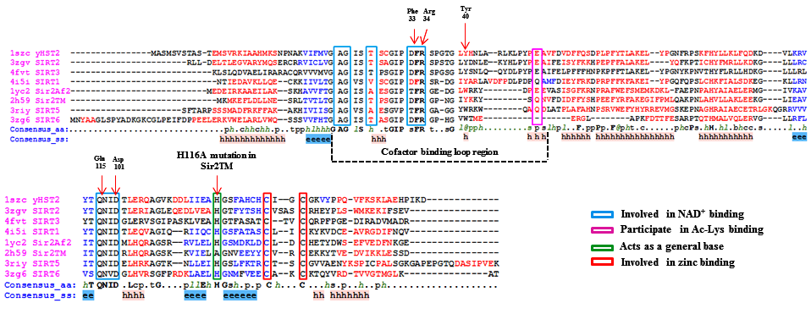

**Fig ……. :** PROMALS3D based sequence alignment of sirtuin proteins.  Residues shown in the alignment are colored according to their predicted secondary structure elements (red: α-helix, blue: β-strand). The boundaries of the co-factor binding loop region are highlighted using black dotted lines. The consensus sequence (consensus_aa) and consensus predicted secondary structure (consensus_aa) are shown at the bottom of the alignment. Consensus amino acid symbols are represented by: conserved amino acids are in bold and uppercase letters; aliphatic (I, V, L): l; aromatic (Y, H, W, F): @; hydrophobic (W, F, Y, M, L, I, V, A, C, T, H): h; alcohol (S, T): o; polar residues (D, E, H, K, N, Q, R, S, T): p; tiny (A, G, C, S): t; small (A, G, C, S, V, N, D, T, P): s; bulky residues (E, F, I, K, L, M, Q, R, W, Y): b; positively charged (K, R, H): +; negatively charged (D, E): −; charged (D, E, K, R, H): c. The global consensus predicted secondary structure are represented by alpha helix (h) and beta strand (e). Residues important for co-factor binding, substrate binding and catalysis are highlighted in colored boxes.

**Summary on the role of the highlighted residues: (Taken form Plin’s document)**

Phe 33 in ySir2

* Plays a critical role both in the initial reaction steps
* Its orientation is likely to be a key mediator of the nicotinamide exchange reaction

His 116 in Sir2Tm

* Catalytically Important residue
* H116D and H116Y mutation decrease deacylation rates in vivo and in vitro
* His acts as a general base to deprotonate one of the ribose oxygens.

Asp 101 in Sir2Tm

* The D101N mutation would lead to the disruption of key hydrogen bonds in the nicotinamide binding pocket and the change of the binding conformation of NAD+.

Gln 115 in Sir2Af1

* Enzymatic activity is severely affected by mutations
* Located at the floor of the NAD binding pocket

RC (3/19): Some of these residues are not highlighted in the Figures below. What criteria were used to choose highlighting in sequence alignment vs structure alignment and MD figures? Please comment since consistency is relevant.

RSK (4/12016): The revised version of the figure [Option B (3/26/2016) in Page 7] has allthe critical residues highlighted.

RSK (4/1/2016): The criteria used for highlighting residues were

1. I retained all the highlighted residues which Ping had in his figure (Because, I realized they were important based on few literatures which I went through)
2. I looked at the summary list of important residues which Plin had compiled (I got this information from Guan, as per you suggestion).
3. I also highlighted certain important residues using color coding, based on the information which I gathered from this particular paper.

“*Structural basis for sirtuin function: What we know and what we don’t*” which appeared in BBA

Regarding the choice of the residue (highlighted in sticks) for figures showing structural superposition (figs in page 13 & 20), I just focused on the cofactor binding loop and the different orientation of the Phe residue. This was primarily done to prevent the image from being cluttered and to show the conformational heterogeneity of the cofactor binding loop and the different orientation of the Phe residue.

If required, we can consider showing some of the critically important catalytic residues, but Ia afraid that may clutter the image.

RSK (4/1/2016): A small clarification. Please be noted that PROMALS3D is not a “sequence to sequence” based alignment. It’s a “Profile based alignment”, wherein the 3D structure of the input sequence/or its close homolog is used to identify structural constrains to drive the sequence alignment. In a strict sense it would be “sequence-structure” based alignment and not a “sequence-sequence” alignment.

**Option B (Old figure)** 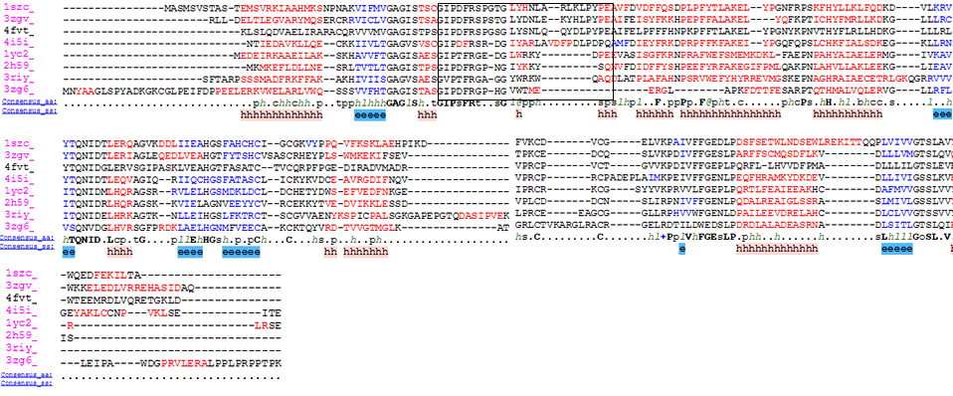

**Raw data: data source not required. I completely recreated it using the PDB entries mentioned in the previous figure prepared by Plin prepared. I crosschecked and the alignment does matches with the earlier figure.**

**---------------------------------------------------------------------------------------------------------------------**

Task 4:

Pymol rendering showing the conformational heterogeneity of the cofactor binding loop (with and without the side chains displayed). The following PDB ids will be used to carry out a structural alignment. (4BVG, 4FVT, 4JSR, and 3GLS).

**Status : Completed**

RC: -- Task 4: Structure alignment from pdbs. Yes, SIRT3 is the priority. I believe there was also a note about Sir2Tm in the Supporting Info. We should bear in mind that using 4 structures might lead to clutter. I believe the priorities were 4BVG and 4FVT? We can consider the others as well possibly for alternate versions of the Fig but with a plan.

RSK: I get your point. I will go ahead and prepare a session file with all four PDB entries. However, for generating image I will use only 4BVG and 4FVT in the display. Since, I will have everything saved in a pymol session file, we can always open the session file and juggle between the PDB entries, as required. A pymol session file will mitigate the need to create a quality rendering each time when required

Option A (4BVG and 4FVT alone used for the display) old figure

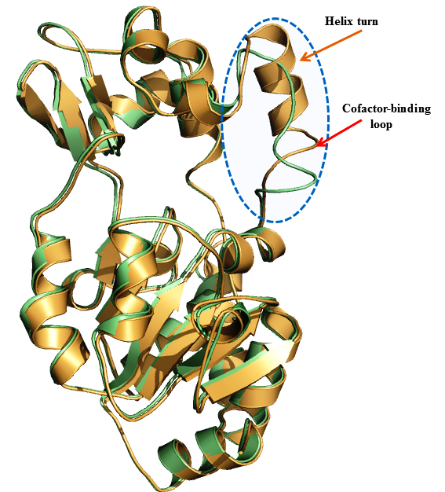

Option B (All PDB ids used)old figure

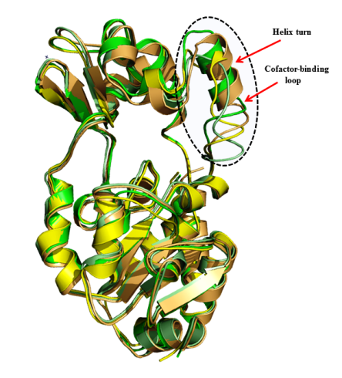

RC: For task 4, you mentioned we can easily edit displays for alternate versions. Zooming in closer to the loop may be desirable in one version.

RSK: Image has been revised; a new figure has been created to address this comment.

RC: Are we still doing a version with side chains displayed?

RSK: Yes, It has been incorporated in the revised image. To prevent cluttering I have displayed only the side chains for the key residue (Phe of the cofactor binding loop) and the substrate (Acetylated Lysine). See fig Option B.

Revisions undertaken: I have created a revised figure based on your comments. The co-factor binding loop is now zoomed in. The key residue (Phe) and the substrate (Ac-Lys) are highlighted and their sidechains display is turned on. In addition, I have also ensured that important subsites and the channel are also highlighted. See the revised figure in page 8: Option B (Revised figure)

Option A: Without side chains (old figure)

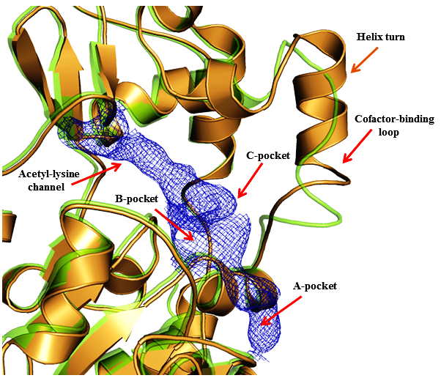

**Figure. Structure alignment of ternary and intermediate SIRT3 complexes highlighting conformational differences in cofactor binding loops. (as per Plin’s document)**

**RSK: I revised the figure legend (old)**

Figure XXXXX: Superposition of Sirt3 native intermediate (4BVG - Green) and Sirt3 ternary complex (4FVT - Orange) showing different conformations of the co-factor binding loop. Individual subsites of the active site are highlighted.

**Option B (Revised figure) old**

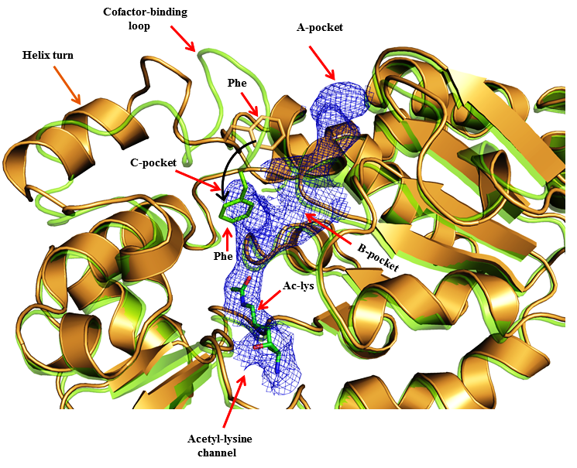

RSK: I also revised the figure legend appropriately to reflect the changes.

Figure XXXXX: Superposition of Sirt3 native intermediate (4BVG - Green) and Sirt3 ternary complex (4FVT - Orange) showing difference in the conformations of the cofactor binding loop and the position of the Phe residue. Individual subsites are highlighted and the movement of Phe residue is indicated by black arrows

RC (3/19): Not certain whether I mentioned this in the task list provided, but we are considering putting a similar figure for Sir2Tm in the SI. Are you working on this? Note some loop residues are missing.

RSK (3/21/2016): This figure was prepared as a replacement for the figure which Ping had in his original document under the caption “***Figure. Structure alignment of ternary and intermediate SIRT3 complexes highlighting conformational differences in cofactor binding loops*.”**

RSK (4/1/2016): Regarding your question for preparing a similar figure for Sirt2Tm, I foresee an issue here. I happened to look through all structures of Human Sirt2 and Sir2TM available in PDB. It appears that all Sirt2 (ternary and intermediate) complexes have the cofactor binding loop unresolved (missing density).

RC (3/19): The version above with substrates may also include NAD+, since showing acetylated peptide implies substrates for ternary complex are being displayed. If the overlap with green Phe leads to lack of clarity we may later remove it or remove side chains.

RSK (4/1/2016): The revised figure that appears below shows CarbaNAD and Ac-peptide (4FVT - Orange) display turned on. The figure legend has been revised appropriately.

**Revised figure (latest figure) 3/29/2016**

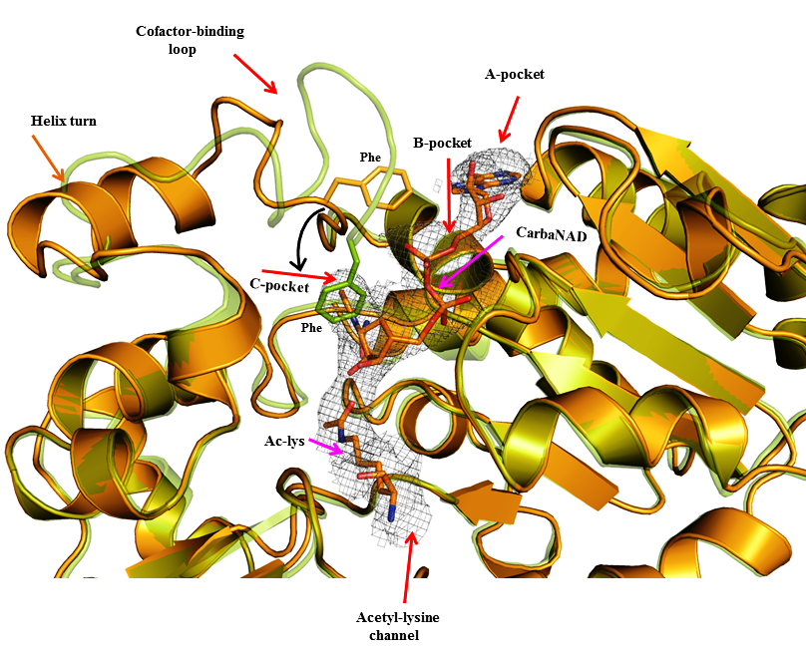

Figure XXXXX: Superposition of Sirt3 native intermediate (4BVG - Green) and Sirt3 ternary complex (4FVT - Orange) showing differences in the conformation of the cofactor binding loop and the position of the Phe residue. Individual subsites are highlighted and the movement of Phe residue is indicated by black arrows. The substrates Carba-NAD and Ac-Lysine are rendered in stick representation.

**-------------------------------------------------------------------------------------------------------------------------------**

Task 5:

A new figure showing the comparison of SIRT3 complexes with cofactor binding loop modeled based on coordinates from ternary and intermediate complexes.

RC: Task 5: This is from MD data, right?

RSK: Yes, that’s right. It’s the MD averaged structure. I have located the pdb file of the MD averaged structure. ***However, the FOOT NOTE for the image provided by Plin in the original summary document says that “the native 4FVT structure after MD is aligned for comparison”. But looking at the image, I see the image to contain only one structure.* This needs to be reconciled. I think that 4FVT_isoNAM_v1_mds_avg10ps.pdb (native 4FVT simulation average structure) is the structure which Pling is alluding to.**

RC: Regarding task 2, we may have the structures match those that will be included in the MD average Fig. We could start with that, following which I will consider further and advise

C:\Users\plin\Documents\MD_works\MD_4BVG_4FVT/Int_fused_4FVT_4BVG.pdb

Remark: I find that Pling in his summary has stated that “*The most stable Phe conformation for INT:NAM complex appears to be with Phe partly in C pocket, but in different conformation from that in INT complex”.* However, looking at the figure, which I created (below), I see that the Phe side chain is oriented towards the B pocket in lieu of the C pocket. I am not sure about this statement.

Old figure

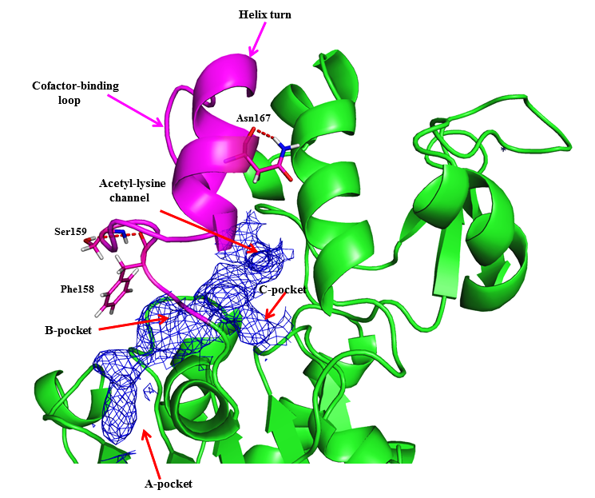

**Caption**

**Figure.** **Comparison of** **SIRT3 complexes with cofactor binding loop modeled based on coordinates from ternary and intermediate complexes, respectively, after side chain optimization and molecular dynamics.** The structure depicted is an MD average**.** SIRT3/INT/NAM prepared from 4FVT w/ loop (res 155-178) replacement from 4BVG and side chain optimization; the native 4FVT structure after MD is aligned for comparison.

Revised Caption:

Fig : MD averaged structure of Sirt3 complex, showing the cofactor binding loop (magenta) modeled based on the coordinates from ternary and intermediate complex.

RC: I am not sure that we are on the same page regarding the MD average figure. See the proposed caption, which mentions that the two loop conformations after MD are to be compared.  
I only see a single purple loop in the figure provided. Is that the INT or ternary conformation of the loop?  
Perhaps this is related to the potential issue you had referred to in a previous posting.

RSK: Yes, that’s what I referred to. It has been fixed in the revised figure.

RC: In this figure, I'm not sure that using different colors for the loops adds to clarity. Perhaps a different rendering or other approach could be considered.

RSK: Okay, will remove the colors for the loop. This issue has been fixed in the revised version.

RC: Regarding the B/C pocket issue for Phe: I noted that the different figs provide varying perspectives on the active site. It may be easier to observe the difference in Phe conformation between the INT complex (shown in green in  
Figure XXXXX: Superposition of Sirt3 native intermediate) and in INT:NAM complex if the figures used the same perspective.

RSK: I had ensured consistency. The revised figures have the same perspective.

RC: What structures did you use for the latest version of this figure (R2 revision)? The intention was to use the MD averages from 4FVT simulations with and without loop replacement from  
4BVG. Is that what you used or did you use a simulation based on 4BVG protein structure for the intermediate?

RSK: **In the revised figure I used an MD average structure (last 10ps) of 4FVT_isoNAM.pdb ( 4FVT-IsoNAM- with loop modelled from 4BVG) superimposed onto native 4FVT structure  
  
I think that I will have to revise this figure using the 4FVT having NAM instead of iso NAM ( ie, 4FVT-NAM- with loop modeled from 4BVG), because I see that is what you require. I think that now we are on the same page on the how the figure should be created. If not let please me know.**

RC (3/19): The 4FVT structure without loop substitution should be that from MD simulation starting with ADPR-intermediate and NAM (not NAD+). Did your 4FVT MD average include NAD+? The simulations to be presented here are the same ones from the MM-GBSA table below. They both have ADPR-intermediate and NAM as ligands.

RSK (3/21/2016): I got it. The 4FVT structure without loop substitution had SIRT3/NAM/NAD+/AC- peptide. I think that this is not the right structure, will redo it.

RSK (4/1/2016): The right structures have been used now for generating the figures. The MD averages were created by me. I used the average of the last 10 ps seconds.

RC (3/19): See also comments regarding files below.

RC: In the figure based on pdb structures, you showed the substrate. In this case would it compromise clarity?

RSK: You mean the Acy-Lys. I will create another one without out the substrate.  
RC: By "In this case" I meant the MD average figure. It is lacking the substrates.

RC: To clarify, “substrates” (more accurately ligands) here referred to the ADPR-intermediate and NAM (technically not the original substrates) from the MD simulations themselves. If showing both for both structures results in clutter, we can reconsider.

RSK: Okay got it. Will create two versions of the figure w/wo substrate. You can choose the one with better clarity.

REVISED FINAL OPTION A (old figure)

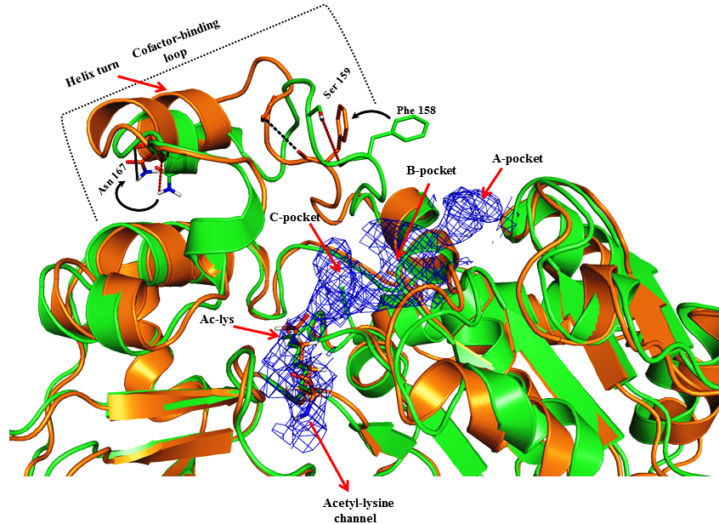

Revised figure **with substrate**

Actual figure legend which Ping had in his document

**Figure.** **Comparison of** **SIRT3 complexes with cofactor binding loop modeled based on coordinates from ternary and intermediate complexes, respectively, after side chain optimization and molecular dynamics.** The structure depicted is an MD average**.** SIRT3/INT/NAM prepared from 4FVT w/ loop (res 155-178) replacement from 4BVG and side chain optimization; the native 4FVT structure after MD is aligned for comparison.

RSK: Revised figure legend

Fig ---- : SIRT3 native ternary complex (4FVT - Green) superimposed onto SIRT3 intermediate complex (Orange) prepared from 4FVT with the cofactor binding loop residues (155-178) replaced from 4BVG structure. Structures shown in figure are MD averaged structures. Differences in the conformations of the cofactor binding loop and the position of the Phe residue are highlighted.

RC (3/19): Why is SIRT3 intermediate structure represented in orange here, and in green in the pdb alignment figures above? This needs to be consistent. Is the caption correct?

RSK (4/1/2016): This has been fixed in the revised figure.

**Also, importantly, we need to assess the differences between the MD average and pdb structures. First, it appears the alignment between the structures below is worse than that between 4FVT and 4BVG, even though both structures below started from the identical protein coordinates for 4FVT (only loop coordinates were modified). Please comment and provide global RMSD.**

**Has the alignment been done correctly? Second, it appears there may be a helical segment to the loop in both MD average structures, whereas in 4BVG there is no helical segment. Please comment/confirm; if necessary you can later show the Ramachandran plots for the loop. Third, in 4BVG the Phe residue backbone approaches the C pocket, but it does not appear to do so here. Please provide this figure in exactly the same perspective as the pdb alignment figures above to facilitate comparison.**

RSK (4/1/2016): Structural alignment has been done correctly, and the issue of the helical segment which should have not been in both the structures stands fixed as we have the right structures now. The issue of Phe pointing to the C pocket is also correct as the right structures are now used. The figure perspective and the color schemes are now consistent. The revised figure appears in **page 20**.

RSK (3/28/2016): I also analyzed the global RMSD differences between the MD averaged structure and the Xtal structures.

1. The global RMSD for all heavy atoms between x-ray structures, 4FVT (ternary complex) vs 4BVG (native intermediate) is very less (0.510 Å).
2. However, RMSD values between MD average structures (**See fig in** **page 20)** starting from 4FVT (with its native loop) vs 4FVT (with loop form 4BVG) is higher (2.253 Å).
3. Similarly, I also computed for other pairs and the numbers are tabulated below.

|  |  |
| --- | --- |
| Complex | Global heavy atom RMSD |
| 4FVT (ternary complex) – Xtal vs 4BVG ( native intermediate) Xtal | 0.51 Å |
| Sirt3/ADPR complex/NAM modelled from 4FVT (**MD average**)  vs  Sirt3/ADPR complex/NAM modelled from 4FVT but with loop replaced form 4BVG (**MD average**) | 2.25 Å |
| 4FVT (ternary complex) – Xtal  vs  Sirt3/ADPR complex/NAM modelled from 4FVT (MD average) | 1.96Å |
| 4FVT (ternary complex) – Xtal  vs  Sirt3/ADPR complex/NAM modelled from 4FVT but with loop replaced form 4BVG (MD average) | 1.11Å |
| 4BVG (native intermediate) Xtal  vs  Sirt3/ADPR complex/NAM modelled from 4FVT (MD average) | 2.01Å |
| 4BVG (native intermediate) Xtal  vs  Sirt3/ADPR complex/NAM modelled from 4FVT but with loop replaced form 4BVG (MD average) | 1.00Å |

RSK (4/1/2016):

**Comments:** *A large RMSD is evident between the MD average structures (2.253 Å) but not between the Xtal structures (0.510 Å) although they started from the identical protein coordinates for 4FVT why?*

The first obvious reason is the Xtal structure comparison is done between ternary vs intermediate (4FVT vs 4BVG), conversely the MD average comparison is between Sirt3/INT/NAM with two different loop conformations (Sirt3/INT/NAM with 4FVT loop vs Sirt3/INT/NAM with 4BVG loop).

Hence, some amount of RMS deviation is anticipated here; because we are effectively comparing intermediate complexes that started with the proper loop conformation (4BVG-intermediate complex) and an improper loop confirmation (4FVT-terneary complex).

Further, structural comparison of the 4FVT crystal structure with the MD average structure modelled based on 4FVT with its native loop shows loss of secondary structure elements, particularly at the Zinc binding domain, large conformational changes in the cofactor binding loop region, and minimal structural in the Rossmann fold containing domain. Loss of secondary structure at the zinc binding domain mostly accounts for the large RMSD (1.967Å).

Conversely, comparing the Xtal structure of 4BVG with the MD averaged structure of Sirt3/INT/NAM intermediate complex modelled from 4FVT (ternary complex), but with the cofactor loop replaced from 4BVG, shows no loss of secondary structure and minimal structural changes (RMSD = 1.004Å).

These findings hint that loss of secondary structure evident from MD simulation for Sirt3/INT/NAM complex modelled from 4FVT/with its native loop is indicative of loss in structural stability.

Structurally, it could be inferred that a co-factor loop conformation with Phe pointing to the B pocket (as seen in 4FVT-ternary complex) may not stabilize the Sirt3/INT /NAM intermediate complex. On the contrary, a cofactor binding loop (with the Phe occupying the C pocket) would stabilize Sirt3/INT /NAM intermediate complex.

Intuitively, this makes sense because the Sirt3/INT /NAM complex modelled with the loop region being replaced form 4BVG (a native intermediate) essentially had the right starting loop conformation. In fact MM/PBSA and MM/GBSA values shown by Plin also corroborate the same.

Depending on the answers to these questions and the differences between the xtal and MD average structures, we will decide whether to use the xtal structures or alternate MD structures (see below) in this paper and leave the above MD structures with loop substitution used for MM-GBSA calculations for the subsequent more detailed computational paper in progress. The MD simulations with loop substitution were carried out for the purpose of energetic calculations.

RSK (4/1/2016): The colors rendering is now made consistent

REVISED FINAL OPTION B (old figure)

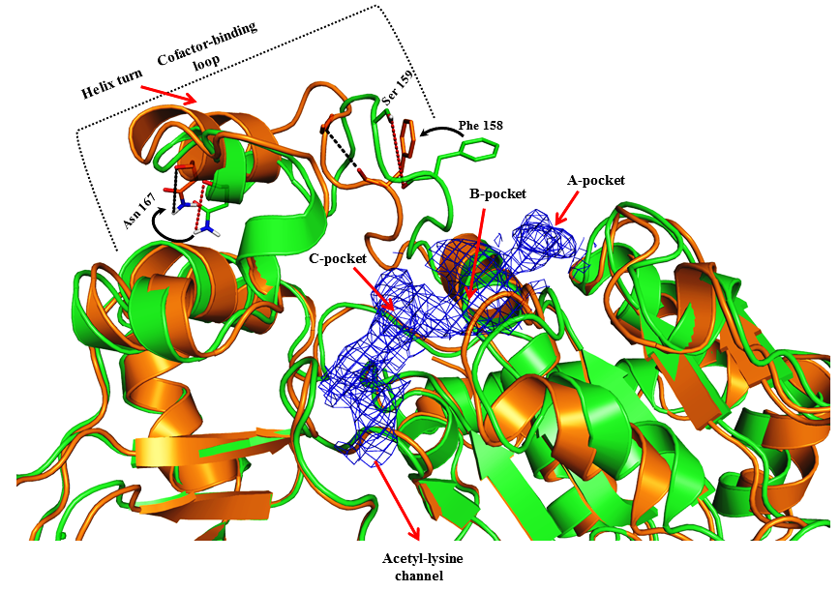

Revised figure **without substrate**

Fig ---- : SIRT3 native ternary complex (4FVT - Green) superimposed onto SIRT3 intermediate complex (Orange) prepared from 4FVT with the cofactor binding loop residues (155-178) replaced from 4BVG structure. Structures shown in the figure are MD averaged structures. Differences in the conformations of the cofactor binding loop and the position of the Phe residue are highlighted.

Data source: The MD average structured of 4FVT is located at C:\Users\plin\Documents\MD_works\ 4FVT_v1_fixed2_mds_last10ps.pdb

The MD average structured of 4FVT with loop residues replaced from 4BVG is located at

C:\Users\plin\Documents\MD_works\ 4FVT_NAM_fixed_v1_mds_avg10ps

RC (3/19): The first structure (at least) needs to be replaced. It should be the MD average with ADPR-intermediate and NAM bound (i.e., the one from the simulation used to generate the MD-GBSA results below).

RSK (4/1/2016): The figures had been created using the right structures now

1. SIRT3/NAM/ADPR-Intermediate (prepared from 4FVT)
2. SIRT3/NAM/ADPR-Intermediate (prepared from 4FVT with the loop modeled from 4BVG)

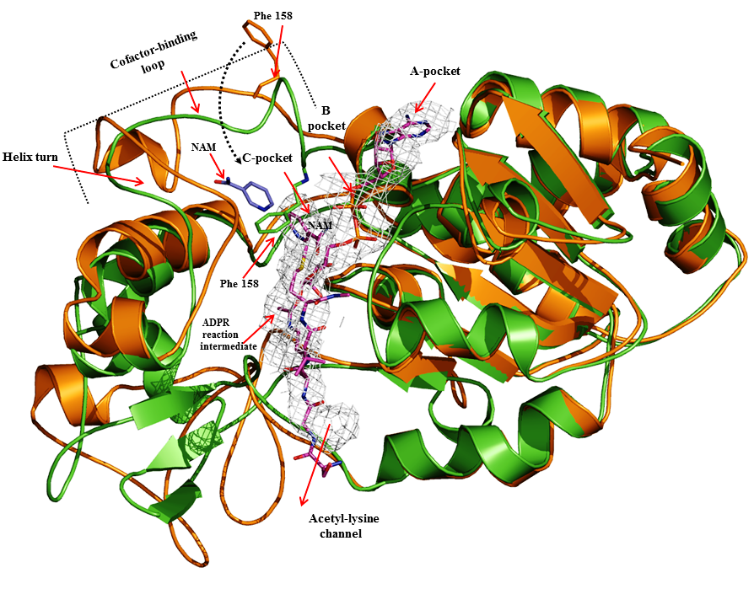

Fig ---- : Superposition of the time averaged MD structures of Sirt3/ADPR/NAM intermediate complex modelled based on the crystal structure of Sirt3 ternary complex (4FVT- orange) and another with the co-factor binding loop residues (155-178) being replaced from an native intermediate structure (4BVG–green). Differences in the conformations of the co-factor binding loop and the position of the Phe residue are highlighted. Individual subsites are highlighted and the ADPR intermediate is rendered in sticks (carbons in Magenta). A short helix is evident in Sirt3/ADPR/NAM intermediate complex modelled using 4FVT (Ternary complex), but not in the complex modelled using the co-factor binding loop replaced from the 4BVG (Native intermediate).

RC (3/19): The version with substrates should show those ligands, not peptide.

RSK (3/22/2016): Okay, will turn on the display for the ligands.

RSK (4/1/2016): NAM and ADPR intermediate are now shown in the revised figure that appear above (page 20)

RC (3/19): Then, please prepare another version of this figure aligning MD averaged structures from

1. SIRT3: peptide:NAD and b) SIRT3:INT (no NAM). I believe the former used 4FVT whereas latter used 4BVG (no loop substitution; please confirm. I will need to check consistency of the simulation input parameters for these later – please list them in your MD simulation parameter task).

RSK (4/1/2016): I located the trajectories corresponding to these complexes. I created the MD average structure for SIRT3/peptide/NAD complex using snapshots obtained from the last 10 ps of the simulation. I see that Sirt3/peptide /NAD complex uses 4FVT (a ternary complex) structure. The other trajectory Sirt3/Int had 4BVG (Intermediate) as the starting structure for the simulation.

RSK (4/1/2016): Regarding MD parameters I have already commented in an earlier section.

*Comment: The MD averaged structures superimpose well on to their respective Xtal structures. However, for the Sitr3/Int complex, I see the formation of a short helix in the cofactor binding loop region (see fig below – green). This particular helix is not evident in the Xtal structure. Not sure what would happen to the helix if we use the full trajectory for averaging?*

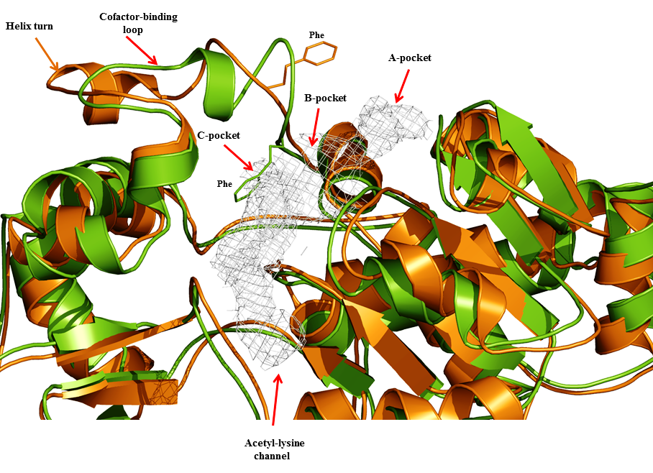

Not for paper but for understanding (I didn’t display the substrates here for reasons of clarity)

Fig ---- : Superposition of the time averaged MD structures of Sirt3/Peptide/NAD ternary complex (4FVT – orange) and Sirt3/Intermediate complex (4BVG – green). Differences in the conformations of the co-factor binding loop and the position of the Phe residue are highlighted. Individual subsites are highlighted.

RC (3/19): We may later explore averages from more than the last 10 ps for comparison if we deem it necessary. Will advise later.

RSK (3/22/2016) : Okay for the time being I will stick on to averages from the last 10 ps.

As another point of comparison, looking at pg 4 of “MD simulations on SIRT3 complexes.docx”, we see snapshots of a simulation of INT:NAM complex starting from 4BVG instead of 4FVT. This was among the only structures Ping showed me from the latest simulations used for MM-GBSA calculations. Here one clearly sees that the loop conformation is similar to that of 4BVG at both 3.6 and 6.7 ns, with Phe in close proximity to NAM in C pocket. In fact, Phe may make favorable contacts with NAM as the energy increases upon Phe flipping out of the pocket. By contrast, in the MD average structures above, Phe does not appear to be close to C pocket. If time permits after completing the above, you might also do a structure alignment of MD averages for the two simulations reported in this document starting from 4BVG (analogous to your figures above but for the simulations starting from 4BVG rather than 4FVT).

RSK (4/1/2016): Will look into it, and update you shortly.

I would also like you to review the ppt on Workshops, Group Mtgs wiki page called “PMC-AT Group Meeting 11112014 PLIN.ppt”. Some slides therein show structures from MD simulations of loop conformational changes after NAM cleavage. I.e., ligand is INT:NAM. You can review the extent of conformational changes that occur during 30 ns of simulation, which are not sufficient for the loop conformational change from 4FVT to 4BVG loop conformations. Based on these results, loop substitution was carried out to facilitate convergence of the simulations. However, based on the figure you presented above, it is not clear whether the INT:NAM MD average loop conformation is more similar to the 4FVT or the 4BVG loop conformation. The new plots requested will clarify this issue.

RSK (4/1/2016):. The new figs created using the right structures shows that Sirt3: INT: NAM time averaged MD structure shows that this complex has a loop conformation similar to the 4BVG loop. Conversely, the 4FVT loop seems to destabilize the complex. An image is shown below for ready reference. Also see loop RMSD plot in page 25.

(This *image is for understanding purpose*)

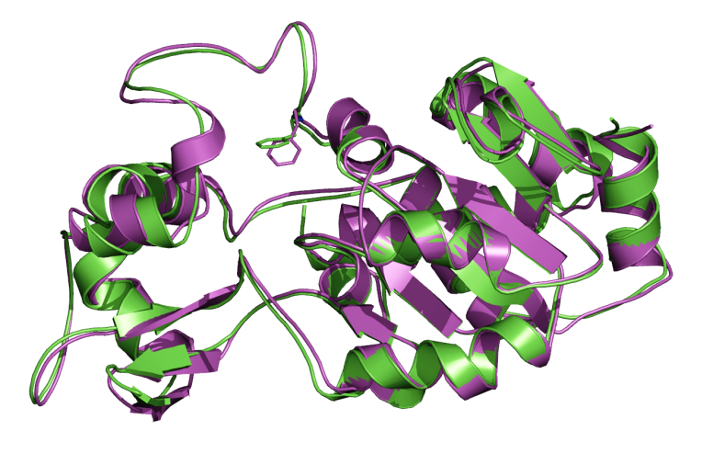

*Time averaged MD structure of Sirt3: INT: NAM modeled using the 4BVG loop (Green) superimposed onto 4BVG Xtal structure (Global RMSD = 1 Å).*

-----------------------------------------------------------------------------------------------------------------

RC: Also, there were RMSD plots in one Fig that is later to be merged with either 4 or 5. Are we planning to use the old versions?

RSK: I will have to recreate one so that it match publication quality image standard and for consistency with the other plots. I have appended this item to the task list as item no 8.

**Status: Completed**

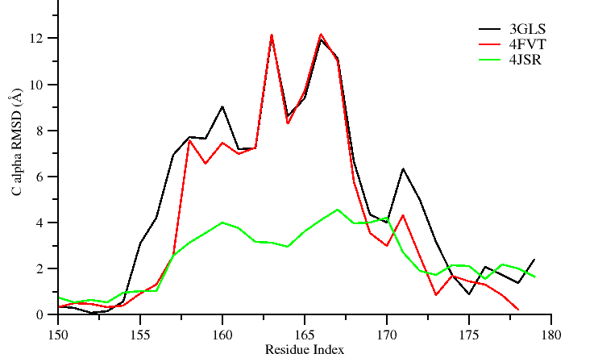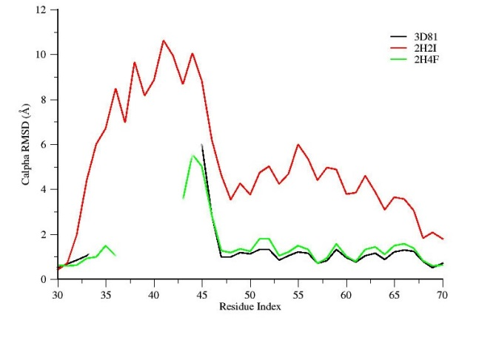

**Legend**

**Figure. Residue-by-residue RMSD of cofactor binding loops in ternary and intermediate complexes, A) SIRT3 and B) Sir2Tm.**

**Revised Figure (new figure 3/29/2016)**

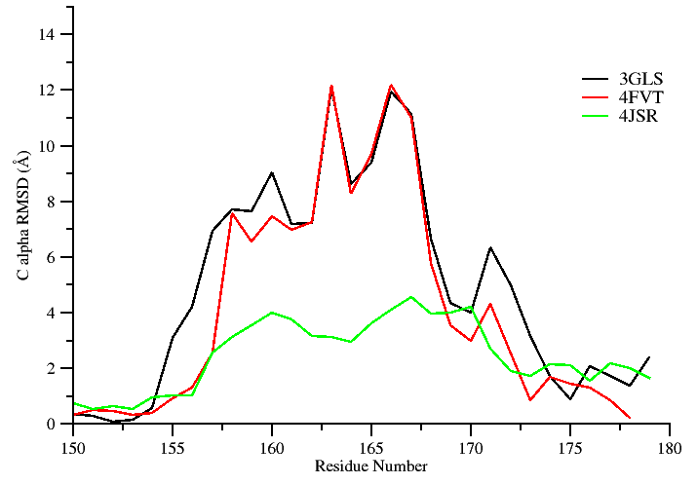 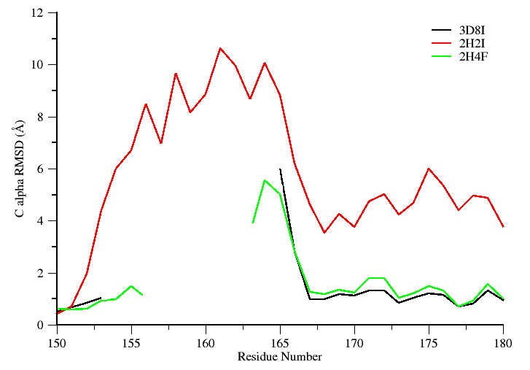

**Figure.** Shown in the left panel are Sirt3 proteins and their per-residue RMSD values for the cofactor binding loop region computed over all atoms with reference to crystal structure of a Sirt3 intermediate complex (4BVG). The right panel shows RMSD values for Sir2Tm proteins calculated with reference to crystal structure of a Sir2 ternary complex (2H59). Residues (155-178) correspond to the co-factor binding loop region and residues (162-170) form a short alpha helix when bound to co-factors. Unresolved loop region are not plotted in the figure.

RC (3/19): The caption does not say what structure the RMSD is calculated with respect to.

RSK (3/22/2016): It is not clear from Ping document and the scripts which he used for running the calculation (all the structures are named refrence.pdb). Ideally, he should have used the time averaged MD structure as the reference here, because he is plotting the standard deviation of the residue displacement over certain time. I will modify the caption stating the reference as the time averaged MD structure.

RSK (4/1/2016): I did more research into it and I found from a document which Ping had prepared stating that RMSD values for Sirt3 proteins were calculated with reference to Sirt3 intermediate complex (4BVG) and for Sir2Tm proteins the reference structure was Sir2 ternary complex (2H59). The reference structures are now mentioned in the revised figure legend (shown above page 24)

RC (3/19): Note from the original task list that we plan to combine the loop RMSD figure with the structure alignment figure to save space. In the event that we use the MD averages for the structure alignment figure, we need to generate a loop RMSD plot for that as well. Hence please make an alternate version of the above figure for the MD averaged loops from the simulations mentioned above.

RSK (4/1/2016): Plot shown below

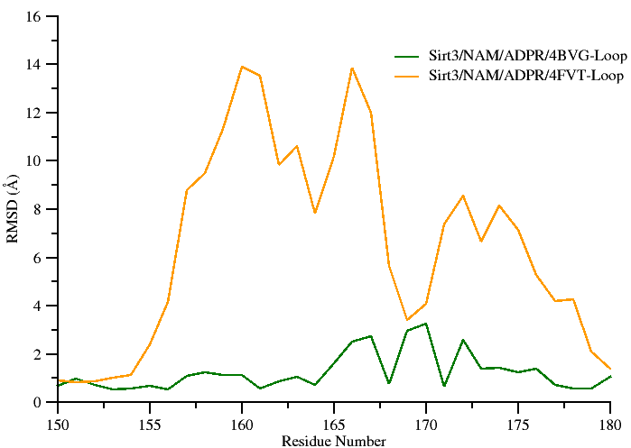

**Figure…..** Per-residue RMSD values for the cofactor binding loop region calculated using the MD averaged structure of Sirt3: ADPR: NAM complex modeled using the loop coordinates obtained from 4BVG (Green) and 4FVT (Orange). Crystal structure of a Sirt3 intermediate complex (4BVG) was used as the reference structure. Residues (162-170) form a short alpha helix when bound to co-factors.

***Note: This figure will be merged with MD averaged figures of Sirt3: ADPR: NAM complex shown in page 20. That’s the reason I used the same colors as used for structural alignment.***

RC (319): Also, please indicate the residue numbers for the helical segment in the loop.

RSK (3/22/2016): Will ensure that residues constituting the helical segment are labelled.

RSK (4/1/2016): The helical segment is now mentioned in the figure legends.

RC (319): In addition, separately for the purpose of analysis (not publication), please provide the following RMSD plots (all for loops only):

1. 4FVT/4BVG (pdb) – 4FVT:INT:NAM (md average)
2. 4BVG/4FVT (pdb) – 4FVT:INT:NAM with loop replacement from 4BVG (md average)
3. 4FVT/4BVG (pdb) – 4BVG:INT:NAM with loop replacement from 4FVT (md average)
4. 4BVG/4FVT (pdb) – 4FVT:INT:NAM (md average)

Where “/” denotes two RMSD plots on same axes, with the 2nd one being a dotted line to distinguish, and ‘-‘ denotes RMSD with respect to. In addition to the by-residue RMSDs for the loop requested above, if further clarification is deemed necessary you may present loop backbone RMSDs vs time in the format shown in slide 11 of the Group Meeting ppt mentioned above. This format of presentation may be more useful for quickly determining whether the simulated loops more closely resemble 4FVT or 4BVG during the course of simulation.

RSK (4/1/2016): Okay, will get it done shortly.

If necessary in order to facilitate explanation of the differences in the structures, you might also identify the starting structures for the simulations (prepared by side chain optimization). Then the initial / MD average structures could also be aligned and loop RMSDs presented.

The reasons for this inquiry were listed above.

-- After we choose final versions of B factor, RMSD and structure alignment figs we will combine them (coupling either B factor or RMSD with structure alignment figs) into a single figure to save space in main text. Remaining SI figures will be finalized thereafter.

RSK:

Revised figure legend.

Figure ----: Comparison of average per-residue RMSD values for the cofactor binding loop region in ternary and intermediate complexes.

Data source: The raw data used for the plot is located at

C:\Users\plin\Documents\MD_works\by-residue_RMSDs.xlsx

-----------------------------------------------------------------------------------------------------------------

Task 6: Recreate new MM/GBSA and MM/PBSA tables similar to the previous PLOS ONE 2014 paper, reporting only binding energy values computed between 2-12 ns time scale. Two such tables need to be created.

**Status: completed**

**Table ….. : Calculated binding energies using MM-PBSA and MM-GBSA. Energy values are reported in kcal/mol.**

|  |  |  |
| --- | --- | --- |
| Energy Components | SIRT3/INT/NAM prepared from 4FVT | SIRT3/INT/NAM prepared from 4FVT with loop (res 155-178) replaced from 4BVG |
| MM-GBSA (Complex) | -7146.48 ± 3.55 | -7201.58 ± 3.44 |
| MM-GBSA (Receptor) | -7050.17 ± 3.55 | -7105.13 ± 3.43 |
| MM-GBSA (Ligand) | -75.99 ± 0.18 | -75.95 ± 0.18 |
| **MM-GBSA (ΔGBind )** | **-20.33 ± 0.13** | **-22.50 ± 0.13** |
| MM-PBSA (Complex) | -5873.69 ± 3.87 | -5901.23 ± 3.76 |
| MM-PBSA (Receptor) | -5796.70 ± 3.89 | -5820.47 ± 3.74 |
| MM-PBSA (Ligand) | -73.03 ± 0.18 | -73.02 ± 0.18 |
| **MM-PBSA ( ΔGBind )** | -**3.96** **± 0.25** | **-7.73 ± 0.26** |

**Data source:**

**The data used in this table is located at:**

**C:\Users\plin\Documents\SIRT\MM-GBPBSA_for_SIRT3complexes.xlsx.**

**REMARK: I see that you have commented to Plin that you need a table that’s similar to the PLOS 2014 paper. For that I would need the raw generated from the MMPBSA.py script. I tried to locate the raw .dat files obtained from the mmpbsa calculations in the gpu node, so that I could tabulate the energetic decomposition. I see that there are umpteen mmpbsa output files. Hence, I have written a shell script that will recursively go in to each directory and search for a .dat file and greps the value. (Will let you know if the script is able to locate a file having the exact ΔGBindvalues shown in the table).**

RC (3/19): Were you able to locate these?

RSK (3/22/2016): My script was not able to locate any file on the gpu node with that has the MMPBSA/MMGBSA final numbers. I need check the other nodes and windows PC too.

**---------------------------------------------------------------------------------------------------------------------**

RC: Should we list the raw data required for each task under the task?

RSK: Yes, I think that would help in maintaining a good documentation. I have added it as item no 7 to the task list.

Task 7:

RC: Add the location/path of the raw data used for completing the assigned task in “Task list1”

**Status: completed**.

**RSK: data source and path has been added now for each completed task.**

**--------------------------------------------------------------------------------------------------------------------**

Task 8: Replot the two RMSD plots contained in the KT document (manuscript computational section excerpts and task.doc)

**Status: completed (I have saved the plots in .agr format. In case if you need any modification, I can get it easily done (I will not have to redo the complete plotting again). Plot was generated using windows version of Xmgrace.**

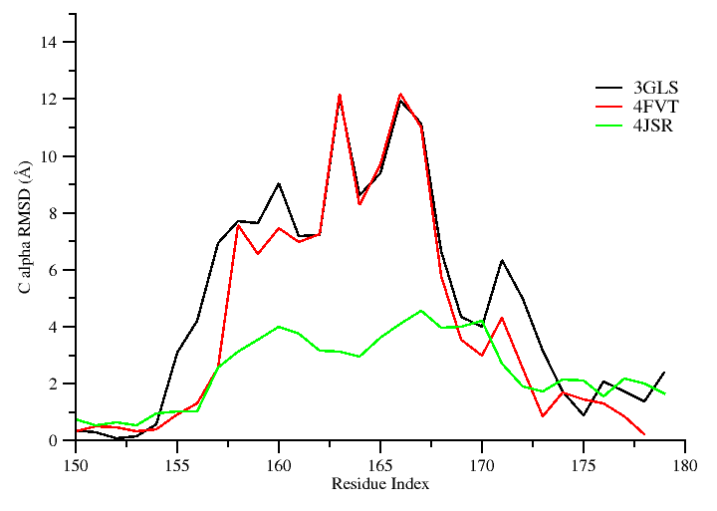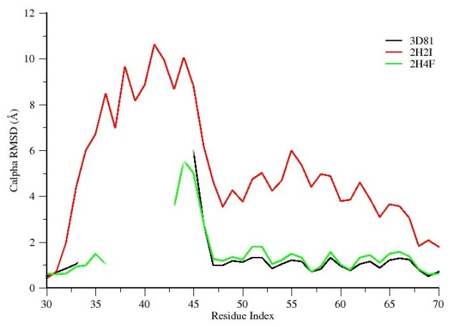

Figure ----: Comparison of average per-residue Cα RMSD values for the cofactor binding loop region in ternary and intermediate Sirt3 complexes.

-------------------------------------------------------------------------------------------------------------------