1. Loop refinement protocol revisited:

In order to improve the accuracy of loop refinement, distance constraints will be applied to limit the conformational space in the search. Here are the rules in selecting distance constraints for loop refinement.

1) Calculate CA-CA distance matrix;

2) Only distances less than 7.2 Angstrom are considered;

3) Only CA-CA distances for residue pair that are three sequences apart are considered;

4) When residue pairs differ by only one residue and by one sequence order, only one CA-CA distance constraint is considered; This rule may be changed to further reduce the number of constraint, e.g. for residue pairs (res1.1-res1.2 and res2.1-res2.2), if abs(res1.1-res2.1)<=1 and abs(res1.2-res2.2)<=1, then only one residue pair is considered.

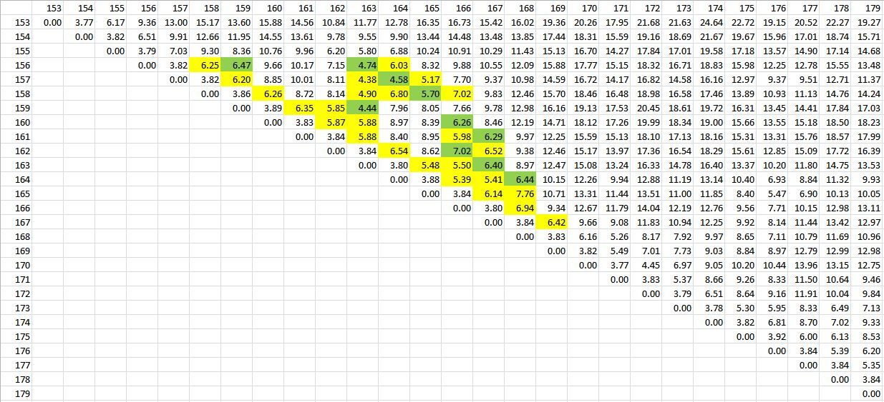The following is the calculated CA-CA distance matrix for residue 153-179 in 4BVG. Assuming the loop refinement will be carried out for residue 156-169 and distances satisfy rule #2 are highlighted in yellow and highlighted in green if satisfy rule #2-4. The number of constraints can be further reduced when more restricted rule #4 is applied. The distance constraints will be applied to loop refinement for structures built from ternary complex (4FVT) or other structures.

Loop refinement will be carried out when Schrodinger license is renewed.

Prime energies will be calculated for various loop conformations for comparison.

1. Residue-by-residue RMSD calculations

Residue-by-residue RMSD calculation is carried by first performing a structural alignment followed by a direct rms calculation on the alignment structure for each residues. By-residue RMSD calculations are carried for 4BV3 (SIRT3:NAD+:Ex527), 4BVH (SIRT3:ac-ADPR:Ex527) and 4FVT(SIRT3:carba-NAD:ac-peptide) with reference to 4BVG (SIRT3:Intermediate).

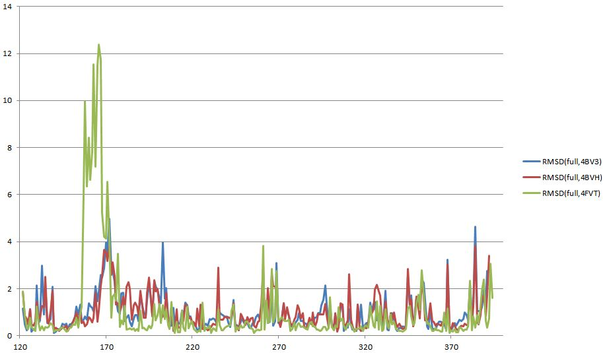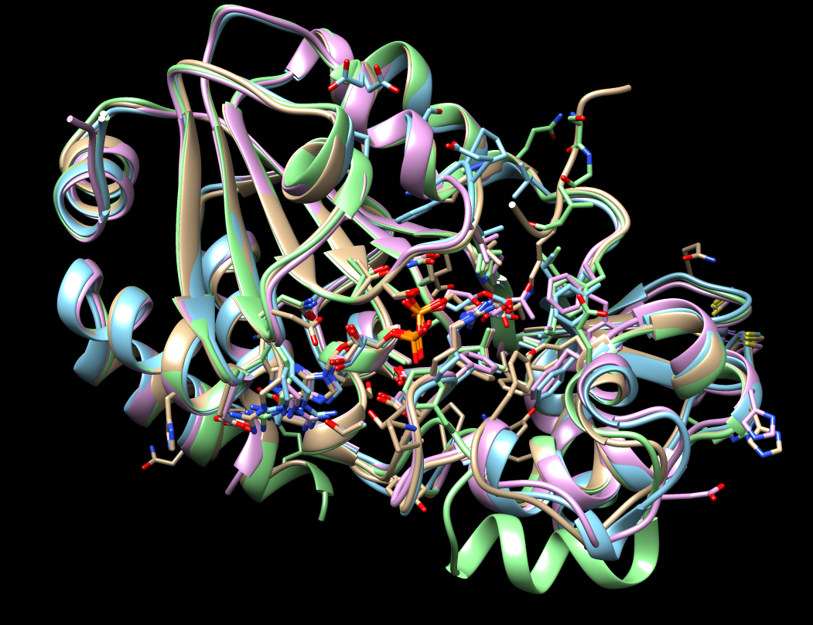

Both RMSDs with CA atom or full residue (not include hydrogen as in pdb file) have been calculated and the RMSD for full residue was presented in the figure above.