1. Investigation of constrained loop sampling to build the intermediate loop starting from the ternary conformation, in both Sir2Tm and SIRT3.
2. Sir2TM study:
3. 2H4F: missing loop PRO37-LYS42
4. 3D81: missing loop ARD34-SER44

The loop

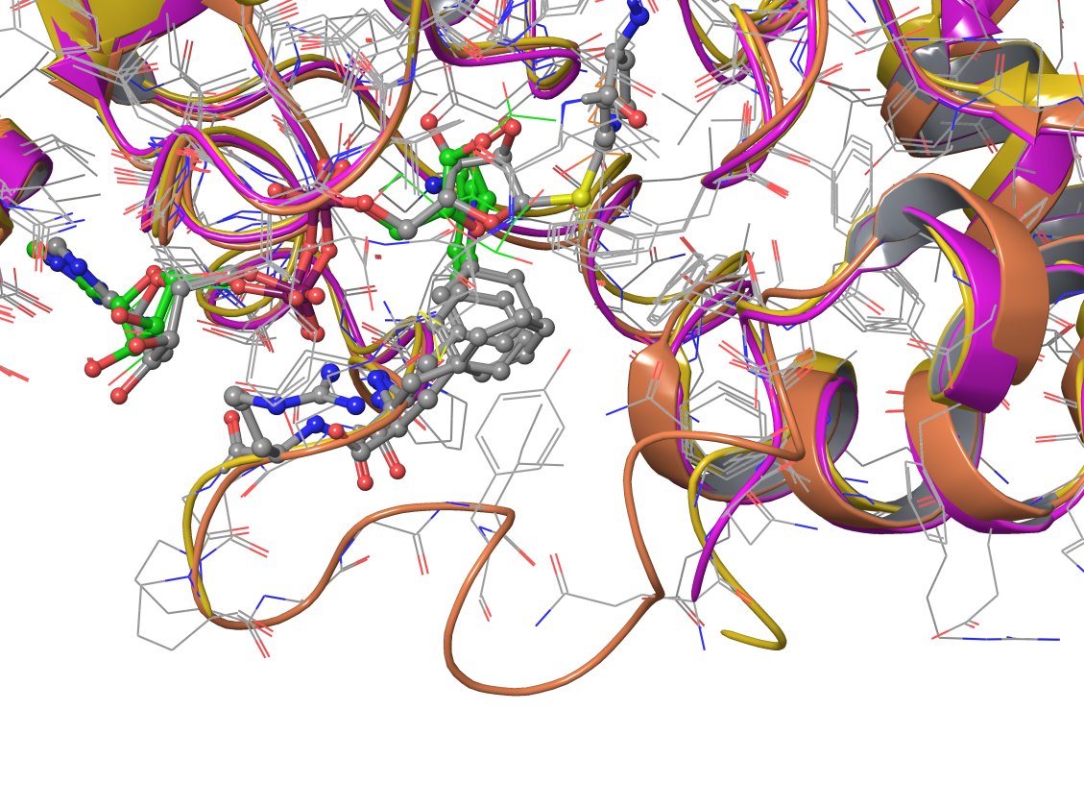

3D81: purple

2H4F: yellow

2H59: orange

Another problem with 3D81: During the original built of the missing loop using protein preparation wizard, the side chain of the adjacent residues changed their positions, which needs to be taken care of during the refinement.

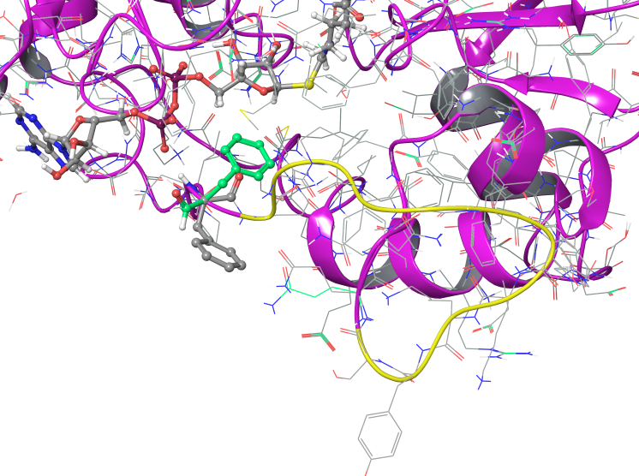

In 3D81: PHE33’s side chain changes significantly from the original position (in green), and it needs to be corrected in the loop refinement.

2H4F run 1: Loop refinement was carried out for ASN37-SER44 after original built using protein preparation wizard, no constraints imposed, OPLS2005 force field and VSGB model applied, residues side chains within 7.5 Angstroms of loop refined, extended loop sampling (15-20 subjobs).

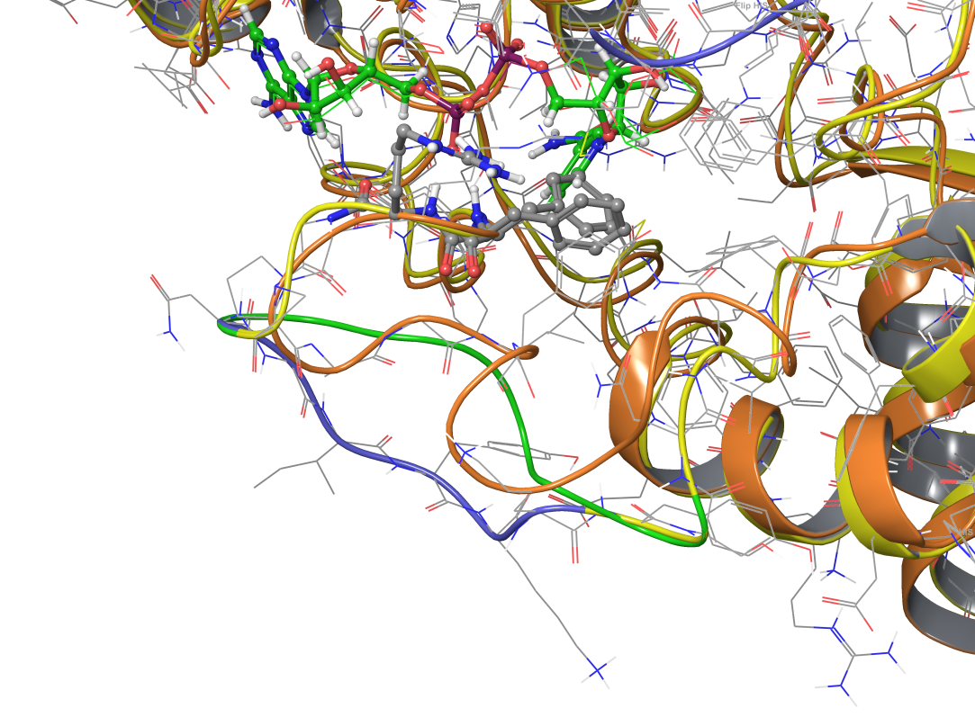

2H4F: refined #1

2H59: orange

2H4F: original built

2H4F run 2: Loop refinement was carried out for GLY35-ASN46 after original built using protein preparation wizard, no constraints imposed, OPLS2005 force field and VSGB model applied, residues side chains within 7.5 Angstroms of loop refined, extended loop sampling (15-20 subjobs).

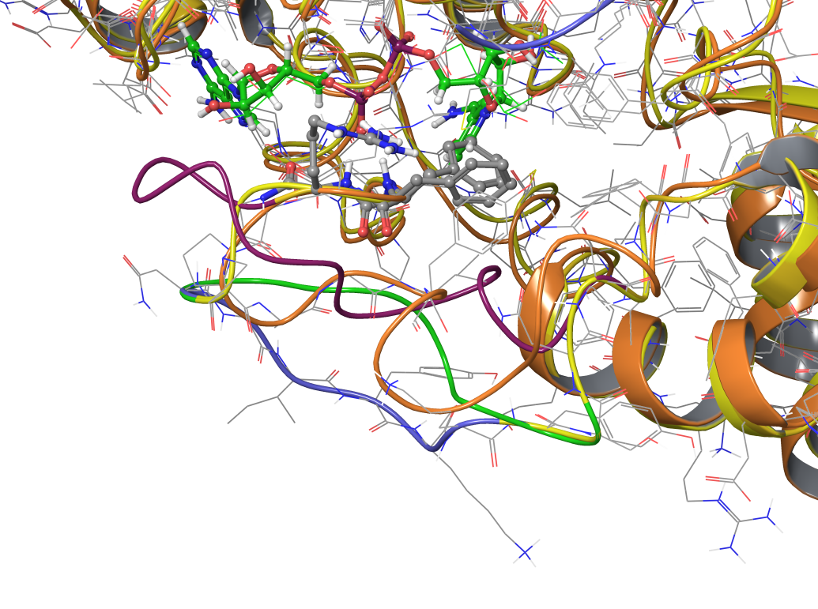

2H4F: refined #2

2H59: orange

2H4F: original built

2H4F: refined #1

3D81 run 1: Loop refinement was carried out for ARG34-SER44 after original built using protein preparation wizard, no constraints imposed, OPLS2005 force field and VSGB model applied, residues side chains within 7.5 Angstroms of loop refined, extended loop sampling (15-20 subjobs).

3D81 run 2: Loop refinement was carried out for PHE33-SER44 after original built using protein preparation wizard, distance constraint between PHE33_CZ and thioimidate_S is set to 4.86 Angstrom, OPLS2005 force field and VSGB model applied, residues side chains within 7.5 Angstroms of loop refined, extended loop sampling (15-20 subjobs).

3D81 run 1: Loop refinement was carried out for PHE33-SER44 after original built using protein preparation wizard, distance constraint between PHE33_CZ and thioimidate_S is set to 4.86 Å, ARG34_CZ and phosphate_P1 to 5.80 Å, OPLS2005 force field and VSGB model applied, residues side chains within 7.5 Angstroms of loop refined, extended loop sampling (15-20 subjobs).

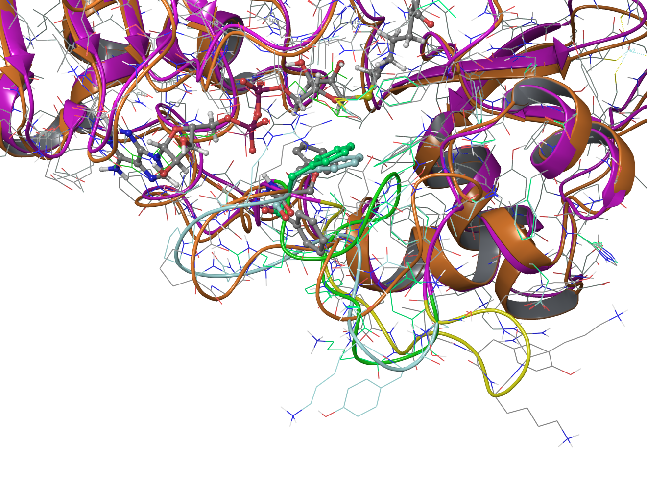

3D81: refined #1: yellow

3D81: refined #2: green

3D81: refined #3: light blue

2H59: orange

MM-GBSA values

|  |  |
| --- | --- |
| **ternary complex: Sir2TM/NAD+/ac-p53** | **MM-GBSA** |
| step 1: protein preparation wizard | -4220.00 |
| minimizing res 37-44 + 7.5 Å after step 1 | -5886.70 |
| minimizing res 35-46 + 7.5 Å after step 1 | -6003.80 |
| loop refinement on res 37-44 after step 1 | -5611.30 |
| loop refinement on res 35-46 after step 1 | -5744.40 |
| re-minimization after loop refinement on res 37-44 | -6038.30 |
| re-minimization after loop refinement on res 35-46 | -6167.90 |

1. One difference between loop refinement and minimization is that the residues within 7.5 Å in loop refinement do not include backbone atoms.
2. The more residues included in the minimization/refinement, the lower the overall energy.
3. Loop refinement does improve the overall energy, but longer loop in the loop refinement doesn’t necessary improve the loop quality. (Loop refinement with res 37-44 shows better result when comparing to resolved loop structure in 2H59.)

|  |  |
| --- | --- |
| **Sir2TM/S-alkylamidate complex** | **MM-GBSA** |
| step 1: protein preparation wizard | 171599.60 |
| run 1: loop refinement on res 34-44 + 7.5 Å after step 1 | 162930.70 |
| run 2: loop refinement on res 33-44 + 7.5 Å with constraint on PHE33 | 162905.30 |
| run 3: loop refinement on res 33-44 + 7.5 Å with constraint on PHE33, ARG34 | 162924.20 |
| minimizing res 33-44 + 7.5 Å after step 1 | 162393.10 |
| re-minimizing res 34-44 + 7.5 Å after loop refinement run 1 | 162508.30 |
| re-minimizing res 33-44 + 7.5 Å after loop refinement run 2 | 162399.30 |
| re-minimizing res 33-44 + 7.5 Å after loop refinement run 3 | 162285.50 |

1. Loop refinement run 3 shows best result when comparing to resolved loop structure in 2H59.