PL(10/24):

**Analysis of SIRT3 PDB structures and prepare dataset for new IFD protocol:**

1) In term of the long loop ILE154-PRO176 that forms the NAD+ binding loop & extra, there are four distinctive cases:

a). with NAD+/ADPR/ac-ADRP/Intermediate(or thio-substituted intermediate) bound but not NAD+ in AC binding mode, (pdbID: 4BVG, 3GLT, 4BN4, 4BV3, 4BVH, 4BVB, 4BVE, 4BVF). The loop of ILE154-SER166 are quite similar, and the RMSD of these structures are less than 0.9 Angstrom.With or without Ex527 didn't change much the loop structure, therefore the claim in hte PNAS paper than Ex527 stabilize the loop may not be true.

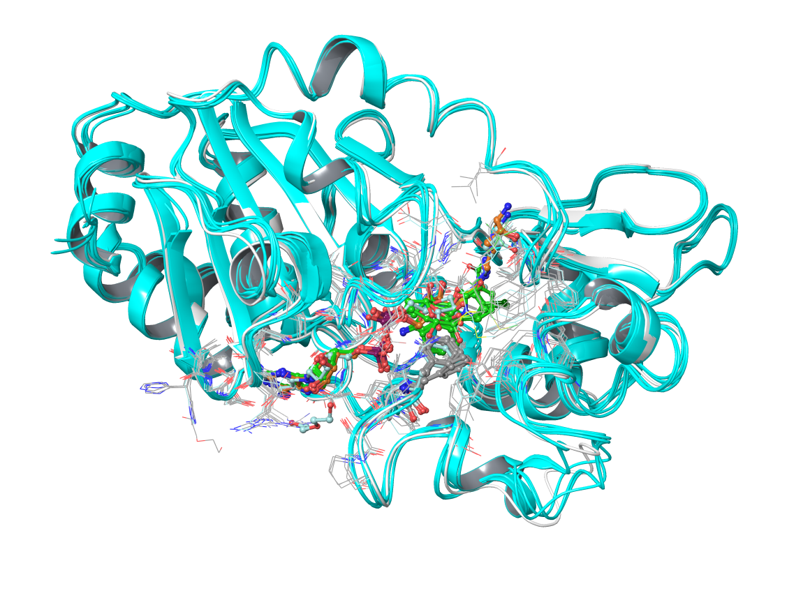

b): no ADP moiety bound or NAD+ in AC pose: helix in loop (residue 162-170) is preserved. (pdbID: 3GLS, 3GLR, 4BN5, 4FVT, 3GLU), which the ternary structure 4FVT is unique in that loop 154-161 differs from others.

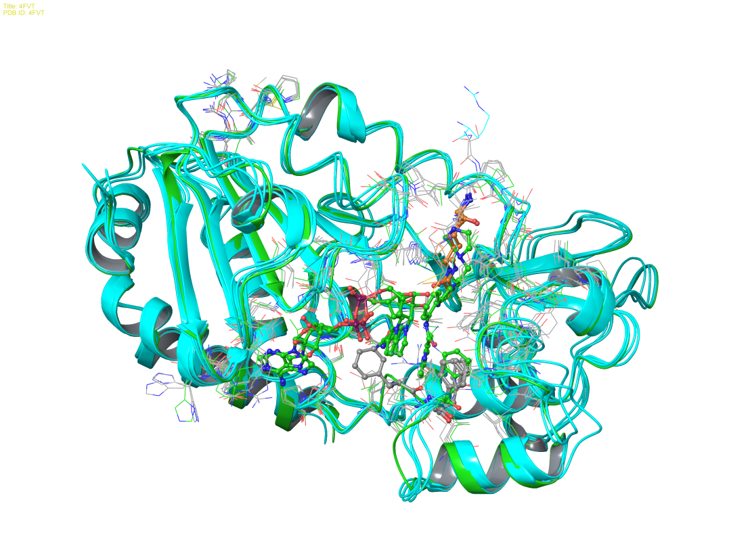

c): ELT inhibitor create a new situation for C pocket binding and cause the shift of the loop, and changes in the helix (pdbID: 4JSR, 4JT8, 4JT9).

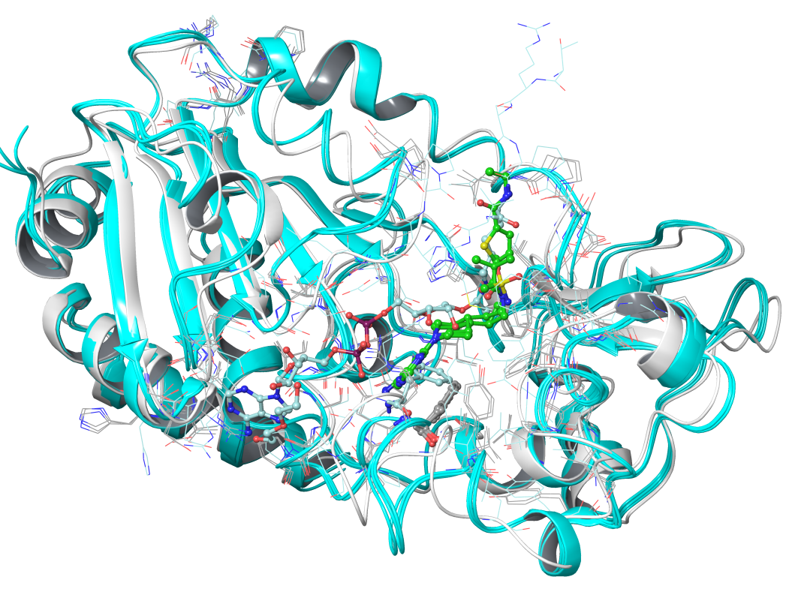

d): Loop structure not completely resolved, in the region 158-170 (pdbID: 4C78, 4C7B, 4FZ3, 4HD8)

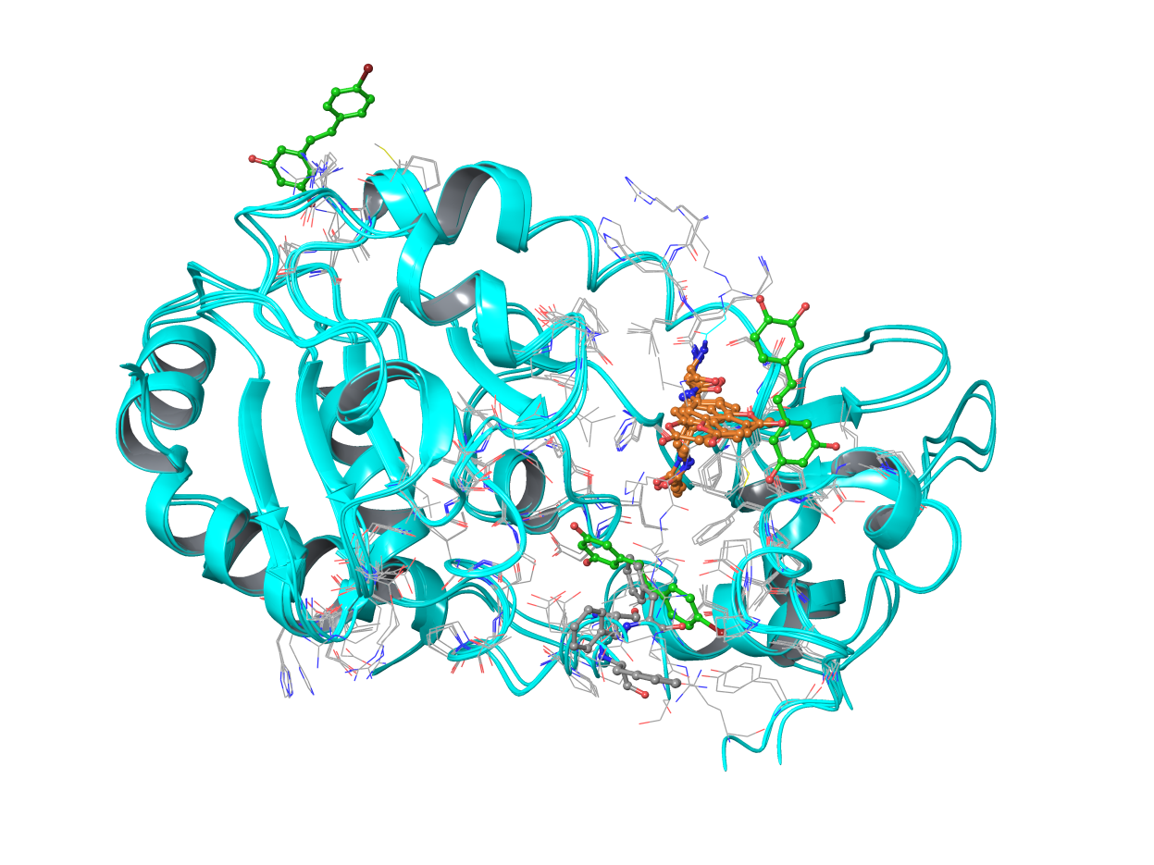

2) From the structures category above, we can choose 4 receptors: (SIRT3 from 4BVG, 3GLR, 4FVT, 4JSR) and three types of ligands (ADPR from 4BN4 and ELT-11c from 4JSR), especially the docking of ELT-11c into 4BVG, as the receptor cannot accommodate the inhibitors in its original pose. For others, although the active size conformations are different, the inhibitors can still fit it easily, the tests in these cases will be to test if the loop conformation can be predicted upon binding of new ligand.

**IFD protocol & scoring function investigation**

The 11 protein/ligand dataset that Schrodinger used for IFD protocol involves minor backbone changes and the IFD mainly correct a limit number of sidechain conformation. Therefore, IFD protocol for complicated cases should be re-investigated.

Attached (IFD original paper and supplementary materials.)

Some comparison of structures of these dataset is provided below:

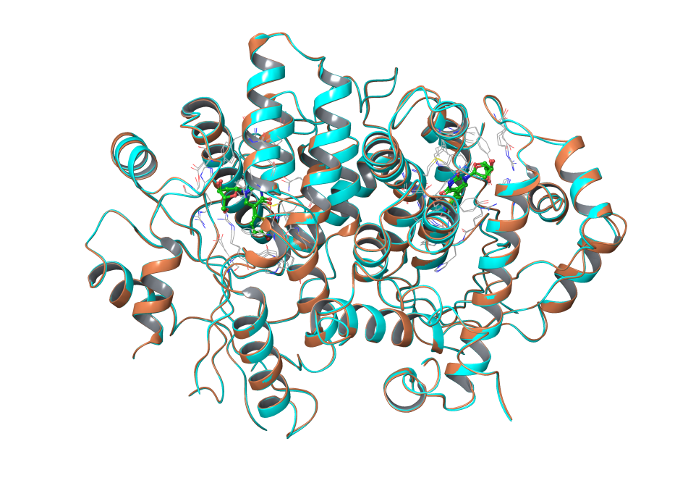Thymidine Kinase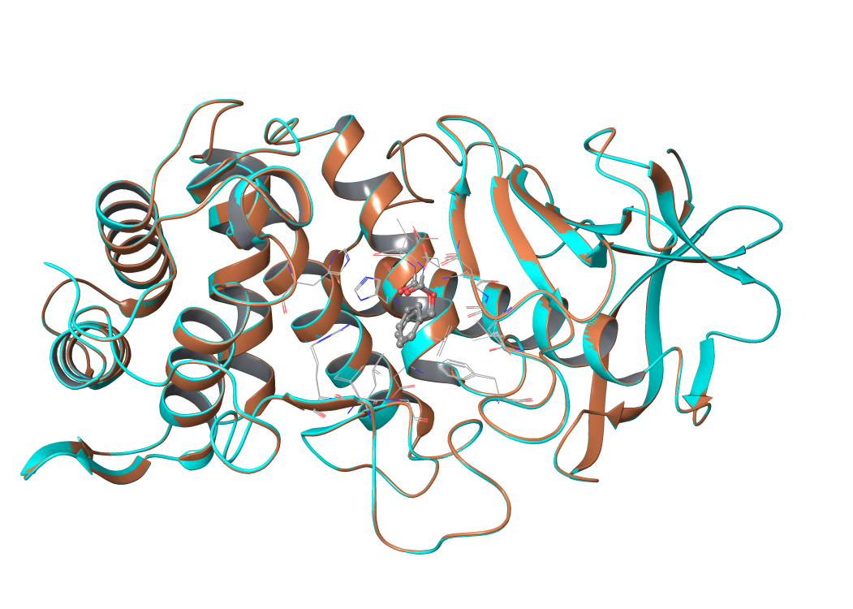Thermolysin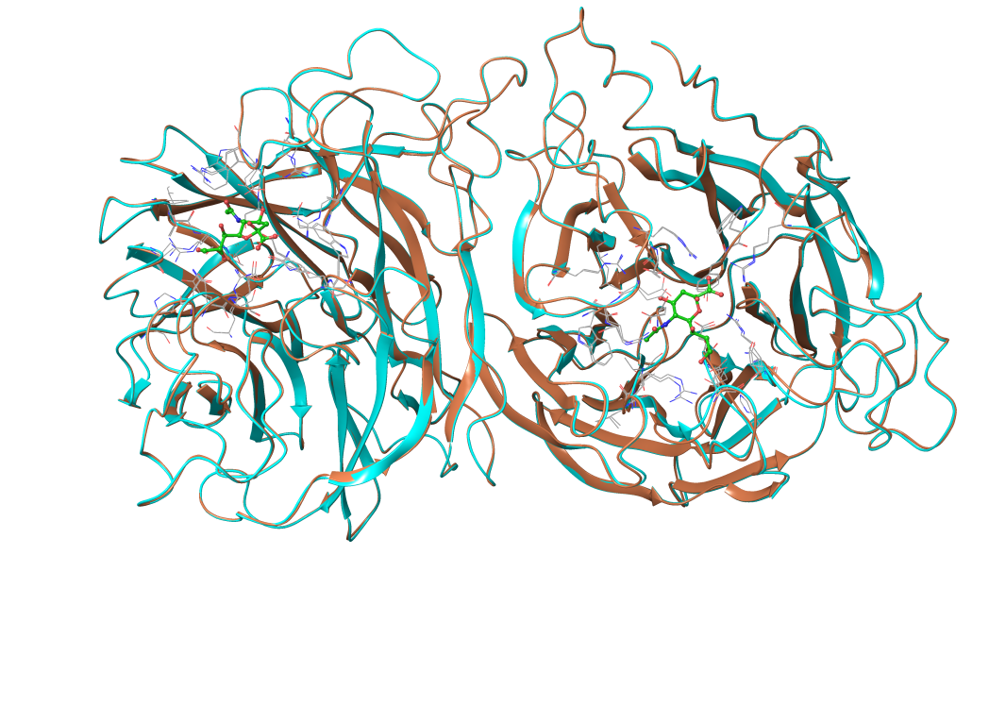Neuraminidase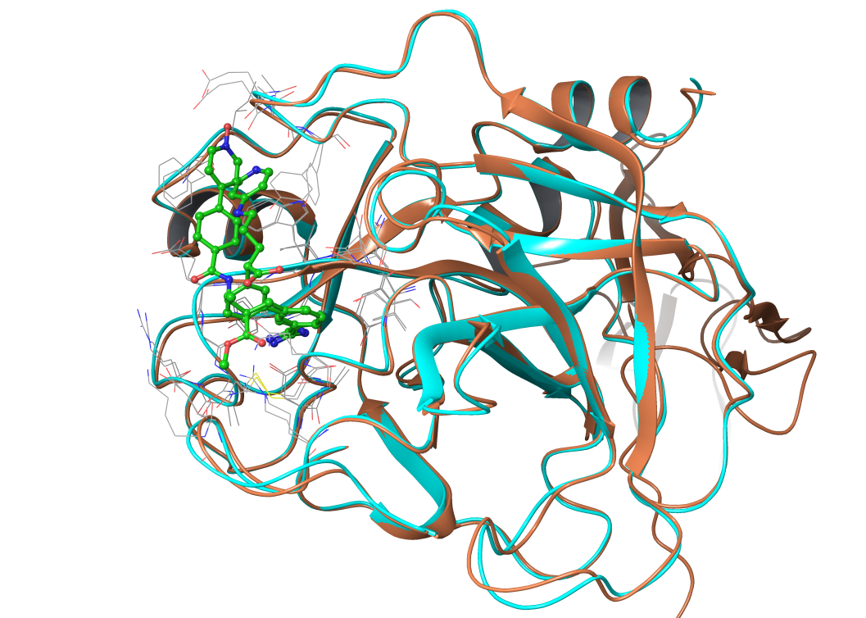Factor Xa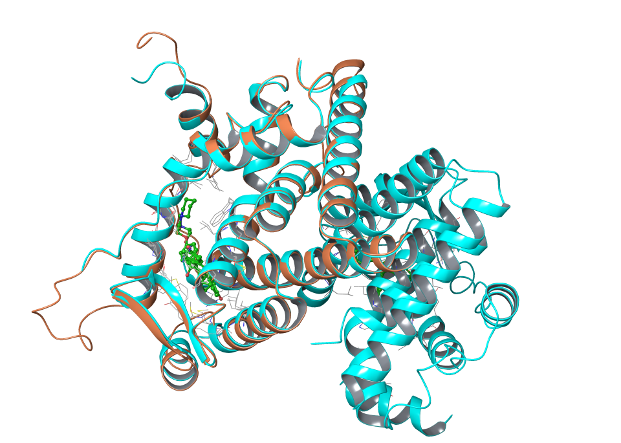Estrogen Receptor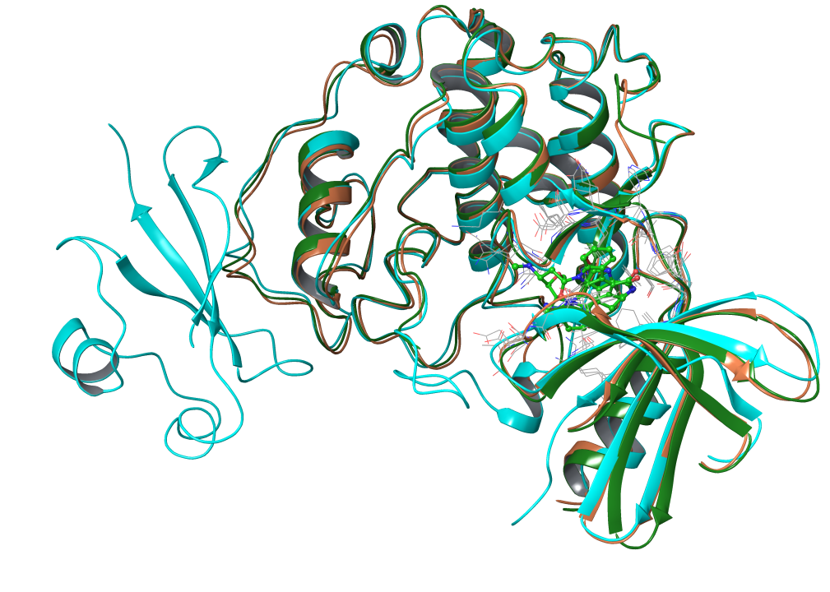CDK2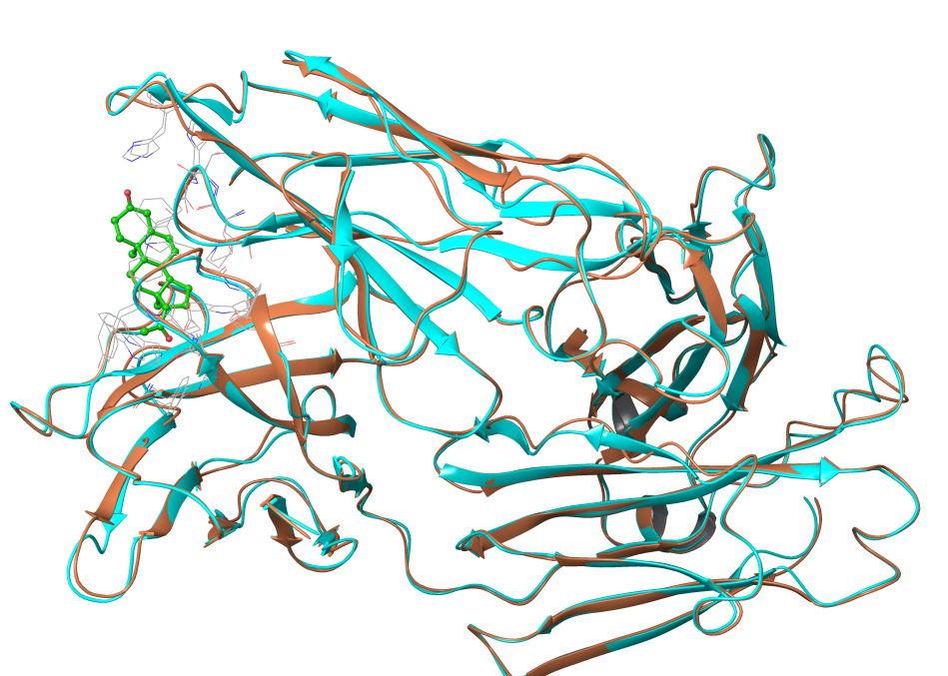Antibody DB3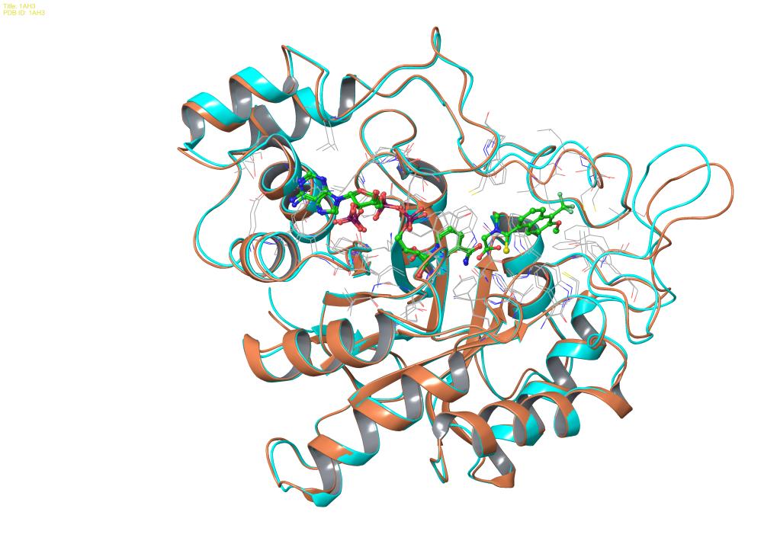Aldose Reductase