MolName | Structure | MMGBSA dG Bind
Ex243 in SIRT3_OAADPR_1water_4BVH_A | 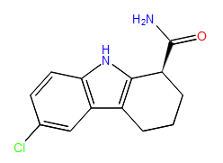 | -97.31212
Ex243 in SIRT3_AADPR_1water_4BV3_5 |  | -86.341836
4-[(trichloroacetyl)amino]benzamide | 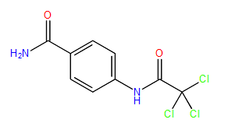 | -77.492745
2-[(3-methyl-2-butenoyl)amino]benzamide | 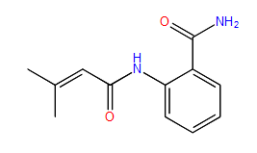 | -74.99934
2-({[(3-chlorophenyl)amino]carbonyl}amino)benzamide | 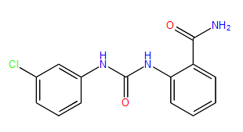 | -72.087047
3-({[4-(aminocarbonyl)phenyl]amino}carbonyl)-7-oxabicyclo[2.2.1]heptane-2-carboxylic acid | 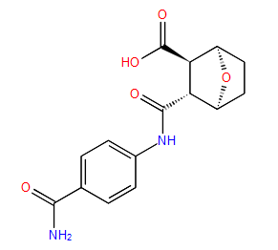 | -70.843851
N-[4-(aminocarbonyl)phenyl]-5-chloro-2-thiophenecarboxamide | 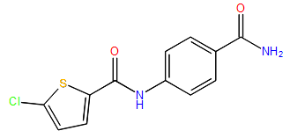 | -70.468438
2-[(anilinocarbonyl)amino]benzamide | 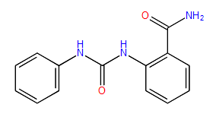 | -70.302862
1,6-dimethyl-2,3,4,9-tetrahydro-1H-carbazole-1-carboxamide | 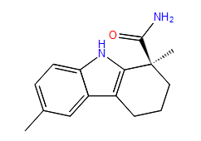 | -88.954033
7-methyl-1,2,3,4-tetrahydrocyclopenta[b]indole-3-carboxamide | 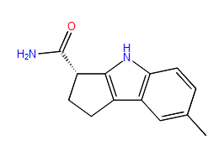 | -83.777736
6,9-dimethyl-2,3,4,9-tetrahydro-1H-carbazole-1-carboxamide | 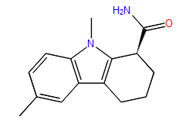 | -80.90636
1,6-dimethyl-2,3,4,9-tetrahydro-1H-carbazole-1-carboxamide | 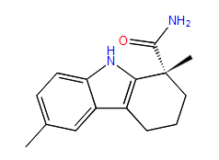 | -73.56296
(1S,3R)-3-amino-N-(4-chloro-3-fluorophenyl)cyclopentanecarboxamide | 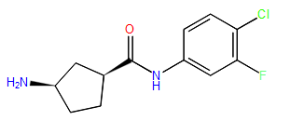 | -83.153259
(1S,4R)-2-(3,4-dichlorobenzyl)-2-azabicyclo[2.2.1]heptan-3-one | 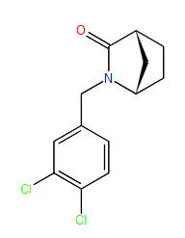 | -73.105783
(1S*,3R*)-3-amino-N-(3-oxo-1,3-dihydro-2-benzofuran-5-yl)cyclopentanecarboxamide | 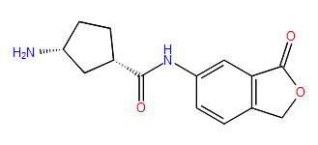 | -71.205785
N-[(1R)-1-(aminocarbonyl)-2-methylpropyl]imidazo[1,2-a]pyrimidine-2-carboxamide | 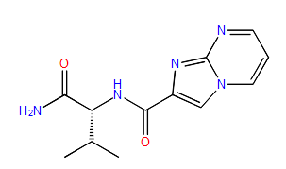 | -82.876988
N~2~-[(2,5-dimethyl-3-thienyl)methyl]-L-alaninamide | 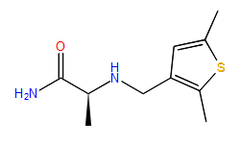 | -77.108601
N~2~-{[2-(dimethylamino)-1,3-thiazol-5-yl]methyl}-D-alaninamide | 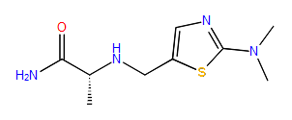 | -76.020931
(2S)-2-(5-methyl-4-oxothieno[2,3-d]pyrimidin-3(4H)-yl)propanamide | 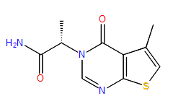 | -72.633096
(2S)-2-(8-fluoro-4-oxoquinazolin-3(4H)-yl)-3-methylbutanamide | 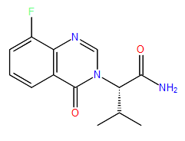 | -71.696717
N~2~-{[5-(tetrahydro-2H-pyran-2-yl)-2-furyl]methyl}-L-alaninamide |  | -71.261914

