1. The residue-by-residue RMSD for Sir2TM complex.

Using 2H59 as reference structure, the RMSD of CA atoms is plotted as followed.

residue 47

residue 33

By comparing to crystal structures, the flexible loop region can be identified as between residue 33 and 47. For intermediate 3D81, the residue missing is 34-44, which is the nature choice of selection.

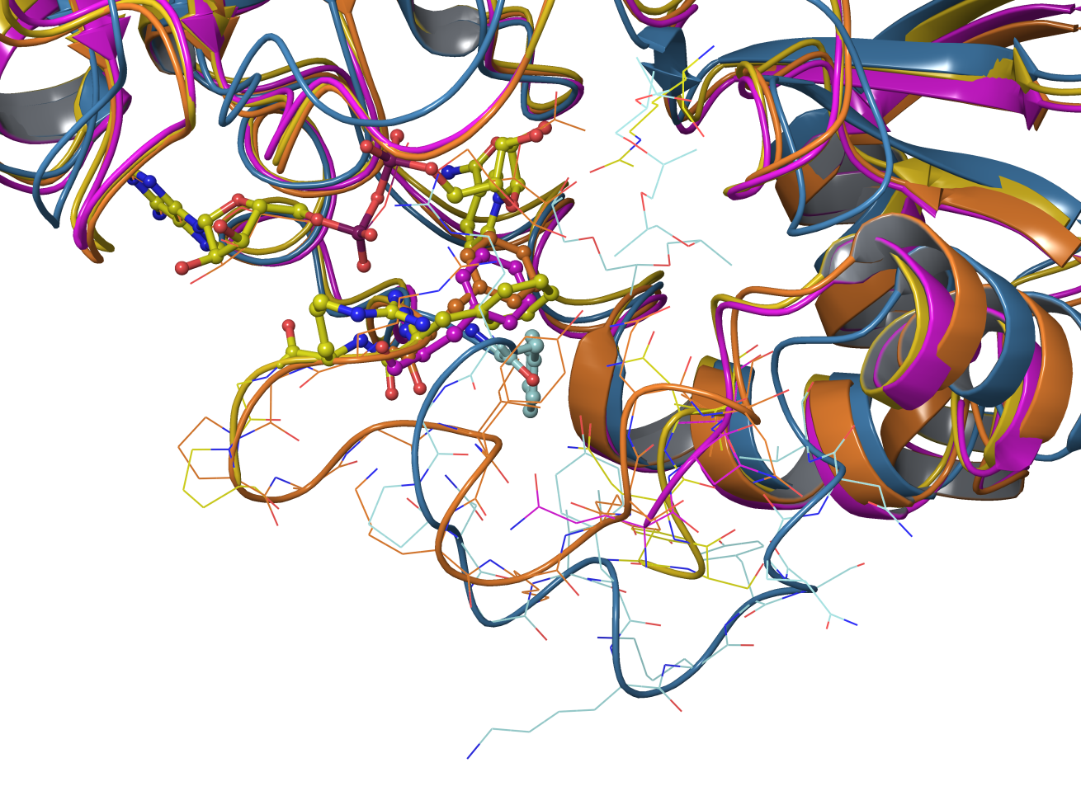

2H59: orange

2H4F: yellow

3D81: purple

2H2I: light blue

RC: According to Liang et accelrys was used to model a 6 residue missing loop in 1SZC (yHst2). Liang also did studies on 2H4F for comparison; it appears results were presented but loop building methodology was not. Apparently 1SZC is a complex with carba NAD, not NAD, whereas 2H4F is a complex with NAD?

Your ppt appeared to indicate that there is yHst2 structure (1Q1A) of complex with intermediate. Please confirm and also indicate how many loop residues are missing in 1Q1A. I believe yHst2 is included in the sequence alignment on the meetings pag.

When were the 1SZC, 1Q1A, 2H4F, 3D81 structures published?