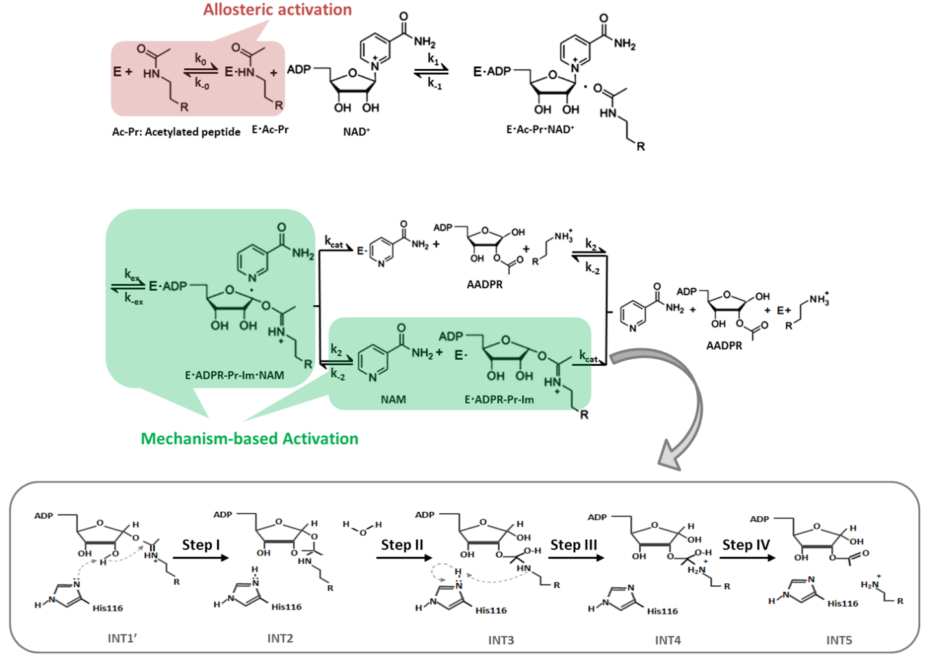

**Figure 1. Chemical mechanism of sirtuin-catalyzed deacylation and modes of sirtuin activation.** Following sequential binding of acylated peptide substrate and NAD+ cofactor, the reaction proceeds in two consecutive stages: i) cleavage of the nicotinamide moiety of NAD+ (ADP-ribosyl transfer) through the nucleophilic attack of the acetyl-Lys side chain of the protein substrate to form a positively charged O-alkylimidate intermediate, and ii) subsequent formation of deacylated peptide. For simplicity, all steps of stage ii as well as AADPR + Pr dissociation are depicted to occur together with rate limiting constant *k4*. **Red**: Allosteric activation increases the affinity of a limited set of peptide substrates for the SIRT1 enzyme only and requires an allosteric binding site. **Green**: Mechanism-based activation is a new mode of enzyme activation that relies on the conserved sirtuin reaction mechanism that are not limited to enhancement of affinity for selected peptide substrates. The schematic highlights mechanism-bsed activation through NAD+ Km reduction rather than the Kd peptide reduction that known allosteric sirtuin activators elicit.

**Change notations of rate constants in this Fig – see comments under Figs below**

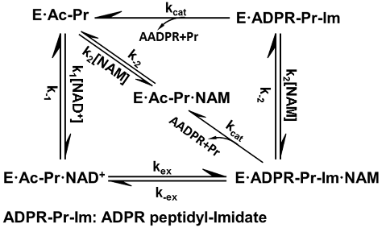

**Change notation on arrows to the new k1-4 notation, but keep the names of species the same**

] 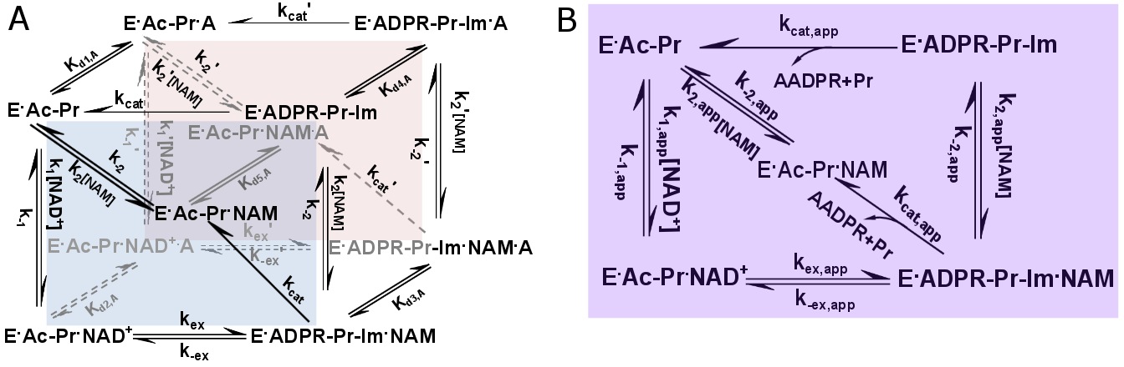

**Figure 3. General model for mechanism-based sirtuin enzyme activation.** A) The front face of the cube (blue) depicts the salient steps of the sirtuin reaction network in the absence of bound modulator. The back face of the cube (red) depicts the reaction network in the presence of bound modulator (denoted by “A”). Each rate constant depicted on the front face has an associated modulated value on the back face, designated with a prime, that is a consequence of modulator binding. B) The purple face is the apparent reaction network in the presence of a nonsaturating concentration of modulator. **Replace w version that shows brackets for modes of mixed modulation. Also, change notation on arrows to the new k1-4 notation, but keep the names of species the same**

**Replace S1 and S with NAD+ and replace P1 with NAM**

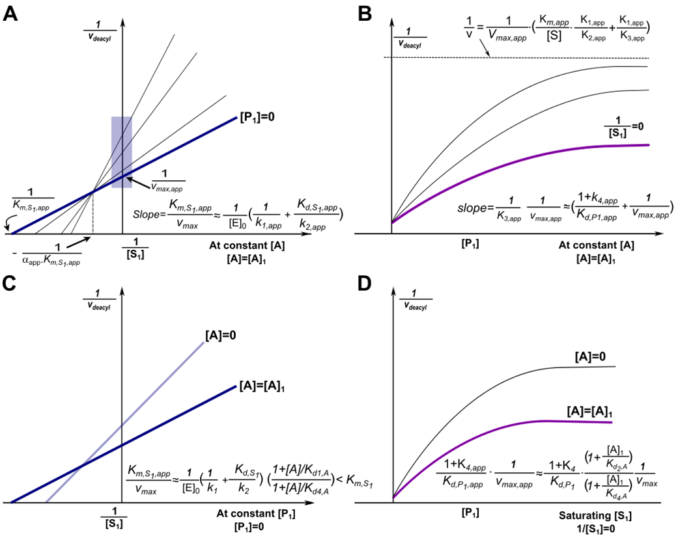

**Figure 4. Mechanism-based activation of sirtuin enzymes: predicted steady-state properties and dose-response behavior.** (a)Double reciprocal plots for deacylation initial rate measurements in the presence of activator. The blue box on the y-axis highlights the data that is used to construct the Dixon plot at saturating [*NAD+*] depicted in (b). (b) Dixon plots for deacylation initial rate measurements in the presence of activator. (c) Comparison of double reciprocal plots at [NAM] = 0 M in the presence and absence of activator. The dotted line represents a selected value of [NAD+] (e.g., a physiological concentration) at which the extent of activation is assessed. (d) Comparison of Dixon plots at 1/[NAD+] = 0 in the presence and absence of activator. **“**A” denotes a mechanism-based sirtuin activating compound.

**-Schematic B): there was a typo in the slope for Dixon. See D where it is correct. Should have been (1+K4,app)/Kd,P1,app*(1/vmax,app).**

**-Make it vmax,app everywhere in A,C and D. Also provide source file and indicate program you used to make edits to eqns**

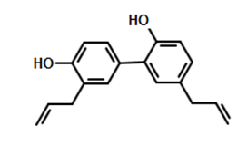

**Figure 5. Structure of honokiol (HKL), 5, 3’-Diallyl-2, 4’-dihydroxybiphenyl (Honokiol).**

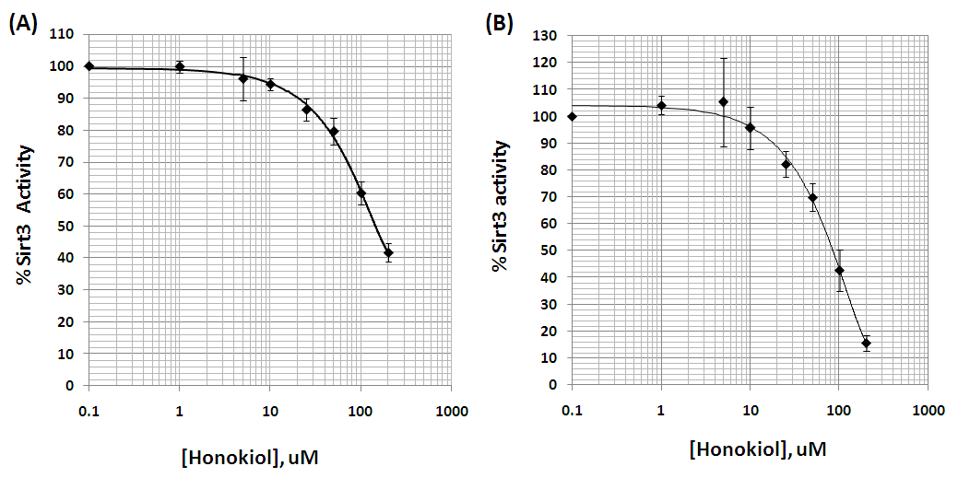

**Figure 6. Dose response of HKL – a-c) for MnSOD in the three formats we studied – 30 min, 50uM NAD; 10 mins, 100uM NAD; 10 mins, 100uM NAD/100uM NAM. At unsat NAD. Alternatively, make a a superposition of all three conditions and b the unsat peptide curv. Effect of Honokiol on Sirt3 deacetylation activity using a label-free assay.** Recombinant human SIRT3 was incubated for 30min at 37oC in the presence of 0, 1, 5, 10, 25, 50, 100, 200µM Honokiol. A details 50uM NAD+ and 600uM MnSOD K122 peptide substrate (N=3). B details 2.5 mM NAD+ and 6.25 uM MnSOD K122 peptide substrate (N= 5).

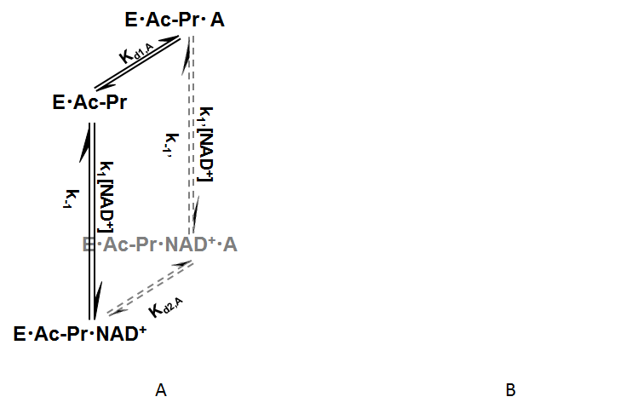  
 **Figure 9. ac mnsod titrated cNAD.** May mention e0s in caption

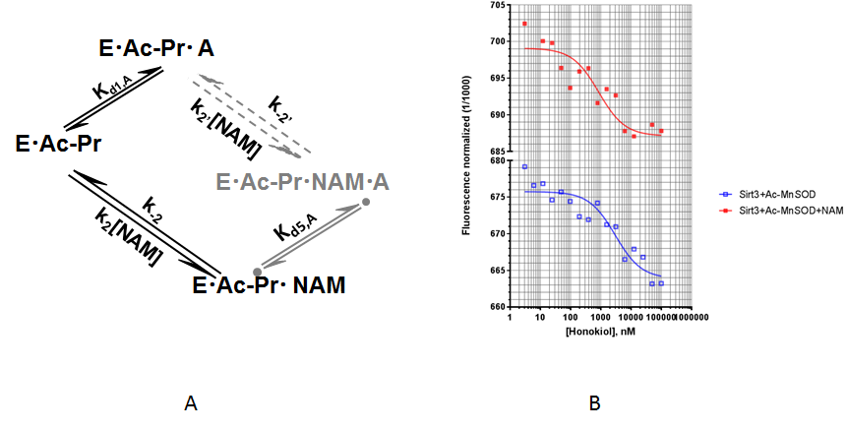

**Figure 10. acmnsod + NAM. Depicted data points are means of two measurements.**

**Figure 11. deac mnsod titrated oaadpr**

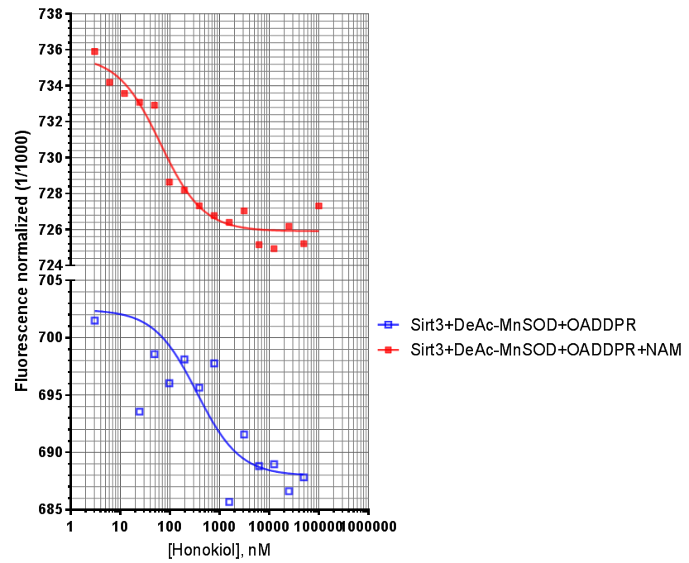

**Figure 12. deac mnsod + oaadpr and NAM   
Figure 13. deac mnsod + nad**



**Figure 15. acp53 titrated cNAD wo amc MST**

Methods

*Chemicals and Reagents*

Human recombinant SIRT3 was purchased from Enzo Life Sciences (Farmingdale, NY, USA). The enzyme purity following multistep column chromatography was determined to be ~ 70% by SDS-PAGE. The specific activity of the enzyme was 20U/g, where one unit will deacetylate 1pmol/min of substrate at 37C, using 500M substrate and 500M NAD+. Enzyme concentrations were determined using the method of Bradford with bovine serum albumin (BSA) as the standard. All other chemicals used were of the highest purity commercially available and were purchased from Sigma (St. Louis, MO, USA), Enzo Life Sciences (Farmingdale, NY, USA), and Fisher Scientific (Pittsburgh, PA, USA).

*Human SIRT3 Expression and Purification*

Human SIRT3-(118–399) plasmid with N-terminal fusion to a hexahistidine affinity tag was purchased from OriGene. The protein was expressed in E. coli BL21-Star (DE3) cells (Life science technology). A single colony was inoculated in LB media containing100 g/ml ampicillin at 37 °C, 250 rpm until the A600 reached 0.3. The culture was then transferred to 30 °C, 250 rpm until the A600 reached 0.6–0.8. Isopropyl 1-thio--D-galactopyranoside was added to a final concentration of 1 mM, and expression was continued at 30 °C, 160 rpm overnight. Cells were collected by centrifugation, and the pellet was resuspended in lysis buffer (200 mM NaCl, 5% glycerol, 5 mM 2-mercaptoethanol, and 25mM HEPES-NaOH, pH 7.5) and sonicated to open the cells. Supernatant was separated from cell debris by centrifugation at 13.3 kg for 40 min at 4 °C and loaded onto a HisTrap HP column (GE Healthcare) that equilibrated with the buffer containing 200 mM NaCl, 5% glycerol, 5 mM 2-mercaptoethanol, 20 mM imidazole, and 25 mM HEPES-NaOH, pH 7.5. The column was washed with 5 column volumes of the buffer containing 200mM NaCl, 5% glycerol, 5mM 2-mercaptoethanol, 50 mM imidazole, and 25 mM HEPES-NaOH, pH 7.5, and eluted with the buffer containing 200 mM NaCl, 5% glycerol, 5 mM 2-mercaptoethanol, 500 mM imidazole, and 25 mM HEPES-NaOH, pH 7.5. The eluted protein was dialyzed in lysis buffer and digested with TEV protease (Invitrogen) to remove the N-terminal His tag at 4 °C overnight. The protein was loaded on a second HisTrap HP column equilibrated with lysis buffer. The untagged protein was eluted by the buffer containing 200 mM NaCl, 5% glycerol, 5 mM 2-mercaptoethanol, 5 mM imidazole, and 25 mM HEPES-NaOH, pH 7.5. The purified protein was dialyzed against the dialyzing buffer containing 200mM NaCl, 5 mM 2-mercaptoethanol, and 20mM Tris-HCl, pH 8.0, and concentrated in the dialyzing buffer. Enzyme concentrations were determined using the method of Bradford with bovine serum albumin (BSA) as the standard. The enzyme purity following multistep column chromatography was determined to be by SDS-PAGE. The specific activity of the enzyme was 20U/g, where one unit will deacetylate 1pmol/min of substrate at 37C, using 500M substrate and 500M NAD+. **Need purity**

*Recombinant expression and purification of human Sirt3 (residues 118-399)*

A fragment of the human Sirt3 gene (corresponding to residues 118-399) was cloned into a pET-21b (+) vector (Novagen, Genscript USA), resulting in an N-terminal 6x His tag and a TEV protease cleavage site upstream of the Sirt3 gene. Proteins were expressed in *E. coli* Rosetta 2 (DE3) cells (Novagen). Cells were cultured at 37 °C, 250 rpm, to an OD 600 nm of 0.3 and growth was continued at 30 °C to an OD 600 nm of 0.6. Sirt3 (118-399) overexpression was induced by equilibrating the culture to 18 °C and addition of 0.3 mM isopropylthiogalactopyranoside (IPTG). Post induction, the cell growth was continued at 18 °C for 24 hrs. Cells were harvested by centrifugation, resuspended in lysis buffer (25 mM HEPES-NaOH, 500 mM NaCl, 5 mM 2-mercaptoethanol, 5 mM imidazole, 5 mM MgCl2, 5 mM adenosine triphosphate, 5% glycerol, pH 7.5) supplemented with 0.1 mM phenylmethylsulfonylfluoride (PMSF) and 1 mg/ml lysozyme. The homogenized cells were lysed by stirring gently at 4 °C for 30 min, following which they were sonicated. The cell lysate was centrifuged at 14,000 × *g* at 4 °C for 25 min and the supernatant was loaded on to a 5 ml His-trap column (GE Healthcare), attached to an AKTA pure FPLC system (GE Healthcare), pre-equilibrated with equilibration buffer (lysis buffer with 20 mM imidazole, pH 7.5). The column was washed with 10 column volumes of wash buffer (lysis buffer with 75 mM imidazole, pH 7.5) and Sirt3 (118-399) was eluted using a linear gradient of wash buffer and elution buffer (lysis buffer with 500 mM imidazole, pH 7.5). The eluted protein fractions were pooled and dialyzed into lysis buffer, overnight, at 4 °C. The dialyzed sample was loaded on to the His-trap column and subjected to a second round of purification using the above method. Eluted fractions were checked by SDS-PAGE and pure fractions were pooled together and dialyzed overnight at 4 °C into dialysis buffer (25 mM Tris-HCl, 100 mM NaCl, 5 mM dithiothreitol, 10% glycerol, pH 7.5). Purified Sirt3 (118-399) aliquots were stored in – 80 °C till further use. **Need purity**

*Dynamic light scattering (DLS)*

Data were collected at a regulated temperature of 25 °C using a Dynapro Nanostar (model WDPN-08, Wyatt Technology, Alliance Protein Laboratories, Inc., USA) using a 1 µl quartz scattering cell. Prior to use, the samples were centrifuged at 10,000 × *g* for 10 minutes. Typically 25 ten-second data accumulations were recorded and averaged to improve signal/noise. The resulting data were analyzed with the Dynamics version 7.1.8.93 software provided by the manufacturer. Mean (*z*-average) sizes are based on the cumulants method. Size distributions were calculated using the Dynals analysis method, with the resolution set at the default value. Weight fractions were estimated using the Rayleigh spheres model. The instrument calibration was absolute, based on units of time and distance (with distance measured by the wavelength of the light source). Since the sample was in buffer containing 10% glycerol, the viscosity and refractive index of the buffer were assumed to be equivalent to those for 10% glycerol within the 1-2% precision of this technique.

*Size exclusion chromatography (SEC)*

A superdex-200 column (1 × 30 cm, GE Healthcare, Alliance Protein Laboratories, Inc., USA) was equilibrated with 0.1 M Na phosphate, 0.2 M arginine, pH 6.8 at a flow rate of 0.5 ml/min or with 0.1 M Na phosphate, 0.5 M NaCl, pH 7.2 at a flow rate of 0.2 ml/min. A 0.1 ml aliquot of 4 mg/ml Sirt3 (118-399) sample was injected into the column. The elution was monitored with the absorbance at 280 nm.

*Label-free measurement of the Effect of Honokiol on Sirt3 deacetylation activity*

Reactions were performed in triplicate and consisted of 2.5 mM NAD+ and 6.25 µM MnSOD derived synthetic peptide (KGELLEAIKAcRDFGSFDKF) or 50 µM NAD+ and 600 µM peptide substrate in presence of different concentrations of Honokiol (Catalogue # H4914, Sigma), ranging from 0-200 µM, in a buffer containing 50mM TRIS-HCl, 137mM NaCl, 2.7mM KCl, and 1mM MgCl2, pH 8.0 and 5% DMSO. The reactions were started by addition of Sirt3 and incubated at 37OC for 30 minutes. The reactions were terminated by immediately stored in -80OC.

An Agilent 1260 infinity high performance liquid chromatography (HPLC) system and a ZORBAX C18 (4.6x250 mm) column were used throughout the study. Components from the enzymatic reaction were separated using gradient system comprising 10% aqueous acetonitrile (solvent A) and acetonitrile containing 0.02% trifluoroacetic acid (solvent B) using a constant flow rate of 1ml/min. Upon injection of the sample (40ul), the HPLC was run isocratically in solvent A for 1 min followed by a linear gradient of 0-51 %B over a 20-min period with the detector set at 214 nm. The gradient was then increased to 100% solvent B over 10-min period to wash the column, and then re-equilibrated with 100% A. The deacetylated and substrate peptides had retention times of ~15 and 16 min, respectively. The percent of product produced was calculated by dividing the product peak area over the total area.

The raw data were fitted to the Michaelis-Menten equation and defined inhibition models by using GraphPad Prism (GraphPad Software, Inc, CA) to obtain the kinetic constants. Due to the two phase time series behavior observed for MnSOD substrate deacetylation, we employed a double exponential fit to the time series data.

*Label-free measurement of the Effect of DHP-1,2 on Sirt3 deacetylation activity*

Reactions for DHP-2 were performed in triplicate and consisted of 3 mM NAD+ and 10 µM P53 derived synthetic peptide (QPKKAC-AMC) or 3 µM NAD+ and 250 µM peptide substrate in presence of different concentrations of DHP-2 (KareBay Biochem, NJ), ranging from 0-400 µM, in a buffer containing 50mM TRIS-HCl, 137mM NaCl, 2.7mM KCl, and 1mM MgCl2, pH 8.0. The reactions were started by addition of Sirt3 and incubated at 37OC for 30 minutes. The reactions were terminated by immediately stored in -80OC.

A Beckman System Gold high performance liquid chromatography (HPLC) and a ZORBAX C18 (4.6x250 mm) column were used throughout the study. Components from the enzymatic reaction were separated using gradient system comprising 0.05% aqueous trifluoroacetic acid (solvent A) and acetonitrile containing 0.02% trifluoroacetic acid (solvent B) using a constant flow rate of 1ml/min. Upon injection of the sample (40ul), the HPLC was run isocratically in solvent A for 1 min followed by a linear gradient of 0-51 %B over a 20-min period with the detector set at 214 nm. The gradient was then increased to 100% solvent B over 10-min period to wash the column, and then re-equilibrated with 100% A. The deacetylated and substrate peptides had retention times of ~12.5 and 14.8 min, respectively. The percent of product produced was calculated by dividing the product peak area over the total area.

Reactions for DHP-1 used a similar protocol, but were carried out at a single concentration of modulator and varying concentrations of NAD+ and fluorolabeled peptide at 370C in a 50 ul reaction volume containing 50 mM Tris/Cl (pH = 8), 137 mM NaCl, and 5% DMSO. [DHP] was 50uM.

*Measurement of Deacetylation Activity Using a Fluorolabeled Peptide*

The steady state parameters and catalytic efficiency (kcat/Km) of deacetylase activity of recombinant human SIRT3 were determined using a fluorometric assay. The deacetylation activities were measured by using the SIRT3 Fluorimetic Drug Discovery Kit (AK 557, Enzo Life Sciences). This assay system allows detection of a fluorescent signal upon deacetylation of an acetylated substrate peptide, comprising amino acids 317–320 of human p53 (Gln-Pro-Lys-LysAc) for SIRT3, when treated with developer. The intensity of fluorescence was measured on a multifunctional microplate reader (TECAN Infinite M200 PRO, Switzerland, Tecan Group Ltd.) with excitation set at 355 nm and emission detection set at 455 nm. The initial rate of the NAD+ - dependent deacetylation activity of SIRT3 enzyme was measured at different concentrations of NAD+. The reactions were carried out at 370C in a 50 l reaction volume containing 50 mM Tris/Cl (pH = 8.0), 137 mM NaCl, and 100 M fluorolabeled peptide substrate. The raw data were fitted to the Michaelis-Menten equation and defined inhibition models by using GraphPad Prism (GraphPad Software, Inc, CA) to obtain the kinetic constants. Fluorimetric assays of sirtuin activity have been shown to provide results comparable to those from assays using unmodified peptides in studies of nonallosteric modulators. In assays of allosteric modulators – which are not considered in the present work – artifacts reported in the presence of the fluorescent label were later shown to occur due to the hydrophobic fluorophore participating in the modulator’s allosteric activation mechanism.

**-Describe hit validation protocols in methods in addl para(s) under methods for fdl**

**Update the following two as needed:**

*Measurement of Dose Response Behavior of Sirtuin Modulators using a Fluorolabeled Assay*

. All reagents are diluted on ice in the following reaction buffer: 50 mM Tris/Cl, pH 8.0, 137 mM NaCl, 2.7 mM KCl, 1 mM MgCl2, and 1 mg/mL BSA. Thus for each reaction well, 5U of SIRT3 enzyme is added to 500 μM NAD+, 250 μM fluorolabeled peptide substrate, and DHP1c of interest at a given concentration (0-100uM) in a total reaction volume of 50 μL. After an hour incubation at 37 oC, the reaction is stopped upon addition of 1X Developer for a final reaction volume of 100 μL. The reaction is incubated at 37 oC for an additional 15 min and then read on the plate reader. Positive controls contained only enzyme, substrate, NAD+, and DMSO while background controls contained substrate, NAD +, and DMSO only.

*Measurement of SIRT3 Activity in the presence of NAM using a Fluorolabeled Assay*

The deacetylation activity was measured by using the SIRT3 Fluorimetric Drug Discovery Kit (AK 557, Enzo Life Sciences). In the presence of M of NAM, deacetylation activity of SIRT3 enzyme was measured under addition of different concentrations of DHP-1, range from 0 M to 50 μM. The reactions were carried out at 370C in a 50 l reaction volume containing 50 mM Tris/Cl (pH= 8), 137 mM NaCl, and 100 M fluorolabeled peptide substrate.

*Solubility Measurement*

Solubility of DHP-2 and Honokiol in HDAC buffer and 5% DMSO/HDAC were 2.303 and 0.12 mg/ml, respectively. DHP-1 in up to 20% DMSO/HDAC was insoluble. In brief, HPLC (Agilent 1100 series) was used to perform the test. Calibration curves were established using concentration range covering the estimated solubility’s. The samples were then analyzed by a well-calibrated HPLC method. The linearity was measured by R-values at least >0.99. The estimated detection limit was around 0.002 mg/mL (2 μg/mL) based on acceptable N/S ratio. Over saturated samples were prepared by dosing excess compounds into the solvent mixtures of interest. The samples were equilibrated at ambient (24-25 oC) for 48 hours and then analyzed by the same HPLC method.

*Binding Analysis by Microscale Thermophoresis*

Human Sirt3 protein was labeled with Alexa647 fluorophore by NHS ester chemistry in 20 mM HEPES, 200 mM NaCl, 0.5 mM TCEP at pH 7.5. A 2:1 molar excess of reactive dye was used over protein, in order to preferentially label one lysine within the protein. Free dye was removed using a size exclusion column and the labeled protein (Sirt3 NT647) was buffer exchanged into 50 mM Tris-HCl pH 8.0, 137 mM NaCl, 2.7 mM KCl, 1 mM MgCl2, 5% DMSO, 0.05% Pluronic F-127. A final concentration of 2 nM Sirt3 NT647 was titrated with varying concentrations of the modulator and thermophoresis was measured (excitation wavelength 650 nm, emission wavelength 670 nm, LED-power 15%, laser-power 80%) using a Monolith NT. 115 Pico (NanoTemper Technologies) at 25 °C in the absence and presence of various concentrations of NAD+, acetylated and de-acetylated peptide (K122-MnSOD peptide). Dissociation constants were determined with GraFit7 (Erithacus Software) by nonlinear fitting using a 1:1 binding model. Each experiment was repeated at least twice.

**-Include buffer for c-NAD and solubility issues**

XXX was chosen as the buffer for MST experiments. Kds for other ligands were compared

in this buffer and HDAC buffer.

*Carba-NAD synthesis*

Carba-NAD [ 1((1R,2S,3R,4R)-4-((((((((2R,3S,4R,5R)-5-(6-Amino-9H-purin-6-yl)-3,4-dihydroxytetrahydrofuran-2-yl)-methody)hydroxphosphoryl)oxy)oxidophosphoryl)oxy)methyl)-2,3-dihydroxycyclopentyl)-3-carbamodylpryridin-1-ium.] was synthesized according to the method of Szczepankiewicz et al. Briefly, the commercially available (1R,4S)-2-azabicyclo[2.2.1]hept-5-en-3-one (R(-)-Vince lactam), was asymmetrically dihydroxylated to provide the corresponding dihydroxy lactam after removal of the all-cis stereoisomer. Acid catalyzed methanolysis of the lactam was then carried out to give the amino ester hydrochloride. This was followed by ester reduction using lithium triethylborohydride for reduction of the ester to the alcohol. Next, the nicotinamide carba-riboside was prepared from the alcohol and 3-carbamoyl-1-(2,4-dinitrophenyl)pyridine-1-ium chloride using sodium acetate in methanol (Zincke reaction). Phosphorylation of the nicotinamide carba-riboside with POCl3 according to Lee’s procedure provided the carba-nicotinamide mononucleotide. This was coupled with adenosine 5’-monophosphomorpholidate using pyridinium tosylate and MnCl2 as a divalent cation source to create the final pyrophosphate bond.

**Insert:**

-Yields of the above steps from Dalton

-Solubility was tested in the following buffers via HPLC:

Appendix



**Figure A1. c-NAD structure. A) c-NAD+; B) NAD+**

**Figure A2. MnSOD t sirt3 c-nad MST.** May mention e0 in caption

**Figure A3. Oaadpr parts a,b.** Pairs of time series plots are shown for comparison. Refer to Figs 13-15

**Figure A4. 2[E]0 parts a,b.** Pairs of time series plots are shown for comparison. Initial rates calculated according to two different methods (one being an omit 0 method with single exponential). The two fittings and associated rates are shown directly in the figures.

*Fdl results*

**Figure A5. 2 double reciprocal mixed with respect to NAM w, wo 200 HKL; FdL; parts a,b**

**Table 2. Mixed inh table for fdl**

**Figure A6. 2 double reciprocal initial rate dose response, 0 and 200 HKL in each plot (for two nam – 0,5mM); FdL; parts a,b**

**Figure A7. Dose response of HKL – for FdL. At unsat NAD**

**Figure A8. acp53 titrated cNAD w amc MST**

*False positive testing of labeled assays*

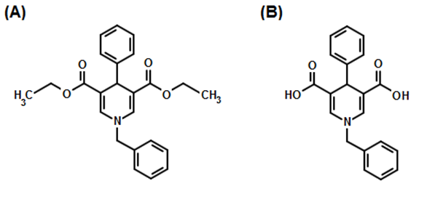

**Figure A9.** Sirtuin test compounds are illustrated. A is N-Benzyl-3, 5-dicarbethoxy-4-phenyl-1, 4-dihydropyridine (DHP-1). B is N-Benzyl-3 , 5-dicarboxy-4-phenyl-1, 4-dihydropyridine (DHP-2).

DHP-1 (Fig A9A) can be dissolved in reaction buffer at 50uM, but only in the form of a metastable solution. Measurement of DHP-1’s solubility using the above protocol revealed that it is thermodynamically insoluble. By mutating the ester groups in DHP-1 to carboxylic acid groups, we obtain the mutated compound DHP-2 (Fig. A9B). In contrast to DHP-1, DHP-2 is thermodynamically soluble (Table 3):

**Table 3.** Solubility of DHP-2 in different % DMSO/HDAC solution.

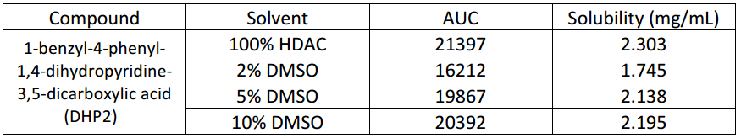

The solubility of Honokiol was also assessed with this protocol (Table 4):

**Table 4.** Solubility of Honokiol in different % DMSO/HDAC solution.

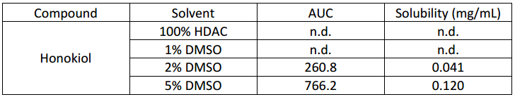

**Insert**:

-Dose response hkl fdl assay, amc. If not done, at least need a bar chart comparing the conditions that were done w labeled and unlabeled assays to show no false positive.

-Dose response dhp 2 w fdl assay, amc -- any unsat conds. If not done, at least need a bar chart comparing the conditions that were done w labeled and unlabeled assays to show false positive

-The dose response we measured with the label-free assay can also be compared to that in ref [Mai et al. JMC], which showed activation.

**Figure A10.** **Dose response via labeled assay – two parts of same fig**, **with caption; parts a,b**. **Done for HKL, app not for dhp(s).**

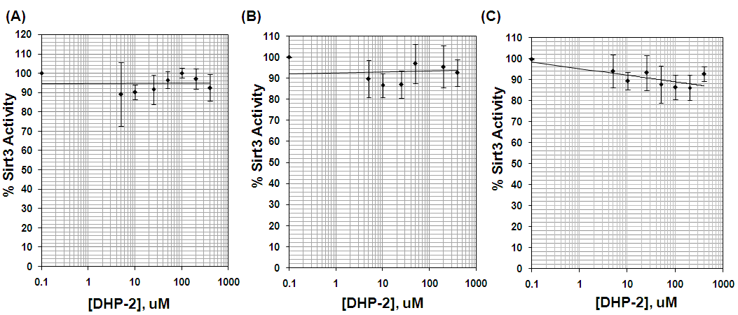

**Figure A11. Dose response of DHP for FdL . Effect of a dihydropyridine derivative (DHP-2) on Sirt3 deacetylation activity using a label-free assay.** Recombinant human SIRT3 was incubated for 30 min at 37oC in the presence of 0, 5, 10, 25, 50, 100, 200, 400µM DHP-2. A details 10uM NAD+ and 250uM FdL2 peptide substrate (N=3). B details 3 mM NAD+ and 3uM FdL2 peptide substrate (N=4). C illustrates 500uM NAD+ and 250uM FdL2 peptide substrate (N=3).

**Figure A12. Autofluorescence scan - for both dhps and HKL checking for overlap between wavelength ranges – parts a,b**

-Summarize other controls xg did including those w custom synthesized peptides and possibly sirtainty (overlapping wavelength range). Do not show any results from above just summarize in words. Indicate that some subtracting background autofluorescence at time 0 is not sufficient. (Change in fluorescence upon product formation cannot be accurately quantified in such cases.)

Dhp autofluorescence not initially checked in previous version. Background subtraction not possible. Standard curve needed for every condition tested due to effect of autofluorescence on dose response. Hence all dhps reported in two jmc papers should be considered possible false positives. Summarize evidence and if also so for sirtainty. Sirtainty and hplc give quantitatively similar results when no autofluorescence

References

1. Kaeberlein M, McVey M, & Guarente L (1999) The SIR2/3/4 complex and SIR2 alone promote longevity in Saccharomyces cerevisiae by two different mechanisms. *Genes & Development* 13(19):2570-2580.

2. Hirsch BM & Zheng W (2011) Sirtuin mechanism and inhibition: explored with N(epsilon)-acetyl-lysine analogs. *Molecular bioSystems* 7(1):16-28.

3. Cen Y (2010) Sirtuins inhibitors: the approach to affinity and selectivity. *Biochimica et biophysica acta* 1804(8):1635-1644.

4. Sauve AA (2010) Sirtuin chemical mechanisms. *Biochimica Et Biophysica Acta-Proteins and Proteomics* 1804(8):1591-1603.

5. Hu P, Wang S, & Zhang Y (2008) Highly dissociative and concerted mechanism for the nicotinamide cleavage reaction in Sir2Tm enzyme suggested by ab initio QM/MM molecular dynamics simulations. *Journal of the American Chemical Society* 130(49):16721-16728.

6. Zhou Y*, et al.* (2012) The bicyclic intermediate structure provides insights into the desuccinylation mechanism of human sirtuin 5 (SIRT5). *The Journal of biological chemistry* 287(34):28307-28314.

7. Mercken EM*, et al.* (2014) SRT2104 extends survival of male mice on a standard diet and preserves bone and muscle mass. *Aging Cell* 13(5):787-796.

8. Mitchell SJ*, et al.* (2014) The SIRT1 activator SRT1720 extends lifespan and improves health of mice fed a standard diet. *Cell Rep* 6(5):836-843.

9. Zorn JA & Wells JA (2010) Turning enzymes ON with small molecules. *Nat Chem Biol* 6(3):179-188.

10. Sinclair DA & Guarente L (2014) Small-molecule allosteric activators of sirtuins. *Annual review of pharmacology and toxicology* 54:363-380.

11. Hubbard BP*, et al.* (2013) Evidence for a Common Mechanism of SIRT1 Regulation by Allosteric Activators. *Science* 339(6124):1216-1219.

12. Dai H*, et al.* (2015) Crystallographic structure of a small molecule SIRT1 activator-enzyme complex. *Nat Commun* 6:7645.

13. Lakshminarasimhan M, Rauh D, Schutkowski M, & Steegborn C (2013) Sirt1 activation by resveratrol is substrate sequence-selective. *Aging (Albany NY)* 5(3):151-154.

14. North BJ*, et al.* (2014) SIRT2 induces the checkpoint kinase BubR1 to increase lifespan. *Embo Journal* 33(13):1438-1453.

15. Brown K*, et al.* (2013) SIRT3 reverses aging-associated degeneration. *Cell Rep* 3(2):319-327.

16. Kanfi Y*, et al.* (2012) The sirtuin SIRT6 regulates lifespan in male mice. *Nature* 483(7388):218-221.

17. Gertz M*, et al.* (2013) Ex-527 inhibits Sirtuins by exploiting their unique NAD(+)-dependent deacetylation mechanism. *Proceedings of the National Academy of Sciences of the United States of America* 110(30):E2772-E2781.

18. Rumpf T*, et al.* (2015) Selective Sirt2 inhibition by ligand-induced rearrangement of the active site. *Nat Commun* 6:6263.

19. Gomes AP*, et al.* (2013) Declining NAD(+) induces a pseudohypoxic state disrupting nuclear-mitochondrial communication during aging. *Cell* 155(7):1624-1638.

20. Qin WP*, et al.* (2006) Neuronal SIRT1 activation as a novel mechanism underlying the prevention of Alzheimer disease amyloid neuropathology by calorie restriction. *Journal of Biological Chemistry* 281(31):21745-21754.

21. Satoh A & Imai S (2014) Systemic regulation of mammalian ageing and longevity by brain sirtuins. *Nat Commun* 5:4211.

22. Massudi H*, et al.* (2012) Age-Associated Changes In Oxidative Stress and NAD(+) Metabolism In Human Tissue. *Plos One* 7(7):e42357.

23. Canto C*, et al.* (2012) The NAD(+) precursor nicotinamide riboside enhances oxidative metabolism and protects against high-fat diet-induced obesity. *Cell Metab* 15(6):838-847.

24. Smith BC & Denu JM (2007) Sir2 deacetylases exhibit nucleophilic participation of acetyl-lysine in NAD+ cleavage. *Journal of the American Chemical Society* 129(18):5802-5803.

25. Avalos JL, Boeke JD, & Wolberger C (2004) Structural basis for the mechanism and regulation of Sir2 enzymes. *Molecular Cell* 13(5):639-648.

26. Liang Z*, et al.* (2010) Investigation of the catalytic mechanism of Sir2 enzyme with QM/MM approach: SN1 vs SN2? *The journal of physical chemistry. B* 114(36):11927-11933.

27. Shi YW, Zhou YZ, Wang SL, & Zhang YK (2013) Sirtuin Deacetylation Mechanism and Catalytic Role of the Dynamic Cofactor Binding Loop. *J. Phys. Chem. Lett.* 4(3):491-495.

28. Avalos JL, Bever KM, & Wolberger C (2005) Mechanism of sirtuin inhibition by nicotinamide: Altering the NAD(+) cosubstrate specificity of a Sir2 enzyme. *Molecular Cell* 17(6):855-868.

29. Guan X, Lin P, Knoll E, & Chakrabarti R (2014) Mechanism of inhibition of the human sirtuin enzyme SIRT3 by nicotinamide: computational and experimental studies. *PLoS One* 9(9):e107729.

30. Cen Y & Sauve AA (2010) Transition state of ADP-ribosylation of acetyllysine catalyzed by Archaeoglobus fulgidus Sir2 determined by kinetic isotope effects and computational approaches. *Journal of the American Chemical Society* 132(35):12286-12298.

31. Sauve AA, Moir RD, Schramm VL, & Willis IM (2005) Chemical activation of Sir2-dependent silencing by relief of nicotinamide inhibition. *Molecular Cell* 17(4):595-601.

32. Hawse WF*, et al.* (2008) Structural Insights Into Intermediate Steps in the Sir2 Deacetylation Reaction. *Structure* 16(9):1368-1377.

33. Armstrong CM, Kaeberlein M, Imai SI, & Guarente L (2002) Mutations in Saccharomyces cerevisiae gene SIR2 can have differential effects on in vivo silencing phenotypes and in vitro histone deacetylation activity. *Mol Biol Cell* 13(4):1427-1438.

34. Szczepankiewicz BG*, et al.* (2012) Synthesis of carba-NAD and the structures of its ternary complexes with SIRT3 and SIRT5. *The Journal of organic chemistry* 77(17):7319-7329.

35. Zhao KH, Harshaw R, Chai XM, & Marmorstein R (2004) Structural basis for nicotinamide cleavage and ADP-ribose transfer by NAD(+)-dependent Sir2 histone/protein deacetylases. *Proceedings of the National Academy of Sciences of the United States of America* 101(23):8563-8568.

36. Sauve AA & Schramm VL (2003) Sir2 regulation by nicotinamide results from switching between base exchange and deacetylation chemistry. *Biochemistry* 42(31):9249-9256.

37. Hockerman GH, Peterson BZ, Johnson BD, & Catterall WA (1997) Molecular determinants of drug binding and action on L-type calcium channels. *Annual review of pharmacology and toxicology* 37:361-396.

38. Mai A*, et al.* (2009) Study of 1,4-dihydropyridine structural scaffold: discovery of novel sirtuin activators and inhibitors. *J Med Chem* 52(17):5496-5504.

39. Jackson MD, Schmidt MT, Oppenheimer NJ, & Denu JM (2003) Mechanism of nicotinamide inhibition and transglycosidation by Sir2 histone/protein deacetylases. *The Journal of biological chemistry* 278(51):50985-50998.

40. Sauve AA & Schramm VL (2003) Nicotinamide inhibition of SIR2 is a consequence of chemical competition for an ADPR - peptidyl intermediate. *Biochemistry* 42(28):8630-8630.

41. Imai S (2010) A possibility of nutriceuticals as an anti-aging intervention: Activation of sirtuins by promoting mammalian NAD biosynthesis. *Pharmacological research : the official journal of the Italian Pharmacological Society* 62(1):42-47.

42. Pacholec M*, et al.* (2010) SRT1720, SRT2183, SRT1460, and Resveratrol Are Not Direct Activators of SIRT1. *Journal of Biological Chemistry* 285(11):8340-8351.

43. Wang G*, et al.* (2014) P7C3 neuroprotective chemicals function by activating the rate-limiting enzyme in NAD salvage. *Cell* 158(6):1324-1334.

44. Hawse WF & Wolberger C (2009) Structure-based Mechanism of ADP-ribosylation by Sirtuins. *Journal of Biological Chemistry* 284(48):33654-33661.

45. Chakrabarti R, Klibanov AM, Friesner RA (2005) Sequence optimization and designability of enzyme active sites. *Proceedings of the National Academy of Sciences of the United States of America* 102: 12035-12040.

Aside from allosteric activation, enhancement of enzymatic activity via “derepression of inhibition” has been explored theoretically and experimentally. Theoretical models proposed [ref] have been limited to inhibitors that are exogenous to the reaction. Experimental studies [ref] have considered alleviation of product inhibition through competition with product binding. These approaches can only enhance enzyme activity in the presence of inhibitor or product accumulation and hence are not included among the four known modes of enzyme activation.

References above are 30,31

In the case of sirtuins, examples of noncompetitive inhibitors include SirReal2 [ref], whereas examples of uncompetitive inhibitors include Ex-527 [ref].

As in the case of Ex-527 [ref], the latter can render product dissociation rate limiting and reduce kcat,.

Honokiol (HKL) has been reported as a SIRT3 activator for the MnSOD protein substrate [ref].

for example, Ex-527, which is known to preferentially bind to a closed loop conformation, reduces coproduct dissociation rate and improves its binding affinity [ref].

By contrast, mechanism-based activation is a molecular engineering problem more akin to enzyme design [ref]

Ref is # 45 (we may add more later)

SIRT3 (118-399), referred to as “truncated SIRT3” or “T-SIRT3” herein, has alternatively been reported to have similar or 50-fold lower activity than SIRT3 (102-399), but has improved solubility properties [ref].

Analogous methods could be directly applied to other compounds recently reported to activate sirtuins other than SIRT1, such as SIRT5 and SIRT6 [ref].

Ref here is Steegborn Dec 2016