***x,y values _ XG***

**Old experiments**

|  |  |  |  |  |  |  |  |  |  |  |  |  |  |  |  |  |  |
| --- | --- | --- | --- | --- | --- | --- | --- | --- | --- | --- | --- | --- | --- | --- | --- | --- | --- |
| [NAD+], uM | Km,NAD+ = 2000 uM | | v'/v | | | | | % Activation | | | | | | | | | |
| y, Fraction of km (NAD+) | | x=0.7 | | x=0.8 | x=0.9 | | 25uM DHP1c | | 50uM DHP1c | | 75uM DHP1c | | 100uM DHP1c | | | |
| 250 | 0.1250 | | 1.3636 | | 1.2162 | 1.0976 | | 106.6 | | 99.6 | | 102.9 | | 104.3 | | | |
| 2000 | 1.0000 | | 1.1764 | | 1.1111 | 1.0526 | | 89.0 | | 105.0 | | 106.8 | | 111.9 | | | |

|  |  |  |  |  |  |  |  |  |
| --- | --- | --- | --- | --- | --- | --- | --- | --- |
| [FdL2 peptide], uM | Km,FdL2 peptide = 32 uM | v'/v | | | % Activation | | | |
| y, Fraction of km (FdL2 pepide) | x=0.7 | x=0.8 | x=0.9 | 25uM DHP1c | 50uM DHP1c | 75uM DHP1c | 100uM DHP1c |
| 50 | 1.5625 | 1.1326 | 1.0847 | 1.0406 | 98.2 | 75.0 | 99.8 | 109.5 |
| 250 | 7.8125 | 1.0352 | 1.0232 | 1.0115 | 89.0 | 105.0 | 106.8 | 111.9 |



**Proposed experiments**

**PMC-XG1-1**

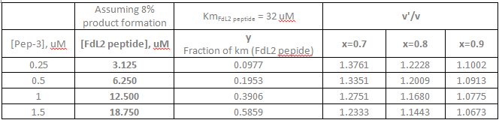

**PMC-XG1-2**

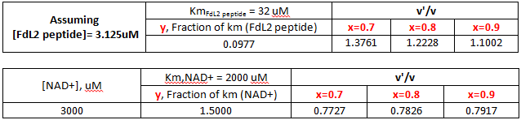

**PMC-XG3**

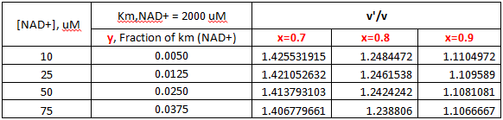

**PMC-XG5-1**

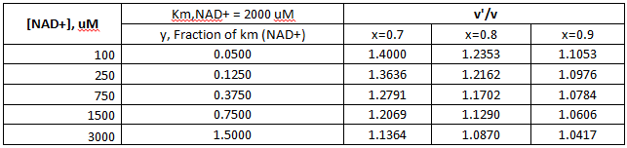

**XG Repeat experiments are [FdL2 peptide]=250 uM.**

***x,y values _ AU***

**Old experiments**

|  |  |  |  |  |  |
| --- | --- | --- | --- | --- | --- |
| [K122 peptide], uM | Km,K122 peptide = 87.6 uM | v'/v | | | % Activation |
| y, Fraction of km (K122 pepide) | x=0.7 | x=0.8 | x=0.9 |
| 10 | 0.1142 | 1.3685 | 1.2188 | 1.0986 | With 2 mM NAD, HNK;  10 uM=10.5%  50 uM = -7.5%  100 uM = -51.6%  200 uM = -88.08% |
| 600 | 6.8493 | 1.0397 | 1.0261 | 1.0129 | With 100 uM NAD, HNK;  10 uM=9.38%  50 uM = -9.21%  100 uM = -71.31%  200 uM = -86.76% |
|  |  |  |  |  |  |
| [K122 peptide], uM | Km,K122 peptide = 33 uM | v'/v | | | % Activation |
| y, Fraction of km (K122 pepide) | x=0.7 | x=0.8 | x=0.9 |
| 10 | 0.3030 | 1.2991 | 1.1813 | 1.0831 | With 2 mM NAD, HNK;  10 uM=10.5%  50 uM = -7.5%  100 uM = -51.6%  200 uM = -88.08% |
| 600 | 18.1818 | 1.0159 | 1.0105 | 1.0052 | With 100 uM NAD, HNK;  10 uM=9.38%  50 uM = -9.21%  100 uM = -71.31%  200 uM = -86.76% |

|  |  |  |  |  |  |
| --- | --- | --- | --- | --- | --- |
| [NAD+], uM | Km,NAD+ = 600 uM | v'/v | | | % Activation |
| y, Fraction of km (NAD+) | x=0.7 | x=0.8 | x=0.9 |
| 100 | 0.1667 | 1.3462 | 1.2069 | 1.0937 | With 600 uM peptide, HNK;  10 uM=9.38%  50 uM = -9.21%  100 uM = -71.31%  200 uM = -86.76% |
| 2000 | 3.3333 | 1.0744 | 1.0484 | 1.0236 | With 10 uM peptide, HNK;  10 uM=10.5%  50 uM = -7.5%  100 uM = -51.6%  200 uM = -88.08% |
|  |  |  |  |  |  |
| [NAD+], uM | Km,NAD+ = 2000 uM | v'/v | | | % Activation |
| y, Fraction of km (NAD+) | x=0.7 | x=0.8 | x=0.9 |
| 100 | 0.0500 | 1.4000 | 1.2353 | 1.1053 | With 600 uM peptide, HNK;  10 uM=9.38%  50 uM = -9.21%  100 uM = -71.31%  200 uM = -86.76% |
| 2000 | 1.0000 | 1.1765 | 1.1111 | 1.0526 | With 10 uM peptide, HNK;  10 uM=10.5%  50 uM = -7.5%  100 uM = -51.6%  200 uM = -88.08% |

**Proposed experiments**

|  |  |  |  |  |  |  |
| --- | --- | --- | --- | --- | --- | --- |
|  | | | Km,K122 peptide = 87.6 uM | v'/v | | |
| [non-Ac-K122], uM | Assuming 10% product formation [K122 peptide], uM | | y, Fraction of km (K122 pepide) | x=0.7 | x=0.8 | x=0.9 |
| 0.625 | 6.25 | | 0.0713 | 1.3889 | 1.2295 | 1.1029 |
| 1.25 | 12.5 | | 0.1427 | 1.3560 | 1.2122 | 1.0959 |
| 2.5 | 25 | | 0.2854 | 1.3044 | 1.1843 | 1.0844 |
| 5 | 50 | | 0.5708 | 1.2361 | 1.1459 | 1.0680 |
| 10 | 100 | | 1.1416 | 1.1629 | 1.1030 | 1.0490 |
|  | | | Km,K122 peptide = 33 uM | v'/v | | |
| [non-Ac-K122], uM | | Assuming 10% product formation [K122 peptide], uM | y, Fraction of km (K122 pepide) | x=0.7 | x=0.8 | x=0.9 |
| 0.625 | | 6.25 | 0.1894 | 1.3373 | 1.2021 | 1.0918 |
| 1.25 | | 12.5 | 0.3788 | 1.2781 | 1.1697 | 1.0782 |
| 2.5 | | 25 | 0.7576 | 1.2058 | 1.1284 | 1.0603 |
| 5 | | 50 | 1.5152 | 1.1354 | 1.0864 | 1.0414 |
| 10 | | 100 | 3.0303 | 1.0804 | 1.0522 | 1.0254 |

|  |  |  |  |  |
| --- | --- | --- | --- | --- |
| [NAD+], uM | Km,NAD+ = 600 uM | v'/v | | |
| y, Fraction of km (NAD+) | x=0.7 | x=0.8 | x=0.9 |
| 100 | 0.0500 | 1.4000 | 1.2353 | 1.1053 |
| 200 | 0.3333 | 1.2903 | 1.1765 | 1.0811 |
| 400 | 0.6667 | 1.2195 | 1.1364 | 1.0638 |
| 600 | 1.0000 | 1.1765 | 1.1111 | 1.0526 |
| 800 | 1.3333 | 1.1475 | 1.0938 | 1.0448 |
| 1200 | 2.0000 | 1.1111 | 1.0714 | 1.0345 |
|  |  |  |  |  |
| [NAD+], uM | Km,NAD+ = 2000 uM |  | v'/v |  |
| y, Fraction of km (NAD+) | x=0.7 | x=0.8 | x=0.9 |
| 200 | 0.1000 | 1.3750 | 1.2222 | 1.1000 |
| 400 | 0.2000 | 1.3333 | 1.2000 | 1.0909 |
| 600 | 0.3000 | 1.3000 | 1.1818 | 1.0833 |
| 800 | 0.4000 | 1.2727 | 1.1667 | 1.0769 |
| 1200 | 0.6000 | 1.2308 | 1.1429 | 1.0667 |

**AU Repeat experiments are [MnSODK-122]=10 uM, [NAD+]=100, 2000uM.(May change based on new saturating NAD concentration.)**